#### Status Survey and Conservation Action Plan

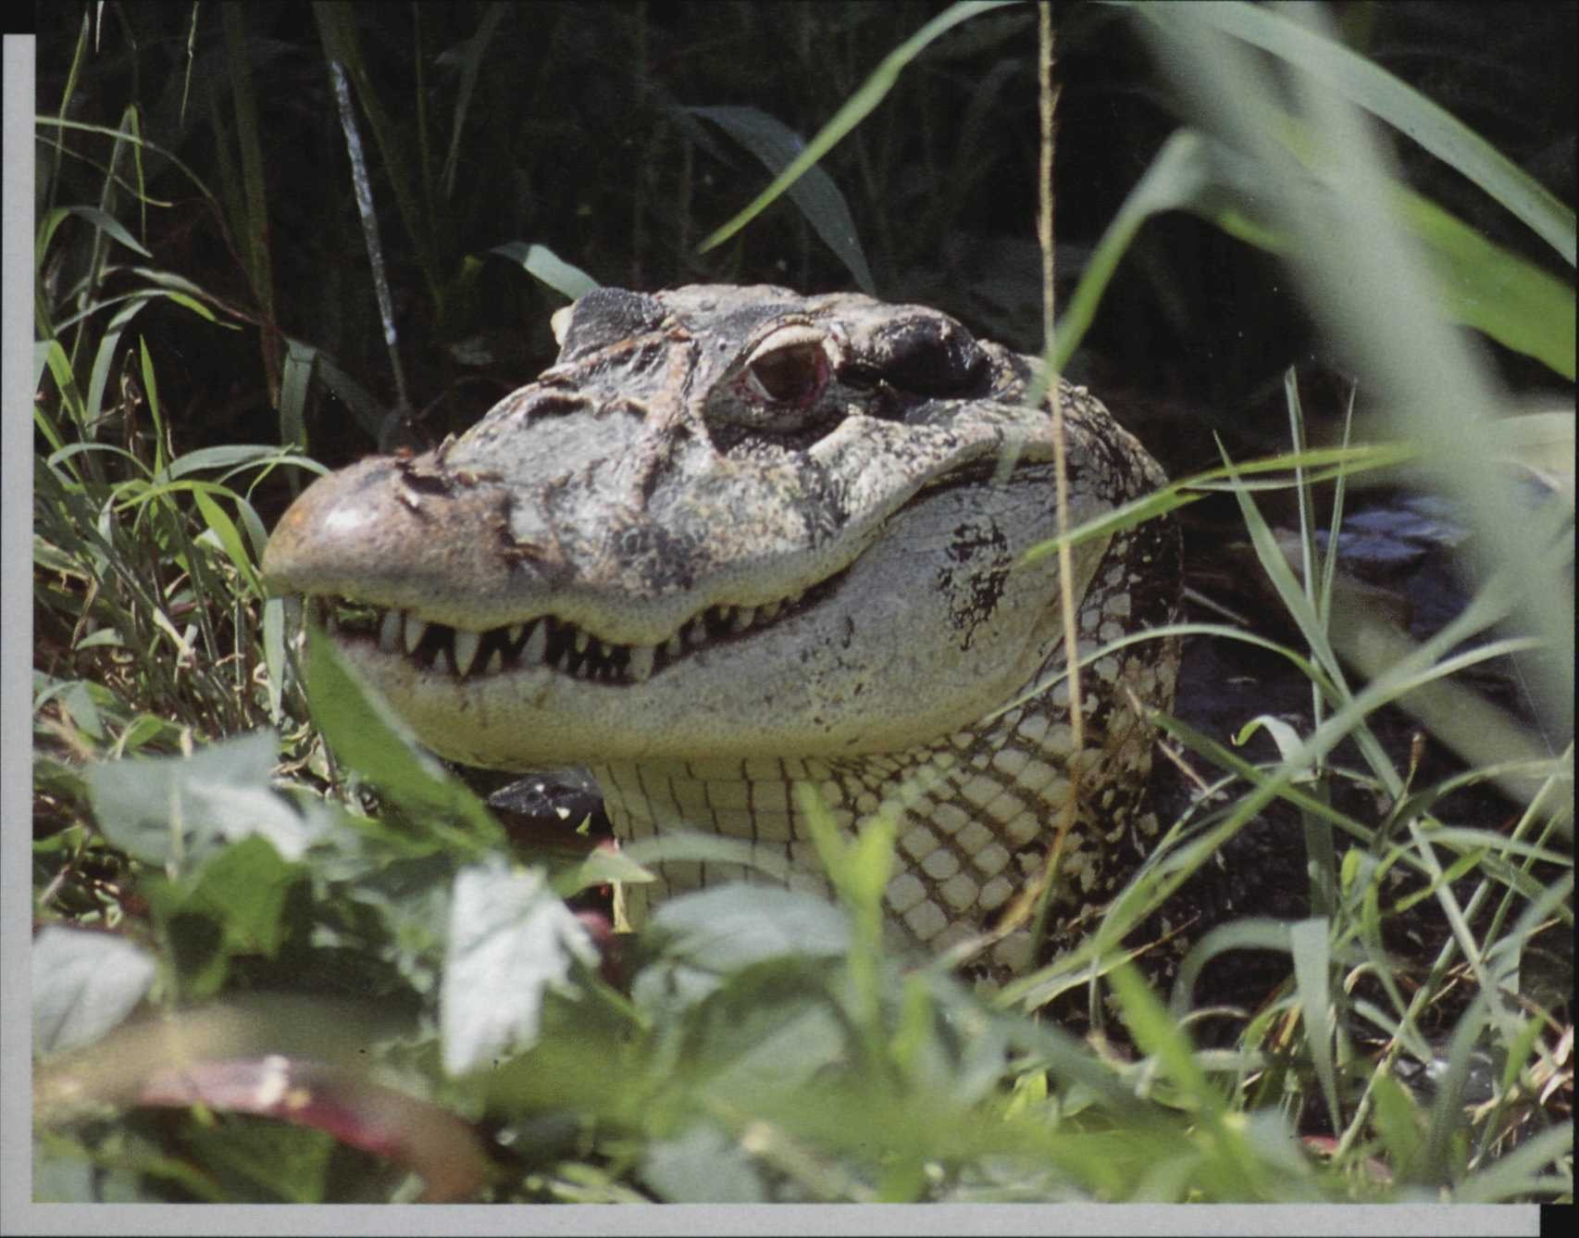

Second Edition

Crocodiles

**Edited by James Perran Ross**

#### IUCN/SSC Crocodile Specialist Group

**IUCN**

**The World Conservation Union**

**Donors to the SSC Conservation Communications Programme and the *Crocodile Action Plan***

The IUCN/Species Survival Commission is committed to communicate important species conservation information to natural resource managers, decision-makers and others whose actions affect the conservation of biodiversity. The SSC's Action Plans, Occasional Papers, news magazine *(Species),* Membership Directory and other publications are supported by a wide variety of generous donors including:

***The Sultanate ofOman*** established the Peter Scott IUCN/SSC Action Plan Fund in 1990. The Fund supports Action Plan development and implementation; to date, more than 80 grants have been made from the Fund to Specialist Groups. As a result, the Action Plan Programme has progressed at an accelerated level and the network has grown and matured significantly. The SSC is grateful to the Sultanate of Oman for its confidence in and support for species conservation worldwide.

***The Chicago Zoological Society (CZS)*** provides significant in-kind and cash support to the SSC, including grants for special projects, editorial and design services, staff secondments and related support services. The mission of CZS is to help people develop a sustainable and harmonious relationship with nature. The Zoo carries out its mission by informing and inspiring 2,000,000 annual visitors, serving as a refuge for species threatened with extinction, developing scientific approaches to manage species successfully in zoos and the wild, and working with other zoos, agencies, and protected areas around the world to conserve habitats and wildlife.

***The Council of Agriculture (COA), Taiwan*** has awarded major grants to the SSC's Wildlife Trade Programme and Conservation Communications Programme. This support has enabled SSC to continue its valuable technical advisory service to the Parties to CITES as well as to the larger global conservation community. Among other responsibilities, the COA is in charge of matters concerning the designation and management of nature reserves, conservation of wildlife and their habitats, conservation of natural landscapes, coordination of law enforcement efforts as well as promotion of conservation education, research and international cooperation.

***The World Wide Fund for Nature (WWF)*** provides significant annual operating support to the SSC. WWF's contribution supports the SSC's minimal infrastructure and helps ensure that the voluntary network and Publications Programme are adequately supported. WWF aims to conserve nature and ecological processes by: (1) preserving genetic, species, and ecosystem diversity; (2) ensuring that the use of renewable natural resources is sustainable both now and in the longer term; and (3) promoting actions to reduce pollution and the wasteful exploitation and consumption of resources and energy. WWF is one of the world's largest independent conservation organizations with a network of National Organizations and Associates around the world and over 5.2 million regular supporters. WWF continues to be known as World Wildlife Fund in Canada and in the United States of America.

***The Department ofthe Environment Transport and the Regions, UK, (DETR)*** supports a Red List Officer post at the SSC Centre in Cambridge, UK, where the SSC Trade Programme staff are also located. Together with two other Government-funded agencies, Scottish Natural Heritage and the Royal Botanic Gardens, Kew, the DETR is also financing a specialist plants officer. Further support for the centre is being offered by two NGO members of IUCN: the World Wide Fund for Nature - UK, and Conservation International, US.

##### Donors to the IUCN/SSC Crocodile Action Plan

This publication was produced by the Crocodile Specialist Group with assistance of a generous gift from Utai Youngprapakorn, Samutprakan Crocodile Farm and Zoo.

#### Status Survey and Conservation Action Plan

Second Edition

Crocodiles

### Edited by James Perran Ross

#### IUCN/SSC Crocodile Specialist Group

Contributors:

Eduardo Espinosa (*Caiman crocodilus, C. yacare*)

B.E.E.C.S. Laboratory, University of Florida

Gainesville, FL 32611, USA

Robert Godshalk (*Paleosuchus palpebrosus. P. trigonatus*) Department of Wildlife Ecology and Conservation

University of Florida Gainesville, FL 32611, USA

Philip Hall (*Crocodylus novaeguineae*) Environmental Office, Camp Blanding Dept. Military Affairs, FLARNG Starke, FL 32091-9703, USA

John Thorbjarnarson (*Crocodylus intermedius, Melanosuchus niger*)

Wildlife Conservation Society - NYZS 185th Street and Southern Blvd., Bronx, NY 10460, USA

Anton Tucker (*Crocodylus johnsoni*) Department of Zoology, University of Queensland

Brisbane 4072, Australia

Luciano Verdade (*Caiman latirostris*) Departo Zootechnica/ESALQ

Universidad de Sao Paulo, Piracicaba, Brazil

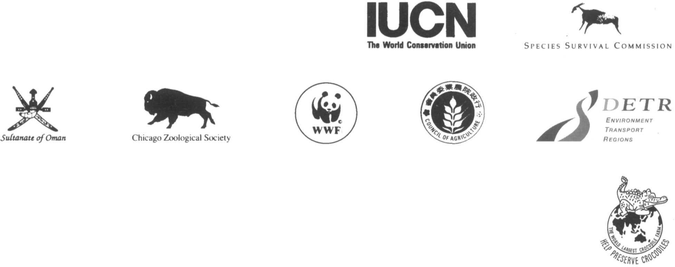

The designation of geographical entities in this book, and the presentation of the material, do not imply the expression of any opinion whatsoever on the part of IUCN concerning the legal status of any country, territory, or area, or of its authorities, or concerning the delimitation of its frontiers or boundaries.

The opinions expressed in this volume do not necessarily reflect those of IUCN.

Published by: IUCN, Gland, Switzerland, and Cambridge, UK and IUCN/SSC Crocodile Specialist Group, Gainesville, Florida, USA

Copyright:

Citation:

ISBN:

Cover photo:

Produced by: Printed by:

© 1998 International Union for Conservation of Nature and Natural Resources

Reproduction of this publication for educational and other non-commercial purposes is authorised without prior written permission from the copyright holder provided the source is fully acknowledged.

Reproduction of this publication for resale or other commercial purposes is prohibited without prior written permission of the copyright holder.

Ross J.P. (ed.). (1998) *Crocodiles. Status Survey and Conservation Action Plan.* 2nd Edition. IUCN/SSC Crocodile Specialist Group. IUCN, Gland, Switzerland and Cambridge, UK. viii + 96 pp.

2-8317-0441-3

Black caiman, *Melanosuchus niger,* Mamiraua, Brazil, where a substantial population of this depleted species is reported to be recovering. Photo by J. Thorbjarnarson.

The Nature Conservation Bureau Ltd, Newbury, UK. Information Press, Oxford, UK.

Available from: IUCN Publications Services Unit

219c Huntingdon Road, Cambridge CB3 0DL, UK Tel: +44 1223 277894, Fax +44 1223 277175

E-mail: [iucn-psu@wcmc.org.uk](mailto:iucn-psu@wcmc.org.uk) WWW: [http://www.iucn.org](http://www.iucn.org/)

A catalogue of IUCN publications is also available.

*The text of this book is printed on 115 gsm Grandeur Pure Velvet, which is rated as 5-star under the Eco-Check system and is made from 100% sustainable fibre sources using chlorine-free processes.*

# Contents

Executive Summary iv

Foreword v

Acknowledgements vi

Objectives and Organization vii

Introduction 1

Crocodilian biology 1

Threats to crocodilians 2

Conservation strategies for crocodilians 3

Conservation Priorities 6

Priority analysis 8

Projects listed in order of priority,

highest to lowest 8

Species Accounts

Alligator mississippiensis American alligator 10

Alligator sinensis Chinese alligator 12

Caiman crocodilus Common caiman 14

Caiman latirostris Broad-snouted caiman 18

Caiman yacare Yacaré 21

Melanosuchus niger Black caiman 3

Paleosuchus palpebrosus Dwarf caiman 29

Paleosuchus trigonatus Smooth-fronted caiman 31

Crocodylus acutus American crocodile 33

Crocodylus cataphractus Slender-snouted crocodile 36

Crocodylus intermedius Orinoco crocodile 38

Crocodylus johnsoni Australian freshwater crocodile. 42

Crocodylus mindorensis Philippine crocodile 44

Crocodylus moreletii Morelet's crocodile 46

Crocodylus niloticus Nile crocodile 48

Crocodylus novaeguineae New Guinea crocodile 51

Crocodylus palustris Mugger 54

Crocodylus porosus Saltwater crocodile 56

Crocodylus rhombifer Cuban crocodile 61

Crocodylus siamensis Siamese crocodile 64

Osteolaemus tetraspis Dwarf crocodile 67

Tomistoma schlegelii Tomistoma 69

Gavialis gangeticus Gharial 71

References 74

Appendix 1. Vernacular and Trade Names for Crocodilians of the World 89

Appendix 2. IUCN Red List Categories 90

# Executive Summary

The revised Action Plan for Crocodiles, provides concise summaries of the current status and recent information for all 23 species of crocodilian. The Action Plan supersedes the 1992 *Crocodiles: An Action Plan for their Conservation.* It reflects the ongoing activities of the Crocodile Specialist Group (CSG) membership, provides some guidance and describes priorities for immediate actions that address the most pressing current problems in crocodilian conservation.

An introductory section provides general information on crocodilian biology and outlines some general principles that are being applied to their conservation. The ecological and economical importance ofcrocodilians in their wetland habitats is noted. Conservation of wild crocodilian populations has numerous spin-off benefits for other species and local human communities. The application of sustainable use to crocodilian conservation is explained, and descriptions of national programs that demonstrate both the application and the effectiveness of these methods are included. The examples of the American alligator in the USA, the Nile crocodile in Zimbabwe and South Africa, and the Saltwater crocodile in Australia and Papua New Guinea are particularly compelling.

This revised Action Plan provides the first application of the new 1994 *IUCN Red List Categories* to crocodilian status assessment. In general, the assessments made using the 1994 categories agree with previous assessments, but in several cases the application of the new objective and quantitative criteria has drawn our attention to some significant gaps in our information and the need for a reconsideration of species status. The Critically Endangered status of *Crocodylus mindorensis, Crocodylus siamensis, Alligator sinensis* and *Crocodylus intermedius* is confirmed and these remain the highest priority for action.

Three species, *Tomistoma schlegelii, Crocodylus moreletii* and *Crocodylus cataphractus* were evaluated to be Data Deficient. New information suggests *Tomistoma* may be Vulnerable and *C moreletii* Lower Risk, conservation dependent. The application of the quantitative criteria and new information on status reassures us that *Crocodylus rhombifer, Gavialis gangeticus* and *Melanosuchus niger* are all showing slow recovery but remain Endangered. The maintenance of ongoing conservation action on these species should continue their recovery. *Crocodylusacutus, Crocodylus palustris* and *Osteolaemus tetraspis* are evaluated as Vulnerable. The remaining ten species of crocodilian are assessed to have a Lower Risk ofextinction. This group includes the major species appearing in trade and subject to sustainable use and management.

The revised Action Plan provides an updated set of action recommendations for each species. The recommended actions include: status surveys, the identification and protection of important populations and habitat; the enhancement of conservation and management capacity of national authorities; the development ofnational management plans for crocodilian conservation; captive breeding and restocking programs; and the development ofeconomic incentives for crocodilian conservation through well-regulated sustainable use. Those high priority projects applying to the most endangered species are analyzed and ranked as a guide to immediate needs.

The plan provides government agencies, management authorities, funding agencies, researchers, non- governmental organizations and other conservation interests with basic information and concrete recommendations for action that will promote the conservation of crocodilians and their habitats.

# Foreword

When *Crocodiles: An Action Plan for their Conservation* was completed and went to press in 1990 we did not truly expect that so many of the facts and recommendations it contained would become obsolete within a short time. To our surprise, and considerable pleasure, such is the case. The period 1990-1997 has seen some tremendous advances in our knowledge of the status of crocodiles and some significant improvements in the status of some species. The overall strategy of the CSG appears to be effective in slowing, and then reversing declines in the various species, and in encouraging proactive conservation programs to ensure their continued survival.

This period has not been without controversy and some setbacks. The CSG's enthusiastic promotion of sustainable use has drawn criticism from some quarters, largely by those who are unaware of, or cannot bring themselves to believe, its demonstrated success. In this period we have also engaged in an extended debate over the relative conservation merits of various forms of sustainable use for crocodilians (ranching, closed-cycle farming and wild harvest) and this Action Plan addresses the advantages, disadvantages, and some important general cautions applying to each. We have also continued to assist and

promote a variety of other conservation mechanisms, including complete protection, captive breeding and restocking. Our commitment to the conservation of wild populations of all species of crocodilians remains undiminished and we will recommend all the available techniques and strategies to achieve success. This task is far from complete but we understand that conservation is a dynamic process that will require continued action.

The Crocodile Specialist Group draws its strength and its effectiveness from its members. Their individual contributions, summed over the numerous countries and projects in which they are involved, provides the information and action which this Action Plan outlines. This revised *Action Plan,* like its predecessor, is intended to be a dynamic document that will be revised again to reflect changing conditions and knowledge. It provides a concise and focused guide to the status of crocodilians and the current actions needed for their conservation and will be a general guide to our activities for the forthcoming period.

Professor Harry Messel

Chairman, IUCN/SSC Crocodile Specialist Group

# Acknowledgements

This work could not have been completed without the financial support generously provided by Utai and Uthen Youngprapakorn and the Samutprakan Crocodile Farm and Zoo. The editor wishes to thank the contributors who provided drafts for the revision of several of the accounts, but retains the full responsibility for the final content and any errors. Professor Harry Messel, CSG Chairman, provided the initial stimulus for revising the Action Plan and continued to provide a firm pressure that ensured its completion. John Polisar and Sylvia Scudder contributed valuable support and comments. The working draft was reviewed by Dennis David, Phil Hall, Jon Hutton, Dietrich Jelden, F. Wayne King, Grahame Webb, Hank Jenkins, Alvaro Velasco, Lala Singh, David Evans, Enrico Chiesa, Norm Scott,

Andreas Schubert, Chris Banks, Mark Bezuijen, Walt Rhodes, Indraniel Das, Gustavo Hernandez, Zilca Campos, Myrna Watanabe, Alan Woodward, Paul Ouboter, and Charles A. Ross. Copy-editing and production assistance was provided by Alexandra Zimmermann. Finally, it is a pleasure to acknowledge the immense contributions of dozens and dozens of CSG members, who by their day-to-day efforts and particularly their communications with the CSG, keep us active and informed about the progress of crocodilian conservation throughout the world. Their work is the firm basis on which the Action Plan is securely grounded.

James Perran Ross, Editor. Executive Officer CSG

# Objectives and Organization

In the executive summary of *Crocodiles: an Action Plan for their Conservation* (1992) the following passage appears;

R. Godshalk

"The seven most critical species in terms of need for conservation are, in order of priority: the Siamese crocodile (*Crocodylus siamensis*), the Philippine crocodile (*Crocodylus mindorensis*), the Chinese alligator (*Alligator sinensis*), the Cuban crocodile (*Crocodylus rhombifer*), the tomistoma (*Tomistoma schlegelii*), the Orinoco crocodile (*Crocodylus intermedius*), and the gharial (*Gavialis gangeticus*). Four other species are endangered, the broad-snouted caiman (*Caiman latirostris*), the black caiman (*Melanosuchus niger*), the American crocodile (*Crocodylus acutus*), and Morelet's crocodile (*Crocodylus moreletii*). Because so little is known about many of these species, emphasis is placed on conducting population surveys to quantify the current population status as a first step towards initiating conservation programs."

In the period following the publication of *Crocodiles: An Action Plan for Their Conservation,* i.e. 1992-1995, considerable progress was made on addressing the conservation needs of the priority species. In the same period the status of the other species also changed. These changes were most clearly demonstrated in the papers presented at the Second Regional Meeting of the CSG in Darwin, Australia, March 1993, the 12th and 13th Working Meetings of the CSG in Pattaya, Thailand, May 1994, and Santa Fe, Argentina, May 1996. Additional new information was published in numerous project reports, publications and CSG reports, some published (e.g. *Crocodile Conservation Action* 1993) and others distributed in both the formal and popular literature. For some species, better information is allowing us to make more effective decisions for conservation, while for others conservation actions have shown beneficial effects. In a few, the situation continues to be bleak. In all cases it is clear that the Action Plan served its purpose as a catalyst for action and a guide for priorities. The situation has, therefore, sufficiently changed that it is useful to revise the Action Plan to reflect new status and altered priorities as they appear to the CSG at the present time.

We therefore undertook a revision of the Crocodile Action Plan with two main goals:

* To update the available information to indicate the current situation.
* To focus the recommended and priority actions for conservation more clearly.

With financial support from Utai Youngprapakorn of the Samutprakan Crocodile Farm and Zoo, a revision of the Action Plan was initiated at the 12th Working Meeting of the CSG, May 1994, to pull together the various reports and integrate them into a new plan. The original Action Plan (1992) has been the template for this revision and where little or no new information is available, the original text is preserved. A new introduction has been added. A bibliography of recent literature is given at the end of the Action Plan. The species accounts in this revised Crocodile Action Plan present the new information on each species. Country specific information is also integrated into the species accounts. The old country accounts have not been revised or included here. The original Action Plan should be consulted for country specific, background and historical material. This revised Action Plan therefore represents a new and self-contained document although it leans heavily upon its predecessor. The whole text is also available on the world wide web to allow instant access for users and ease of future revision (http:// [www.flmnh.ufl.edu/natsci/herpetology/crocs.htm).](http://www.flmnh.ufl.edu/natsci/herpetology/crocs.htm))

The original Action Plan was intended to be a dynamic working document. This revision and future revisions continue to reflect the changing nature of the status of crocodilians and the changing requirements for their conservation.

The fundamental goal of the CSG remains unchanged, to prevent the extinction of all crocodilians and to encourage management and conservation of crocodilians and their habitats at levels that ensure their ecological integrity and preserve their resource value.

Common caiman, *Caiman crocodilus,* and capybara, *Hydrochaeris Hydrochaeris,* in Masaguaral ranch, Venezuela. Sustainable use of wildlife provides valuable economic returns to owners of llanos wildlife.

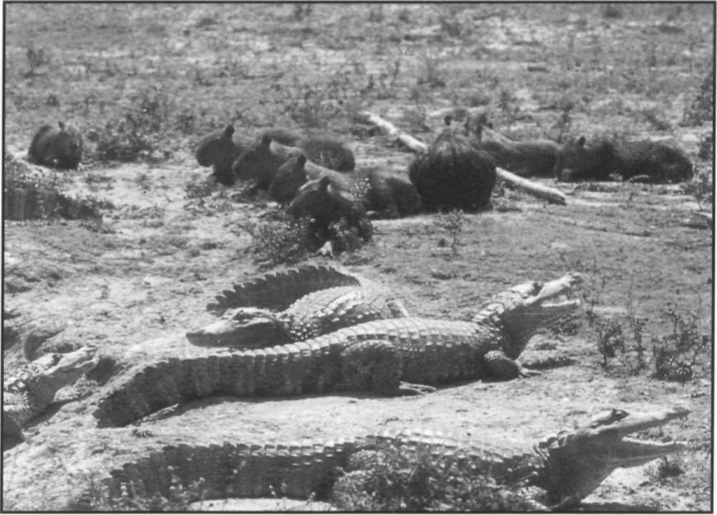

The objectives of this action plan are to:

1. Summarize new information on the current status of wild crocodilian populations;
2. Summarize new information on current management programs;
3. Assign priorities to species in terms of the need for conservation action; and
4. Develop a list of priority conservation projects for each species.

With these objectives the Action Plan serves the dual purposes of assisting government bodies, local conservation groups and researchers to define their crocodile conservation needs, and to stimulate and support fundraising for priority projects.

Information on population status and management programs was gleaned from published sources, unpublished reports, and from direct communications with CSG members and correspondents. Some of the accounts were drafted by individuals who are listed as the revisers and most of the accounts, and the organization of the whole document, was directed by the editor. The priority conservation programs were projects recommended by CSG members, either specifically for this Action Plan or as recommendations in published or unpublished

reports, or were projects deemed to be of particular importance by the editor and revisers. Not all conservation recommendations could be incorporated as specific projects, rather the intent was to address the principal areas of conservation concern and outline, in a very broad sense, what needs to be accomplished. The most immediate priorities are ranked based on urgency. These projects represent an inventory of conservation needs; the details regarding project personnel, budget and timetables are left for future elaboration. A list of people to contact for each project, country or species needs to be developed.

The revised Action Plan follows King and Burke (1989) in recognizing 23 species of crocodilian, although where there is taxonomic confusion or revision in progress this is indicated in the species account. We have generally used the scientific binomial names for crocodilians rather than common names. The scientific names are unique, unambiguous and internationally recognized, while each species has a plethora of common and colloquial names that can cause great confusion. We have inserted some common names to orient the lay reader. A full review of nomenclature of crocodilians is given in King and Burke (1989). An exhaustive list of common, vernacular and trade names is given in the CITES Identification Guide- Crocodilians 1995, Appendix 1.

Yacaré, *Caiman yacare.* Cooperative group feeding. Crocodilians have a complex social structure that is poorly understood.

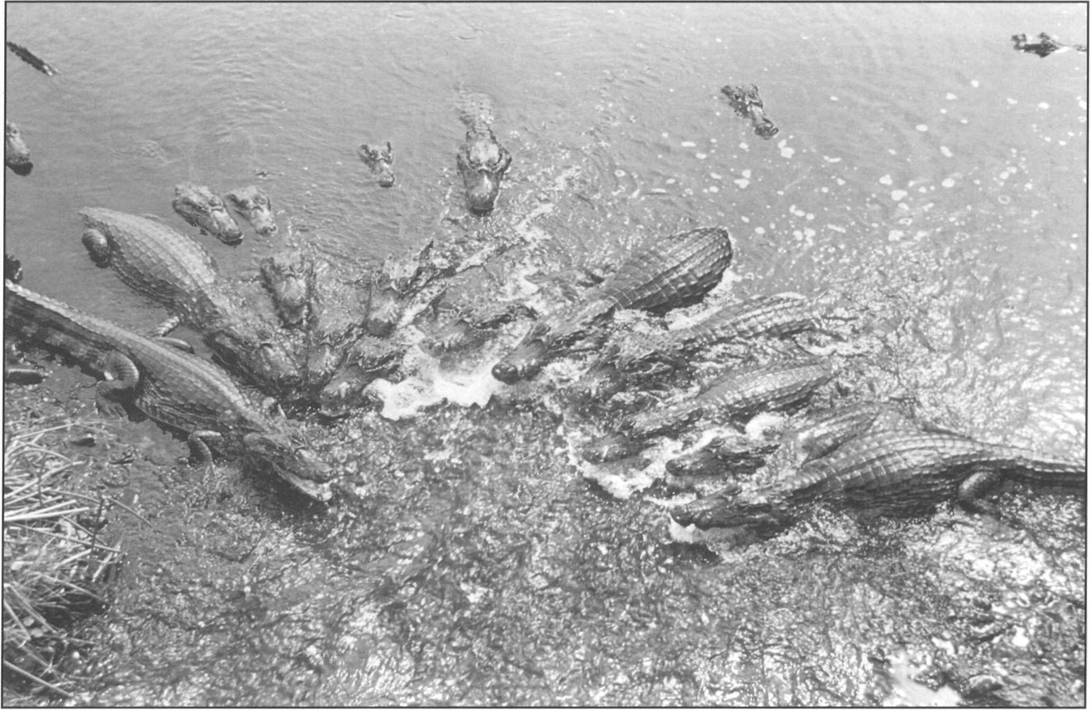

**Introduction**

### Crocodilian biology

L.A.K. Singh

Crocodilians (crocodiles, alligators, caimans, and gharials), are prominent and widespread occupants of tropical and subtropical aquatic habitats. The group is ofgreat antiquity with hundreds of fossil forms and three major radiations. Table 1 shows the taxonomy of the extant 23 species. Crocodilians are implicated in positive effects in their environments as "keystone species" that maintain ecosystem structure and function by their activities (King 1988, Craighead 1968). These include selective predation on fish species, recycling nutrients, and maintenance of wet refugia in droughts.

Crocodilians have some unique aspects of natural history that create special challenges for their conservation. They are the largest predators in their habitats and can threaten humans and their livestock. Many species are exploited for their valuable skin, which supports an international trade worth over US$500 million annually. They are also heavily affected by habitat loss and the pollution of aquatic habitats. Loss of any species of crocodilian would represent a significant loss of biodiversity, economic potential and ecosystem stability. There is a wide diversity of size, habitat, food preference, reproductive behavior and many other aspects of biology among the 23 species of crocodilian. However, all species have the following basic similarities. All crocodilians are very effective aquatic predators. At smaller sizes they often eat aquatic insects, small fish and crustaceans and as they grow larger they tend eat more vertebrates, including fish, turtles, birds and mammals. Crocodiles attempt to maintain their body temperature within narrow limits by basking in the sun when cool and seeking shade when hot. They are metabolically efficient and have fast reflexes and effective locomotor ability on land, where they walk on erect legs, and in the water, where they swim rapidly driven by their powerful tails. Crocodilians have complex behaviors including social interactions, dominance hierarchies, vocalization, coordinated feeding, and well developed maternal behavior. Females deposit from 10 to over 60 hard-shelled eggs into a nest which is either a hole dug into the ground, or into a mound of vegetation formed by the female. Most females remain near their nest during incubation and may protect it from predators. Upon hatching, vocalizations made by the hatchlings induce the female to assist the hatchlings to emerge, and in some cases to carry the tiny babies to the water in her mouth. Hatchlings remain together near the mother for several months, deriving protection from her. As they grow and become more widely dispersed and independent, a large number of the offspring perish - some eaten by other crocodilians.

**Table 1. List of the species of crocodilians, after King and Burke (1989).**

**Order Crocodylia Family Alligatoridae**

*Alligator mississippiensis* (American alligator)

*Alligator sinensis* (Chinese alligator)

*Caiman crocodilus* (caiman) includes *C. crocodilus crocodilus, C. c. fuscus, C. c. apaporiensis*,

C. c. *chiapasius*

*Caiman latirostris* (broad-snouted caiman)

*Caiman yacare* (yacaré)

*Melanosuchus niger* (black caiman) *Paleosuchus palpebrosus* (dwarf caiman) *Paleosuchus trigonatus* (smooth-fronted caiman)

**Family Crocodylidae Subfamily Crocodylinae**

*Crocodylus acutus* (American crocodile) *Crocodyluscataphractus*(slender-snoutedcrocodile) *Crocodylus intermedius* (Orinoco crocodile) *Crocodylusjohnsoni* (Australian freshwater crocodile) *Crocodylus mindorensis* (Philippine crocodile) *Crocodylus moreletii* (Morelet's crocodile) *Crocodylus niloticus* (Nile crocodile)

*Crocodylus novaeguineae* (New Guinea Crocodile)

*Crocodylus palustris* (mugger) *Crocodylus porosus* (saltwater crocodile) *Crocodylus rhombifer* (Cuban crocodile)

*Crocodylus siamensis* (Siamese crocodile) *Osteolaemus tetraspis* (dwarf crocodile) **Subfamily Tomistominae**

*Tomistoma schlegelii* (tomistoma)

**Family Gavialidae**

*Gavialis gangeticus* (gharial)

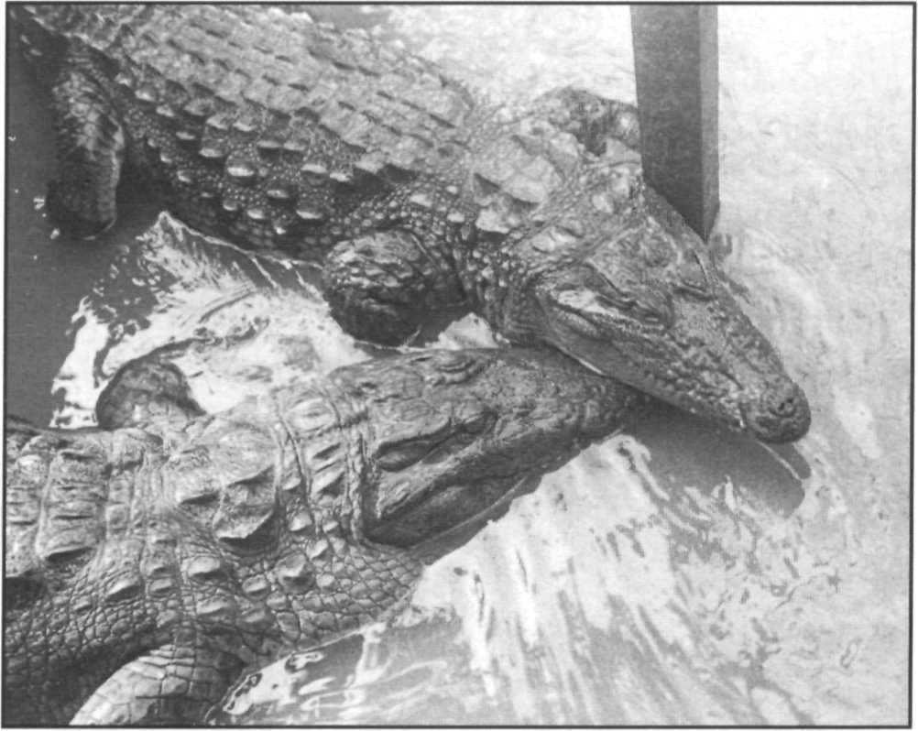Courting mugger, *Crocodylus palustris,* Tirkarpada, Orissa, India. Crocodilians show complex social behaviour. Courting may involve roaring, postural changes, positioning and snout rubbing, shown here.

F.W. King

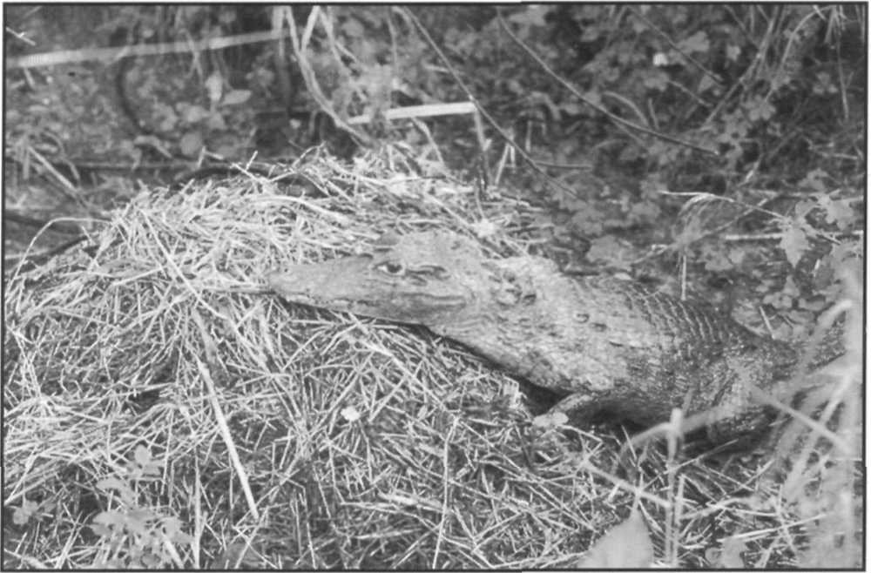

Common caiman, *Caiman crocodilus,* attending nest. Many crocodilians form nests of mounds of vegetation.

The survivors reach maturity after a period of 5-15 years depending on the species. Females grow more slowly and reach maturity at a smaller size than males, who continue growing and usually exceed females in maximum size. Crocodilians can be long lived in the wild and there are records of particular individuals residing for decades at some locations. Adults of several species emit loud vocalizations during the breeding season. Details of crocodilian biology as it pertains to their management and conservation can be found in Webb *et al.* (1987). These biological characteristics give the potential of great resiliency to some crocodilian populations, enabling them to recover from population depletion and sustain relatively high harvest rates. However, unregulated killing of adults can lead to rapid population depletion, particularly if combined with habitat loss.

Identifications and keys to the crocodilian species are given in CITES 1995, King and Brazaitis (1971), Brazaitis (1973) and the CITES Identification Manuals (Dollinger 1983).

### Threats to crocodilians

Crocodilians are threatened by many human activities. Foremost and the most significant among these is the destruction or alteration of wild habitat. In the past, commercial overexploitation and indiscriminate killing have resulted in many species suffering drastic declines in numbers and reductions in distribution, but no species has become extinct because of direct human exploitation. However, overexploitation combined with severe habitat loss have brought several species to the brink of extinction.

Crocodilians of all species depend upon wetland habitats. Different species have varying preferences and requirements and crocodilians have adapted to most available tropical and subtropical wetland types (marshes, mangroves, rivers, lakes, lagoons etc.). Because they are quite large animals and because crocodiles increase through

several orders of magnitude of size as they grow from hatchling to adult, they require areas of habitat that are both large and diverse. A few species are adaptable and are able to persist in small areas of disturbed habitat, for example the common caiman and Chinese alligator. However, most species require relatively large areas (hundreds of square kilometers) of undisturbed wetland to maintain large populations.

Habitat destruction has taken many forms. The most obvious destruction ofwetlands is by drainage and infilling, deforestation, conversion to agricultural use and pollution. However, more subtle habitat alteration may also be disastrous for crocodiles. In the Andaman Islands the saltwater crocodile is dependent upon restricted areas of fresh water marsh for successful nesting. Unfortunately these areas are increasingly used for human agriculture and crocodiles attempting to nest in them are killed. Therefore, while large areas of pristine riverine and mangrove habitat remains, the population is in decline. In the Philippines, people live along the rivers and use them extensively for fishing and transport. While the riverine habitat appears intact, and many areas have relatively low human densities, the constant attrition of crocodiles killed by people and caught in nets has caused the virtual disappearance of two species, the Philippine and saltwater crocodiles. Rural people are often intolerant of large and potentially dangerous crocodiles and the deliberate destruction of both nests and adults is widely reported (e.g. Madagascar, Andamans, China, Bangladesh). The creation of dams and impoundments has an ambiguous effect. Initially, the original complex, well vegetated marshy habitats may be replaced by simpler reservoir lakes with bare shores and crocodile populations may decline. New impoundments are often highly productive and support crocodile populations (e.g. Lake Argyle, Western Australia,

R. Godshalk.

Skinning farm raised alligators, *Alligator mississippiensis.* This tightly regulated program produces over 100,000 legal skins annually and provides in excess of US$ 1 million to support conservation, management and research on this species.

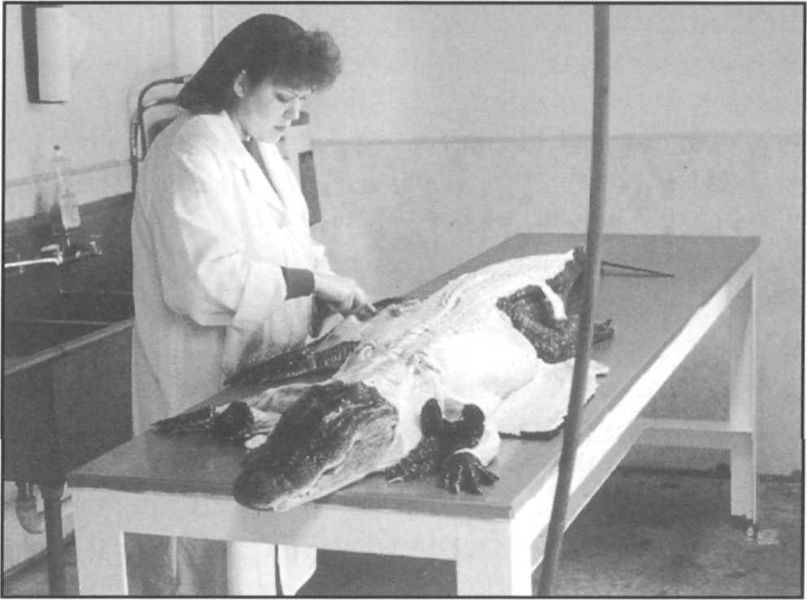

Lake Kariba, Zimbabwe), but fluctuations in water level due to agricultural or hydroelectric demand has affected reproduction ofcrocodiles in impoundments in Honduras, India, and Zimbabwe. The effect of humans on crocodile habitat may also be indirect and distant, such as the contamination with mercury and pesticides in Florida. This is suspected to inhibit crocodilian reproduction. In general, crocodilian populations become threatened in direct proportion to the proximity and density of human populations. At the same time, most species of crocodilian are relatively adaptable and ecologically robust. If their minimal requirements for prey, suitable thermal conditions and nesting habitat can be maintained then they can often persist in habitats that are modified by people. However, crocodile mortality by people, both deliberate and inadvertent, must be controlled.

B. Vernon

Conservation of crocodilian populations is therefore highly dependent upon providing incentives to maintain crocodiles and their habitats in a relatively undisturbed state, and a willingness to accept management practices that allow crocodiles and humans to co-exist.

### Conservation strategies for crocodilians

Since about 1970, after recognition that the uncontrolled exploitation of earlier decades had caused serious declines, many species have benefited immensely from the institution of improved protection and tightly controlled exploitation. However, crocodiles pose some difficult problems for conservationists. The larger species in particular are usually regarded as dangerous and unattractive by the people who have to live near them. When conservation programs have succeeded and crocodile populations have grown, problems of crocodile-human conflict often increase. Some species continue to require complete protection in protected areas and preservation in captivity. However, the majority of the species require a more creative approach that provides incentives to people living with crocodiles to offset their real and perceived costs.

Sustainable use has become a key element in the conservation of crocodilian species (Thorbjarnarson 1992, Jenkins 1993). An activity is sustainable if it can be continued indefinitely (IUCN/UNEP/WWF1991). Sustainable use is complex because we must consider both the effects on the target population (e.g. caiman that we wish to hunt) and the effects on non-target species and the associated ecosystem (e.g. hunting caiman may affect wetland nutrient cycles and fish populations). In many cases, it is difficult to prove that use is sustainable, but it is relatively easy to recognize when use is not sustainable. If people use any resource at a rate that exceeds the ability of the resource to replace itself, then the resource will become depleted.

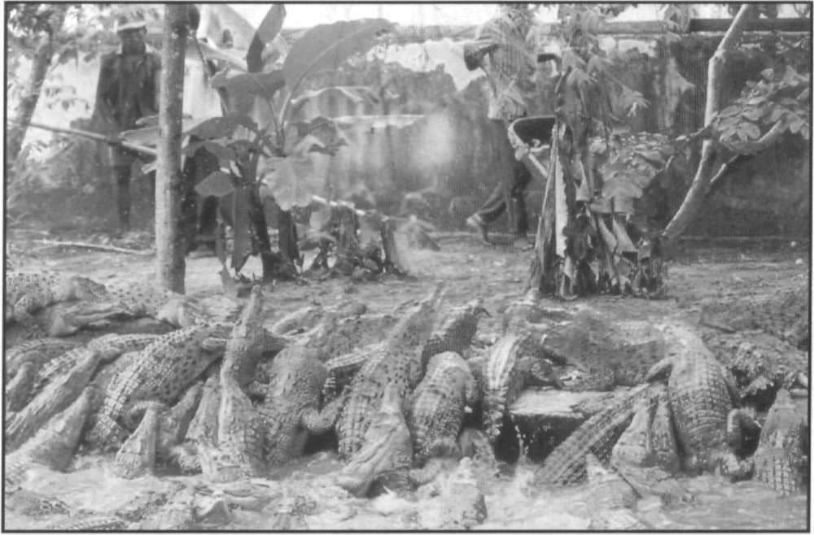

Saltwater crocodile, *Crocodylus porosus,* and New Guinea crocodile,

G.J.W. Webb

*Crocodylus novaeguineae,* in a ranch in Irian Jaya, Indonesia.

The challenge for researchers and managers responsible for crocodilians is to establish programs where there is high probability that use is sustainable, which can only occur if the resource and habitats are conserved.

Sustainable use of crocodilians can provide the necessary economic incentives to encourage people to maintain crocodilians and their habitats in a natural state. A general model has emerged for the successful sustainable use of crocodilians based on experience of nearly 20 years in such diverse countries as Papua New Guinea (Genolagani and Wilmot 1990), Venezuela (Quero de Peña 1993), Zimbabwe (Hutton and Child 1989), USA (Joanen *et al.* 1990) and Australia (Webb *et al.* 1992). While each of these countries uses a different management scheme, there are elements of similarity. In each of these examples crocodilian populations have increased or remained stable in the wild while supporting economically viable levels of exploitation. This is surely the ultimate test of sustainability although it remains to be seen if these systems remain stable for longer time periods.

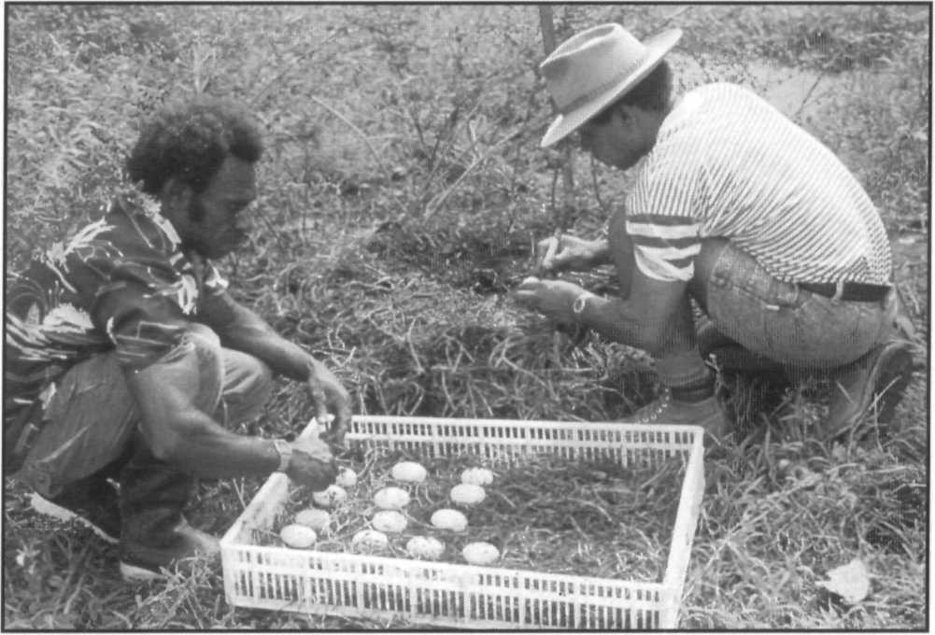Crocodile eggs are carefully packed for transport to a central incubator facility at the ranch. In Papua New Guinea, hen eggs and a cash price are paid to local villagers who protect nesting females as a valuable resource.

The basic components for crocodilian sustainable use demonstrated by these programs are the following:

1. **Survey:** An extensive but fairly superficial survey of crocodilians was conducted using standardized techniques to establish an index of distribution and abundance. This index was compared with similar indices from other locations and through time at the same location, and general inference about the size/status of the population was made.
2. **Recovery:** Where necessary and indicated by the survey, exploitation was preceded by a period of complete protection. This allowed crocodile populations to increase in size and management agencies to develop expertise and infrastructure. Crocodilians have a life history strategy that enables them to recover from low population levels quite rapidly (5-10 years), as long as their habitats remain intact.
3. **Monitoring:** Based upon the same standardized techniques, a regime of periodic monitoring of the population was undertaken. Changes in the rate of exploitation were based upon the results of this monitoring program. It is noteworthy that neither survey or monitoring need generate an absolute estimate of the number of crocodilians present, as long as a reliable index of the trend (increasing or decreasing) is obtained.
4. **Biology:** Exploitation of the crocodilian population was structured to focus harvest on those life stages where high mortality has the least affect on the population. This was usually the eggs and hatchlings, and adult males. Determination of which parts of a population to exploit, and how much, were derived from biological studies. The similarity of life style of different species of crocodilians has allowed the broad extrapolation of results on a few species to others with only superficial corroborating studies. It was not necessary to exhaustively study each species.

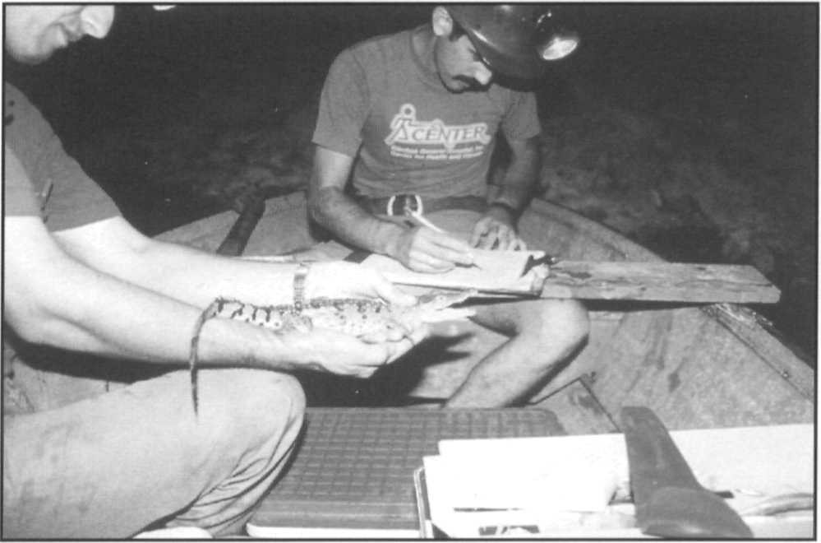Dante Videz (left) and Andres Siejas (right) record field data on an American crocodile hatchling, *Crocodylus acutus,* in Venezuela.

1. **Caution:** Levels of exploitation were kept well below the calculated levels that the population may be able to sustain. This was accomplished by implementing closed seasons, size limits, gear limitations, restricted licensing of processors and traders, harvest and export quotas, and often by the intrinsic inaccessibility of some parts of the crocodile population's range. In this way, natural environmental fluctuations and unexpected catastrophes can still be absorbed by the population.
2. **Local benefit:** The immediate economic benefits, and the responsibility for management were vested in the social groups closest to the extraction phase of exploitation. In Papua New Guinea these were tribal land owners, in Venezuela ranchers, in Australia and USA local businessmen and farmers.
3. **Enforcement:** Despite optimistic expectations that enlightened self interest would ensure good compliance with regulations, an effective enforcement mechanism was necessary to ensure compliance. This extended to harvest, trading, tanning, manufacturing and export controls.
4. **Trade control:** Because the main economic benefit of crocodile use is derived from international commerce, a stringent system for controlling international trade was a primary mechanism for controlling use and ensuring sustainability.
5. **Economic feedback:** A proportion of the economic returns from use was retained and used to support monitoring, management and enforcement. This was usually in the form of license fees, export fees, and user access charges.

Crocodilians can be used sustainably by several methods; hunting of wild crocodilians, ranching (i.e. bringing eggs or hatchlings from the wild and raising them

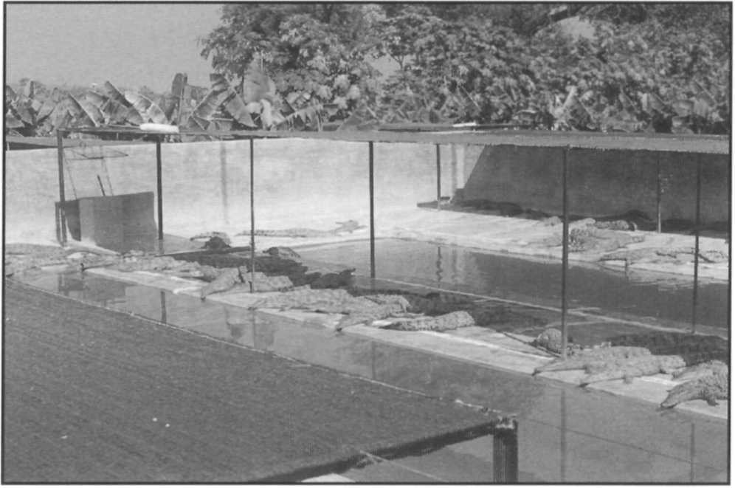Nile crocodiles, *Crocodylus niloticus,* on a ranch in Zimbabwe. Ranching of eggs taken from the wild gives an incentive to conserve wild populations and their habitats.

F.W. King

P. Ross

in captivity) and captive breeding (farming) by maintaining breeding adults in captivity and raising their offspring. Each of these has advantages and disadvantages in terms of conservation value, ease of regulation, and economic costs and returns (David 1994). Sustainability is possible, and demonstrated, for each method and many successful national crcocodilian management systems utilize a combination of methods. Understanding the relative advantages and problems of the different methods is crucial to making sustainable use likely.

Applications of these measures are described in David (1994). The two key elements of this system are that (i) monitoring allows a prompt response (by changing use levels) to any perceived downward trend in abundance or population structure indicating overexploitation and, (ii) that the people who might be tempted to overexploit the population have the greatest vested interest in maintaining it. The real breakthrough for crocodilians has been the success of the Crocodile Specialist Group in convincing the large international traders and manufacturers of crocodilian products that they can successfully do business with equal or enhanced profits if sustainable use schemes are in place. The support of the commercial sector has provided powerful leverage to encourage compliance by producing countries and has been an incentive to invest in good sustainable crocodilian management.

This link between commerce and conservation has some perils. Between 1990 and 1993, the price of all crocodilian skins on the international market was dramatically reduced (Woodward *et al.* 1993). The cause of the crash was complex, involving worldwide economic trends and overproduction of skins in farms beyond the market demand. Concerns were expressed that the sudden removal of economic incentives for conservation would undermine the CSG sustainable use strategy. Great hardship was experienced in the commercial sector. Some operators withdrew from the industry and most management programs based on sustainable use saw a reduction in their budgets. However, an anticipated upswing in illegal, unsustainable production of crocodile skins did not occur. The combination of national and international regulations and the long term interest of producers and traders served to maintain and considerably strengthen the regulatory system. We take this as strong evidence that the application of sustainable use strategies to crocodilian conservation is based on a firm foundation

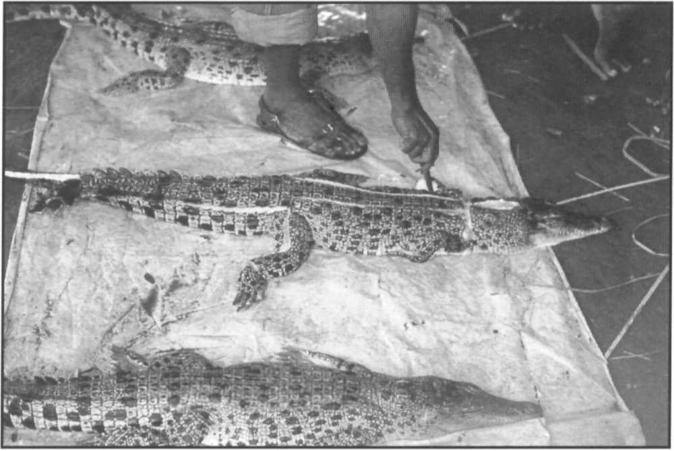

Skinning saltwater crocodiles during a government demonstration and training course for villagers on the Sepik River, Papua New Guinea. Size limits control harvest of wild crocodiles in Papua New Guinea.

D. Jelden

and is sufficiently robust to withstand occasional economic setbacks.

There remains a group of crocodilian species that, because of their current status or undesirable quality of their products, are unlikely to benefit from sustainable use. The CSG remains strongly committed to the application of more traditional conservation practice such as habitat protection and captive breeding for such species. We also recognize that the individual characteristics of different countries make some techniques more feasible and effective than others. The species accounts detail many of these programs and the CSG remains committed to our basic goal of crocodilian conservation.

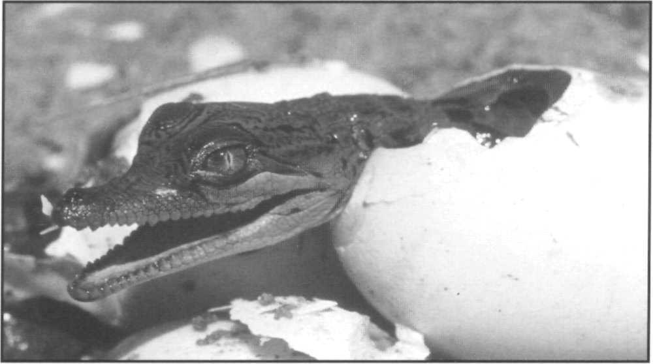Saltwater crocodile, *Crocodylus porosus,* hatchling, Northern Territory, Australia. Successful incubation of crocodile eggs from the wild is the basis of ranching programs.

G.J.W. Webb

# Conservation Priorities

In the period 1992-1994, IUCN and CITES both revised and clarified the criteria by which species were evaluated for conservation status. Previous categories used in both the IUCN Red Lists and in the CITES Appendices were seen to be vague and sometimes arbitrary. Although they had served well for many years it was deemed advisable to develop new categories, defined by criteria that were objective (i.e. measurable and quantitative), simple, universal (i.e. broadly applicable to all or most taxa) and flexible. The revised criteria have been developed based upon an understanding of population dynamics and how these affect the probability of a species becoming extinct in a given period of time (Mace and Lande 1991, Mace *et al.* 1992). Four fundamental foundations of species biology are recognized:

* 1. Rate of population reduction
  2. Extent and fragmentation of occupancy or range
  3. Effective population number (number of breeding adults)
  4. Life history structure

In simple terms, species that remain numerous and widespread and have no specially limiting features of life

history are considered to be unlikely to become extinct in an immediate (1-10 years) or ecological (10-100 years) time frame. Species which show a sharp reduction in one or more of these, or which have specially limiting life histories (e.g. extremely long periods to reach maturity, special habitat requirements) are more likely to become extinct. After extensive discussion and numerous revisions a series of criteria based on these fundamentals have evolved. Some debate remains on the extent to which the criteria are truly objective and meet conservation needs but for the present the revised categories, known as the IUCN Red List Categories (IUCN 1994), provide a valuable and improved method for evaluating species status. Full details of these new categories are described in Appendix 2 of this Action Plan. Table 2 provides an overview of the extent to which survey data are available for the species of crocodilians. The species accounts of this revised Action Plan include an evaluation of each species using the new criteria (Table 3).

These analyses confirm our earlier evaluation of which crocodilian species warrant priority conservation action, but reassesses which countries need priority action. Two additional species *Crocodylus cataphractus* and *C. moreletii*

|  |  |  |
| --- | --- | --- |
| **Table 2. Classification of crocodilian species according to the quality of quantitative population survey data available. Information summarized from the species accounts. In some cases adequate survey data are available for some parts of the range (e.g. *Crocodylus niloticus, C. porosus)* but large parts of the range remain unsurveyed.**  **Survey data Species Common name** | | |
| EXTREMELY POOR  (inadequate to judge status anywhere in the range) | *Crocodyluscataphractus Osteolaemustetraspis* | Slender-snouted crocodile Dwarf crocodile |
| POOR | *Tomistomaschlegelii* | Tomistoma |
| (Important areas of the range lack surveys) | *Crocodylus niloticus* | Nile crocodile |
|  | *Crocodylusporosus* | Saltwater crocodile |
|  | *Crocodylussiamensis* | Siamese crocodile |
|  | *Crocodylusintermedius* | Orinoco crocodile |
|  | *Crocodylus acutus* | American crocodile |
|  | *Caimanlatirostris* | Broad-snouted caiman |
|  | *Crocodylus moreletii* | Morelet's crocodile |
|  | *Paleosuchustrigonatus* | Smooth-fronted caiman |
|  | *Paleosuchuspalpebrosus* | Dwarf caiman |
|  | *Melanosuchusniger* | Black caiman |
| ADEQUATE | *Caiman crocodilus* | Common caiman |
| (Sufficient to make informed decisions on status) | *Caimanyacare* | Yacaré |
|  | *Alligator sinensis* | Chinese alligator |
|  | *Crocodylus rhombifer* | Cuban crocodile |
|  | *Crocodylusmindorensis* | Philippine crocodile |
|  | *Crocodylusnovaeguineae* | New Guinea crocodile |
|  | *Crocodylus palustris* | Mugger |
|  | *Gavialisgangeticus* | Gharial |
| GOOD (Sufficient to manage and conserve the species throughout its range) | *Alligatormississippiensis Crocodylus johnsoni* | American alligator  Australian freshwater crocodile |

|  |
| --- |
| **Table 3. Species of crocodilian evaluated by the IUCN Red List Categories 1996.**  CR = Critically Endangered, EN = Endangered, VU = Vulnerable, LR = Lower Risk, DD = Data Deficient. Criteria which qualify each species for its status are indicated.  **Species Category Criteria** |
| *Tomistomaschlegelii* DD Insufficient data to establish status (Probably EN based on criteria A.1 or C.2)  *Crocodyluscataphractus* DD Insufficient data to establish status (Maybe EN or V based on criteria A.1)  *Crocodylusmoreletii* DD Insufficient data to establish status. Re-analysis at a CSG worshop in 1996  suggested LRcd (Lower Risk, conservation dependent) category. (Ross 1996)  *Crocodylusmindorensis* CR A.1.c, C.2.a  Decline >80% in 3 generations, area of occupancy population <250, severely fragmented and declining  *Crocodylussiamensis* CR A.1. a, c  Decline >80% in 3 generations, area of occupancy  *Alligatorsinensis* CR A.1.C, D.1  Decline >80% in 3 generations, area of occupancy area of occupancy >10km2, fragmented possibly fewer than 50 adults  *Crocodylusintermedius* CR A.1.c, C.2.a  Decline >80% in 3 generations, area of occupancy population <250, fragmented and declining  *Melanosuchusniger* EN A.1.c,d  Decline >50% in 3 generations, exploitation over much of range. Re-analysis at  a workshop in 1996 indicated widespread recovery tending toward VU or even LR(Ross 1996).  *Crocodylusrhombifer* EN A.1.c,e, B.1  Area of occupancy <500km2, 1 location, hybridization with C. *acutus*  *Gavialisgangeticus* EN C.2.a, E  Population <2,500 and severely fragmented. Quantitative analysis (India PHVA 1995)  *Crocodylusacutus* VU A.1a, c  Decline >20% in 3 generations, extent of occurrence  *Crocodyluspalustris* VU A.1.a, C.2.a  Decline >20% in 3 generations, extent of occurrence population <10,000 continuing decline and fragmented  *Osteolaemustetraspis* VU A.2.c,d  Decline >20% in 3 generations, exploitation, inferred reduction extent of occurrence  *Crocodylusmoreletii* LR Conservation dependent, >10,000 individuals, widely distributed  *Alligatormississippiensis* LR 100,000's widespread *Crocodylusniloticus* LR 100,000's widespread *Crocodylusnovaeguineae* LR 50,000+ widespread  *Crocodylusporosus* LR 50,000+ widespread (locally rare/endangered)  *Crocodylusjohnsoni* LR 50,000+ widespread  *Caimancrocodilus* LR 100,000's widespread (locally depleted)  *Caimanyacare* LR 100,000's widespread (locally depleted)  *Caimanlatirostris* LR 10,000+ widespread *Paleosuchustrigonatus* LR Numerous widespread *Paleosuchuspalpebrosus* LR Numerous widespread |

|  |  |  |
| --- | --- | --- |
| **Table 4. Priorities for crocodilian conservation action.**  Species are listed in priority order. Countries are listed in order of highest priority action. Needed conservation actions are specified in the species accounts and include basic surveys and identification of key habitats and populations, protection of habitats and species, enhancement of national management and conservation capacity, captive breeding and restocking, and development of incentives for crocodile and habitat conservation.  **Species Common name Country** | | |
| *Alligator sinensis* | Chinese alligator | China |
| *Crocodylus mindorensis* | Philippine crocodile | Philippines |
| *Tomistoma schlegeli* | Tomistoma | Indonesia, Malaysia |
| *Crocodylus siamensis* | Siamese crocodile | Cambodia, Vietnam, Lao PDR, Thailand, Indonesia |
| *Crocodylus intermedius* | Orinoco crocodile | Colombia, Venezuela |
| *Crocodylus rhombifer* | Cuban crocodile | Cuba |
| *Gavialis gangeticus* | Gharial | India, Nepal, Pakistan, Bangladesh, Bhutan |
| *Crocodylus cataphractus* | Slender-snouted crocodile | Central and west Africa |

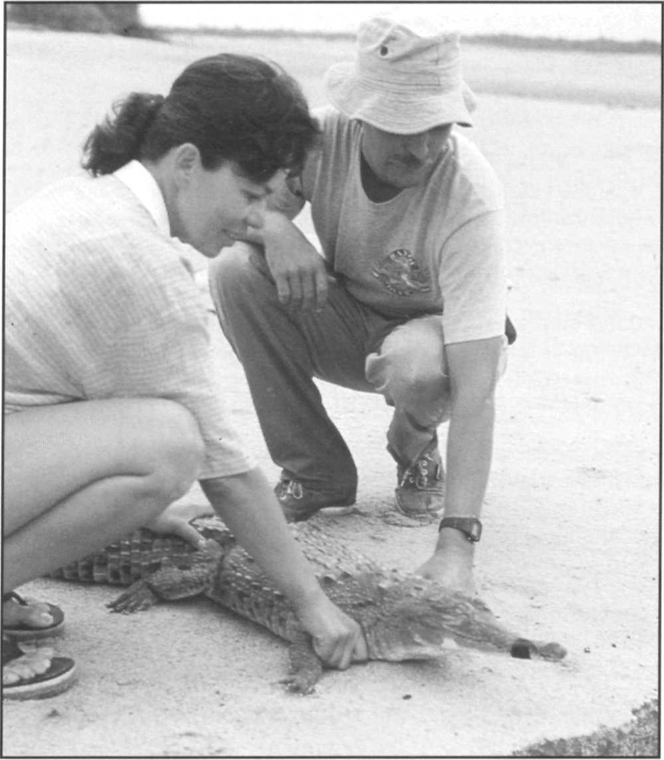a concise list of 35 key projects. Of these, five are substantially in progress, with funding and personnel assigned and activities underway. Thirteen could be considered as in the early stages of initiation, proposals are written, preliminary field studies have been carried out, initial contacts in target countries are well established. The remaining seventeen are projects that have yet to be initiated and indicate a clear direction for future activities.

Projects should not be considered for funding or implementation in strict order of rank, but all things being equal, a higher ranked project should be considered with favor over a lower ranked project. As all things are rarely equal, we expect that other factors, including available funds, available expertise, preferences and priorities of funding agencies, political stability, probability of success, available time and other similar factors will continue to influence project funding and implementation. Notwithstanding such considerations, some clear priority ranking emerges from this analysis that could usefully guide project development.

To assign priorities the following considerations were applied in order of importance:

C. Lageaux

Orinoco crocodile, *Crocodylus intermedius,* raised in captivity and released as part of a population restocking program in Venezuela.

are noted as being unlikely to be seriously endangered at present, but are a priority for information gathering to allow adequate status assessment. Combining these evaluations produces a new set of priorities which are presented in Table 4.

* + Species of highest priority (Tables 3 and 4).
  + Countries of highest priority (Table 4 and accounts).
  + Projects of highest priority (accounts).
  + Projects to immediately avert extinction.
  + Projects involving several countries.
  + Projects to implement management and conservation.
  + Projects to ascertain status.
  + Basic biology and research.
  + Moderate priority projects.

### Priority analysis

In the species accounts which follow we have analyzed the present status and state of knowledge of the crocodilian species, identified countries in which the needs are most urgent, and specified the highest priority projects. By combining these factors, it is possible to rank projects and identify the most immediate priorities. Ranking is always problematic, in part because different criteria of urgency may conflict, and in part because favored or politically desirable projects may not appear in the rank order where we would most like to see them. There is also a degree of arbitrariness in assigning more concern to one species over another. However, in the present analysis, the species rankings are based on our best evaluation of the severity of current threats (Table 3).

The following ranking should therefore be accepted only provisionally as a general guide to what is really urgent and what might be safely delayed without increasing the likelihood of extinction of a crocodilian species.

Analysis of high priority projects for high priority species, endangered species and vulnerable species yields

### Projects listed in order of priority, highest to lowest

More complete descriptions of each project are given following each species account on the indicated pages.

Al. *Alligator sinensis,* China, avert extinction, enhanced protection and continued monitoring of wild populations (initiated), p. 13.

A2. *Alligator sinensis,* multinational. China, USA, Thailand, management and coordination of captive populations, p. 13.

Bl. *Crocodylus mindorensis,* Philippines, development of a national crocodile conservation program (initiated), p. 45.

B2. *Crocodylus mindorensis,* multinational. Philippines, USA, Australia, coordination of captive breeding program (in progress), p. 45

Cl. *Tomistoma schlegelii,* Malaysia, status surveys in Sarawak and Malaysia, (initiated) p. 70.

C2. *Tomistoma schlegelii,* Indonesia, implementation of conservation programs (initiated), p. 70.

C3. *Tomistoma schlegelii,* Indonesia, status survey Kalimantan and Sumatra (in progress 1996), p. 70.

Dl. *Crocodylus siamensis,* Thailand, extinction prevention, protection of habitat and restocking (initiated), p. 66.

D2. *Crocodylus siamensis,* Cambodia, status survey and conservation and management plan development, p. 66.

D3. *Crocodylus siamensis,* Vietnam, status survey and conservation and management plan development, p. 66. D4. *Crocodylus siamensis,* Laos, status survey and conservation and management plan development, p. 66.

D5. *Crocodylus siamensis,* Indonesia, verification of distribution and protection in Kalimantan (initiated), p. 66.

El. *Crocodylus intermedius,* Colombia, survey of

population status (initiated), p. 40.

E2. *Crocodylus intermedius,* Venezuela, conservation in Cinaruco-Capanaparo National Park (in progress), p. 41.

E3. *Crocodylus intermedius,* Venezuela, monitoring of restocked populations (in progress), p. 41.

Kl. *Crocodylus palustris,* Pakistan, prevent extinction, survey as a base for conservation and management program, p. 55.

K2. *Crocodylus palustris,* Sri Lanka, prevent extinction, survey as a base for conservation and management program, p. 55.

L1. *Osteolaemus tetraspis,* multinational. Congo, Dem. Rep. Congo, Gabon, Nigeria, Central African Republic, surveys and local use assessment, see H1. above, p. 68.

Ml. *Crocodylus moreletii,* Mexico, status surveys and development of conservation and management programs (initiated), p. 47.

M2. *Crocodylus moreletii,* Guatemala, status surveys and development of conservation and management programs, p. 47.

N1. Crocodylus mindorensis, Crocodylus siamensis,

*Crocodylus novaeguineae* Taxonomic clarification of the complex, p. 66.

N2. *Crocodylus palustris,* Iran, conservation, p. 55.

N3. *Crocodylusporosus,* Sri Lanka, survey and conservation,

Fl.

*Crocodylus rhombifer,* Cuba, prevent extinction, protection of the Zapata Swamp (initiated), p. 62.

p. 59.

F2. *Crocodylus rhombifer,* Cuba, management and conservation, re-establishment of additional wild populations (in progress), p. 62.

F3. *Crocodylus rhombifer,* Cuba, survey of the Lanier Swamp (in progress), p. 62.

Gl. *Gavialis gangeticus,* India, national management plan for crocodiles (initiated), p. 73.

The species accounts also list additional projects with the suggested rank order of:

* Moderate priority projects for high priority species.

* Moderate priority projects for Endangered species.
* Moderate priority projects for Vulnerable species.
* All projects for Lower Risk species.

G2. *Gavialis gangeticus,* binational. India, Nepal, coordination of gharial management and conservation (initiated), p. 73.

G3. *Gavialis gangeticus,* Pakistan, status survey and development of captive rearing, p. 73.

H1. *Crocodylus cataphractus,* multinational. Congo, Dem. Rep. Congo, Nigeria, Gabon, Central African Republic, status surveys, p. 37.

Technicians weigh an Australian freshwater crocodile, *Crocodylus johnsoni,* at McKinley River, Northern Territory, Australia.

I1.

I2. I3 I4.

J1.

J2.

J3.

J4.

*Melanosuchus niger,* multinational. Brazil, Colombia, Ecuador, Guyana, French Guiana, Peru, status surveys, p. 28.

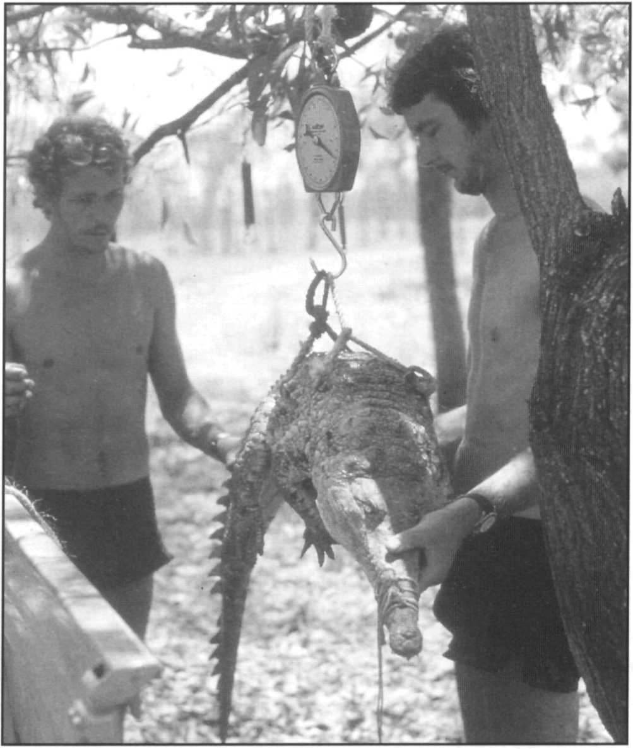*Melanosuchus niger,* Brazil, implementation of conservation and management program, p. 28.

*Melanosuchus niger,* Colombia, implementation of conservation and management program, p. 28.

*Melanosuchus niger,* Brazil, basic ecological studies (initiated), p. 28.

*Crocodylus acutus,* Cuba, management and protection program (in progress), p. 35.

*Crocodylus acutus,* Belize, management and protection program, p. 35.

*Crocodylus acutus,* Colombia, status and distribution, p. 35.

G.J.W. Webb

*Crocodylus acutus,* multinational. Mexico, Costa Rica, Panama, Jamaica, status surveys and conservation and management program, p. 35.

***Alligatormississippiensis***

**Common names:** American alligator, gator

**Range:** United States

### Conservation overview

**CITES:** Appendix II

CSG Action Plan:

Availability of Survey Data - Good

Need for Wild Population Recovery - Low Potential for Sustainable Management - Highest

**1996 IUCN Red** List: Not listed **(LRlc** Lower Risk, least concern.)

**Principal threats:** Habitat destruction, environmental contamination.

### Ecology and natural history

The American alligator, along with the Nile and the saltwater crocodiles, is one of the best known species in terms of behavior and ecology (see Brisbin *et al.* 1986, Mazzoti and Brandt 1994). Alligators are widely distributed throughout the southeastern United States. Maximum size of adult males rarely exceeds 4.5m, but historical accounts of larger specimens exist (Woodward *et al.* 1995). American alligators are principally inhabitants of swamps and marshes, although they may be found in lower densities along streams, rivers, and in lakes. In some regions alligators are even known to inhabit coastal

brackish water habitats.

The name "alligator" presumably derives from a corruption of the Spanish word "el lagarto." The work of Mcllhenny (1935) in Louisiana was among the first to document some of the remarkable aspects of the natural history of this species. More recent studies on alligator social behavior have demonstrated a significant degree of complexity in the species' ability to communicate vocally (through bellows and headslaps), and visually (through a complex series of body postures) (Garrick *et al.* 1978, Vliet 1989). Females become sexually mature at a size of about 1.8m. Courtship and mating take place during the spring warming period, and nesting is done during the early part

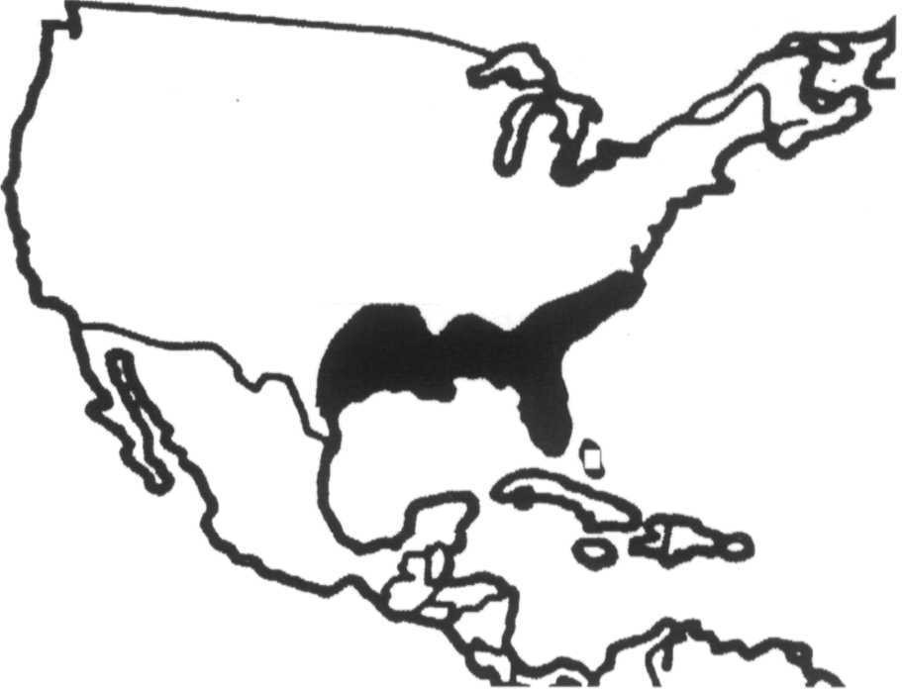

of the warm, wet summers. Females construct a mound nest and lay 30-50 eggs. Females open the nest and will remain near the pod of hatchlings for up to nine months. In some cases hatchlings overwinter with the female in her den.

In many areas alligators are well known burrowers and spend many of the cooler months inactive in these dens. Alligators are one of the most temperate species of crocodilians and are known to survive short spells of below freezing weather by resting in shallow water with their snouts at the surface, thus keeping a breathing hole open in the surrounding ice (Brisbin *et al.* 1982).

### Conservation and status

The American alligator is the outstanding example of successful conservation of a crocodilian accomplished by the application of controlled use at a sustainable level. Although heavily exploited since the 1800s, and considered to be endangered in the early 1960s, populations of American alligators have responded well to management and have recovered rapidly. Extensive surveys of alligator populations have been done throughout the species' range. Continuous monitoring of numerous localities is conducted as part of sustainable use programs in several states. Overall, alligator populations are quite healthy and, owing to expanding human populations, programs to control alligators that occur near people and dwellings (termed nuisance alligator control) are an integral part of alligator management and conservation. In some states, near the periphery of the alligator's distribution, alligator populations are less dense and are completely protected.

Sustainable management programs have been operated in Louisiana, Florida, Georgia, Texas and South Carolina for more than a decade. Management is based on a combination of farming, ranching and direct cropping of wild adults. Farming and ranching are now being done on a large scale, particularly in Louisiana and Florida. The

current stock in farms and ranches is well over 350,000 and throughout the country there are over 150 farms and ranches involved in commercial alligator production. Captive breeding (farming) produces about 20,000 hatchlings annually, i.e. about 10% of production. Commercial production of skins is highly regulated with an interlocking system of permits, licences, periodic stock inventories, ranch inspections, and rigorous tagging and export permit requirements.

In Louisiana, exploitation is primarily in the form of egg collection for ranches and a managed hunt that utilizes seasonal habitat segregation of female alligators into less accessible parts of the range to focus the hunt on males (65%-75% of harvest) (Elsey *et al.* 1994). Wild harvest generates 20,000-25,000 skins annually. Hunting quotas are controlled by allocating a number of tags to each licensed hunter, based on the area and quality of alligator habitat and population estimates based on nest surveys. Egg collection from private and state owned lands provides 150,000-250,000 eggs annually to ranches. Seventeen percent of the animals commercially ranched (>1.2 m long) are required to be returned back to the wild. Skin production from ranches has ranged from 88,000-150,000 per year since 1990.

In Florida, the program includes farming, hunting and nuisance alligator control, as well as egg and hatchling harvests for ranching. Controlled hunting and egg collection on both private and public lands are based on harvest allocations generated from annual population surveys and nest counts for each area. Long-term studies on harvested wetlands demonstrate that alligator populations remain stable when up to 13% of animals over 4 feet long are hunted annually or up to 50% of located nests are collected for ranching (Rice 1996, David *et al.* 1996). Harvest quotas based on annual monitoring of both nesting and population density is an integral part of the program. Annual production of skins in Florida is around 30,000-40,000 from all sources. A small farming program has also begun in Georgia.

South Carolina has recently initiated a program allowing controlled hunting on private lands (Rhodes 1996). In Florida, Louisiana, Georgia and South Carolina nuisance alligator control is achieved by licensed trappers who, acting under the direction of wildlife officials, respond to public complaints of alligators over 4 feet long that are considered a potential peril to people, pets or livestock. Such animals are trapped and in most instances killed and their skin and meat sold to defray costs. These programs have converted an expensive animal control program into a self-financing public service and provided important re- assurance to the public who live in alligator habitat. Alligator populations under these management programs are certainly stable or even increasing. The only remaining threat to alligators is the loss of habitat to expanding agriculture and residential development, pollution and

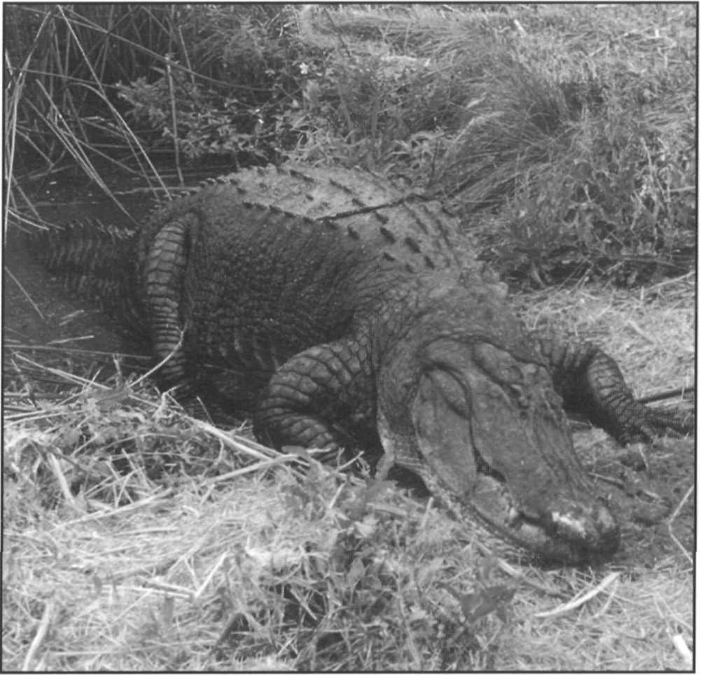American alligator, *Alligator mississippiensis,* Rockefeller Refuge, Louisiana, USA.

A. Yanosky

water diversion. Sustainable use of alligators in the USA generates more than 60 million dollars annually, providing a substantial incentive to retain habitat and tolerate alligators. Fees from the regulatory system provide funding for management, regulation, enforcement and research programs on alligators.

### Priority projects

**Moderate priority**

**Investigations of population biology:** The presence ofhealthy alligator populations, and the availability of institutional and financial resources has lead to numerous investigations of alligator biology over the years. Although the American alligator is the most thoroughly studied of all crocodilians, we still know relatively little about its population dynamics and behaviour. A better understanding of the population ecology of this species would not only benefit the management of alligators, but other large crocodilians as well. These investigations are facilitated and financed by the presence of management programs such as cropping and ranching, and are currently underway.

**Research on husbandry techniques:** Because of the extensive commercial ranching and farming industry in the United States, the American alligator is a prime candidate for research on captive husbandry. Captive breeding, incubation and rearing techniques need to be improved to increase the efficiency of the industry. Extensive research on these topics is currently underway, particularly in Louisiana and Florida.

***Alligator sinensis***

**Common names:** Chinese alligator, Yangtse alligator, T'o, Yow Lung

**Range:** China

### Conservation overview

**CITES:** Appendix II (Captive bred population)

CSG Action Plan:

Availability of Survey Data - Adequate,

Need for Wild Population Recovery-Highest, Potential for Sustainable Management - Moderate

**1996 IUCN Red List: CR** (Critically Endangered). Criteria:

A.1.c. A decline of >80% in 3 generations in area of occupancy, area of occupancy >10km2, Dl. possibly fewer than 50 wild adults.

**Principal threats:** Habitat destruction, limited distribution.

### Ecology and natural history

The Chinese alligator is a relatively small crocodilian with a maximum length of approximately 2m (Brazaitis 1973). Although it was at one time more widely distributed in China, the Chinese alligator is currently found only in parts of the lower Yangtze (Chang Jiang) River, principally in the provinces of Anhui, Zhejiang, and Jiangsu (Huang 1982, Chen 1990). Because they occur at a comparatively high northern latitude, Chinese alligators spend a large portion of the year hibernating in subterranean burrows (Huang 1982, Watanabe and Huang 1984). The burrows can be quite complex, with above and below-ground pools, and numerous airholes (Chen *et al.* 1990). The extensive use of these burrows and their very secretive behavior has allowed Chinese alligators to inhabit wetland habitats in areas with dense human populations. The three principal habitat types where this species can currently be found are riverine and swampy areas, low-elevation agricultural communes, and tree farm communes up to 100m above sea level (Watanabe and Huang 1984).

Chinese alligators usually begin to emerge from their dens to bask in May. In June, with warming temperatures, alligators will begin to make nocturnal sorties. Nesting occurs from early July to late August (Huang 1982). Like

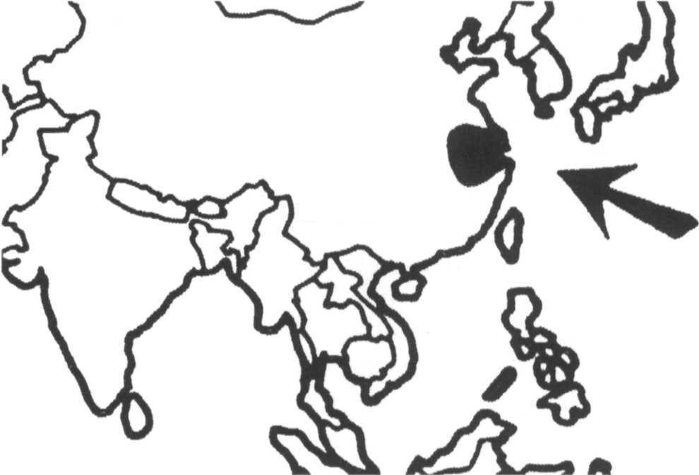

the American alligator, Chinese alligators make a mound nest of decaying vegetation. Nesting takes places in mid- July, and clutches typically contain 10-40 eggs.

### Conservation and status

The Chinese alligator is one of the world's most endangered crocodilians. Although it was at one time widely distributed throughout the eastern Yangtze River system, the current distribution of the species is restricted to extremely small fragments of its former range in Anhui and Zhejiang Province. The single greatest problem facing the Chinese alligator is habitat destruction related to the intense human population pressures in the region. Very little natural wetland habitat remains, and what does exist contains very few alligators. Most of the remaining populations are located in modified wetlands associated with agricultural or tree-farm communes, where they are vulnerable to human predation. Occupation of surrounding land for agriculture is complete and the destructive effect ofalligator burrows on farm dykes causes problems with local people. New information was produced as a result of a site visit conducted by CSG members in early 1992 and an application of China to register a captive breeding facility (Webb and Vernon 1992). The Chinese alligator has apparently become more restricted in distribution since the surveys by Huang 1982. Chinese alligators are found in the wild in 13 small protected areas (up to 3km2) within the Anhui Research Center of Chinese Alligator Reproduction (ARCCAR) conservation reserve, and in a small number of localities outside the reserve in Anhui Province. In some cases these are small or remnant populations with little or no breeding known. In several protected areas, the populations are substantial (30-100 individuals) and natural reproduction continues. Personnel of ARCCAR estimate a current wild population of around 800-1,000 individuals. Surveys conducted between 1981 and 1990 suggest a rate of population increase of around 15% per year in protected

habitats (Webb and Vernon 1992). A very small remnant population may persist in Anji county of Zhejiang Province (Fu 1994). Alligators are legally protected, and a number of the communes have been classified as alligator preserves, but animals may still be killed or collected for sale to zoos or government-sponsored farms.

Besides the official protected status, the conservation of alligators in China has been based on the development of a number of rearing centers. ARCCAR was established in 1979 and stocked between 1981-82 with 212 individuals collected from the wild. Of these, 160-170 were still alive in 1990. Wild eggs (787 in total) were also collected between 1982 and 1985. Captive breeding has been very successful and the first F2 were produced in 1988. By 1991 the total stock held was 4,197 alligators with 500-900 new hatchlings produced annually. A much smaller farm at Yinjiaban is operated by the local cooperative and maintains 118 alligators (2:2:114). Additional breeding centers have been established at National Forest Park of Gianaohu (Thousand Island Lake), and Quiongshan, Hainan Island (Zhang 1994a and 1994b.).

In 1992 the ARCCAR facility was registered with CITES as a captive breeding operation and qualified to enter trade with captive bred Chinese alligators. The intentions expressed at the time of registration were to provide alligators for local meat consumption and for the European pet market. Some discussion was also held on utilizing temperature dependent sex determination to provide single sex animals for the market. The current level of trade is not known but income from the export of alligators is needed to support the continuation of captive breeding and conservation. In 1993, management of the farm was leased to a Thai company that intends to operate the farm and has provided a substantial capital injection (Zhang 1993). Additional breeding facilities have been established at Beijing and on Hainan Island with stock from ARCCAR. The future survival of the Chinese alligator in China is now dependent upon continuing economic success of the commercial captive breeding operations (see Watanabe 1983, Webb 1993).

Captive breeding of Chinese alligators has also been accomplished at the Bronx Zoo, the St. Augustine Alligator

Chinese alligator, *Alligator sinensis,* captive adult female ID 910261 from the Bronx Zoo. Part of the US captive breeding program for this species.

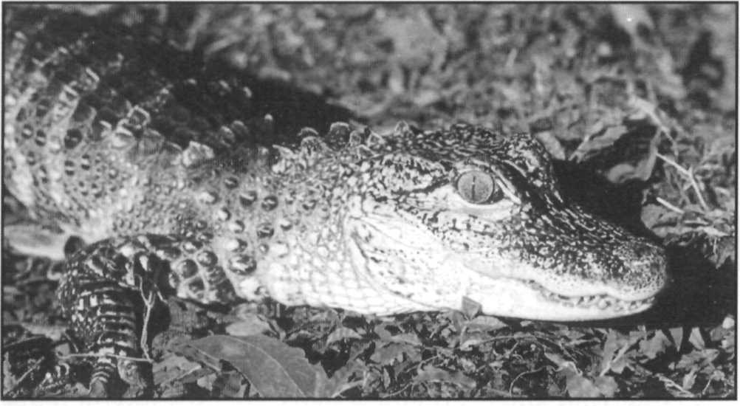

Farm, and the Rockefeller Refuge in the United States. A studbook is maintained for US captive breeding by the American Zoo and Aquarium Association (AZA). At present there are 209 specimens in zoos outside of China; 147in 14 US zoos(Behler 1993) and seven in four European zoos (Honegger and Hunt 1990).

### Priority projects

##### High priority

**Improve surveys of the status of wild populations:** Continued monitoring and quantitative surveying of the known wild populations is needed to ensure that these are maintained at the best possible abundance within the very limited available habitat. The survey should address the current status and distribution of wild populations. An important function of this survey should also be to identify suitable alligator habitat that could be used for reintroduction or restocking programs.

**Enhanced protection of wild populations:** Many of the surviving alligator populations are located in human made habitats in close association with dense human populations. Efforts are needed through education, to emphasize the protected status of the alligator and enforce the existing protective legislation. Part of this program should include an educational component to increase the awareness among local people of the protected status of Chinese alligators.

**Maintain and manage captive populations:** Captive populations, both within and outside China, are the current repository of most of the individuals and most of the genetic diversity of this species. These populations should be managed in a manner that ensures maximum genetic diversity and the maintenance of an adequate founder base for the future. To this end the managers of the various captive collections should communicate and cooperate in matters of information and studbook maintenance, exchange of captive specimens and husbandry technology.

##### Moderate priority

**Investigation of the ecology of wild animals:** A prerequisite for any conservation action is a good understanding of the ecology of the species involved. Before any active management of wild Chinese alligator populations (such as restocking or reintroduction) is attempted, ecological studies should be initiated. A number of study sites need to be established where regular censusing can be conducted, and a number of basic ecological questions addressed. In particular habitat use, population size structure, sex ratio, and nesting ecology need to be investigated.

B. Shwedick

## Caiman crocodilus

**Important synonyms:** *Caiman sclerops*

**Common names:** Common caiman, spectacled caiman, baba, babilla (Venezuela, Colombia), guajipal (Nicaragua), jacaré tinga,

jacaré, lagarto bianco, cocodrilo, ocoroche, cascarudo, cachirre, tulisio

**Range:** Brazil, Colombia, Costa Rica, Ecuador, El Salvador, Guyana, *French Guiana, Guatemala, Honduras, Mexico, Nicaragua, Panama, Peru,* Suriname, Trinidad and Tobago, Venezuela (introduced: Cuba, Puerto Rico, United States)

Revised by Eduardo Espinosa

**Conservation overview**

**CITES:** Appendix II, except *C. crocodilus apaporiensis -*

Appendix I

CSG Action Plan:

Availability of Survey Data - Adequate Need for Wild Population Recovery - Low

Potential for Sustainable Management - Highest

**1996 IUCN Red List:** Not Listed **(LRlc** Lower Risk, least concern, probably numbers in the millions, widely distributed throughout range, although locally depleted or extirpated in some localities.)

**Principal threats:** Illegal hunting, habitat loss.

### Ecology and natural history

The common caiman is the most widely distributed of the New World crocodilians, ranging from southern Mexico to Peru and Brazil. It is also the most geographically variable species with four or five subspecies generally being recognized as follows (Medem 1981, King and Burke 1989):

* *C. c. crocodilus,* the nominate form, distributed throughout the Orinoco drainage and llanos in Venezuela and the Amazon drainage from Colombia through Brazil north and east of Bolivia to Peru.
* *C. c. fuscus,* Atlantic coastal drainages of Colombia

(including the Magdelena River) and into western Venezuela.

* *C. c. chiapasius****,*** Central America, Mexico to pacific

Colombia and possibly Ecuador and to the Gulf of Uruba. Some authorities consider this identical to C. *c. fuscus.*

* *C. c. apaporiensis,* a narrower snouted form restricted

to the upper Apaporis river of Colombia although a cline of narrow snouted caimans may be present across Colombia and the Venezuelan llanos (Ayarzagüena 1984, Gorzula 1994)

* *C. c. yacare* (= *C. yacare*), the southern form, is distributed from southern Brazil through Bolivia, Paraguay, and Argentina. It is variously considered to be a subspecies or a full species by different workers. In this Action Plan the most recent taxonomic review is followed (King and Burke 1989), which classifies

*C. yacare* as a full species. The most recent morphological (Busack and Pandya *in litt.*) and DNA analyses (Amato and Gatesby 1994) suggest that

*C. c. fuscus* and *C****.*** *c. chiapasius* form one natural group and *C. c. crocodilus* and *C. c. yacare* another.

The common caiman is a small to medium sized crocodilian (maximum length in males ca. 2.8m), that is extremely adaptable in terms of habitat requirements. At one time this species may have been relegated to a much smaller ecological niche, but with the extensive commercial overharvesting of the larger sympatric species of crocodilians (*C. acutus, C. intermedius, M. niger*), the common caiman now inhabits virtually every type of low altitude wetland habitat in the Neotropics.

A great deal of biological investigation has been carried out on this species, particularly in seasonal savanna habitats. Relatively less is known about its behavior and ecology in forested or swamp habitats (Ouboter and Nanhoe 1988, Ouboter 1996). Much ofthe earlier ecological information for this species is summarized in Gorzula and Seijas (1989). Female common caiman reach sexual maturity at about 120 cm total length and lay an average of 20-40 eggs in a mound nest, usually during the annual wet season.

### Conservation and status

Owing to the extensive development of ventral osteoderms (boney inclusions), caiman belly skins are of inferior commercial quality compared to those of crocodiles and the American alligator, and usually only the lateral flank

region is used. Because of the low value of the hide, caiman exploitation did not begin until the 1950s when stocks of the more valuable classic crocodiles had dwindled. However, since the 1950s, millions of caiman have been harvested, and *Caiman crocodilus* and *C. yacare* continue to supply the vast majority of skins on the market. Caiman appear to have been quite resilient to commercial hunting for a number of reasons, particularly because they reproduce at a relatively small size, and hunting in many areas appears to have concentrated on the larger adult males. Another important factor has been the near extirpation of larger, sympatric species of crocodilians of greater commercial value. Caiman now occupy habitats that were formerly dominated by *Melanosuchus niger, Crocodylus intermedius* and *C. acutus* (Magnusson 1982, Thorbjarnarson in press). Furthermore, in areas such as the llanos of Venezuela and Colombia and the Brazilian Pantanal, the proliferation of man-made water bodies (e.g., borrow-pits) has increased the carrying capacity for caiman populations in these habitats. Although they may be locally depleted, present populations may be larger than they were historically. The ecological adaptability of the common caiman is evident in the United States (Florida and Puerto Rico) and Cuba, where introduced caiman populations are established and impossible to eradicate. The Cuban population is alleged to have contributed to the extirpation of *Crocodylus rhombifer* from the Lanier Swamp on the Isle of Pines. In Guatemala, a population of *Caiman crocodilius crocodilus* is reported to have been introduced, allegedly from Venezuela as hatchlings (R. Jenkins from O. Lara pers comm.).

After the completion of recent new surveys of caimans in Nicaragua (King, Ross, Morales and Gutierrez 1994) Paraguay (King, Aquino, Scott and Palacios 1994) and Colombia (Barahona *et al.* 1996a and b), relatively good survey data are available in nine of the 17 countries in which *Caiman crocodilus* is found. However, surveys are still being planned in several Central American and northern South American nations. In all the countries surveyed, densities and inferred numbers are highly variable due to seasonal aggregation at times of low water, and dispersal at high water. In general, densities of 5-50+ individuals per kilometer of standard survey are observed, with lower densities 0.5-5.0/km in areas of heavy hunting (see King, Aquino, Scott and Palacio 1994 for summary). Little information is available for the northern end of the species range in Mexico, El Salvador and Guatemala. Also, few surveys have been done on the introduced populations in the United States (Florida and Puerto Rico) and Cuba.

Although the available information is sketchy in many areas, caiman populations appear to be doing relatively well in most countries. Only in El Salvador are populations suspected to be severely depleted, and very little recent

information is available for this country. In many areas where recent surveys have been conducted (e.g. Honduras, Costa Rica, Nicaragua, Venezuela), the species does not appear to be significantly depleted although it does face an array of problems such as illegal hunting or habitat destruction. In areas heavily frequented by hunters the larger size classes may be rare. Local extirpation adjacent to urban areas and intensive agriculture is observed, but wherever their habitat remains intact, this adaptable small crocodilian appears to remain abundant. Where harvest regulations and use programs are enforced on a sustainable basis, populations are reported to be stable or increasing (e.g. Velasco and Ayarzagüena 1992, Gorzula and Pilgrim 1992).

Despite the overall good status of this species, urgent conservation action is needed for *Caiman crocodilus apaporiensis.* This virtually unknown subspecies has a very restricted range in the Colombian Amazon, and surveys are needed to determine its population status.

A number of Latin American nations have developed sustainable management programs for the common caiman. Because the species produces a lower value hide, some of these management schemes are based on the cropping of wild populations. By far the largest such program is in Venezuela and is based on the harvest of adult males. Other cropping programs exist in Guyana, Nicaragua, and formerly in Honduras. However, in recent years a number ofcountries have begun to develop ranching and farming programs. A major program in Columbia that focuses on captive breeding produces between 300,000 and 450,000 skins per year (Jenkins *et al.* 1994). Brazil is also developing extensive captive breeding programs with over 100 facilities established. There is also increasing interest in developing ranching programs, particularly in the Pantanal region. Because of the low relative value of caiman hides, the economic viability of these activities has been questioned (Magnusson 1984). This species, along with the yacaré caiman, is currently supplying approximately three-quarters of the legal crocodilian skins in international trade.

Since 1983, Venezuela has operated the largest cropping program for any species of crocodilian based on controlled hunting by private landowners. The system allows private landowners to harvest up to 20% of caiman above 180cm total length each year, effectively restricting the harvest to adult males. Quotas were initially established based on census data from each property, provided by licensed surveyors engaged by the property owners. Annual exports average 70,000-90,000 skins per year. The program also includes a rigorous system of licensing of producers and processors, centralized inspection and storage of skins and careful monitoring of tanneries and exports. However, annual evaluations of the program and independent surveys in 1991-92 suggested overexploitation in some areas (Velasco and Ayarzaguena 1992). In 1994,

a new method to assign the harvest quotas was established and the annual export quota was reduced to 30,000 skins. Currently, quotas are assigned on the basis of regional surveys, ecological region and the size of the property, and restricted to 15% of the class IV (180 cm length) individuals (Velasco *et al.* 1995). The values generated are compared with the regional average values derived independently by the management authority - CITES study, and adjustments to the estimated population, and harvest quota, calculated (de Sola and Velasco 1994). The program offers an unparalleled opportunity to establish experimental harvesting regimes in conjunction with population studies. In 1996, Venezuela instituted a complete halt to caiman harvesting to allow detailed analysis of the effects on populations (Quero and Velasco 1995). Harvest re-opened in 1997 based on the results of extensive re-evaluation of the populations in the field. The Orinoco Delta region has been recently incorporated into a program of exploitation of caiman based on a recent study (Velasco *et al.* 1994), which showed that only 3% of the individuals in this region are harvestable animals.

Illegal trade in caiman skins has been, and continues to be, a problem. Legal production of caiman skins now numbers in excess of half a million skins a year (Collins 1995). Improved enforcement and CITES implementation, as well as reduced demand during 1990-1994, appears to have reduced the flow of illegal skins. However, significant illegal shipments continue to be interdicted. Meeting the world demand from legal, sustainable production, improved coordination for CITES implementation in the region, and the requirement to tag all crocodilian skins (CITES Resolution Conference 9.22) are expected to further curtail illegal trade. However, illegal trade

undermines the economic viability and regulatory capacity of sustainable use programs in the region. Continued enforcement within Latin America, and coordinated action with the major consuming countries are needed to eliminate illegal trade in caiman skins.

### Priority projects

##### High priority

**Survey of Apaporis River caiman in Colombia:** *Caiman crocodilus apaporiensis* is thought to be present only in the upper and middle Apaporis River and some adjacent areas in southern Colombia. No recent information on the status of these populations is available. Surveys are urgently needed to determine the present status of this unusual form of the common caiman.

**Control of illegal trade in caiman skins:** Substantial quantities of illegal caiman skins continue to pass from South America to consuming and manufacturing countries. The general success of CITES measures to control trade indicate that full enforcement of CITES will be an effective way to control this illegal trade. This requires coordinated action in both producing and consuming countries. In some cases existing national legislation is an impediment to CITES implementation. For example the ban on wildlife exports from Brazil impedes the development of sustainable ranching programs in that country; and in Thailand inadequate inspection, documentation and enforcement makes assessment of the caiman trade impossible. Inconsistencies between international CITES regulations and more

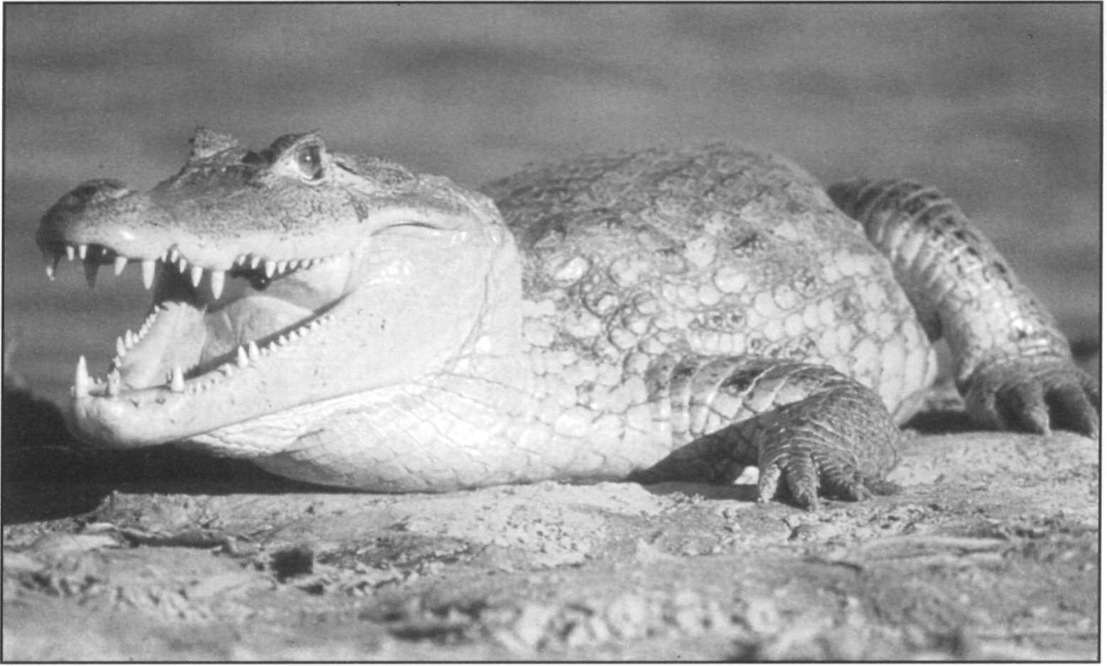Common caiman, *Caiman crocodilus,* in Venezuela. This widespread and abundant species has several subspecies and successfully supports international trade of over 500,000 skins annually from sustainable programs.

R. Godshalk

stringent national regulations in the USA remain a serious impediment to the orderly development of international trade controls. Allegations of extensive illegal trade from Brazil and Colombia remain undocumented but persistent. Considerable progress has been made in these areas. CITES implementation would be facilitated by regular consultation, exchange of intelligence, technical assistance and cooperation between CITES management authorities within Latin America and with consuming countries. The CSG has a major role to play in promoting these activities.

##### Moderate priority

**Implementation of caiman sustainable management programs:** Because caiman mature relatively fast and are extremely adaptable in terms of habitat requirements, they have a very high potential for inclusion in sustainable management programs. Support for developing such programs throughout Latin American is needed. Initial work should center on conducting population surveys and making recommendations tailored to the type of management being considered (cropping, ranching).

**Taxonomic study of the caiman species complex:** The relationships among the caiman species complex are still poorly understood. This has created conservation problems due to the inability to recognize subspecific taxa that may differ in trade restrictions. Investigation of the southern

*C. crocodilus - C. yacare* relationships is underway but remains inconclusive. In the near future such research should include the use of genetic tools, such as DNA analysis, to determine phylogenetic relationships within the *Caiman* species complex. This work needs to be expanded to include northern South America and Central America.

**Long-term ecological studies in the Venezuelan llanos:** The Venezuelan llanos has been the site of a considerable amount of research on the ecology of the common caiman. It also is the site of a large harvest program, and offers unequaled opportunities for the investigation of a number of aspects of the population biology of this species. This work is done in conjunction with the monitoring of harvest effects in order to improve our ability to manage wild populations ofthis species. Although reductions in hunting quotas may affect the funding ofthe management program, the continuous monitoring of the population must be seen as a top priority.

## Caiman latirostris

**Common names:** Broad-snouted caiman, Jacaré overo, Jacaré de papo amarelo, Caiman de hocico ancho, Ururan

**Range:** Argentina, Brazil, Bolivia, Paraguay, Uruguay Revised by Luciano Verdade

**Conservation overview**

**CITES:** Appendix II (ranching) Argentina, Appendix I in all other countries

CSG Action Plan:

Availability of Survey Data - Poor

Need for Wild Population Recovery - Variable throughout distribution range (moderate to high)

Potential for Sustainable Management - Variable throughout distribution range (low to high)

**1996 IUCN Red List:** Not listed **(LRlc** Lower Risk, least concern)

**Principal threats:** Habitat destruction, illegal hunting.

### Ecology and natural history

The broad-snouted caiman is a medium-sized crocodilian. Although its maximum reported size is 3.5m, animals longer than 2.0m are presently rare in the wild. This species' geographic distribution includes the drainages of the Parana and Sao Francisco River systems, spreading over regions of northeast Argentina, southeast Bolivia, Paraguay, and northern Uruguay. It also includes a large number of small Atlantic coast drainages from Natal, at the eastern tip of Brazil, to northeast Uruguay. Although this species is broadly sympatric with *C. yacare,* Medem (1983) reported that *C. latirostris* was generally found in more densely vegetated, quieter waters. In Paraguay, Scott *et al.* (1990) found *C. latirostris* to be a habitat generalist, but when in sympatry with *C. yacare* it tended to be found in more ephemeral habitat, and was a better colonizer of isolated cattle stock ponds. This kind of man-made habitat has been also reported to be colonized by the species in Brazil (Verdade and Lavorenti, 1990) and Argentina (Venturino 1994).

*C. latirostris* has also been found in mangroves of coastal islands of southeast Brazil (Moulton 1993). According to Morato (1992), the broad-snouted caiman can be found

from sea level up to 600m of altitude in the state of Parana in Brazil.

Due to a lack of field studies, little is known about the behavior and ecology of this species. Much of what is known about reproduction has come from individuals in captivity. *C. latirostris* is a mound nester, laying 18-50 eggs during the wet season. The broad-snouted caiman, as its name implies, has, proportionally, the broadest snout of any crocodilian. Although it has a very generalized diet, in some parts of its range it feeds to a large extent on ampullarid snails (Diefenbach 1979).

### Conservation and status

The broad-snouted caiman has well-developed ventral osteoderms; however, its skin is considered better for manufacturing goods than that of the other species of the genus *Caiman* (King and Brazaitis 1971 and Brazaitis 1987). Commercial hunting began in the 1940s and 1950s throughout most of the range of this species, although according to Medem (1983) *C. latirostris* was never hunted commercially in Uruguay. Although still occurring in some places, illegal hunting is no longer the major problem for this species possibly because of a combination of reduced density, improved protection, increased cost of illegal hunting, and legal skins becoming more attractive to traders. On the other hand, habitat destruction has significantly increased in recent years.

Surveys for the broad-snouted caiman have been conducted in Argentina and Paraguay. In these countries, most of the original habitats of the species still remain and healthy populations have been found. Populations of this species are considered to be severely depleted in Bolivia, which is on the limit of its natural range. No recent survey data are available in Uruguay, although some reports suggest that the populations of this species are in decline in that country due to habitat destruction. Most of the natural wetlands of the Parana

and Sao Francisco River systems have been dammed for the construction of large hydroelectric stations in Brazil. Vast areas have also been drained for agricultural purposes and pollution has been a considerable problem in rivers that flow through big cities. Studies on the impact of the construction of large hydroelectric stations on the dynamics of broad-snouted caiman populations are underway (Campos and Mourao 1995, Mourao and Campos 1995).

The successful initial results of the experimental ranching program carried out in Santa Fe, Argentina (Larriera 1993a and 1994), are demonstrating the great potential for the establishment of sustainable programs for the conservation and management of this species. A second generation (F,) has been obtained in captivity at the University of Sao Paulo, in Brazil (Verdade and Oliveira, in press). The proceedings of regional workshops held in Brazil and Argentina (Verdade and Santiago 1991; Verdade and Lavorenti 1992; Verdade *et* ***al.*** 1993; Larriera *et* ***al.*** 1994; Larriera *et al.,* in press), and the first volume of *La Conservacion y el Manejo de Caimanes y Cocodrilos de America Latina* (Larriera and Verdade 1995) present good information about the biology, management and conservation of the broad-snouted caiman and other Neotropical crocodilians.

### Priority projects

##### High priority

**Survey of status and distribution in Brazil:** The largest part of the range of the broad-snouted caiman is located within Brazil but only scanty information is available concerning the species status in that country. Hydroelectric dams,

wetlands drainage for agriculture, and pollution are still affecting large portions of its geographic distribution in that country, possibly affecting the whole species. This scenario should be considered in the planning of conservation and management of this species in Brazil. The utilization of Geographic Information Systems (GIS) and satellite imagery might help to survey the remnant habitats still available and the actual distribution of this species.

**Ranching program in Argentina:** The successful initial results of the experimental ranching program in Santa Fe, Argentina, should guide the establishment of similar programs in other provinces of that country, where original habitats still remain and considerable wild populations still can be found. This sustainable yield management program might reach a commercial scale in a few years.

**Investigations of population biology:** Few studies of the behavioral-ecology of this species have been undertaken. Its capacity to colonize man-made habitats in response to original habitat destruction should be studied to guide future conservation and management programs on areas of fragmented habitats. Molecular genetics might be used to determine how habitat alterations have affected reproduction and dispersal patterns of this species. Long-term behavioral-ecological studies should guide the establishment of sustainable management programs as well as the establishment of conservation areas.

**Implementation of conservation and management programs in Bolivia, Brazil, Paraguay, and Uruguay:** The wide geographic distribution of this species resulted in different scenarios for its management and

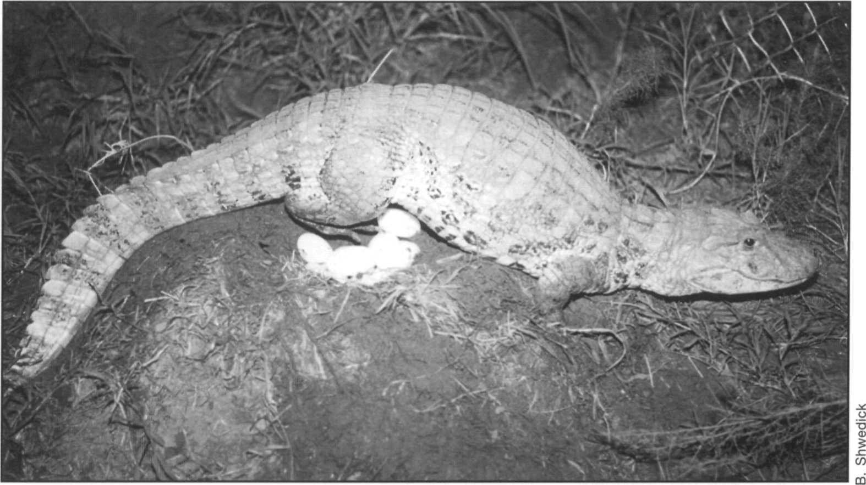Broad-snouted caiman, *Caiman latirostris,* captive at Gator Jungle, Florida, USA; female laying eggs.

conservation. In some regions, where original habitats still remain, sustainable programs might be implemented, like the one that is in progress in Santa Fe, Argentina. In some other regions, there is considerable demand for increasing habitat conservation or even restoration and/or reclamation before implementing ranching programs. The development of successful management programs should include conservation of habitats, public education, professional training, caiman husbandry research, the adaptation of local existing tanning industries, the utilization of a hide marking system, and the stimulation of local caiman meat consumption.

##### Moderate priority

**Survey status and distribution in Bolivia:** The few data available show that *C. latirostris* populations are highly endangered in Bolivia. Information about the status and actual distribution of this species in that country are essential to the establishment of conservation programs.

**Survey status and distribution in Uruguay:** Populations of

*C. latirostris* are known from Uruguay, but no recent survey data are available. Some reports suggest that habitat destruction is the main cause of population decline of this species in that country.

## Caiman yacare

**Important synonyms:** *Caiman crocodilus yacare*

**Common names:** Yacaré, Jacaré, Lagarto, Yacaré negro, Yacaré tinga

**Range:** Argentina, Brazil, Bolivia, Paraguay Revised by Eduardo Espinosa

**Conservation overview**

**CITES:** Appendix II

**CSG Action Plan:**

Availability of Survey Data - Adequate

Need for Wild Population Recovery - Moderate Potential for Sustainable Management - Highest

**1996 IUCN Red List:** Not Listed **(LRlc** Lower Risk, least concern. Widespread and numerous populations, although locally depleted.)

**Principal threats:** Illegal hunting, habitat destruction.

### Ecology and natural history

The yacaré caiman is found in southern Brazil and Bolivia, southwards through the Paraguay/Parana River systems and into northern Argentina. Morphologically and ecologically this species is very similar to the common caiman, and similarly can be found in a wide spectrum of habitat types. Most of the ecological studies on this species have been carried out in the Pantanal region of southern Brazil (Crawshaw and Schaller 1980, Schaller and Crawshaw 1982, Cintra 1986). More recent studies also include Bolivia (Pacheco 1993a, Godshalk 1994). Nesting habitats were monitored during the incubation and hatching period (Borges and Filho 1993), and the effect of water level on hatchlings survivorship have also been evaluated (Continho 1993). Aerial surveys of caiman nests have been started in the Pantanal (Mourao *et al.* 1994).

Although often considered a subspecies of *Caiman crocodilus,* the yacaré occupies a distinct geographic range and a special position in the international skin trade and is therefore treated separately here for convenience. Resolution of the systematic relationships within the very widespread *Caiman crocodilus* complex is needed. Extensive surveys and specimen collection in southern Brazil, northern Bolivia and Paraguay suggest

a very complex gradient of morphological features between *C. crocodilus* and the yacaré. Analyses of mitochondrial DN A to resolve the relationships between these taxa are incomplete and inconclusive (Brazaitis *et al.* 1993).

Yacaré caiman are mound nesters, with egg-laying usually peaking in the middle wet season. Clutch size is typically in the 25-35 range. The natural tendency of females to guard their nests is apparently influenced by human hunting pressure (Crawshaw 1987), which results in decreased nest attendance and a lower hatching success. Detailed information is now available on the ecology of the species in the Brazilian Pantanal from the work of Campos, Mourao and colleagues (Campos 1993, Mourao *et al.* 1994, Campos and Magnusson 1995, Campos *et al.* 1995, Mourao *et al.* 1996, Santos *et al.* 1996, Couthino and Campos 1996).

### Conservation and status

Most of what is written about the conservation of the common caiman applies equally well to this species. Basic survey information is available for this species in all countries where it occurs. This information has resulted principally from a series of CITES sponsored surveys of southern Brazil, Bolivia, and Paraguay. Populations of yacaré caiman are considered to be somewhat depleted in all four countries where it occurs, and this is principally due to widespread illegal hunting during the 1970s and 1980s. Poaching remains a problem throughout much of this species' range, particularly in Brazil (Brazaitis *et al.* 1988, Brazaitis 1989). However, due to their small size at maturity, their ability to adapt to a wide variety of habitat types, and their learned wariness, caiman are particularly resilient to hunting pressure. Recent analyses in Brazil suggest that the hunting pressure, while illegal, has not negatively impacted populations and may be sustainable

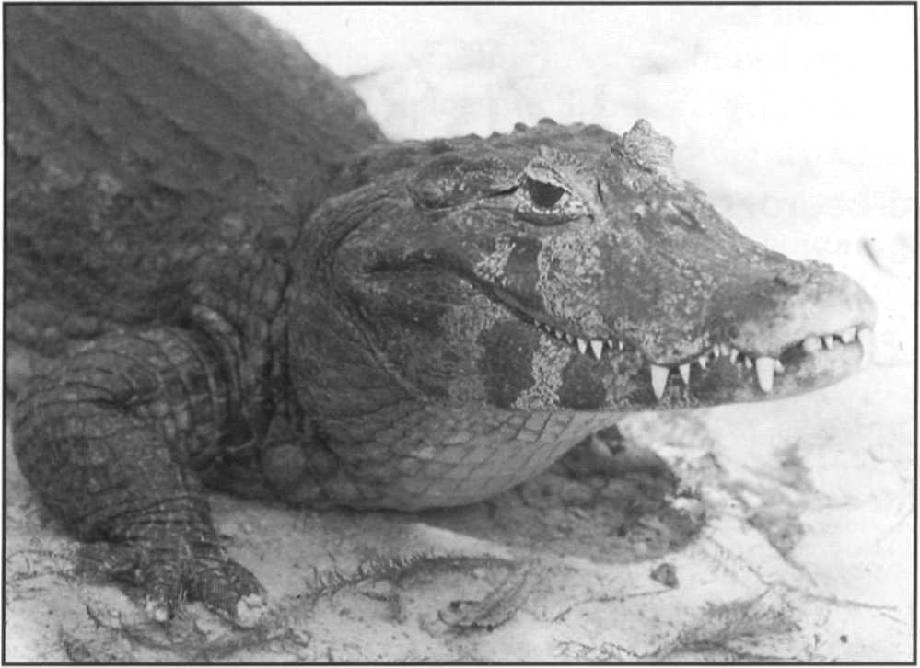

Yacaré, *Caiman yacare.* The southern form of this widespread species remains abundant in the Pantanal of Brazil.

(Mourao *et al.* 1996). Surveys in Paraguay (Scott *et* ***al.*** 1990, King, Aquino, Scott and Palacios 1994) and Argentina (Waller and Micucci 1993) indicate that extensive populations remain or have recovered from previous exploitation since the closure of uncontrolled exploitation and implementation of export controls.

Commercially oriented management programs are in place in three of the four countries for yacaré. Paraguay is moving toward sustainable management (King, Aquino, Scott and Palacios 1994) and permitted an experimental export quota of 5,000 in 1994. Cropping was permitted in Bolivia, where hides were exported under a CITES quota until a ban was instituted in 1989. Recently, new surveys were initiated and a controlled hunting program similar to the Venezuelan program has been proposed (Godshalk 1994). In Brazil, hunting of wild animals is not permitted, but ranching and farming programs are developing rapidly. Captive breeding farms have proliferated and Brazilian regulations require that all caiman skins.must be produced on farms, be tagged, semiprocessed to the 'wet blue' stage and have a minimum belly width of 18cm (TRAFFIC 1994). An experimental ranching system is being developed in the Pantanal. In Argentina, a plan for the captive rearing of yacaré for reintroduction is still underway, which hopefully may be as successful as the program for *Caiman latirostris* (Larriera 1993). Studies on distribution, habitat characterization and habitat availability of yacaré have been already conducted in the province of Corrientes (Waller and Micucci 1993). A second phase of studies is required to define management alternatives for yacaré in this region of Argentina.

### Priority projects

##### High priority

**Implementation of management programs in Brazil:** Brazil has undertaken a very rapid development of captive breeding (farming) of caiman similar to that in Colombia. A number of facilities are registered with the government and CITES as captive breeding facilities and are producing skins for export. Unfortunately little conservation benefit is resulting from these activities. There is a need to develop government regulatory and management capacity and provide a linkage to protection of wild caiman populations and their habitats.

R.S. Funk

**Control of illegal trade in *Caimanyacare* skins:** This project is as described in this volume for *Caiman crocodilus.*

**Study of *Caiman* systematics:** To clarify the complex taxonomic situation of yacaré, molecular techniques employing the D-loop of the control region of the mitochondrial DNA could be used to determine genetic relationships among subspecies because of its higher resolution (Avise 1994). The use of this region allows more accurate differentiation at a lower taxonomic level (species or subspecies rather than families) than other studies to date. Parallel studies of morphological variation, particularly in areas of intergradation are also needed.

##### Moderate priority

**Long-term ecological studies in the Pantanal, Brazil:** Like the llanos of Venezuela and Colombia, the Pantanal is a large seasonally inundated savanna that offers excellent research opportunities for the study of caiman population dynamics. The interest in the development of sustainable management programs should foster the development of research programs to investigate aspects of the life history of the yacaré.

**Implementation of management program in Paraguay:** A survey conducted by King, Aquino, Scott and Palacios. (1994) encountered numerous populations of yacaré. That report's recommendations provide the basis for a sustainable utilization program for the species. At the beginning the hunting activity should be restricted to the Alto Paraguay. A continuous monitoring program to evaluate the status of the population, particularly under exploitation, will be also important to ensure the sustainability of the program.

## Melanosuchus niger

**Common names:** Black caiman, Jacaré assu (also açu, uassu, guaçu), Jacaré negro, Caimán negro, Caimán, Cocodrilo

**Range:** Bolivia, Brazil, Colombia, Ecuador, French Guiana, Guyana, Peru

Revised by John Thorbjarnarson

**Conservation overview**

**CITES:** Appendix II in Ecuador (ranching) subject to quota from 1997; Appendix I in all other countries.

**CSG Action Plan:**

Availability of Survey Data - Poor

Need for Wild Population Recovery - High Potential for Sustainable Management - Moderate

**1996 IUCN Red List: EN.** Endangered. Criteria A.1.c. d. Inferred decline >50% in 3 generations, exploitation over much of range. Current recovery may be trending toward Vulnerable.

**Principal threats:** Illegal hunting, habitat destruction.

### Ecology and natural history

The black caiman is the largest member ofthe Alligatoridae, with adult males surpassing 4m in length. This species is widely distributed throughout the Amazon River basin, but populations are also known from peripheral areas outside the Amazon (the Rupununi and upper Essequibo River drainage in Guyana; the Kaw region of French Guyana; Vasquez 1991). Until recently the black caiman had been little studied. However, during the 1980s research on wild and captive populations was carried out by Herron and collaborators (1985, 1990, 1991, 1994) in southern Peru, Pacheco (1990a and b, 1993a and b, 1994) in Bolivia, and Asanza (1985, 1992) in Ecuador. Ecological studies are presently being carried out in Brazil (Sociedade Civil Mamirauá), Ecuador (EcoCiencia), and Colombia (Universidad Nacional de Colombia). Additionally, information on aspects of the ecology of this species was gathered during survey work conducted by Brazaitis *et al.* (1990a and b), and King and Videz-Roca (1988). Hines and Rice (1992, 1994) have conducted recent surveys of population status in Ecuador. Gorzula and Woolford (1990) surveyed black caiman in the Essequibo region of Guyana. These studies have augmented the work done by

Medem on this species in Colombia throughout the 1950s, 1960s and 1970s (Medem 1981), and the studies of Otte (1978) in Peru.

The black caiman occupies a wide variety of habitats including large rivers and streams, oxbow lakes, and in some areas seasonally flooded savannas. Ecological habitat partitioning between this species and the other Amazonian caimans appears to be taking place in many areas, but habitat relations among the species have been blurred by the severe reduction in numbers of black caiman in most areas (Magnusson 1982). Herron (1994) found that common caiman and black caiman were spatially separated in a Peruvian oxbow lake. Fittkau (1970) hypothesized that black caiman played a vital role in nutrient cycling in the rivers and mouth-lakes of the lower Amazon. The demise of *Melanosuchus* populations has been linked anecdotally with a decrease in fisheries productivity. However, little ecological evidence is available to confirm or refute these ideas. Peres and Carkeek (1993) provide an interesting account of how large caiman populations in the Brazilian Amazon protect fish stocks by destroying fishing nets.

The black caiman, like all alligatorids, is a mound nester, however, many aspects of this species' reproductive ecology are poorly known. Available information suggests that females reach sexual maturity when ca. 200cm total length (TL). Mean adult female size is 280cm TL, and clutch size averages 39.3. *Melanosuchus* lays very large eggs averaging 143.6g (Thorbjarnarson 1996). Herron *et al.* (1990) report on a *Melanosuchus* nest in Peru observed throughout the entire period ofincubation. Pacheco (1990a and b) presents information on the reproduction of captive *Melanosuchus* in Bolivia.

### Conservation and status

Commercial hunting of the black caiman did not begin in earnest until the 1940s, when stocks of the South American

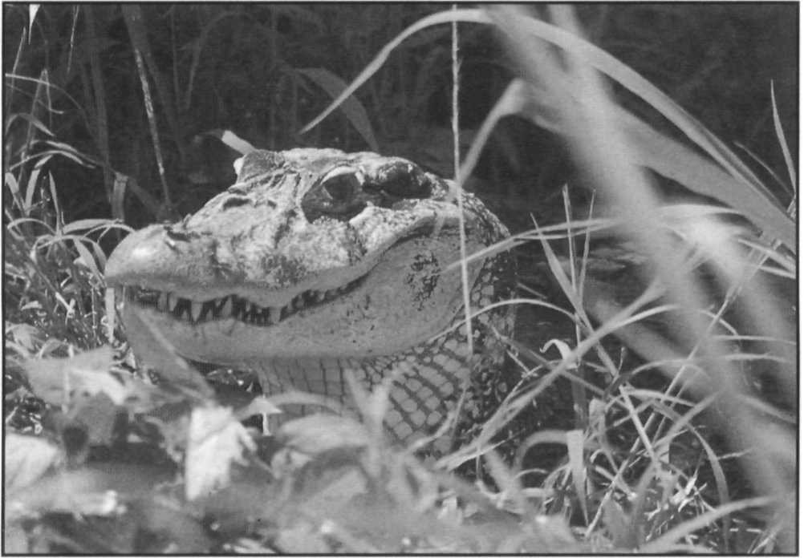

Blackcaiman,*Melanosuchusniger,*Mamiraua,Brazil,whereasubstantial population of this depleted species is reported to be recovering.

J. Thorbjarnarson

crocodiles (*Crocodylus acutus*, *Crocodylus intermedius*) were becoming very low. Hunting peaked during the 1950s, and declined markedly through the 1960s, when trade in *Caiman crocodilus* began to increase. However, in some areas significant trade in black caiman extended into the 1970s (Plotkin *et al.* 1983, Gorzula and Woolford 1990). Commercial hunting continues to be a problem in some areas. In the upper Amazon of Brazil, most hunting is for the sale of meat which is reportedly sold in Para or Leticia. Ecological competition with the smaller common caiman may also be playing an important role in slowing natural population recovery (Magnusson 1982, Brazaitis *et al.* 1988).

Some recent census work has been conducted throughout most of the range of the black caiman. Although it is widely distributed (principally in the Amazon basin) past overhunting and continued poaching has drastically reduced populations. Populations of black caiman are considered to be severely depleted in four of the seven nations in which the species occurs, and are depleted in the remainder. Relatively good populations remain scattered in isolated areas of Guyana, Peru, and Ecuador, particularly in oxbow lakes and other marshy, non-riverine wetlands where access is difficult. The population in the Kaw region of French Guiana has been decimated by hide hunting, and in Bolivia and Colombia black caiman appear to be still widely distributed, but occur in low numbers. Some Brazilian populations are locally dense but in most areas they represent but a small fraction of their former levels. While commercial exploitation has been illegal and minimal in recent years, people throughout the region continue to utilise black caiman for other purposes. The fat is collected for medicinal purposes and the meat is reportedly used to bait traps for edible tortoises. For human consumption, the meat of black caiman is considered rank and, in comparison to the meat *of Caiman* and *Paleosuchus,* is poorly regarded by indigenous people, (Ortiz van Halle 1995, Alvarez 1995).

Ecuador is initiating a trial ranching program. In all other countries management programs for the black caiman are exclusively based on the legal protection of wild populations. However, as in the majority of developing countries, the enforcement of these laws is difficult.

**Columbia**

Black caiman were at one time abundant in the Colombian Amazon region from the southern city of Leticia to the Rio Atacuari along the border with Peru, and in the Putumayo, Caqueta, and lower Apaporis rivers (Medem 1981; Plotkin *et al.* 1983). Commerial hide hunting began in the 1940s and populations were rapidly depleted. Wild populations of black caiman have been virtually extirpated in Colombia. Surveys by biologists in the 1970s found very few individuals in the Amazon and Putamayo region (Medem 1981, Plotkin *et al.* 1983). Based on interviews in the vicinity of Leticia, Pachon and Rios (1993) believe that little hunting is currently taking place and populations are slowly recovering. However, only three adults were seen during five diurnal foot surveys, and none were observed during nocturnal counts by boat. Additional surveys and ecological studies were planned for 1994-95.

*Melanosuchus* were legally protected in Colombia in 1969 with the implementation of a total ban on hunting (Resolution No. 411). Hunting and egg collection is also specifically banned for *Melanosuchus* (INDERENA Resolution No. 573 of 1969; Plotkin *et al.* 1983), but little enforcement has been in effect and significant commercial hide hunting continued into the 1970s. Recently, it has been reported that *Melanosuchus* has been removed from the list of totally protected species because population status was judged to be secure in well protected habitat (Jenkins *et al.* 1994). One farm was reported to be registered for experimental captive breeding of black caiman (breeding stock 2 males, 8 females in 1994). However, INDERENA officials have stated that commercial exploitation would not begin before a wild population monitoring program was established and the farm registered under CITES regulations (King 1994).

**Ecuador**

In Ecuador, Asanza (1992) reports that *Melanosuchus* was heavily exploited between 1930 and 1970, with approximately 500,000 skins being traded, mostly through Leticia and Manaus. In the 1970s, Medem (King 1973) believed that Ecuador was the only place where *Melanosuchus* was not on the verge of extinction. Populations are known to exist in several parts of the Ecuadorian Amazon, particularly in isolated oxbow lakes. Miyata (in Groombridge 1982) reports that the species may be relatively common in the lower Rio Aguarico and the Rio Yasuni-Lagartococha area near the Peruvian border. The Zancudococha population appears to be a

healthy one with an estimated population size of 100 to 150 (Jahoda 1990, Bowes 1992); however, based on two years' census data, Asanza (pers, comm.) estimated the total population size to be 260, with a mean density of 23/ km. Asanza (1992) reports that significant populations are still found in the Aguarico River system (Cuyabeno lakes and river, Imuya Pacuya and Zancudococha lakes, and the Cocaya River), the Napo River system (Jivino, Indillana, Tipitini and Yasuni rivers, and Limoncocha, Taracoa, Arango, Challuacocha, Panacocha, Garzacocha and Jatuncocha lakes), the lower Nashino and Cononaco rivers, the lower and middle Curaray River, the lower Pindoyacu, the lower Yaupi and upper Morona, and the Pastaza River system (Bufeo, Capahuari, and lower Ishpingo rivers). Population densities in the Cuyabeno region have been relatively stable since 1978, with mean values of 5.68/km in the lakes and 3.15/km in the lakes and rivers. Densities in Zancudococha (23.5/km) and Lagartococha (23.6/km) lakes have been high based on five and two years ofsurveys respectively. However, Asanza (1992) reports a decline in the population of *Melanosuchus* in Limoncocha between 1983 and 1990.

Hines and Rice (1992, 1994) conducted caiman censuses in Ecuador during 1992 and 1993 along 18 survey routes (131.2km total) of optimal habitat. Black caiman were observed at 16 of 17 locations and densities ranged from 0/km to 13.25/km, with a mean value of 4.65/km. The highest densities were found at Challuacocha (11-13/km), Lagartococha (up to 13.25/km), and Limoncocha (10.25/km). In a total of 28 surveys, 309 *Melanosuchus* and 188 *Caiman* were observed. The size class distribution reflected an abundance of juvenile animals.

The black caiman was not protected in Ecuador by the wildlife resolution of 1970, but is included in the total ban on export of commercial wildlife (Plotkin *et al.* 1983). Asanza (1982) reports that Decreto 487 (of 1980) and Ley No. 74 (1981) prohibit the commercial hunting of all reptiles and the export of indigenous species. The population in Limoncocha is protected as result of the site being a research station. Efforts are underway to have the Zancudococha lagoon included in the national park system, and a biological station similar to the one on Limoncocha established (Asanza, pers. comm.). In 1995-6, population surveys and ecological research on black caiman in and around the Yasuni National Park were planned by EcoCiencia, an Ecuadorian NGO, as part of the SUBIR (Sustainable Use of Biological Resources) project.

In the late 1980s, an illegal trade in small (40-120cm TL) live *Melanosuchus* was reported. Although their final destination is unknown, numbers of these animals were reported to be illegally exported over the Colombian and Peruvian borders (Asanza, pers. comm.). At the 1994 CITES meeting, a ranching program for *Melanosuchus* in Ecuador was approved. This program will be managed by

the government wildlife management authority INEFAN. However, due to questions pertaining to the readiness of the management program, a two-year zero-export quota was voluntarily agreed to by the Ecuadorian authorities. Ecuador has drafted a management plan for the ranching program, and assigned an INEFAN representative to manage it. A three-year trial program will collect a maximum of 1,500 eggs and/or hatchlings per year, with only one company licensed to participate. INEFAN and the company will jointly conduct population monitoring. All captive animals will be tagged, and exported skins will not exceed 2.2m in length. Provisions will also be made to permit export of live animals (up to 15% of the export quota, of one sex only).

Peru

Plotkin *et al.* (1983) considered the black caiman to be on the verge of extinction in Peru. Historically the species was common throughout the upper Amazon drainages in Peru, but was depleted by hunting which began around 1950 (Plotkin *et al.* 1983). Surveys by Otte (1974) found no *Melanosuchus* along the Sotileja, Heath and the Pariamanu Rivers, but some black caiman were observed in the upper Rio de las Piedras. Based on information from caiman hunters and skin buyers, Otte (1974) concluded that exploitable populations were only found in the upper regions of the Tambopata, Manü, Piedras and Amigo Rivers. More recently, viable populations were observed in lagoons along the Tampopata River (Plotkin *et al.* 1983), and some evidence suggests that populations may be recovering in the Manu-Madre de Dios region. Population surveys have been conducted in Cocha Cashu in Manu National Park since the early 1970s. Otte (1974) estimated a population size of 37 in 1971-1972. Similar counts carried out in 1978 suggested a 50-60% increase in population size. A census in 1982 estimated population size to be 213 (Vasquez 1982-3). During nocturnal counts in Cocha Cashu (4.0km) by Herron (1985), 99-111 black caiman were sighted (uncorrected population estimate; density = 24.74-27.75/km shoreline), with a population heavily skewed towards juveniles. Researchers studying otters in the Manu region indicate that the park contains a good population of black caiman, with smaller numbers being found in the Madre de Dios River, the Rio de los Amigos, the Rio de la Torre, the Rio Tambopata, and the Rio Heath (C. Schenck and E. Staib, *in litt.,* 6 August 1993). In the Manu park, black caiman were seen in the cochas (oxbows) of Cashu, Lagarto, Brasco, Salvador, Huarez and Garza.

Another small population remains in the Pacaya- Samiria National Reserve. Nocturnal counts in the Samiria river found a mean *Melanosuchus* density of 0.28/km (Verdi *et al.* 1980). During the early 1970s, Vasquez (1981) conducted nocturnal counts of black caiman in the Jenaro Herrera region and found densities of 0.46/km in lake

habitat to 3.11/ha in swamp areas (4.5ha surveyed). Vasquez (1982-3) suggests that *Melanosuchus* populations have recovered to some degree since the decline in illegal hide hunting.

Hunting of black caiman is prohibited in all cases except for subsistence purposes, although in some areas illegal commercial hunting continues (Plotkin *et al.* 1983). Ecological studies of *Melanosuchus* in the Manu region have been conducted by Otte (1978), Herron (1985, 1991,

1994) and Herron *et al.* (1990).

Bolivia

Black caiman were historically widespread throughout northern and eastern Bolivia, but were heavily impacted by hide hunting during the period 1942-1960 (Plotkin *et al.* 1983). Surveys in 1986-1987 found black caiman to still be distributed throughout most of its historical range, but in very low numbers (King and Videz Roca 1989). Of the very few individuals that were encountered, most were juveniles or sub-adults. Recent surveys in certain parts of the Beni and Santa Cruz lowlands indicate that populations in some areas are still locally abundant. *Melanosuchus* was found to be relatively abundant within the Beni Biological Station protected area (Pacheco 1993). Densities in six lagoons ranged from 0.47-19.5 individuals/km. Densities of *M. niger* in rivers were lower (to 1.4/km), but Pacheco considers the Beni Biological Station to harbor an important population of this species. Surveys conducted in rivers in the Rios Blanco y Negro Wildlife Reserve in Santa Cruz have found densities of 1.4/km in the Rio Negro (168km surveyed) and 0.9/km in the Rio Blanco (A. Taber, pers. comm.). Surveys in lakes have not yet been conducted. Reports also suggest the presence of localized populations in floodplain lakes along the Rio Itenez within the Noel Kempff Mercado National Park (D. Rumiz, pers. comm).

Prior to 1979, Bolivian laws permitted the legal cropping of wild *Melanosuchus* populations (Decreto Supremo 08063 of 1967). Hunting was prohibited between 31 July and 1 January, and the minimum legal size was 2.5m (Medem 1983). Nevertheless these regulations had little effect in controlling the widespread hunting. Presently, the species is fully protected under Decreto Supremo 16606 of 1979 (Klemm and Navid 1989), but some illegal hunting continues (King and Videz-Roca 1989). Pacheco (1990a and b, 1993a and b) presents information on captive breeding and rearing of *Melanosuchus* in Bolivia

In August 1990, a total of 25 adult black caiman (>2.2m TL) were released in the Laguna Normandia, located adjacent to the Beni Biological Station near San Borja. These animals came from a group of approximately 150 captive individuals on the El Dorado cattle ranch. They had been brought there in the late 1970s for the establishment of a commercial farm. The release project

was sponsored by PRODENA, a Bolivian conservation group, in association with the Beni Biological Station and the owners of El Dorado. Monitoring showed that only a small percentage of these animals remained in the lagoon (Vaca 1992). Pacheco (1995) reports that 8-10 of the group remain resident and reproduction was observed in 1995.

Brazil

Black caiman were at one time found throughout much of the Brazilian Amazon, but today have been extirpated from many of these areas (Plotkin *et al.* 1983, Brazaitis *et al.* 1992). Hide hunting was particularly intense in the early 1950s (Fittkau 1973), but was still in evidence in the late 1970s (Magnusson 1979). Magnusson (1979) reported a small population of *Melanosuchus* in the Tapajos National Park. The largest concentration was in a small lake, Lago das Piranas, where a total of 16 individuals were seen over a distance of 3km. Brazaitis *et al.* (1988, 1990a and b, 1992) report that the species is seriously depleted throughout central and southern Brazil. Of 47 sites in the Amazon basin, localized populations were only found at six sites: the Río Galera in Mato Grosso, the Rio Madeira (Borba) in Amazonas, the Lago Comprido, Pracuba in Amapá, parts of the Rio Branco and Rio Ajarani in Rondonia, the Rio Amazonas at Parana do Trinidade, Amazonas, and the Rio Uraricoera, Igarape Grande, in Rondonia.

Magnusson *et al.* (1994) report a low density of black caiman in the Anavilhanas Archipelago in the Rio Negro, and that some nesting is taking place. Peres and Carkeek (1993) note that although populations of *Melanosuchus* were intensively hunted in the Brazilian Amazon, and that small-scale hunting for meat continues, populations of both *Caiman crocodilus* and *Melanosuchus niger* are recovering in parts ofthe Amazon and its major tributaries, and illustrates this claim with their experience in the Rio Jurua. In June-July 1994, R. da Silveira (pers. comm.) censused over 700km of rivers, streams and lakes within the nearby Mamiraua Ecological Station. Although these surveys were done during a period of high water, *Melanosuchus* were observed at low densities at most sites within the reserve. Population surveys by Silveira during lower water periods (October) have demonstrated a healthy population of *Melanosuchus,* with some densities in excess of 30 individuals/km.

In Brazil, commercial hunting, farming or ranching of the black caiman is prohibited. Illegal hunting continues throughout much of the Amazon. In the Mamiraua Ecological Reserve, dry season hunting for caiman is widespread, with the meat being sold in Leticia (Colombia) or along the lower Amazon (Para) as pirarucu fish *(Arapaima gigas)* (da Silveira, pers. comm.). Peres and Carkeek (1993) suggest that this trade is widespread in the Brazilian Amazon. No hide hunting is reported.

**Guyana**

Medem (1983) reported that the black caiman was restricted to the upper and middle Essequibo, Rupununi, Rewa, and Berbice Rivers, as well as to two Amazon basin rivers (the Takatu and the Ireng) in Guyana. Gorzula and Woolford (1990) noted a similar distribution but were unable to confirm the reports from the Berbice River. Medem's survey (1983) found black caiman to be close to extinction in Guyana following a period of intensive hide hunting. During the period of peak hunting, Guyanese residents would apply for permits, then have Brazilian hide dealers from Boa Vista cross the border and organize hunting parties of local Amerindians (Plotkin *et al.* 1983). Gorzula and Woolford (1990) reported that large-scale commercial hunting took place from 1955 to 1965, and that most of the skins went out via Brazil. Some hunting was reported into the 1970s.

The survey by Gorzula and Woolford (1990) found that *Melanosuchus* populations had apparently made a recovery in the northern Rupununi region, where they were locally abundant. The overall mean uncorrected population density was 7.4/km (41.2km surveyed). They estimated the total population in the North Rupununi Savanna region to be 2,000-4,000 non-hatchlings. Anecdotal reports suggested that a similar population recovery was taking place downstream to the Tambio Inlet on the Essequibo River. Following a period of intensive hunting, the Guyanese government initiated a five year ban on caiman hunting in 1968 (Plotkin *et al.* 1983). As with *Caiman,* this species was classified as a game animal under the Fisheries Regulations of 1966 (Klemm and Navid 1989). No management program

is currently in operation.

**French Guiana**

In French Guiana, black caiman are found in the coastal Kaw region in the northeast of the country, principally in the seasonally flooded grasslands bordering the Kaw

River, and in the neighboring Savanne Angelique swamp. Smaller numbers of black caiman were also reported from the area between the lower Approuague River and the Ounary River located to the east of the Kaw, and in the small Ouapou Creek to the south of the Montagnes de Kaw. Formerly, *Melanosuchus* was also known from areas to the west of the Kaw including the Gabrielle Creek, and the Mahury River, but has since been extirpated. Along the border with Brazil black caiman were known from the lower Oyapock River and its tributaries, but have been virtually eliminated from this area by Brazilian hunters (Plotkin *et al.* 1983).

The population in the vicinity of the Kaw was reported to be quite large, but has been severely impacted in recent years by hide hunting (Plotkin *et al.* 1983). Recent surveys by Behra (1994a) have confirmed the presence of *Melanosuchus* in the Kaw Swamp and in the Approuague River, but reported that they are absent from the Onanary and Kourouai Rivers. In the Approuague River, the caiman are living in an estuarine environment near islands where freshwater enters the river (Behra 1994a). Most of the animals observed by Behra during a 1993 survey were juveniles, and he suspects that the population increased between 1989 and 1993.

Black caiman were protected in French Guiana in 1968 (Plotkin *et al.* 1983) but this law apparently did little to stop the commerce in *Melanosuchus* skins. Stronger legislation was enacted in 1975 which was not immediately effective, but resulted in officials seizing skins and appears to have reduced illegal trade (Plotkin *et al.* 1983). Black caiman are included in Article 1 of the Decree No. 77- 1295, which provides complete protection throughout the country (Behra, in litt 13 July 1990). This species is also protected in the newly designated Kaw Swamp Sanctuary (Behra 1990). However, Behra (1994a) reports that night time hunting of other crocodilians is allowed, making protection of black caiman difficult.

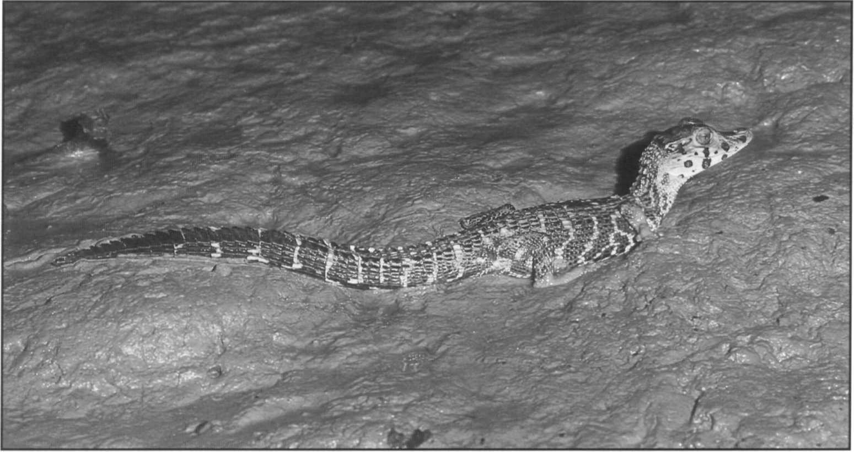Black caiman, *Melanosuchus niger,* Kaw River, French Guiana.

M. Blanc

Venezuela

Donoso-Barros (1966a, 1996b) reported *Melanosuchus* in Venezuela, citing a specimen from the Rio Negro originating from the region south of Cocuy. Gorzula and Paolillo (1986) noted the imprecise locality data, and cited Medem (1983) for a lack of confirmed specimens from Venezuela. Based on their observations in Bolivar and Amazonas states they concluded that no firm evidence suggested *Melanosuchus* to be found within Venezuela. King (1991) reported a black caiman killed just southeast of Puerto Ayacucho (presumably in or around the Rio Cataniapo) in 1967 by Jay Wilson, a caiman hide dealer. King (1991) suggests that this area and other sites in the upper Orinoco be revisited to confirm this record.

### Priority projects

##### High priority

**Population Status** Surveys: The lack of population status information throughout the species' range is a major limiting factor for the development of conservation and management programs for this species. Countries such as Colombia are interested in developing management programs based on controlled commercial utilization, once adequate information has been obtained on the species status in that country. Very little information is available from throughout most of Brazil, Bolivia, French Guiana (particularly the Kaw Swamp), and Peru. There is anecdotal evidence that population recovery is taking place in certain areas, and this needs to be documented through systematic survey work. Historically, Marajo island at the mouth of the Amazon held huge populations of black caiman which were killed off by ranchers. Recent reports of a recovering

population should be investigated. In Ecuador, basic surveys have been carried out, but need to be continued in the form of population monitoring as part of the ranching program.

**Basic Ecological** Studies: Although it has a wide distribution and in some areas is found in locally dense populations, few ecological studies have been conducted on *Melanosuchus.* Certainly, in comparison to *Caiman crocodilus,* very little is known about black caiman. Ecological investigations now underway in Brazil at the Mamiraua Ecological Station should be continued and expanded. Ecological studies should be incorporated into the ranching and population monitoring program in Ecuador.

**Initiate management programs in Brazil:** Brazaitis *et al.* (1988) strongly urged the development of a coordinated management program for black caiman and the other crocodilians in Brazil. This program should include long- term ecological investigations in areas such as the Rio Guapore (near Guajara Mirim and Costa Marques) and the Rio Galera in Mato Grosso. Several sites in Amazonas state, particularly the Mamiraua Ecological Reserve, are good candidates as well.

**Regional management coordination:** Coordinated efforts between the range states of this species to develop compatible sustainable use programs and to control illicit trade are needed. Efforts need to be directed at controlling the illegal sale of caiman meat (including international control of the trade in meat between Brazil, Colombia, and Peru, particularly in Leticia) as a first step towards evaluating the potential for controlled commercial management. Initiatives to achieve this are underway under the auspices of the Amazonian Treaty and under the leadership and coordination of Colombia.

## Paleosuchuspalpebrosus

**Common names:** Dwarf caiman, Cuvier's smooth-fronted caiman, Jacaré pagua, Cachirre, musky caiman, Cocodrilo

**Range:** Bolivia, Brazil, Colombia, Ecuador, French Guiana, Guyana, Paraguay, Peru, Surinam, Venezuela

Revised by Robert Godshalk

**Conservation overview**

**CITES:** Appendix II

CSG Action Plan:

Availability of Survey Data - Poor

Need for Wild Population Recovery - Low Potential for Sustainable Management - Low

**1996 IUCN Red List:** Not Listed **(LRlc** Lower Risk, least concern. Widespread and remains locally abundant although quantitative data on trends is lacking.)

**Principal threats:** Habitat destruction, local subsistence hunting.

### Ecology and natural history

The two species of *Paleosuchus* are very similar to each other and can be confused. They are both small, secretive and are frequently sympatric. Until recently, very little work has been done on either species. Ecological work on this genus was done by Federico Medem (Medem 1981, 1983). This dwarf caiman is essentially restricted to the Amazon and Orinoco River drainages and the Atlantic coast drainages that lie between these two rivers. Limited populations inhabit the upper Paraguay River drainage in Paraguay (Medem 1983, Scott *et* ***al.*** 1990). Much of what is known concerning the ecology of the dwarf caiman is summarized in Magnusson (1989) and Ouboter (1996). Ecological studies are currently being undertaken in Brazil (Campos *et* ***al.*** 1995).

The dwarf caiman inhabits a number of aquatic habitats in the central Amazon basin, including the flooded forests near the major rivers and lakes (Magnusson 1985). On the Brazilian shield (Rebelo and Louzada 1984), and in the Venezuelan llanos, the species occurs in streams lined by gallery forest (Thorbjarnarson 1992). It does not inhabit small forest streams that drain rainforest tracts, a principal habitat

for *P. trigonatus* (Magnusson 1992a). Ouboter (1996) considers it a species of the shallow margins of blackwater rivers in Suriname.

The water is frequently nutrient poor, and may be acidic, as in the *Mauritia* palm swamps in Venezuela (Godshalk 1982a). Terrestrial movement may be extensive in order to reach ephemeral wetlands (Paolilla and Gorzula 1985). King and Videz-Roca (1989) report both species of *Paleosuchus* present in both large rivers and small streams in Bolivia, usually along stretches of bare shore and frequently in association with dead trees.

The dwarf caiman may be the smallest extant species of crocodilian in the world, with the maximum length of males reported to be only about 1.6m (Medem 1981). Ouboter (1996) reports animals of 1.8m in Surinam. Little is known about its reproduction, but females are known to make mound nests during the rainy season and lay 10-15 eggs.

### Conservation and status

Both species of *Paleosuchus* have well-developed osteoderms over most of the body. This, and the species small size, makes the hide virtually worthless commercially and has resulted in only limited hunting pressure. Basic surveys have been conducted in a large majority (80%) of the countries containing this species. Most surveys were undertaken to determine the status of other crocodilians, but reported on *Paleosuchus* as well. Hines and Wilkinson (pers, comm.) report night count densities of 0.83 - 2.20/km on the Rio Curaray in Ecuador. Subsistence hunting does take place widely, and can locally reduce *Paleosuchus* densities, but populations of this species do not appear to have been impacted much. However, gold mining activities and its resultant pollution are increasing and also have an impact on this species in certain areas.

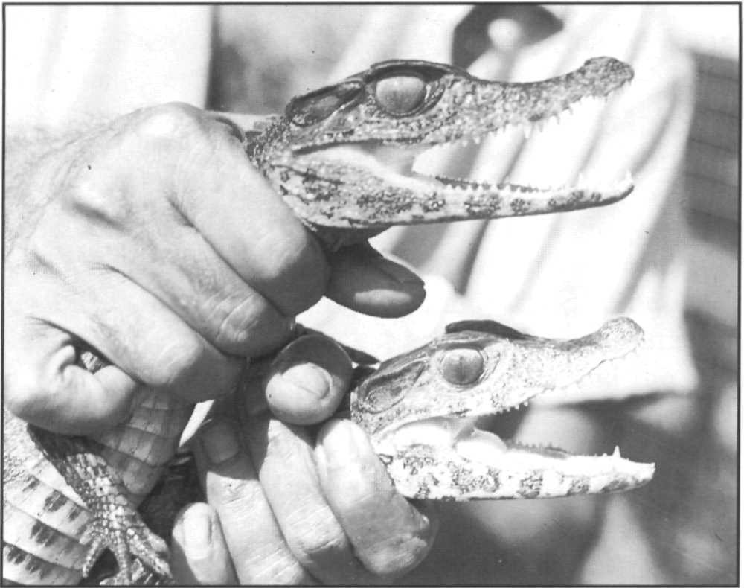

Dwarf caiman, *Paleosuchus palpebrosus,* (below) and smooth-fronted caiman, *Paleosuchus trigonatus,* (above) in Guyana. These two similar small species remain widely distributed in South America.

P.C.H. Pritchard

The dwarf caiman holds little potential for the development of commercially oriented management

programs. The primary value in most countries is for subsistence hunting by rural inhabitants. *Paleosuchus* is sometimes taken preferentially over *Caiman* spp. Commercial exploitation in Guyana is based on the capture and sale of dwarf caiman for the pet industry.

### Priority projects

##### Moderate priority

**Investigations of ecology and population biology:** This species is perhaps the least known of the New World crocodilians. Even such basic topics as prey, habitat preference and reproduction are poorly known. Ecological interactions with other crocodilians and the effects of subsistence hunting would be important management topics to address. Areas where ecological investigations could be fruitfully undertaken include the Brazilian Amazon, Guyana, and the Venezuelan Guyana region. Bolivian populations have long been isolated from disturbance and would also be suitable.

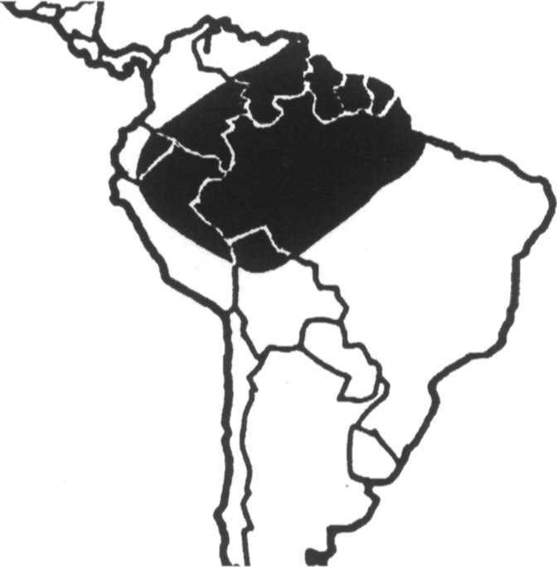***Paleosuchus trigonatus***

**Common names:** Smooth-fronted caiman, Schneider's smooth-fronted caiman, Cachirre, Jacaré coroa

**Range:** Bolivia, Brazil, Colombia, Ecuador, French Guiana, Guyana, Peru, Surinam, Venezuela

Revised by Robert Godshalk

**Conservation overview**

**CITES:** Appendix II

CSG Action Plan:

Availability of Survey Data - Poor

Need for Wild Population Recovery - Low Potential for Sustainable Management - Low

**1996 IUCN Red List:** Not Listed **(LRlc** Lower Risk, least concern. Widespread and remains locally abundant although quantitative data are lacking.)

**Principal threats:** Habitat destruction, local subsistence hunting.

### Ecology and natural history

The smooth-fronted caiman is somewhat larger than the dwarf caiman *P. palpebrosus* with a maximum male length of ca. 2.3m; (Medem 1981). It has a similar distribution

but does not enter the Brazilian shield region or the Paraguay River drainage. In Brazil, this species is found principally in rivers and streams of heavily forested habitats (Magnusson 1992b). In Venezuela, *P. trigonatus* is principally restricted to chemically poor rivers and streams of the Guayana Shield and western llanos (Godshalk 1982a, Gorzula and Paolillo 1986, Gorzula *et* ***al.*** 1988), and has been reported at elevations up to 1,300m. The habitat in Bolivia is similar to that reported in the

*P. palpebrosus* account (King and Videz-Roca 1989).

Magnusson (1989) summarizes much of the published information on this species. Pritchard (1995) reports a specimen emerging from the sea onto a beach in Guyana, although the identification of the specimen may be in question (Ross *et al.* 1995). Ecological studies on this species by Magnusson and co-workers (Magnusson 1985, Magnusson *et al.* 1985, 1987) revealed that the diet is comprised to a large extent of terrestrial vertebrates. Egg laying apparently takes place at the end of the dry season

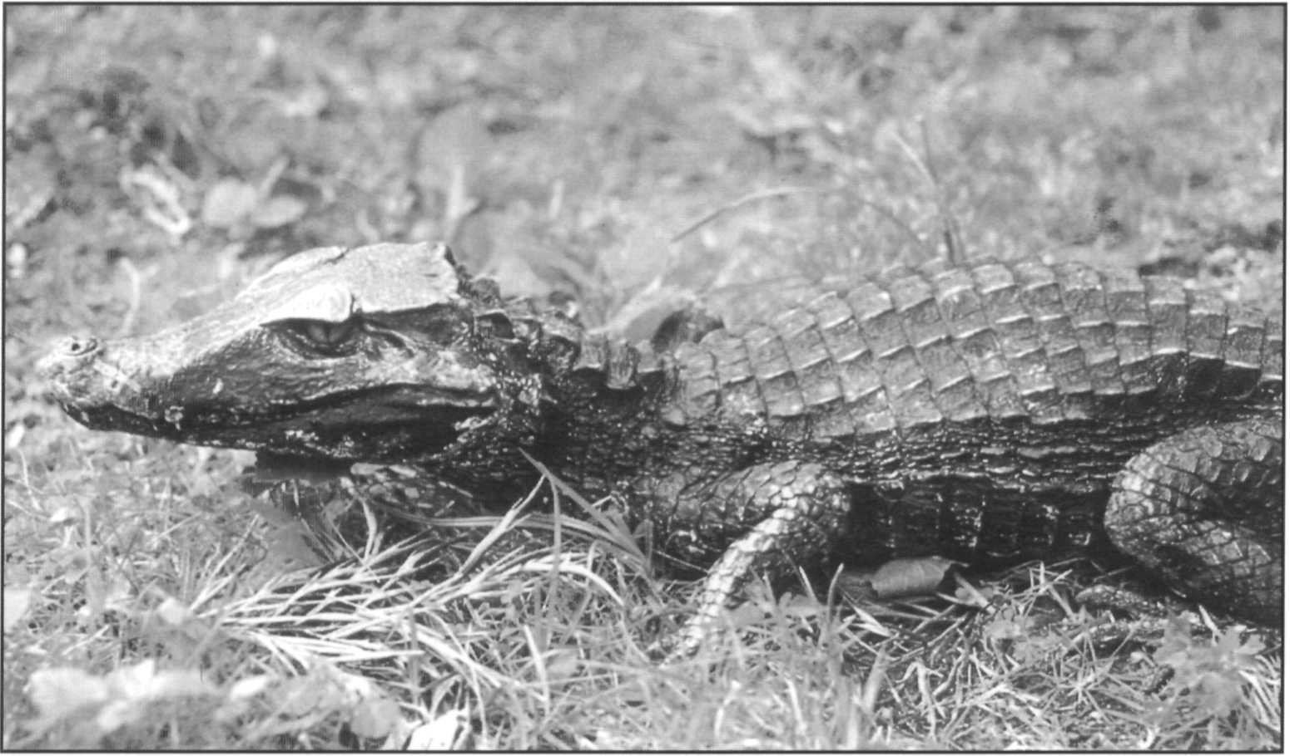Smooth-fronted caiman, *Paleosuchus trigonatus,* Venezuela.

R. Godshalk

and many of the mound nests are located adjacent to or on top of termite mounds, thereby maintaining a stable elevated nest temperature. The incubation period appears to be the longest of any crocodilian and is in excess of 100 days (Magnusson 1989).

### Conservation and status

As with the dwarf caiman, surveys have mostly been conducted for other species of crocodilian throughout much of the range of this species. Owing to the limited potential for commercial exploitation, the smooth-fronted caiman has been hunted mostly on a subsistence basis and populations appear to remain healthy throughout the species' range. Environmental pollution associated with gold mining in Venezuela and Brazil (and increasingly in Bolivia and Peru) appears to be having an increasingly negative impact the riverine ecosystems and is affecting this species and other crocodilians.

Because of the species' small size and extensive ventral ossification, the commercial value of the hide of

*P. trigonatus* is very low. The management of the smooth- fronted caiman is based principally on the protection of wild populations. Limited cropping is only allowed in Guyana, principally for the pet trade.

### Priority projects

##### Moderate priority

**Investigations of ecology and population biology:** Although more is known about the behavior and ecology of this species than about the dwarf caiman, many aspects of the smooth-fronted caiman's life history remain to be investigated. One of the important management related topics is to determine the effect of gold mining on populations of *Paleosuchus.*

## Crocodylus acutus

**Common names:** American crocodile, Cocodrilo, Lagarto, Caiman de la costa, Caiman aguja

**Range:** Belize, Colombia, Costa Rica, Cuba, Dominican Republic, Ecuador, El Salvador, Guatemala, Haiti, Honduras, Jamaica, Nicaragua, Mexico, Panama, Peru, United States, Venezuela

**Conservation overview**

**CITES:** Appendix I

CSG Action Plan:

Availability of Survey Data - Poor

Need for Wild Population Recovery - High Potential for Sustainable Management - Moderate

**1996 IUCN Red List: VU** Vulnerable. Criteria A.l.a.c. inferred decline >20% in 3 generations, inferred from reduction in extent of occurrence.

**Principal threats:** Illegal hunting, habitat destruction.

Ecology and natural history

The American crocodile is the second most widely distributed of the New World crocodiles, ranging from the southern tip of Florida, both the Atlantic and Pacific coasts of southern Mexico, Central America, and northern South America, as well as the Caribbean islands of Cuba, Jamaica, and Hispaniola. The habitat of the American crocodile consists largely of freshwater or brackish water coastal habitats such as the saltwater sections of rivers, coastal lagoons, and mangrove swamps. However, populations are known from freshwater areas located well inland, including a number of reservoirs. Also, one of the largest known populations is in Lago Enriquillo, a landlocked hypersaline lake situated 40m below sea level in the arid southwestern Dominican Republic.

The American crocodile is a relatively large species, with males having maximum lengths of 5-6m range, although some 7m individuals have been reported (Schmidt 1924, Medem 1981). This species is characterized by the most reduced and irregular dorsal armour (osteoderms) of any crocodilian (Ross and Mayer 1983).

*Crocodylus acutus* is one of the most adaptable crocodilians in terms of nesting ecology. Throughout most of its range the American crocodile is a hole-nesting species. However, in areas where access to well drained

nesting beaches is limited, females will form mound-type nests (Campbell 1972a, Kushlan and Mazzotti 1989b). Clutch size is typically in the 30-60 range, although in some populations mean clutch size is in the low 20s (Thorbjarnarson 1989). As with most hole nesting species,

*C. acutus* nests during the annual dry season with eggs hatching around the beginning of the annual rainy period (Thorbjarnarson 1989). Extensive nest protection has not been reported in most areas (although see Dugan *et al.* 1981).

A number of studies have examined aspects of the population ecology of the species in Florida (Kushlan and Mazzotti 1989 a and b, Ogden 1978, Moler 1991, Moler and Abercrombie 1992), Haiti (Thorbjarnarson 1988a), and Venezuela (Seijas 1988). Behavioral studies in captivity have been carried out and published by Garrick and Lang (1977). Much of the published information on the ecology of this species prior to 1988 was summarized by Thorbjarnarson (1989).

### Conservation and status

The American crocodile is found in 17 countries in the northern Neotropics. This species produces a commercially valuable hide and the principal reason for past declines in population size can be attributed to the extensive commercial overexploitation that occurred from the 1930s into the 1960s. Current threats are habitat destruction and in some areas continued hunting. The collection of adult breeders to stock farms could become a serious problem in some countries if not closely regulated by the appropriate management authorities.

At present, the overall quality of survey data is poor. No recent surveys are available from El Salvador, Guatemala, Panama, Colombia, Ecuador and Peru. In 11 countries some survey data are available, and in one (the United States) widespread survey work has been conducted.

In Mexico, populations remain in the Santiago river of Nayarit and Jalisco (Casas Andreau 1990, 1994) although they may be threatened by hydroelectric construction. Some populations in Sinaloa, Yucatan and Veracruz are reported to be greatly depleted or eliminated. Populations are also reported to be greatly depleted in Guatemala (Enrique Fernandez, pers. comm.). A private program to maintain a captive breeding stock for conservation purposes is underway. In Honduras, most of the major rivers of the Atlantic drainage support small populations, although these may be depleted (King, Espinal and Cerrato 1990, King and Cerrato 1990). A population in El Cajon reservoir is negatively affected by changing water levels and human interference (Rodriguez 1990). Surveys in Nicaragua by King, Ross, Morales and Gutierrez (1994) report *C. acutus* to be very rare but still present in the Atlantic drainage, and several viable populations were identified on the Pacific coast (Estero Real, las Salinas) and near Managua. Incidental illegal take in association with the legal caiman harvest is a problem. In Costa Rica, a viable population of over 300 individuals is reported from the Rio Grande de Tarcoles (Sasa and Chaves 1992) and another of around 35 individuals in Estero Roto (Chaves 1993). Crocodiles are also known to be present at Playa Nancite (Plotkin and Zanella 1994) and are rare but present in the major Atlantic rivers. The situation in Colombia is poorly known, but major populations on the Atlantic coast and Magdelena river drainage are thought to be severely depleted or extirpated. A small population is reported to persist in Bahia Portete (Abadia 1995). Farms in Colombia are maintaining stock for captive breeding. In Ecuador, coastal mangrove destruction for the construction of shrimp aquaculture facilities is removing crocodile habitat. Small numbers of *C. acutus* are being held in captivity for future

breeding (Forestieri 1994). The species reaches its southern limit in the vicinity of Tumbes in northeastern Peru. Small populations are reported from the estuaries and mangroves of the Tumbes, Mango, Tigre, Ucumares and Chica rivers (Vasquez and Pickens 1995)

In Venezuela, an active program of surveys and restocking from ranched stock has been conducted in Falcon province in the north east of the country (Arteaga 1993) and in Aragua province (Lander and Bisbal 1994). Comparative surveys between 1986 and 1993 suggest that populations in several locations are stable or growing as a result of protection and restocking, although residual problems of illegal killing for medicinal products is reported (Arteaga 1994). The small population in south Florida, USA, is steadily growing with a record 34 nests in 1993 (Anon. 1993a, Moler 1991). The population of C. *acutus* in Lago Enriquillo, Dominican Republic, has received intense study and conservation action since 1992. This population is thought to have declined to about a third of its estimated size in 1980 of 300-600 due to illegal killing and a decrease in fish resources from overfishing. A program of protection was developed by the Department of Wildlife D.R., and the population is now thought to be stable at around 200 individuals. A program to establish a genetic reserve of 130 juveniles transfered to the Dominican National Zoo was unsuccessful (Schubert 1994, Schubert and Santana 1996). Thorbjarnarson (1989) reported on the population in Etang Sumatre in Haiti and some other coastal locations. Recent informal surveys indicate this population is greatly reduced (A. Schubert *in litt.* 1996)

Surveys in Cuba conducted for the Cuban crocodile also reported substantial populations of *C. acutus* in the Zapata swamp (Ramos *et al.* 1994) and populations on Isla de Juventud, Canarreos Archipelago, Jobabo and

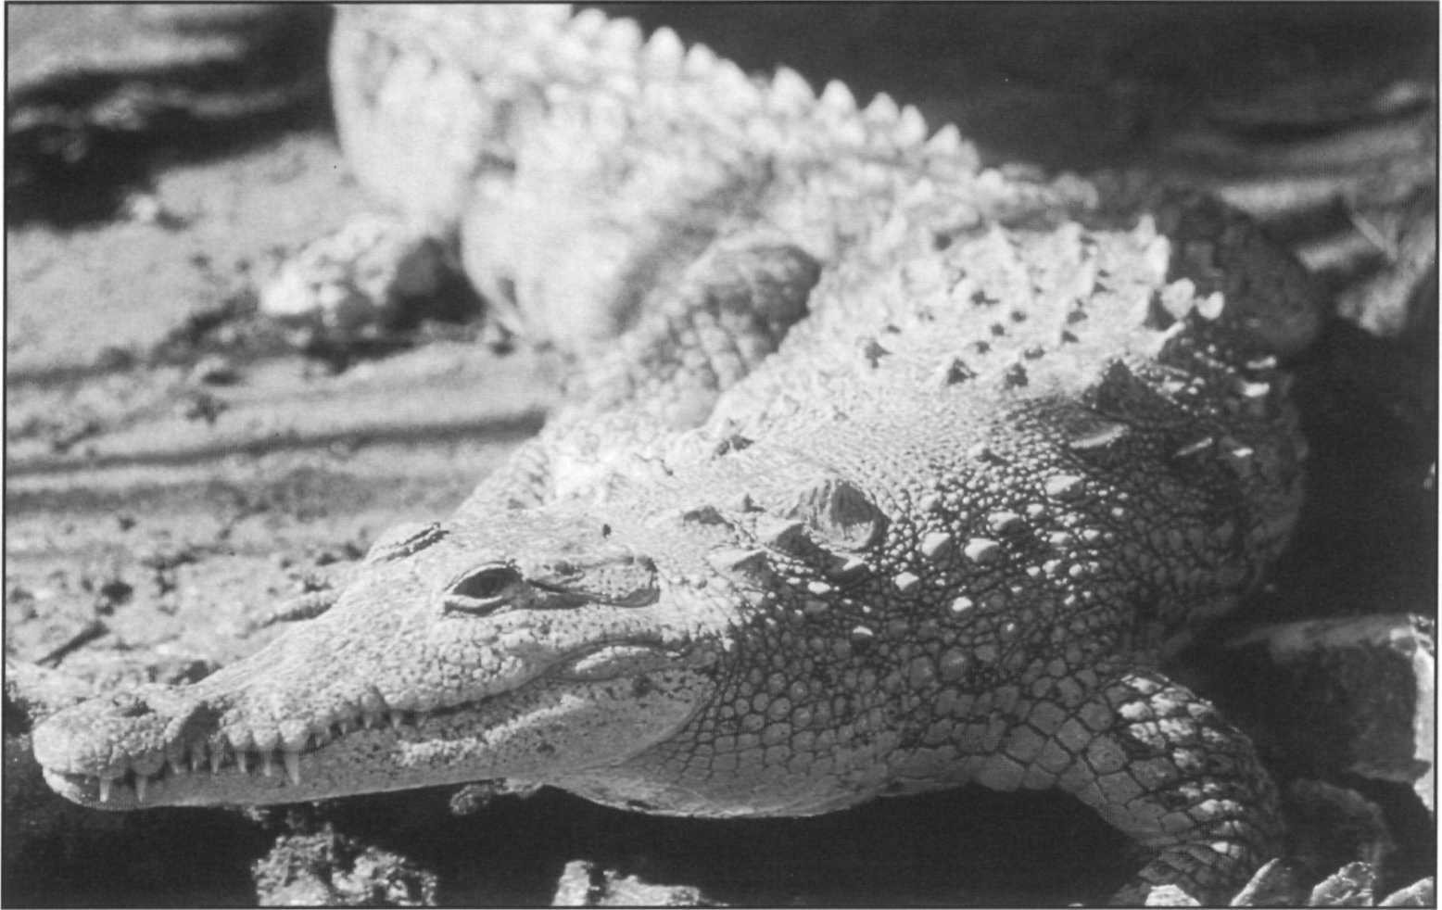American crocodile, *Crocodylus acutus,* USA.

R. Godshalk

Cheve lagoon and Birama swamp are reported to be robust (Ottenwalder and Ross 1991). Platt (1994b) summarizes localities of *C. acutus* in Belize including six mainland localities and 11 offshore Cays. Platt provides quantitative survey data for Turneffe Atoll indicating a population of at least 50 non-hatchling individuals. Meerman (1992) reports surveys in the Shipstern area. Belize, with Cuba, may be one of the remaining strongholds for the species, although some reduction of available habitat by coastal development is evident in both countries.

A majority of countries (eight) have management programs based on complete protection, but only a few have enforced this legislation. Two countries (El Salvador and Haiti) have no management programs whatsoever. In five countries, farming of *C. acutus* has begun (farming is also being planned in Jamaica), and in Cuba ranching is also conducted.

As American crocodiles produce a commercially valuable hide, sustainable utilization programs based on ranching and farming are feasible. However, the development of management programs based on sustainable utilization must be approached on a country- by-country basis and be directly linked to the health of wild populations.

### Priority projects

##### High priority

**Status and distribution in Colombia:** Since the work of Medem (1983), very little work has been done on crocodilians in Colombia. While populations were widespread along both the Caribbean (particularly in the Magdalena River basin) and Pacific coasts, they suffered heavily from commercial hide hunting. Surveys are urgently needed to determine the status of current populations as a first step towards establishing a management for this species, in association with the development of captive breeding programs.

**Establishment of management and protection for breeding areas in the offshore cays of Cuba and Belize:** These two areas are emerging as the largest remaining concentrations

of the species with the least potential for human conflict. Securing these important areas for conservation and possible sustainable use is a priority.

**Status and ecology in Costa Rica:** Reports indicate the presence of healthy populations of *C. acutus* in Costa Rica, particularly in the Tempisque and Tarcoles River. Because of its excellent institutional infrastructure, Costa Rica would be an ideal site to conduct population research on this species for management and conservation purposes.

**Status and distribution in Mexico:** Although some surveys are being conducted along the western coast in Jalisco, no coordinated effort is being made to assess the status of *C. acutus* in Mexico. With the developing interest in managing the species on a sustainable basis, more extensive survey work will be necessary. Of related interest will be surveys of the status of the introduced *Crocodylus moreletii* populations along the Pacific coast and an assessment of the threat that they represent to the native

*C. acutus.*

##### Moderate priority

**Status and distribution in Panama, Ecuador, El Salvador, Guatemala, Honduras, Haiti and Peru:** Existing information suggests these are either peripheral range states or already depleted. Nevertheless, basic surveys as a preliminary to conservation action are needed.

**Development of a management program in Jamaica:** American crocodiles are reasonably abundant in a number of areas along Jamaica's southern coast. Recent interest has developed in farming this species, but a comprehensive management plan needs to be developed that addresses the well-being of wild crocodile populations. The relative advantages of farming and ranching should be addressed, and a crocodile population monitoring program established.

**Restocking and conservation in Venezuela:** Continuation of the existing conservation and restocking program in Falcon and Aragua provinces.

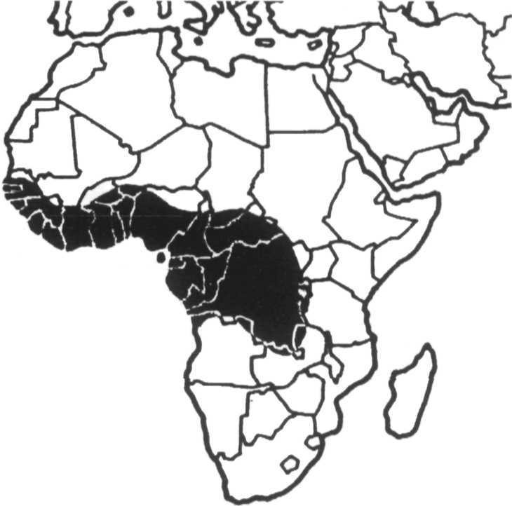***Crocodylus cataphractus***

**Common names:** Slender-snouted crocodile, African gavial

**Range:** Angola, Benin, Burkina Faso, Cameroon, Central African Republic, Chad, Congo, Côte d'lvoire, Dem. Rep.

Congo, Equatorial Guinea, Gabon, Gambia, Ghana, Guinea, Guinea Bissau, Liberia, Mali, Mauritania, Nigeria, Senegal, Sierra Leone, Tanzania, Togo, Zambia

**Conservation overview**

**CITES:** Appendix I

CSG Action Plan:

Availability of Survey Data - Extremely Poor Need for Wild Population Recovery - High Potential for Sustainable Management - Moderate

**1996 IUCN Red List: DD** Data Deficient, possibly EN Endangered or VU Vulnerable based on suspected declines.

**Principal threats:** Habitat destruction, illegal hunting.

### Ecology and natural history

This narrow-snouted, medium-sized species reaches a maximum size of up to 4m (Brazaitis 1973). It is distributed widely throughout western and central Africa, where it apparently prefers riverine habitats in areas with dense vegetation (Waitkuwait 1989).

What little is known about *C. cataphractus* in the wild has been summarized by Waitkuwait (1989). Mound nests composed of organic matter are constructed along riverbanks at the beginning of the wet season. The nesting season broadly overlaps that of the sympatric dwarf crocodile (*Osteolaemus tetraspis*), but is more concentrated in time, and there appear to be differences in types of nesting habitat used. Females lay an average of approximately 16 eggs, and egg size is very large relative to female size.

### Conservation and status

As with the largely sympatric dwarf crocodile, very few survey data are available for this species. Information from the work of Waitkuwait (1989) in Cote d'lvoire, and the surveys of Behra (1987) in Gabon, Congo and the Central African Republic, suggested that in these four

countries populations of *C. cataphractus* were somewhat depleted but not imminently threatened at that time. The largest remaining known population appears to be in the Ogoue River in Gabon. Incomplete information for three additional countries suggests that this species is somewhat depleted in Liberia, and severely depleted in Chad and Angola. Population decline in the past has been attributed to increased hide hunting associated with the decline of *Crocodylus niloticus* populations. Subsistence hunting and habitat destruction have also contributed to population decline (Pooley 1982).

Little new information has come to light on this species since the 1992 Action Plan was published. Surveys conducted in The Gambia, Senegal and Guinea-Bissau did not find any *C. cataphractus* and they may be extirpated there (Jones 1991). Dore (1991) reported that the status of

*C. cataphractus* was "precarious ... if it still exists" in Nigeria. Reports from Togo and Congo both suggest

*C. cataphractus* is very rare but still subject to harvest for skins (Behra 1993b, 1994b). Simbotwe (1993) suggests that Zambia was probably the southern range limit for the species and that changing habitat conditions in the Luapula river, Lake Mweru and Lake Tanganyika may mean

*C. cataphractus* is now extinct in Zambia. Disruption of habitat by removing riverside vegetation and direct harvest for meat and skins are the major threats.

In most countries the management of *C. cataphractus* is based on the legal protection of wild populations. Limited sustainable utilization is beginning in some nations, based solely on the direct cropping of wild animals. Congo maintained an CITES export quota for the species of 200 per year in 1990-1992, but this has now lapsed and a few skins were exported. The regulated hunting of this species is permitted in Chad, Sierra Leone, Togo, Cameroon, and Dem. Rep. Congo, but does not appear to be part of specific management plans. No ranching or farming of the species has been attempted.

This species is one of the few crocodilians where the available information, although sparse, suggests a seriously

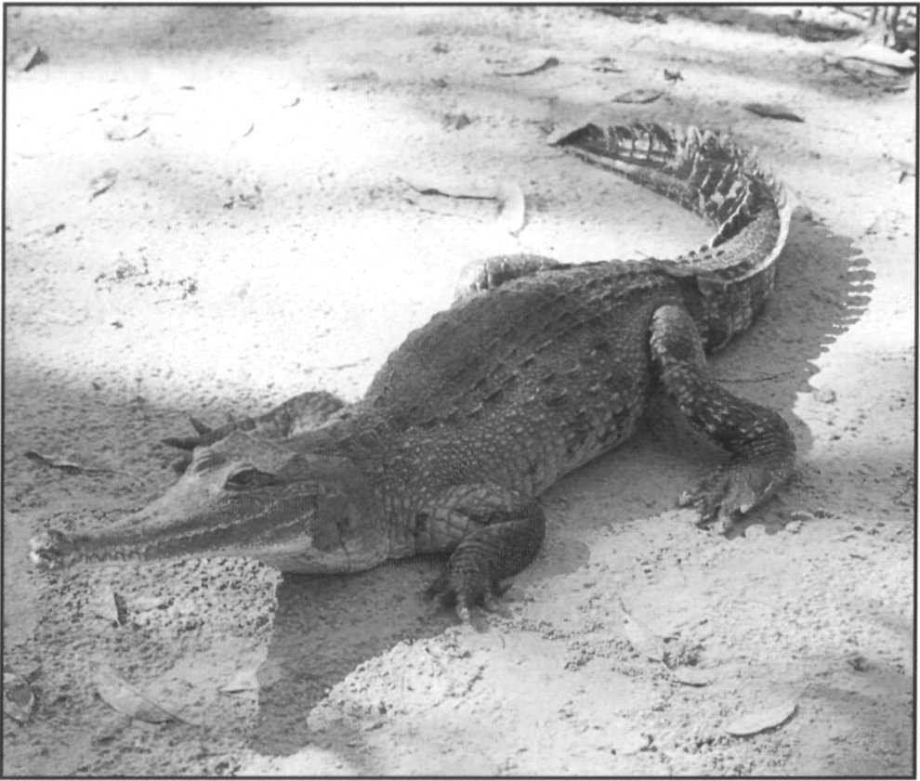

Captive slender-snouted crocodile, *Crocodylus cataphractus,* a native of west and central Africa, Gator Jungle, Florida, USA.

deteriorating status. However, there are vast areas of potential habitat through the drainages of the Congo (Dem. Rep. Congo), Niger (Nigeria), Ogoue (Gabon) and numerous other large rivers in the region. Logistic difficulties and political instability make surveys in this region problematic. There is insufficient information to

assess the status of this species and rectifying this situation is an urgent priority.

### Priority projects

##### High priority

**Surveys of population status throughout West and central Africa:** Very little is known about the status of this species in the wild. Surveys need to be undertaken virtually throughout the species range. Surveys should be done on a country-by-country basis as part of an overall program for establishing conservation and management programs.

R.S. Funk

##### Moderate priority

**Studies on ecology and population dynamics:** Very little is known about the ecology of this species. Ecologically it appears to be somewhat similar to the tomistoma (*Tomistoma schlegelii*), another virtually unknown crocodilian. Population studies need to be undertaken at a number of sites, again as part of an overall plan for developing conservation and management plans for the species in the wild.

## Crocodylus intermedius

**Common names:** Orinoco crocodile, Caiman del Orinoco

**Range:** Venezuela, Colombia Revised by John Thorbjarnarson

**Conservation overview**

**CITES:** Appendix I

CSG Action Plan:

Availability of Survey Data - Poor

Need for Wild Population Recovery - Highest Potential for Sustainable Management - Low

**1996 IUCN Red List: CR** Critically Endangered, Criteria

A. 1 .c, inferred decline of>80% in 3 generations, reduced area of occurrence. C.2.a. Wild adult population may be less than 250 individuals, with continuing declines and fragmentation.

**Principal threats:** Habitat destruction, illegal hunting, limited distribution.

### Ecology and natural history

The Orinoco crocodile is a large, relatively long- nosed crocodile restricted to the middle and lower reaches of the Orinoco River in Venezuela and Colombia (Thorbjarnarson and Franz 1987). Although this crocodile was found in a wide variety of habitats, including rivers in tropical evergreen forest and piedmont streams in the foothills of the Andes, it reached its greatest numbers in the seasonal rivers of the llanos savanna region (Medem 1981, 1983, Godshalk 1982b, Thorbjarnarson and Hernandez 1992). The Orinoco crocodile is a hole nesting species, laying its eggs in seasonally exposed sandbars and riverbanks early in the annual dry season (January-February). Clutch size is typically in the 40-70 range, and the young hatch out during the rise in river levels associated with the wet season (Thorbjarnarson and Hernandez 1993a). Reported dry season concentrations of these crocodiles were very dense, a factor which facilitated hide hunting (Medem 1981, 1983). In smaller rivers that are reduced to a series of interconnected or isolated pools during the dry season, crocodiles aestivate in burrows dug into the river banks. Only a moderate

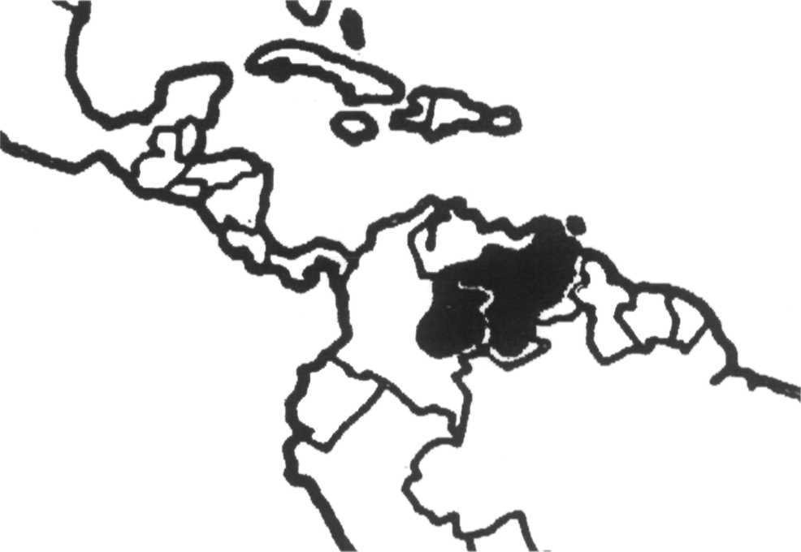

amount of ecological information is available for this species. Accounts by Medem (1981, 1983) cover a number of aspects of its ecology in Colombia and Venezuela. Godshalk (1982b), Thorbjarnarson and Hernández (1990, 1993a, 1993b) deal with aspects of the species' status and ecology in Venezuela. Ecological and behavioral investigations are underway in Venezuela (Thorbjarnarson, pers. comm.).

### Conservation and status

The Orinoco crocodile is one of the most endangered New World crocodilians. Commercial overexploitation from the 1930s through the 1960s decimated wild populations and little recovery has been evident since that time. Medem (1974, 1976) surveyed the Colombian llanos in 1974 and 1976, and found evidence of only 280 adult crocodiles throughout a large part of the drainages of the Arauca, Casanare, Meta and Vichada rivers. The species' current status in Colombia is very poorly known; however, Myrian Lugo from the Estacion de Biologia Tropical Roberto Franco and investigators employed by the Environment Ministry are carrying out surveys in several parts of the Colombian llanos. Prior to these surveys, the last census work was carried out in the early 1970s by Prof. Medem. Recent indications suggest that remnant populations may be found in parts of the Arauca, as well as in the Casanare, Meta and Vichada Departments. The Orinoco crocodile is legally protected in Colombia but this has had little effect on hunting in the past (Medem 1981). The Colombian government is considering future commercial exploitation of Orinoco crocodiles based on closed-cycle farming. The Ministry of the Environment is developing an experimental breeding program at their Guafal Biological Station in Arauca. Captive breeding of crocodiles for release into the wild is being done at the Estacion de Biologia Tropical Roberto Franco in Villavicencio. The center is looking for ways to improve the cramped conditions under which the

crocodiles are currently kept. A trial release program is being considered for the El Tuparro National Park. The sale of young crocodiles may be becoming a problem. Juveniles caught by fishermen have occasionally been offered for sale and have been confiscated by the Ministry and placed on caiman farms for safekeeping.

New field surveys conducted in 1994-1995 by the National University and Ministerio el Medio Ambiente, indicate that populations of *C. intermedius* are still present in the Casanare drainage (Cuilito, Cravo Norte, Lipa, Ele and Casanare rivers), and in Meta province near the Serrania Macarena. Populations are very small with the largest estimated at around 50 individuals in the Casanare area (Lugo 1996, Barahona *et al.* 1996b).

In Venezuela, preliminary survey work has been completed throughout a large part of the crocodile's range. Remnant populations are found in isolated areas where human impact has been minimal. However, even these populations are under threat today from a combination of factors including habitat destruction, egg collecting, intentional and incidental killing, and the capture of animals for sale. The potential for population recovery may also be inhibited by a large increase in populations of the sympatric common caiman *Caiman crocodilus.*

Surveys by Godshalk (1978, 1982b) in the late 1970s indicated that populations of the Orinoco crocodile were severely depleted in Venezuela. More recent surveys by Franz *et al.* (1985), Ramo and Busto (1986), Ayarzagüena (1987) and Thorbjarnarson and Hernández (1992) confirm these findings. Orinoco crocodiles today remain at extremely low densities. The largest known populations are in the Cojedes/Sarare and Capanaparo river systems. The Capanaparo population is not thought to exceed 500 non-hatchlings. The Cojedes population can be divided into three sections with approximately 20 non-hatchlings in the Sacare/Eneal section, 200-400 non-hatchlings in the

Carlo de Agua section, and 100 in the Caño Amarillo section. However, nesting in 1990 was very reduced. At least 30 nests a year are produced in the Caño de Agua section (Ayarzaguena 1990). Although recent surveys by Seijas and Chavez have shown high population densities (in some areas exceeding 20/km), severe habitat modification in the form of a government-sponsored river canalization project has greatly impacted the Cojedes population over the last few years and will continue to do so in the near future. The river is severely threatened by contamination from agricultural residues and urban sewage, and plans are also being developed to dam an upstream section. Other isolated populations are known to exist in areas of low population density and at least two smaller populations are in reservoirs (Camatagua and the Tucupido; Thorbjarnarson 1988a, Seijas, pers. comm.). Neither appears to offer suitable habitat for the long-term survival of crocodile populations.

The Orinoco crocodile is legally protected in Venezuela (Resolucion No. 95, 1979). In Apure state, crocodile habitat has been set aside in the Cinaruco- Capanapro National Park (also known as Santos Luzardo N.P.) along the Capanaparo and Cinaruco Rivers, but no management plan has yet been implemented for the species. Recent civil unrest in this area has interfered with crocodile research and population monitoring and has left the park without any functioning staff. Also in Apure state, a wildlife refuge was established in 1989 along the Caño Guariquito, with land donated by surrounding ranches. In Guarico state, crocodile habitat is found within the Aguaro-Guariquito National Park. A number of non- governmental organizations, including FUDENA, the Wildlife Conservation Society, the Agencia Espafiola de Cooperacion, the UNELLEZ university, private individuals (Tomás Blohm), businesses (Almaca) and the Venezuelan Government have developed a reintroduction/ restocking program for the species. Three sites have been

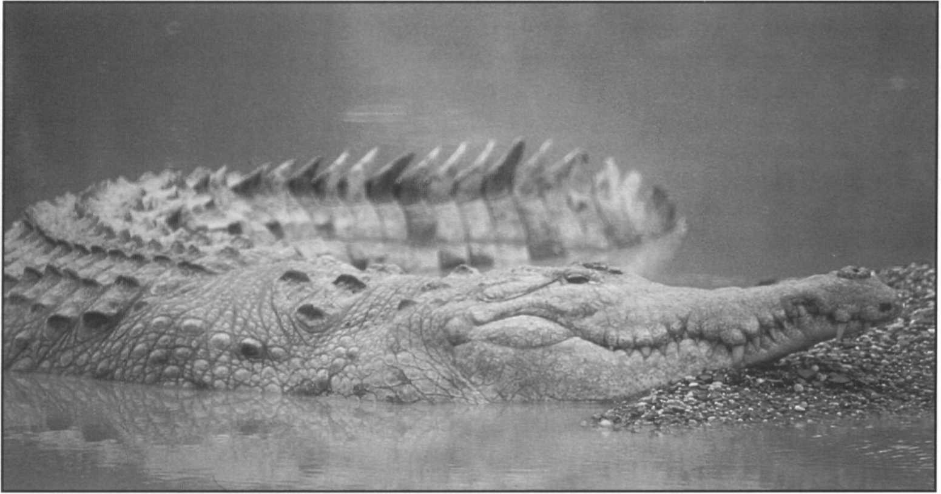Orinoco crocodile, *Crocodylus intermedius,* Masaguaral, Venezuela.

J. Thorbjarnarson

|  |  |  |  |
| --- | --- | --- | --- |
| **Table 5. Orinoco crocodiles released in Venezuela. Animals released in the Capanaparo are head started animals collected as eggs or hatchlings from the Capanaparo River.**  **Release Date No. Reared at Released at** | | | |
| April 1990 | 31 | Masaguaral/UNELLEZ | Caño Macanillal |
| March 1991 | 31 | Masaguaral/UNELLEZ/EI Frio | Caño Macanillal |
| March 1991 | 10 | Masaguara! | Capanaparo River |
| August 1991 | 24 | Masaguaral | Caño Macanillal |
| December 1992 | 2 | Masaguaral | Capanaparo River |
| February 1992 | 15 | El Frio | Caño Macanillal |
| April 1992 | 165 | Masaguaral | Capanaparo River |
| May 1992 | 33 | Masaguaral/EI Frio | Caño Macanillal |
| May 1992 | 25 | UNELLEZ | Caño Macanillal |
| May 1992 | 19 | Masaguaral | Caño Guaritico |
| June 1992 | 99 | Masaguaral | Capanaparo River |
| August 1992 | 100 | Masaguaral | Capanaparo River |
| November 1992 | 18 | UNELLEZ | Tucupido Reservoir |
| February 1993 | 9 | El Frio | Caño Macanillal |
| April 1993 | 39 | UNELLEZ | Caño Guaritico |
| April 1993 | 4 | Masaguaral | Rio Matiyure |
| May 1993 | 200 | Masaguaral/Pto Miranda | Capanaparo River |
| June 1993 | 103 | Masaguaral | Caño Guaritico |
| January 1994 | 118 | Mas./UNELLEZ/EI Frio/Pto Miranda | Caño Guaritico |
| May 1994 | 30 | Masaguaral | Rio Mocapra |
| **Total** | **1056** |  |  |
| *Note:* Caño Guaritico is in the Refugio de Fauna Silvestre Caño Guaritico and the Capanaparo River is in the Parque Nacional Cinaruco-Capanaparo (Santos Luzardo). The Rio Mocapra is located in the Aguaro-Guariquito National Park. The Rio Matiyure is in Hato El Cedral, and the Caño Macanallal is on Hato El Frio. | | | |

selected for the release of crocodiles, Caño Guaritico Wildlife Refuge and two national parks, Cinaruco- Capanaparo and Aguaro Guariquito. Small numbers of crocodiles have also been released on three private ranches (Hato El Frio, Hato Piñero and Hato El Cedrai) and in one reservoir (Tucupido). Captive breeding is carried out at several sites including Hato Masaguaral, Agropecuario Puerto Miranda, Hato El Frio, and at the UNELLEZ university. A program for collecting eggs from the wild has been conducted in the Cojedes and Capanaparo rivers. Crocodiles from the Cojedes have been released on El Frio and in the Caño Guaritico Refuge. Eggs and juveniles taken from the Capanaparo have been returned to their site of origin. The first group of 31 captively reared young were released in April 1990 in Caño Macanillal on Hato El Frio. As of December 1994, 1,054 crocodiles 1-4 years of age have been released (Table 5). A year-long radio telemetry study of released crocodiles was carried out by Muñoz and Thorbjarnarson in the Capanaparo River, and the results of this study suggest that reintroduction can be a viable management technique to speed population recovery. Periodic follow-up surveys have also been conducted on Hato El Frio and in the Caño Guaritico. Monitoring of released crocodiles in the Aguaro- Guariquito National Park is also being planned. FUDENA, PROFAUNA, and members of the Venezuela Crocodile Specialist Group have been working on the production of Orinoco Crocodile Action Plans. A series of

recommendations has been produced, stressing the need to:

1. Assess the current status of wild populations and their

habitat,

1. identify and legally protect areas containing viable wild populations of crocodiles,
2. promote the establishment ofprotected areas on private land,
3. promote more in-depth bioecological studies on crocodiles,
4. optimize the functioning of the captive breeding centers and establish a long-term strategy for the reintroduction and restocking of crocodiles,
5. promote environmental education and community participation programs, and
6. strengthen inter-institutional cooperation and coordination of work.

### Priority projects

##### High priority

**Population status in Colombia:** Virtually nothing is known about the present status of this species in Colombia. As a first step towards undertaking a conservation program work urgently needs to be undertaken to determine if viable populations remain.

**Re-initiation of crocodile work in the Cinaruco-Capanaparo National Park, Venezuela:** Civil unrest has resulted in the cessation of crocodile research and conservation activities in this park. The Venezuelan National Parks department needs to re-establish their presence in the park, and crocodile monitoring and nest protecting activities should be reinstituted.

**Monitoring of populations of released crocodiles in Venezuela:** Crocodiles have been released into three protected areas and several private ranches. Monitoring of these crocodiles has been done, but sporadically. A better coordinated system of follow-up surveys needs to be developed to assess the efficacy of these releases as a conservation technique.

##### Moderate priority

**Conduct surveys in peripheral parts of the species range in**

**Venezuela:** Population surveys have covered much of the

llanos region looking for remnant crocodile populations. Recent survey work has found surviving populations in isolated areas outside oftypical crocodile habitat, including small rivers in the foothills of the Andes, and in forested regions in the south of the country. Additional surveys need to be conducted to look for unknown populations.

**Analysis of genetic diversity within and among populations:** Many of the conservation plans for this species depend on restocking and reintroduction programs. However, nothing is known about genetic variation among populations. Since many of the remaining populations exist in peripheral habitats, the possibility of genetic differentiation should be explored as part of an overall conservation plan.

**Identify areas for reintroduction of crocodiles in Colombia:** Orinoco crocodiles are now being bred in small numbers in Colombia with the intention of releasing them back into the wild. As part ofpopulation surveys now being initiated, areas need to be identified for trial releases and monitoring.

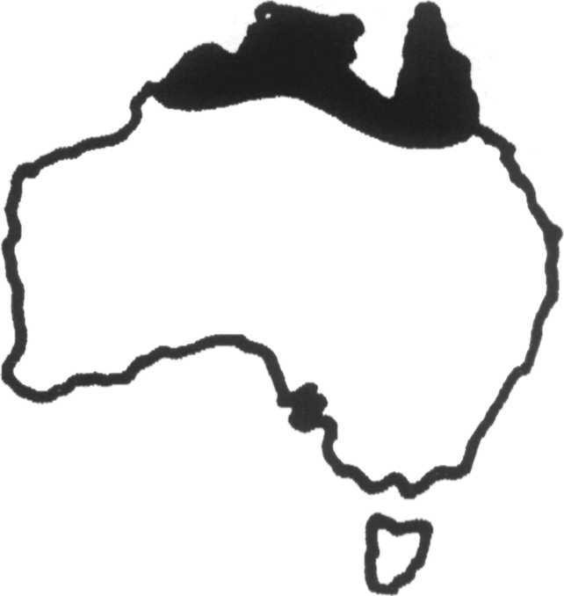***Crocodylus johnsoni***

**Common names:** Australian freshwater crocodile, freshie, Johnson's, Johnstone's or Johnston's crocodile

**Range:** Northern Australia Revised by Anton Tucker

**Conservation overview**

**CITES:** Appendix II

CSG Action Plan:

Availability of Survey Data - Good

Need for Wild Population Recovery - Low Potential for Sustainable Management - High

**1996 IUCN Red List:** Not Listed **(LRlc** Lower Risk, least concern.)

**Principal** threats: Habitat destruction.

### Ecology and natural history

The Australian freshwater crocodile is a small to medium- sized freshwater crocodile restricted to tropical northern Australia. It is similar to other fresh water species in the Asian region (e.g. *Crocodylus mindorensis, Crocodylus novaeguineae)* but morphologically distinct because of its unusually narrow snout. The species is commonly referred to in the literature as *Crocodylus johnstoni* [see King and Burke 1989 for discussion. *Ed.*]. Maximum size of males approaches 3m, and the species is generally restricted to freshwater habitats upstream of tidal areas in Western Australia, Northern Territory and Queensland (Webb *et al.* 1987). This includes almost any type of permanent freshwater habitat including rivers, creeks, swamps and floodplain lakes and lagoons ("billabongs"). In some rivers freshies extend into tidal, saline waters, although they may be restricted from colonizing such areas by saltwater crocodiles (Messel *et al.* 1981).

Although it has a narrow snout, the diet of this species is very catholic and includes a wide variety of invertebrates and small vertebrates (Webb *et al.* 1983). Females lay eggs into holes which they dig in sand bars exposed in the dry season. Clutch size averages 13, and predation by monitor lizards (*Varanus* sp.) and feral pigs is high. Incubation normally lasts 75-85 days (Webb *et al.* 1983). Recent biological studies include reports of population dynamics

(Cooper-Preston and Jenkins 1993, Tucker *et al.* 1993), aestivation (Rennet and Christian 1993), osmoregulation (Taplin *et al.* 1993), and the energetics of incubation and development (Whitehead *et al.* 1992).

### Conservation and status

*C. johnsoni* is currently at low risk of extinction. The population is large and widely distributed, harvest rates are low and habitats are largely intact. A detailed assessment of conservation status is given by Cogger (Cogger *et al.* 1993). The human influences on the population which have been identified and require monitoring are loss of riparian habitat, erosion of nesting areas and water diversion for irrigation. Entanglement in fishing nets is reported but is mainly restricted to areas of high crocodile density. Feral pig predation of nests is reported but it is unclear whether this significantly affects populations (Webb *et al.* 1983b). The frequency and severity of early nest season flooding has increased significantly since the 1800s (Tucker, pers. comm.), but the effect of such natural stochastic events on recruitment of long lived crocodilians is debatable.

Many populations of *C. johnsoni* have recovered since legal protection was enacted in the 1960s-1970s. Recent population estimates in the Northern Territory range from 30,000-60,000 (Webb *et al.* 1987). In Western Australia a total population estimate is not available, although combined estimates from separate populations in Fitzroy and Ord rivers and Lake Argyle total at least 47,000 (McNamara and Wyre 1994). The status of the species in Queensland is unquantified but presumed to be abundant (Miller 1993). A large scale research and management program was undertaken in the late 1970s. The species appears to be highly suitable for adaptive management (Webb and Manolis 1993) although their skins are of relatively low value. Sustainable use began in 1983 with the collection of hatchlings for a ranching

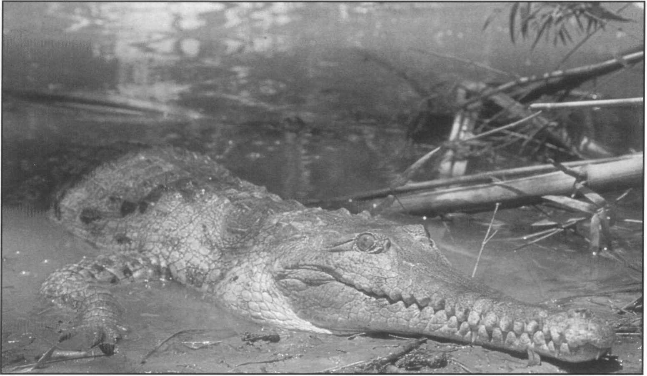Australian freshwater crocodile,

*Crocodylus johnsoni.*

program. Management programs vary among the states. Western Australia and Northern Territory permit a mixture of ranching, harvesting and farming while Queensland allows only farming. The effects of population biology on sustainability of management actions is addressed by Tucker (1995).

G.J.W. Webb

### Priority projects

##### Moderate priority

**Investigation of population dynamics:** Little conservation action is needed for this species, but *C. johnsoni* offers superb potential for conducting research on crocodilian

population dynamics. An intensive research effort has been conducted by Conservation Commission of the Northern Territory since the late 1970s. A similar program is underway in Queensland. The continuance of these long-term research programs will yield much needed data for management programs for this and other species of crocodilians.

**Population status assessment:** Continued monitoring of the population status of the species is a necessary component of the ongoing sustainable use and management of the species. The CSG Regional Meeting in Darwin March 1993 recommended regular monitoring of a series of index rivers to assess population changes.

## Crocodylus mindorensis

**Common name:** Philippine crocodile

**Range:** Philippines

#### Conservation overview

**CITES:** Appendix I

CSG Action Plan:

Availability of Survey Data - Adequate

Need for Wild Population Recovery - Highest Potential for Sustainable Management - Low

**1996 IUCN Red List: CR** Critically Endangered. Criteria

A. 1 .c, Observed decline in extent ofoccurence >80% in 3 generations. C.2.a Less than 250 adults in the wild, populations highly fragmented and declining.

**Principal threats:** Habitat destruction, limited distribution.

**Ecology and natural history**

The Philippine crocodile is a relatively small, little known freshwater Asian crocodile. Maximum size in males reportedly does not exceed 3m. Until fairly recently the Philippine crocodile was considered to be a subspecies of the New Guinea crocodile *(Crocodylus novaeguineae).* Ross (1990, 1992) has resurrected the name *Crocodylus raninus* for a species of lacustrine crocodile similar to

*C. mindorensis* and *C. novaeguineae* based on four 19th century museum specimens and restricted to Borneo, but the paucity of specimens from that region make its identity and taxonomic status difficult to evaluate. The identity and taxonomy of the freshwater crocodiles of Indo- Malayan region requires further study.

The historical distribution of the Philippine crocodile is Luzon, Mindoro, Masbate, Samar, Jolo, Negros, Busuanga and Mindanao (Ross 1982, Ross and Alcala 1983). The report of a small introduced population on Palau is now known to be in error (Messel and King 1992a). Its preferred habitats include freshwater marshes, the tributaries of large rivers, small lakes and ponds (Ross 1982). Very little else is known about the ecology of wild populations. In captivity females are known to make mound nests and lay 10-20 eggs.

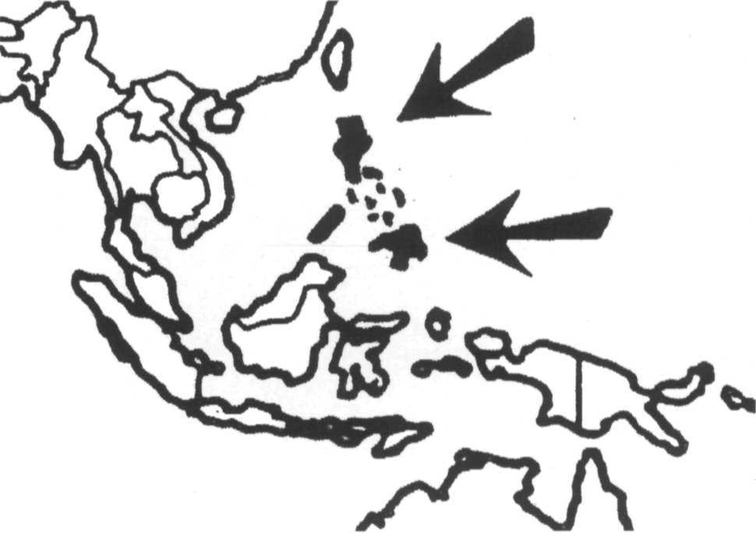

### Conservation and status

The Philippine crocodile is one of the most severely threatened species of crocodiles. Initial population decline was associated with commercial overexploitation. Currently, the principal threats are habitat loss and killing by local people. Very high human population density and the people's intolerance of crocodiles is the major threat. Current re-occupation of agricultural land abandoned during political strife may cause continued depletion. Surveys in 1980-1982 (Ross 1982, Ross and Alcala 1983), reported extremely depleted wild populations, with perhaps no more than 500-1000 individuals remaining. Crocodiles have apparently disappeared from Luzon, Masbate, Samar and Jolo, where they formerly occurred, and no large population exists. The species persist as isolated individuals and small populations in Mindanao, Negros and Mindoro. Confirmed sites include Nabuntaran, Calarian Lake, Macasendy marsh, Liguasan marsh (Mindanao) and the Pagatban river (Negros) (Ortega and Regoniel 1993).

*C. mindorensis* still occurs in the Dipuyai and Busuanga rivers on Busuanga (Regoniel 1993, Ortega, Regoniel and Ross 1994), where they were previously thought extinct. Current wild population size may be no more than 100 non-hatchlings.

A small captive propagation program is being conducted by Silliman University with a single breeding pair and 23 crocodiles in total. The Crocodile Farming Institute, operated by the Philippines government, is breeding *C. porosus* and *C. mindorensis* for commercial and conservation purposes. CFI acquired 204

*C. mindorensis* between 1987 and 1992 from both the wild and private captive sources. Successful captive breeding was initiated in 1989. The CSG reviewed this program in 1992 and 1993, making extensive recommendations for improved operations (Messel *et al.* 1992,1993). The captive stock has steadily increased from 265 (1992), to 349 (1993) and 500 (1994) of which 33 were adult females producing eggs (Anon. 1993). Annual production of live hatchlings

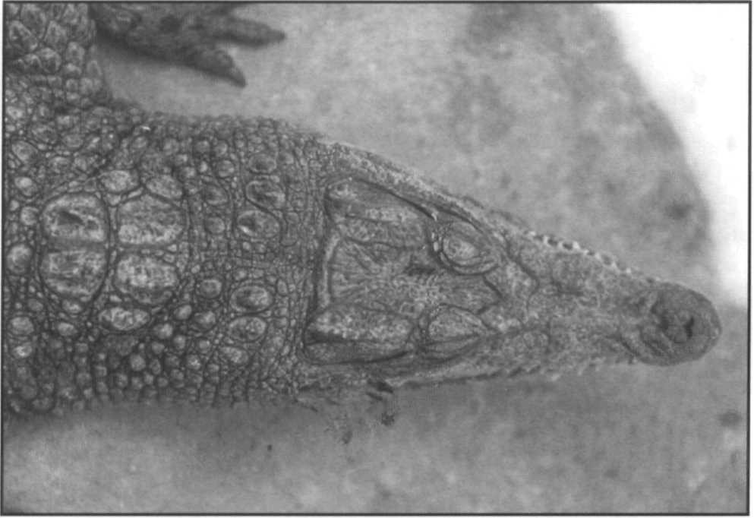

Philippine crocodile, *Crocodylus mindorensis.* Crocodile Farming Institute, Palawan, Philippines. This Critically Endangered species urgently requires conservation action.

F.W. King

exceeded 500 in 1993 and 1994 (Ortega, Regoniel and Ross 1994). A number of private zoos and collections in the Philippines hold crocodiles but most of these are thought to be *Crocodylus porosus* as the majority of privately held

*C. mindorensis* have been acquired by CFI.

Two overseas breeding programs were initiated with stock from the Silliman University project. Gladys Porter Zoo in Texas, USA, has two pairs and two excess males and has repatriated some of its hatchlings to the Philippines. Melbourne Zoo in Australia received a sub-adult pair in 1993 and will also cooperate with the Philippine program. Melbourne Zoo has also developed a public education program with posters in conjunction with CFI. In addition, a small number of *C. mindorensis* are held by zoos and private collections in USA and Europe.

Given the pessimistic situation of the natural habitat, it seems likely that captive breeding will be the central activity for the conservation of this species for some time to come. Refinement of this program is needed to include analysis of founder stock base, genetic diversity and optimal exchange of genetic stocks for maintainance of diversity.

Continued support of the captive breeding program, integration of the diverse breeding programs, and continued assessment of the feasibility for reintroduction should be encouraged.

### Priority projects

##### High priority

**Development of a national crocodile management program:** Philippine crocodiles are presently found in only one officially protected area, the Lake Naujan National Park. However, effective protection of crocodiles is not evident at this site, and better enforcement is needed. A national management plan for *C. mindorensis* and *C. porosus* needs to be drawn up outlining a conservation policy. Areas should be identified where the protection of crocodiles could be reasonably certain, and the feasibility of declaring them as reserves determined. Crocodile conservation is not a popular topic in the Philippines and efforts to enlist more public support, through educational campaigns or through sustainable management should be encouraged.

**Coordination of captive breeding program:** Captive breeding should be integrated on a cooperative world wide basis using current techniques for maintaining genetic diversity in anticipation of eventual reintroduction from captive stocks.

##### Moderate priority

**Continued surveys of the status and distribution of the species:** Although relatively good survey data are available, most were conducted in the early 1980s and need to be repeated. Many unsurveyed areas are suspected to have crocodiles, but many of these areas are suffering from civil disturbance problems.

***Crocodylus moreletii***

**Common names:** Morelet's crocodile, alligator (Belize), Cocodrilo de pantano (Mexico)

**Range:** Belize, Guatemala, Mexico

**Conservation overview**

**CITES:** Appendix I

**CSG Action Plan:**

Availability of Survey Data - Poor

Need for Wild Population Recovery - Moderate Potential for Sustainable Management - Moderate

**New IUCN Categories 1995: DD** Data Deficient (Re- analysis at a CSG workshop in 1996 suggested a LRcd Lower Risk, conservation dependent category, Ross 1996.)

**Principal threats:** Habitat destruction, illegal hunting.

### Ecology and natural history

The Morelet's crocodile is a relatively little known species from the Atlantic coast of Mexico and northern Central America. This species was confused with *C. rhombifer* and

*C. acutus* until it was shown to be a distinct species by Schmidt (1924). It is a moderately small species, today rarely exceeding 3m in length and has a relatively broad snout. The habitat of *C. moreletii* is primarily that of freshwater habitats, particularly marshes, swamps, ponds and lagoons, but in some areas this species can be found in brackish water areas. Throughout the southern portion of its range, this species overlaps with *C. acutus,* but the habitat relationship between these two species is not completely known. A good general account of many aspects of the behavior and ecology of this species was given by Alvarez del Toro (1974).

Morelet's crocodile is the only New World crocodile that is exclusively a mound-nesting species. Normally, a clutch consists of 20-40 eggs, and oviposition occurs in Chiapas in April-June before the annual rainy season (Perez-Higareda 1980). Observations on captive animals reveal that females will respond to hatchling vocalizations and open the nests, and will also defend hatchlings against largerjuveniles or subadult conspecifics (Hunt 1975, 1977)

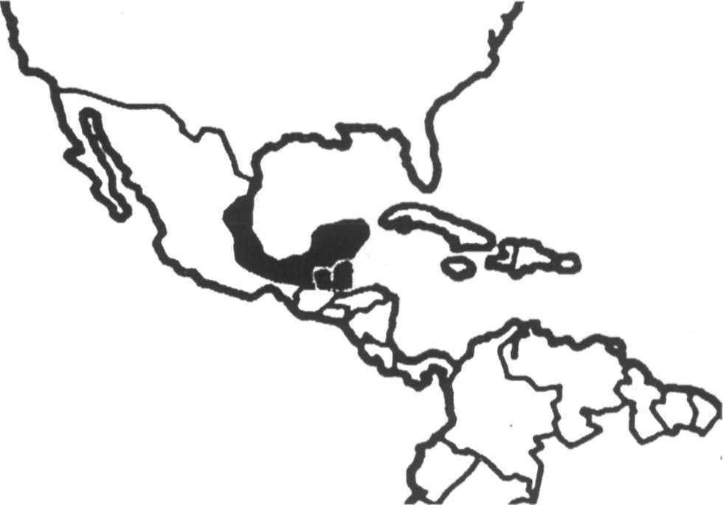

### Conservation and status

Populations of Morelet's crocodile were greatly reduced in many areas due to uncontrolled hide hunting, which took place principally in the 1940s and 1950s. A limited amount of basic survey work is available over the range of the species in Mexico (Powell 1973, Campbell 1972b, Perez-Higareda 1980) and Belize (Abercrombie *et al.* 1980). Detailed surveys in Guatemala are lacking, although the species is reported to be reasonably common in the Peten area. More recent survey data available from Belize suggest some reduction of populations near human centers of population (Abercrombie *et al.* 1982) although the species is said to remain quite common in remote areas. Surveys at Cox lagoon 1990-1994 (Hunt and Tamarak 1992, Hunt *et al.* 1994), show a stable population of 18-45 non- hatchlings. Morelet's crocodile is sympatric with

*C. acutus* and extends its range into brackish habitats in the lagoons of northeastern Belize (Ouboter 1992, Meerman 1992), where several localities with small numbers of individuals are reported. A study of the biology of crocodiles, including *C. moreletii,* in Belize is underway (Platt 1994a, Platt and Montanucci 1993). Status in the south of Belize is unknown. Recent information on the status of the species in Mexico and Guatemala is lacking apart from incidental records (e.g. Sigler and Gonzalez 1994, Sigler 1994). Anecdotal reports suggest the species remains widely distributed in the Mexican states of Tabasco, Chiapas, Yucatan and Quintana Roo although it may be diminishing, largely due to habitat destruction and loss. Several populations have been established on the Pacific coast of Mexico by escapes from farms and deliberate introduction. The effect on local populations of

*C. acutus* is of concern. The situation in the interior of Peten in Guatemala remains poorly known. There is inadequate quantitative information to judge the status of this species throughout the bulk of its range.

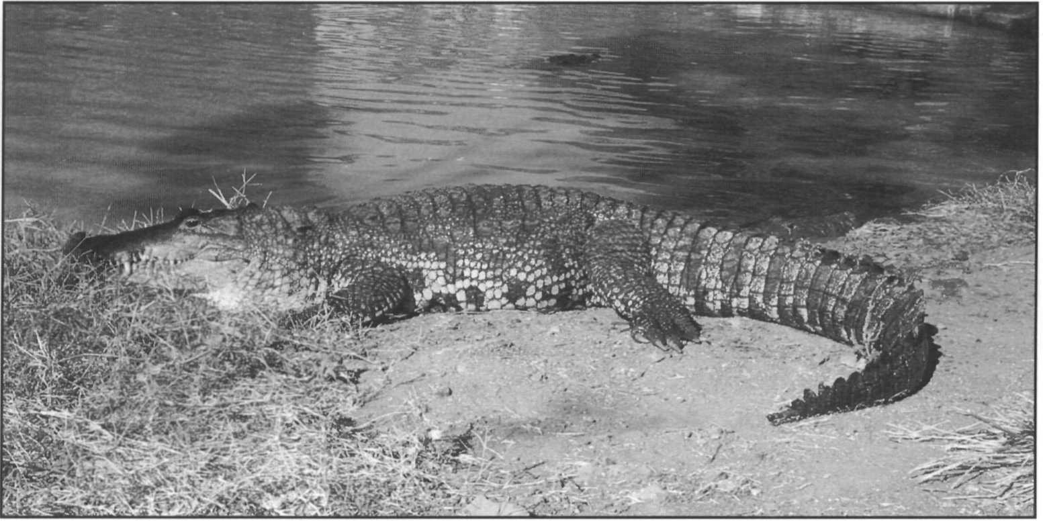Morelet's crocodile, *Crocodylus moreletii.*

Populations of *C. moreletiiare* considered to be depleted in all three countries within the species' distribution. However, in some areas, such as the Centla Biosphere Reserve, Lacandon forest and the Sian Kaan Biosphere Preserve in Mexico, and in Belize, healthy populations exist. Although wild populations are protected in all three countries, some movement toward the development of sustainable management has been made. In Mexico, a number of commercial farming operations have started, including one in Sinaloa on the Pacific coast, outside the species' natural range. Interest has been expressed both in Belize and Guatemala in initiating sustainable management programs as well. An application to register a captive breeding facility in Sinaloa for international trade was approved in 1996 by the CITES Secretariat.

### Priority projects

###### High priority

**Surveys of status and distribution in Guatemala:** Little

is known about this species in Guatemala, where,

however, interest is developing in its commercial management. Status surveys and ecological studies need to be completed.

P. Ross

**Surveys of status and distribution in Mexico: In** view of the increasing interest in sustainable use and captive breeding of this species in Mexico, assessment of its current status and development of effective management and conservation are urgently needed. Little is known about populations along the Gulf of Mexico. In addition to expanded surveys, ecological work in the Sian Kaan Biosphere reserve should be continued, and a management plan developed for the species.

###### Moderate priority

**Development of a management plan for Belize:** Ongoing work by Howard Hunt and colleagues in Cox Lagoon, and by Steve Platt throughout Belize are providing baseline information on distribution and status. A population monitoring project and long-term ecological studies need to be implemented.

## Crocodylusniloticus

**Common names:** Nile crocodile, Mamba (Swahili), Garwe (Shona), Ngwenya (Ndebele)

**Range:** Angola, Benin, Botswana, Burkina Faso, Burundi, Cameroon, Central African Republic, Chad, Congo, Cote d'lvoire Dem. Rep. Congo, Egypt, Eritrea, Ethiopia, Equatorial Guinea, Gabon, Gambia, Ghana, Guinea, Guinea Bissau, Kenya, Liberia, Madagascar, Malawi, Mali, Mozambique, Mauritania, Namibia, Niger, Nigeria, Rwanda, Senegal, Sierra Leone, Somalia, South Africa, Sudan, Swaziland, Tanzania, Togo, Uganda, Zambia, Zimbabwe

**Conservation Overview**

**CITES:** Appendix II in Botswana, Ethiopia, Kenya, Malawi, Mozambique, South Africa, Tanzania, Zambia and Zimbabwe (ranching criterion) Appendix II in Madagascar, Uganda (annual quota criterion)

Appendix I in all other countries

CSG Action Plan:

Availability of Survey Data - Variable, Adequate in Southern Africa, but Poor or extremely poor elsewhere Need for Wild Population Recovery - Moderate Potential for Sustainable Management - Highest

**1996 IUCN Red List:** Not Listed **(LRlc** Lower Risk, least concern, may be threatened in some parts of the range.)

**Principal threats:** Conflict with people.

### Ecology and natural history

The Nile crocodile is among the largest and best known biologically of all the crocodilians. Nile crocodiles are widely distributed throughout sub-Saharan Africa, and historical records indicate its range formerly extended into southern Israel and Jordan. The species was also established on the Comoros Islands, and still exists on Madagascar. As with all crocodilians, size among Nile crocodiles is sexually dimorphic with the larger males reaching lengths of up to 6m in exceptional cases. A large volume of published information exists on topics such as diet, thermoregulation, reproduction, social behavior, habitat preference, and population dynamics. The first modern monograph on the ecology of a crocodilian was that of Cott (1961) on Nile crocodiles.

Nile crocodiles may be found in a wide variety of habitat types including large lakes, rivers, and freshwater swamps. In some areas they extend down into brackish water environments. Cott (1961) demonstrated that, as is generally true among crocodilians, there is an ontogenetic

shift in diet, from insects and small aquatic invertebrates when young, to predominantly vertebrate prey among larger crocodiles. Hutton (1989) demonstrated differences in habitat utilization between juveniles, sub-adults and adults at Ngezi, Zimbabwe, and noted that animals entered a dispersal phase when approximately 1.2m long. Modha (1967) described some aspects of the social behavior, including the establishment of breeding hierarchies. Fergusson (1992) has recently studied the success of farm- raised crocodiles released to the wild.

Nesting is done in holes excavated in sandy banks during the annual dry season. Females become sexually mature when approximately 2.5m long, and lay an average of 45-50 eggs, although this varies considerably among populations. Incubation lasts 90-95 days, and the females open the nest and guard the young for a period after hatching. A model of Nile crocodile population growth and use is given by Craig (1992). The responses of the Zimbabwe population to prolonged sustainable harvest are also well studied (Loveridge and Hutton 1992, Taylor *et al.* 1992)

### Conservation and status

In southern and eastern Africa a number of surveys for Nile crocodiles have been conducted in recent years, and information on crocodile status is good. Recent survey information is available for Tanzania (Games and Severre 1992), South Africa (Blake and Jacobsen 1992) and Kenya (Soorae 1994), while Hutton and Games (1992) provide a collection of recent surveys for Botswana, Kenya, Madagascar, Malawi, Mozambique, and Zambia conducted between 1981 and 1989. Most of this work has been part of a CITES sponsored initiative to implement sustainable management programs in countries that wish to harvest crocodiles. However, in central and western Africa very few survey data exist. For this region information on the status of Nile crocodile is provided by

Behra (1987) for Gabon, Congo and the Central African Republic, and Waitkuwait (1988, 1989) for Cote d'lvoire. The situation in Dem. Rep. Congo and Congo remains poorly known. Recent reports (e.g. Jones 1991) suggest that continued population declines in west Africa are largely due to habitat loss, although heavy extraction of skins in the 1970s has also contributed (Behra 1994c). For instance, Behra (1987) surveyed Gabon without seeing a single Nile crocodile. However, it is possible that Nile crocodiles in west Africa are found at naturally lower densities due to habitat factors and the presence of two other sympatric crocodilians. More survey and ecological studies in central and western Africa need to be undertaken to resolve this question. A remnant population was recently reported to be present at Matmata in the Tagant Highlands of Mauritania (Behra 1994c). For the majority of African countries (25 out of 39), there is inadequate information on the status of Nile crocodile populations. Although the status of the Nile crocodile is relatively secure and abundant in southern and eastern Africa, in western Africa it is greatly depleted. Among the 20 African countries where we have some indication of the status of

*C. niloticus,* they are considered to be severely depleted in six (30%), somewhat depleted in 12 (60%), and not depleted in two countries (10%). Nile crocodiles have been extirpated from three countries at the periphery of their range: Israel, Algeria, and Comoros. However, the disappearance of crocodiles from the former two countries may be partially related to climate change and the resulting loss of wetland habitats. A proposal to reintroduce Nile crocodiles to Algeria is indefinitely postponed due to civil unrest (H. Dumont, pers comm.). Crocodiles reported as extirpated from the Seychelles are now shown to have been *Crocodylus porosus* (Gerlach and Canning 1993) not *Crocodylus niloticus* as previously thought.

As with all of the other large, commercially valuable species, hide hunting in the 1940s-1960s resulted in dramatic declines in population size throughout most of

its range. However, protection given by national laws and international trading regulations have resulted in a recovery in many parts of the species range. As a whole, Nile crocodiles are not threatened, and locally large populations exist. Because of the species' good status in southern and eastern Africa and the lack of information throughout most of west and central Africa, the Nile crocodile was given a "moderate" rating for the need for the recovery of wild population. In some areas human-crocodile conflicts have become a major problem, and is one of the driving forces behind the implementation of sustainable management programs. Serious problems of human mortality from crocodiles was reported from Tanzania (Jelden *et al.* 1994) and a special wild hunt quota of 1,000 was granted for 1995 and 1996 to address this problem (Anon. 1994b).

The Nile crocodile is one of the most commercially utilized species of crocodilians producing a "classic" hide. World trade numbered 80,000 skins annually in 1993 with the majority coming from Zimbabwe (54%) and South Africa (15%) from ranching and captive breeding (Collins 1995). Illegal trade is thought to be insignificant. In recent years the CITES Nile crocodile program has played an important role in developing sustainable yield programs, and has tried to emphasize ranching as the preferred means of obtaining conservation benefits from crocodile utilization. Zimbabwe, Botswana, Malawi, Mozambique and Zambia have long-standing ranching programs, permitted under the CITES ranching criteria (Res. Conf. 3.15), and no limitations on exports. Countries given quotas under Res. Conf. 5.21 were permitted to export cropped skins with the understanding that the future development of crocodile management programs will move towards ranching. This incentive appears to have worked and since 1990 five other countries (South Africa, Ethiopia, Kenya, Somalia, and Tanzania) have transferred to Appendix II ranching systems. Uganda and Madagascar retain CITES Appendix II under the quota system (Res. Conf. 5.21) and

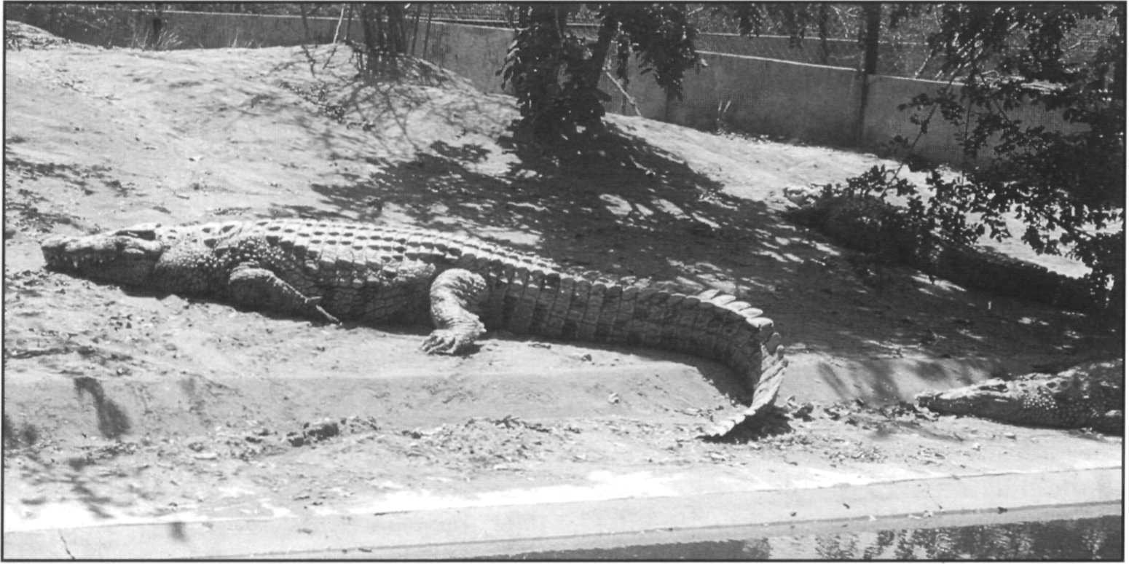Nile crocodile, *Crocodylus niloticus,* Ume, Zimbabwe.

P. Ross

Sudan reverted to Appendix I status in 1994 following its failure to develop a successful ranching program. The direct cropping of crocodiles is discouraged under CITES ranching criteria, but still exists in Malawi, Tanzania and Mozambique. Cropping of crocodiles is still legal in other African nations (Sudan, Chad, Sierra Leone, Togo, Cameroon, Congo, Dem. Rep. Congo), but legal exports under CITES are not permitted.

No central or west and central African countries have implemented sustainable management programs as yet.

### Priority projects

##### High priority

**Surveys of wild crocodile populations in western and central Africa:** Survey data are urgently needed for this region, not only for Nile crocodiles but also for the two other African crocodilians, *Crocodylus cataphractus* and *Osteolaemus tetraspis.* Country by country surveys of crocodile status and distribution are a prerequisite for developing conservation and management programs. Of particular interest are the major river systems and wetlands where substantial populations may remain e.g. the Congo- Ubangi system (Dem. Rep. Congo and Congo), Ogooe (Gabon), Niger-Benue (Nigeria), the Volta system (Ghana), and the Bahr Salamat-Chari system (Chad).

##### Moderate priority

Development and implementation of management programs for those countries planning sustainable utilization: A

number of African nations are developing fledgling management programs based on sustainable harvesting. Population surveys and monitoring, training and program support are needed to foster these programs. A recent prioritization of countries to receive such support listed: Kenya, Tanzania, Sudan, Ethiopia, Somalia, and Congo (Hutton 1990).

Hutton (1990) outlines priority areas that need to be addressed for the development of sustainable use programs in these countries:

1. Pre-feasibility studies (e.g. harvest potential).

Policy and legislation to provide the management

1. framework.

Feasibility studies (identification of potential

1. production sites, evaluation and quantification of factors inherent in sustainable use programs).
2. International requirements for trade (CITES submissions, documentation and tagging of hides).
3. Population census and monitoring (technical support and training).
4. Technical support for developing ranching/farming programs.
5. Marketing.

**Comparative studies of population dynamics:** The development of good management programs should include a significant research program. Sustainable management offers tremendous opportunities for collecting ecological data. Information on population dynamics is valuable from an empirical standpoint, and also for the improvement ofthe management program. A considerable amount of ecological research has been done in east Africa, but long-term comparative studies need to be established in different parts of the continent.

## Crocodylusnovaeguineae

**Common names:** New Guinea crocodile, Buaya air tawar, Pukpuk, Wahne huala

**Range:** Indonesia (Irian Jaya only), Papua New Guinea

Revised by Philip M. Hall

**Conservation overview**

**CITES:** Appendix II

CSG Action Plan:

Availability of Survey Data - Adequate

Need for Wild Population Recovery - Moderate Potential for Sustainable Management - Highest

**1996 IUCN Red List.** Not Listed (**LRlc.** Lower Risk, least concern. The species appears to remain abundant in its extensive habitat.)

**Principal threats:** Illegal hunting, habitat disruption.

### Ecology and natural history

The New Guinea crocodile is a medium-sized crocodile found only on the island of New Guinea. Maximum documented adult size is approximately 3m for females and 3.5m for males (Hall 1991b). Recent work (Hall 1989) describes morphological differences in cranial features and squamation between the southern (Papuan) population and northern populations and their putative similarities to the Philippine crocodile, *Crocodylus mindorensis.* This work suggests that the southern population of

*C. novaeguineae* may be a distinct and as yet unnamed taxon. New Guinea crocodiles prefer freshwater habitats, and are found throughout most of New Guinea's vast system of freshwater swamps and marshes.

Females become sexually mature at lengths from 1.6 to 2.0m, and lay eggs in mound nests. The northern population oviposits during the annual dry period, whereas the southern population nests during the wet season. Northern crocodiles also lay larger clutches of smaller eggs than do southern animals. Among northern animals, nests are usually found on floating mats of vegetation, frequently in densely overgrown channels and river tributaries (Cox 1985). Nests in the southern populations are more frequently located on land (Hall and Johnson 1987).

Populations of *C. novaeguineae* have benefited from the large amount of wetlands habitat and the low human population density on the island of New Guinea. Adequate survey data indicate the presence of good populations in both Irian Jaya (Indonesia) and Papua New Guinea. Commercial hunting of this species commenced following World War II and peaked in the 1960s. Management programs have been developed in both countries, and for practical reasons both *C. porosus* and *C. novaeguineae* are subject to the same regulations. The aim ofthe management programs in both countries is to regulate harvests of both wild skins and eggs or hatchlings for ranches at sustainable levels while providing equitable economic incentives to indigenous landowners for retention of the resource.

### Conservation and status

In Papua New Guinea, the recognition of inefficient harvesting led to legislative controls in the late 1960s and the establishment of a regulated program in the 1970s based on cropping and ranching. Crocodiles are managed at sustainable levels for the benefit of traditional land owners who own most of the land in Papua New Guinea. Crocodiles can be legally harvested by land owners for personal use (food and ritual) but commercial sale and export of hides is restricted to the size range of 18-5 lcm belly width, which corresponds to approximately 0.9- 2.1m total length. Wild harvests have declined from in excess of 20,000/year (1977-1980) to 12,000-20,000/year (1981-1989) and are currently 3,000-5,000/ year (Anon 1994a, Solmu 1994). Over the same period, an increasing number of hatchlings and eggs have been collected and raised in centralized ranches, and harvests for this purpose have been in the range of 2,500-10,000 in recent years. Early attempts to establish village level ranches foundered due to technical limitations. Traditional owners now sell crocodile hatchlings and eggs to centralized raising facilities in exchange for cash and chicken eggs. Annual surveys of

nests in a representative area of the Sepik river suggest the population has remained stable since 1981. A very extensive harvest data base exists on this species. Harvest data or skulls of harvested animals are extremely useful for monitoring populations especially in areas where spotlight or aerial surveys are logistically and economically impractical. For detailed analyses see Hall (1990a and b), Hall and Portier (1994) and Solmu (1994). Manolis (1995) recently reviewed the monitoring program in Papua New Guinea and found it basically sound. Recommendations were made to improve the standardization ofdata collection and the availability of trained personnel, to provide timely and pertinent analyses.

A similar management program is now under development in Irian Jaya, Indonesia. Basic surveys and development of egg and hatchling collection systems and ranches was undertaken during an extensive FAO funded project in 1986-1992 (Cox 1992). In the same period, extensive illegal hunting and smuggling of skins was addressed and aggressive enforcement of regulations initiated. At present, crocodile management in Indonesia is undergoing detailed redesign in response to concerns raised by the parties to CITES, CSG and other NGOs (Messel 1993, Thomsen 1993). With the assistance of expert consultancies (Webb and Jenkins 1991) and reviews by CSG teams (Messel, Jelden and Hemley 1992, Messel 1993), a coordinated management plan for both *C. porosus* and *C. novaeguineae* is being developed. Results to date include the formation of a Crocodile Management Task Force in the CITES Management Authority (PHPA), the adoption of enabling legislation for crocodile conservation regulations, the development of a tracking system for both

ranched and wild hides, and the establishment of an interlocking system of licences and permits to regulate collection, movement, trade, ranching, processing and export ofcrocodilian products. In October 1994, Indonesia imposed a suspension of exports of all crocodile products (except personal effects) pending the completion and implementation of the new system.

In both Indonesia and Papua New Guinea, trade of wild skins is subject to an upper size limit, which aims to protect the proportion of the adult breeding population which exceed that size. In Papua New Guinea, trade occurs as salted skins between (18-5 lcm) belly widths. In Indonesia (Irian Jaya) crocodile trade is proposed in animals between (25-5lcm) belly widths, but this applies to wet blue processed skins. Skins shrink during processing by an average of 10%. As a result the Indonesian size limits actually translate to around 28-56cm belly width of raw skins. The effect of this needs to be analysed. Differences in the legal lengths in the two countries in the past, provided the opportunity for avoidance of size controls by illegal transfer across the border. In its 1994 CITES proposal for *C. porosus,* Indonesia proposed bringing the upper size limits for wild skins of both species into concurrence at 5 lcm belly width, although the lower limits remained different. Harvest analysis data from Papua New Guinea suggest that between 40% and 75% of nesting

*C. novaeguineae,* as well as some nesting *C. porosus* are smaller than this size and are thus subject to harvest (Hall 1991 b, Hall and Johnson 1987, Montague 1983,1984, Cox 1985). The smaller lower size limit in Papua New Guinea may be biologically defensible, but it is economically wasteful due to the low prices offered for such size hides.

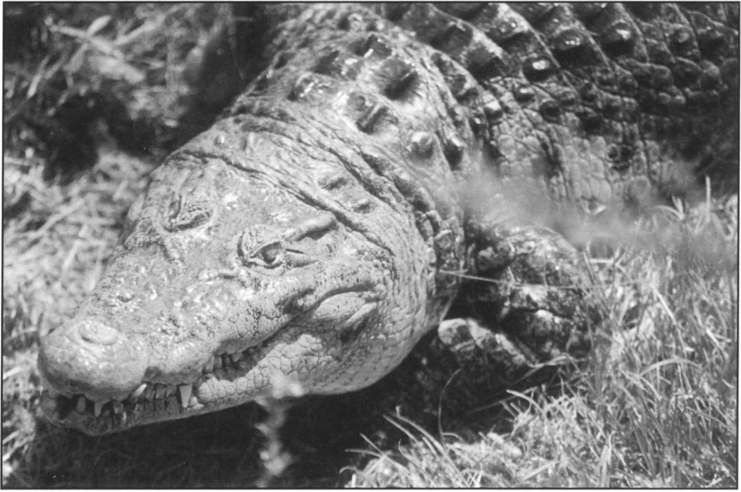New Guinea crocodile, *Crocodylus novaeguineae,* Saint Augustine Alligator Farm, Florida, USA.

B. Shwedick

### Priority projects

##### High priority

**Implementation and enforcement of crocodile management regulations in Indonesia:** An external review of the Indonesian crocodile management program, conducted by Webb and Jenkins (1991a), provided specific guidelines for restructuring the existing program. The recommendations were incorporated into the proposals for crocodile management in Indonesia and form part of the Indonesian proposal for CITES Appendix II listing of its *C. porosus* population. Continued action is needed to develop and implement this program and to assist Indonesia in establishing workable regulatory mechanisms for using its New Guinea crocodile resources.

##### Moderate priority

**Standardize harvest size limits between range states at biologically optimal sizes:** Different size limits for trade in crocodiles remain in the two neighboring range states. Both states should review existing data, conduct any necessary additional studies, and adopt a size limit that ensures sustainable use, protects the breeding stock and encourages sound economic use of the resource.

**Continued population monitoring and analysis of exploited crocodile populations:** Both Indonesia and Papua New Guinea should undertake the collection, collation and analysis of survey data with a view to deriving cost- effective long-term monitoring programs that can be sustained by the government and the industry, and which will determine the extent to which the harvest is sustainable.

***Crocodylus palustris***

**Common names:** Mugger, muggar, marsh crocodile

**Range:** Bangladesh, Iran, India, Nepal, Pakistan, Sri Lanka

**Conservation overview**

**CITES:** Appendix I

CSG Action Plan:

Availability of Survey Data - Poor

Need for Wild Population Recovery - High Potential for Sustainable Management - Moderate

**1996 IUCN Red List: VU** Vulnerable - Criteria: A.1.a. decline of 20% in 3 generations in extent of occurrence.

C.2.a. Wild population less than 2,500 adults and habitat fragmented and declining.

**Principal threats:** Habitat destruction.

### Ecology and natural history

The mugger is a medium-sized crocodile (maximum length ca. 4- 5m), and has the broadest snout of any living member of the genus *Crocodylus.* Muggers are principally restricted to the Indian subcontinent where they may be found in a number of freshwater habitat types including rivers, lakes and marshes. In India and Sri Lanka, mugger crocodiles have adapted well to reservoirs, irrigation canals and man made ponds, and in some areas may even be found in coastal saltwater lagoons (Whitaker 1987, Whitaker and Whitaker 1989). In some areas of northern India and Nepal, mugger populations are sympatric with gharial, but the two species tend to be segregated by habitat. Where found together with gharial, muggers tend to bask in midstream on rocks or muddy banks (Groombridge 1982). This species, like a number of other crocodilians, is known to dig burrows.

Mugger crocodiles are a hole nesting species. As with other hole nesters, egg laying takes place during the annual dry season. Females become sexually mature at a length of approximately 1.8-2m, and lay 25-30 eggs (Whitaker and Whitaker 1989). Nests are located in a wide variety of habitats, and females have even been known to nest at the opening of, or inside, the burrow (B.C. Choudhury, pers.

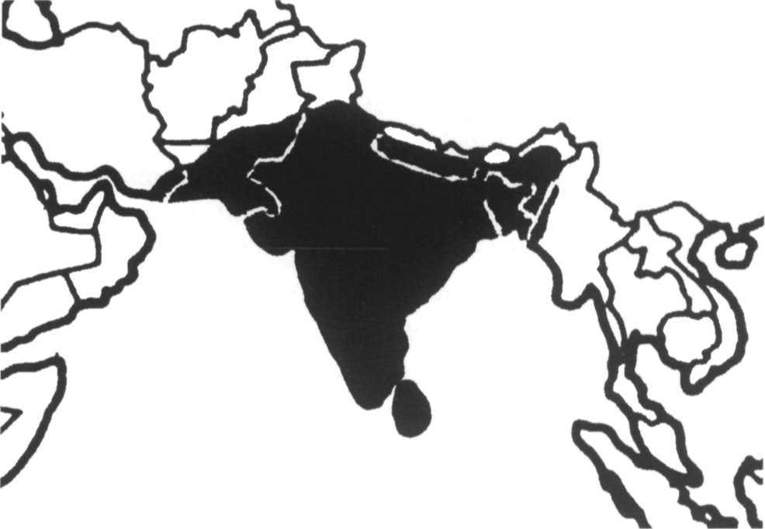

comm.). In captivity, some mugger crocodiles are known to lay two clutches in a single year (Whitaker and Whitaker 1984), but this has not been observed in the wild. Incubation is relatively short, typically lasting 55-75 days (Whitaker 1987). Whitaker and Whitaker (1989) provide a good review of the behavior and ecology of this species.

### Conservation and status

While illegal skin trade was a major problem in the past (1950s-1960s), the current threats to the mugger crocodile are principally habitat destruction, drowning in fish nets, egg predation by people, and the use of crocodile parts for medicinal purposes (Groombridge 1982). Adequate survey data exist only for India and Sri Lanka, and indicate that populations, while generally small and isolated, are widespread. Sri Lanka has the largest remaining wild populations (approx. 2,000 individuals), but they are concentrated in only two National Parks, Wilpattu and Yala (Whitaker and Whitaker 1979). In other areas, muggers are being threatened by rapid agricultural and industrial development (Whitaker and Whitaker 1989). In India, muggers are reported from over 50 locations and the wild population is tentatively estimated at 3,000-5,000 (Anon. 1993b). In Pakistan, the mugger is reported to be extinct in the Punjab province due to alteration ofhabitat (Chaudhury 1993). Small populations are reported in Sind along the Nara Canal, in Khairpur Sanghar and Nawab districts and Haleji lake. These are said to be vulnerable and diminishing. The mugger remains widely distributed in Baluchistan with confirmed locations on the Nari, Hab, Titiani, Hingol and Dasht rivers and Nahang and Kach Kuar. In all cases the populations are of unknown but small size. Approximately 50 individuals are held in captivity in seven facilities and three pairs are breeding. A program is ongoing to obtain mugger from the captive bred stock in India for release into protected habitats. A survey in Nepal was initiated in 1993 (McEachern 1994). Preliminary results indicate that the

mugger is now restricted to isolated populations, primarily in protected habitats. Small numbers of individuals are known or suspected from the Mahakali, Nala, Karnali, Babai, Rapti, Narayani and Koshi river systems. Alienation of habitat by river disruption and damming, and mortality in fisheries are major problems. A recent investigation in Bangladesh (Cox and Rahman 1994) reports the mugger to be extinct in the wild and only six wild derived specimens are kept in captivity. In Iran, muggers are known from the drainages of the Sarbaz (=Dashtiari) and Kajou (=Koja) rivers. Preliminary counts of the main habitat in 1992 revealed at least 118 individuals (Gholi Kami 1994, Gholi Kami and Saghari 1993). Van Dink (1993), reports that the last record of muggers in Myanmar was 1867-68 and that the species is probably extinct there.

Management of mugger crocodiles is based principally on the legal protection of wild populations and captive breeding for restocking. In India, a large-scale captive rearing program was initiated in 1975. The project has collected eggs from the wild, as well as produced young from captive adult breeding stock. The resulting juveniles have been used to restock natural populations in 28 national parks, wildlife reserves and crocodile sanctuaries throughout the country. A total of 1,193 individuals were released between 1978 and 1992. Unfortunately, there has been little improvement in persuading people to live with crocodiles and there is little additional habitat where more muggers can be introduced. Currently there are over 12,000 muggers in captivity. Facing a crisis of overcrowding, the Indian government instructed breeding centers to cease producing new offspring in 1994 and the program is currently at a standstill.

The Indian government has adopted a policy prohibiting any evaluation ofcommercial use ofcaptive bred crocodiles for conservation. The future of the mugger in India is therefore uncertain.

Captive-bred muggers, *Crocodylus palusths,* at Madras Crocodile Bank, India. Shortage of locations for wild release is causing crowding in captive rearing facilities.

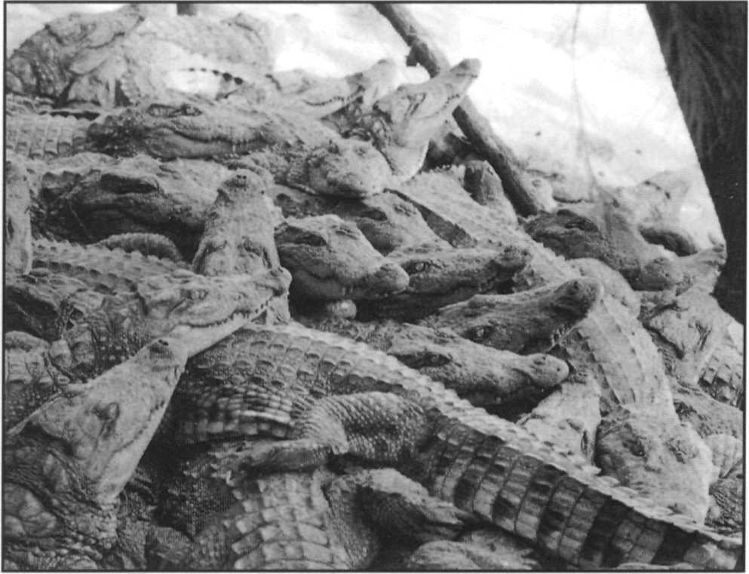

### Priority projects

##### High priority

**Determination of the status of restocked muggers in India:** No single agency is responsible for tracking the success of restocking activities. The current crisis of overstocking in captive breeding centers and uncertainty on the success of restocking remains an impediment to developing a coherent new strategy to meet current needs. Ongoing studies on survival, growth and population size at restocked locations are needed.

**Establishment of a conservation / management program in Pakistan:** Recent reports suggest that mugger crocodile populations in Pakistan remain viable after being severely depleted by commercial hunting. However, no formal surveys have been conducted, and in some parts of the country continued killing has been reported. Interest has been expressed in initiating a restocking program similar to the one in India. However, surveys of population status and a biological research program are a prerequisite to establishing a management program.

**Conservation and management in Sri Lanka:** Since the surveys by Whitaker and Whitaker (1979) no work has been done in Sri Lanka, which at that time had the best remaining wild mugger populations. New surveys **are** required to reassess the current status of the species, and are needed as a prerequisite to developing a conservation program.

##### Moderate priority

**Expansion of restocking program in India:** Restocking efforts have declined in recent years, in part due to a lack of suitable release sites. This has been attributed to the lack of field investigations and positive public-relations programs (Whitaker and Whitaker 1989). In some areas local opposition to crocodile releases has blocked restocking proposals. New areas appropriate for crocodile releases need to be identified and included in the crocodile reserve system. Appropriate public relations efforts also need to be undertaken to ameliorate local opposition based on misinformation concerning crocodiles.

**Potential for sustainable management in India:** The surplus of captive animals and recent human-crocodile conflicts have made the sustainable utilization (ranching or farming) of this species a potential alternative management strategy. The feasibility of limited commercial utilization needs to be examined as a means to invigorate the Indian crocodile conservation program.

H. Andrews

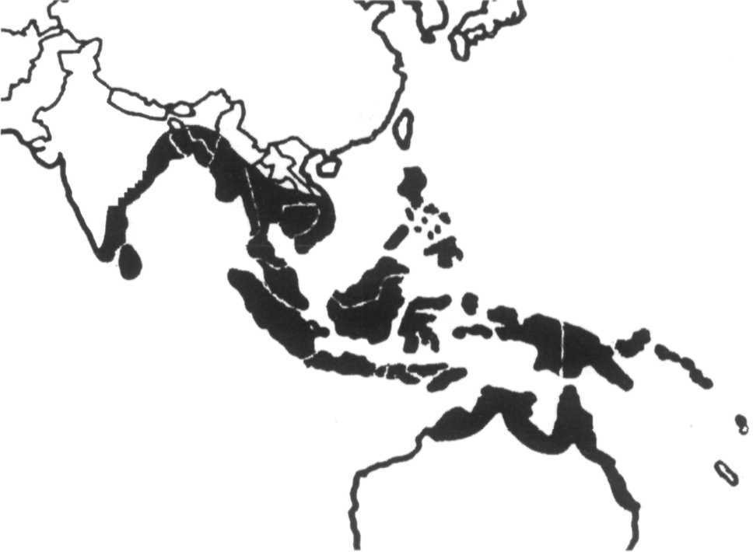***Crocodylus porosus***

**Common names:** Saltwater crocodile, salty, estuarine crocodile, Indo-Pacific crocodile, Buaya muara (Indonesia), Baya, Pukpuk, Kone huala (Papua New Guinea), Jara Kaenumkem (Thailand)

**Range:** Australia, Bangladesh, Brunei, Cambodia, China, India, Indonesia, Malaysia, Myanmar, Palau, Papua New Guinea, Philippines, Seychelles (extinct), Singapore, Sri Lanka, Solomon Islands, Thailand, Vanuatu, Vietnam

**Conservation overview**

**CITES:** Appendix II in Australia and Papua New Guinea Appendix II in Indonesia (Ranching 3.15 with special conditions)

Appendix I in all other countries

CSG Action Plan:

Availability of Survey Data - Variable, Good in Australia and Papua New Guinea, Poor and Extremely poor elsewhere

Need for Wild Population Recovery - High Potential for Sustainable Management - High

**1996 IUCN Red List:** Not Listed **(LRlc** Lower Risk, least concern. Total numbers tens of thousands, numerous localities and extensive range. Population seriously depleted in much of range but secure in Australia and New Guinea.)

**Principal threats:** Illegal hunting, habitat destruction.

### Ecology and natural nistory

The saltwater crocodile, along with the gharial, is the largest of the living crocodilians, with reported lengths of up to 6-7m. Noted for its large size and fierce disposition, the saltwater crocodile has a reputation as a man-eater. Saltwater crocodiles are the most widely distributed of the crocodilians, ranging from southern India and Sri Lanka, throughout southeast Asia and the Indo-Malay Archipelago, to the Philippines, New Guinea and northern Australia. Isolated populations are also known from the Solomon Islands, the Banks Islands (Vanuatu) and on Palau (Caroline Islands).

A great deal of ecological work has been done on this crocodile in Australia and New Guinea. As the common name implies, in many areas this species is found in coastal brackish water habitats and the tidal sections of rivers. However, the saltwater crocodile is also well known from the freshwater sections of rivers, and also

frequents inland lakes, swamps and marshes (Webb *et al.* 1987, Messel and Vorlicek 1989).

In the tidal waterways of northern Australia the movement of crocodiles between river systems appears to be related to ontogenetic changes in social status as well as the nature of the river's salinity profile (Messel *et al.* 1981). Breeding and recruitment take place principally in rivers with significant freshwater input, or in freshwater swamps. As crocodiles grow they encounter larger territorial animals, and many sub-adult crocodiles appear to be excluded from the breeding areas and are forced to occupy marginal habitats such as higher salinity rivers. Mortality among these intermediate-sized crocodiles also appears to be very high.

Females become mature at lengths of approximately 2.2-2.5m (about 12 years of age) and make mound nests during the annual rainy period (Webb *et al.* 1987). Clutch size is typically 40-60 and incubation normally lasts some 90 days. Nesting is a wet season activity and in northern Australia loss of nests due to flooding is very high. Nest predators include monitor lizards and humans.

### Conservation and status

The saltwater crocodile presents a number of challenging problems for the development of conservation programs. It is widely distributed over a vast area including thousands of islands where status and trade are difficult to monitor or control. The saltwater crocodile has the most commercially valuable hide of any crocodilian. Habitat loss associated with coastal development and intensive hide-hunting (from the late 1940s through the 1970s) depleted populations throughout much of the species' range. Habitat loss continues to be a major problem, and illegal hunting also persists in some areas. Several surveys were conducted in recent years and at least basic survey data are available from 12 countries.

In India, saltwater crocodiles only remain in the northeastern coastal region, and in the Andaman Islands. A restocking program in the Bhitarkanika National Park in Orissa has been quite successful, with over 1,400 crocodiles released by 1993. Surveys in 1994 indicated at least 580 surviving individuals. This population is recovering under active management and protection (Kar 1994). In the Andamans, crocodiles are widely distributed but restricted by the limited areas of freshwater swamp for breeding. Human occupation of these sites is displacing crocodiles (Andrews and Whitaker 1994). The total population of this species in India is estimated at 1,000 (Anon. 1993b). The recent situation in Sri Lanka is considered very serious as there are no conservation or management programs in place.

In Bangladesh, saltwater crocodiles are reported to remain in the Sunderbans (the Ganges delta) (Cox and Rahman 1994).

In Myanmar, (Burma) an unpublished survey by Caughley in 1982 (cited in Aung Moe 1994) estimated 4,000 saltwater crocodiles, mainly in the Irrawaddy delta and in the vicinity of Bogale (=Dalla) river. No recent surveys have been carried out and the surviving number is thought to be less now. A crocodile farm established in 1979 maintains approximately 50 male and 70 female breeders and produces over 1,000 eggs each year. Crocodiles are reported to be exported to Thailand (Aung Moe 1994). An unpublished WWF report identifies crocodile localities at Meinmahal Island, the Arakan and Tenasserim coasts and the Megui Archipelago, all in the Irrawaddy (=Ayarwaddy) delta, which seems to be the remaining stronghold of the species in Myanmar (Van Dink 1993). Recent crocodile surveys in Thailand (Ratankorn, Amget and Otley 1994) revealed recent sightings of one or two *C. porosus* on Phuket island but the majority of the suitable habitat in this area has been destroyed or occupied by people and no viable population is thought to persist. Some isolated sections of coastal mangrove habitat may support a remnant population but confirmation by surveys

is needed.

Preliminary reports from Cambodia (Thuok and Tang 1994) suggest the species may still occur in small numbers there, although no quantitative estimates or localities were specified and the reports do not clearly differentiate between *C. porosus* and *C. siamensis.*

Saltwater crocodiles persisted in southern Vietnam and the Mekong delta until 10 or 20 years ago but recent extensive habitat degradation and direct killing of crocodiles has greatly reduced the population and no more than 100 are thought to survive in the wild (Cuc 1994). Although crocodiles are legally protected, illegal killing is widespread.

In Peninsular Malaysia, the saltwater crocodile is now considered rare. Sebastian (1993) lists 10 localities where crocodiles have been reported and suggests that the Setui-

Chalok-Bari basin on the east coast near Trengannu may hold a significant population. In Sabah, *C. porosus* is reported to be common in the Kinabatangan River and associated wetlands. Stuebing and Mohammed Sah (1992) conducted extensive surveys on the Klias river and found a small but viable population of around 50 individuals that appears to be flourishing. In Sarawak, crocodiles occur in most major rivers and large individuals are sufficiently common to be considered a serious threat to people. In May of 1992, a notorious maneater, the 'Bujang Senang', was killed after a 30-year career in which it is said to have eaten 13 people. The animal measured 5.5m in length and weighed more than 900kg (Richie and Johnson Jong 1993). However, earlier surveys (Cox and Gombek 1985) found uniformly low densities of crocodiles throughout Sabah and Sarawak.

In the Philippines, survey information was collected by the Crocodile Farming Institute. Saltwater crocodile populations and habitats are greatly reduced throughout the Philippines and no large populations are known (Ortega *et al.* 1994). Remaining crocodiles appear to distributed as single individuals and small groups scattered through the remaining habitat. Particular areas of distribution include the island of Mindanao, the Liguasan swamp area, and numerous small rivers around Palawan and northeastern Luzon. Crocodiles have also been recently sighted or captured from Siargo, Negros, Bohol, and Panay (Ortega and Regoniel 1993). On Palawan, the majority of wild adults (141 individuals) are thought to have been caught and moved to the CFI farm where they form the nucleus of a captive population for breeding efforts for commercial use and restocking.

Despite an extensive survey program conducted by FAO and PHPA there is still no reliable estimate of saltwater crocodile populations in Indonesia. The complex geography ofthe nation makes such a count both extremely difficult and of marginal relevance to conservation. The species is thought to be significantly reduced from historic levels but probably occurs in suitable wetlands on most of the major islands. However, high human densities and past exploitation may have reduced these to remnants in many areas. In the 1994 CITES proposal, 38 protected wetland areas throughout the archipelago were listed where the species is present. Other important localities are the northern swamps of Sumatra and the extensive rivers and lowlands of Kalimantan (Borneo). The species is also widespread in Irian Jaya, particularly in the Mamberano drainage in the north. Standard spotlight surveys in Irian Jaya, Sumatra and Kalimantan have generally shown low counts, but these are thought to be the result of difficult survey conditions rather than low density (Cox 1992). Crocodile conservation and management in Indonesia is undergoing rapid development (Webb and Jenkins 1991a). A system based on cropping and ranching wild eggs, similar to that of Papua New

Guinea, is proposed for Irian Jaya, while captive breeding is proposed elsewhere. Persistence of wild populations outside Irian Jaya will probably be dependent on the effectiveness of protected areas. Approximately 20,000 *C. porosus* are housed on private farms. A combination of licences and permits, harvest regulations (including size limits compatible with the program in Papua New Guinea), internal and international trade controls, and export quotas has been proposed. The Indonesian population of *C. porosus* was approved for listing on Appendix II ranching in 1994. Export quotas remained zero contingent upon implementation of the proposed management scheme, which was achieved in 1997.

*C. porosus* is widely distributed throughout the lowlands of Papua New Guinea and also occurs on New Britain, New Ireland and Manus. A ranching and management program has included regular surveys of representative habitats since 1977. Nesting indices indicate that the population is approximately stable, although showing some reduction (7-12%) in the most recent years (Solmu 1994). However, index levels remain above the baseline levels set in the early 1980s. A review of survey results conducted in early 1995 concluded that the number of nests in the survey areas was steadily increasing (Manolis 1995). Combined harvest levels of eggs, hatchlings and wild skins (another index of population trends) have fluctuated around 5,000 per year since 1990. The Papua New Guinean management system, involving a combination of wild cropping, egg and hatchling harvest and ranching, appears to be maintaining the crocodile population. Residual concerns remain about the unknown extent or effect of habitat disruption and pollution (for example by upstream lumbering and gold mining) and the status of isolated populations in eastern Papua New Guinea and the offshore islands. Given the very large area of inaccessible and undeveloped habitat (in excess of 50,000km2) and the incentives for local traditional landowners to maintain crocodiles, the species seems secure in Papua New Guinea.

Surveys by Messel and colleagues established the baseline for crocodilian management and recovery in Australia (Messel *et al.* 1978-1987). Australia has undertaken a major development of its crocodile management strategy with transfer of the Australian population in 1994 to Appendix II under the Berne Criteria (Anon. 1994d). In the Northern Territory, surveys conducted annually since the early 1970s indicate continuing population recovery despite high levels of the removal of eggs for sustainable use programs. Total population and population size and age structures are thought to be approaching pre-exploitation levels (Webb *et al.* 1994). A sustainable use program based on ranching of wild collected eggs forms the basis of management,

combined with an aggressive program of problem crocodile removal and public education to reduce conflicts with people. In Queensland, heavy occupation by people of the eastern coastal lowlands has reduced crocodile populations, and in recent years problem crocodiles have been removed to farms. However, substantial populations remain in northern and western Cape York Peninsular and Princess Charlotte Bay. Surveys are underway to assess population numbers and a conservation plan has been prepared to maintain populations in protected areas (Anon. 1994c). In Western Australia, major populations in the northwest are in protected areas and small scale use by native peoples occurs. There are three farms supported by captive breeding, ranching eggs and problem animal removal. Australia seems sure to be the major stronghold of the species into the future.

A crocodile survey of the Solomon Islands was conducted in 1989 (Messel and King 1990). Suitable habitat is restricted by the terrain and further reduced by human occupation and agriculture. Three localities, Lauvi lagoon (Guadacanal), Lake Tatae (Russells Is.) and Ghahirahobo (Santa Isabel) support small populations with widely scattered stragglers occurring elsewhere. Total number of non-hatchling crocodiles is in the order of

200. Twelve 'farms' hold a total of 131 captive crocodiles, but none of the farms are set up for captive breeding. Crocodiles in the Solomons were greatly depleted by hunting for skins up until 1989 and continue to be killed by local people who consider crocodiles vermin. Recommendations for complete protection and continued monitoring were made.

Palau (Caroline Islands) supported extensive exports of crocodile skins between 1965 and 1981. In 1991, Messel and King conducted a survey and investigated historical and local records concerning which species were present (Messel and King 1992a). They concluded that there is no historical or biological support for the presence of any species on Palau except *Crocodylusporosus* (Messel and King 1991). Night surveys revealed 42 crocodiles in 112km of surveyed waterway, concentrated in two small populations at North Estuary on Belilou and Ngerdok Lake, Babeldaob. Additional small groups and single sightings were made at Ngeremeduu Bay, Kadebel river, Irur and Iwekei rivers (Babeldaob) and in the Rock Islands. The species is nearing extinction on Palau following a prolonged eradication program through the 1960s into the 1980s. Total population is probably less than 150 and no evidence of recent breeding was seen. A recovery plan has been drafted by the US Fisheries and Wildlife Service proposing the acquisition of critical habitat, protecting breeding areas, increased enforcement to prevent crocodile killing and the establishment of a public education program (Brazaitis 1994).

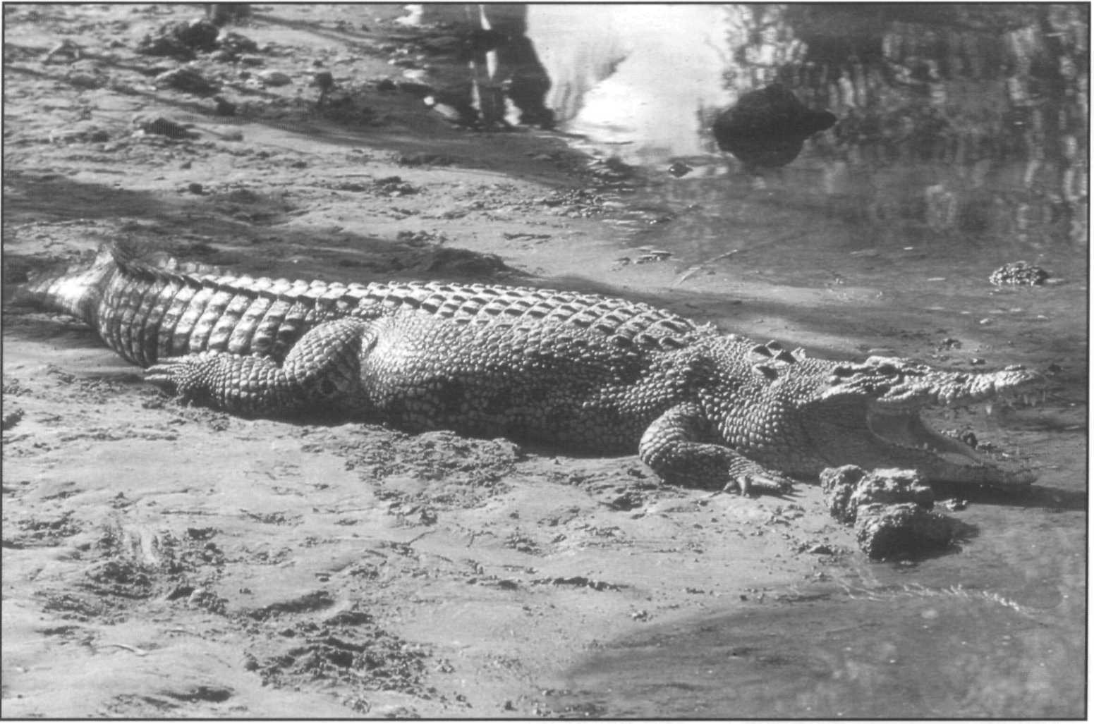Saltwater crocodile, *Crocodylus porosus,* Northern Territory, Australia. In Australia this species has recovered substantially from earlier exploitation and is the subject of an intensive monitoring, management and use program.

The eastern-most population of *C. porosus* is recorded from eastern Vanua Lava in Vanuatu (New Hebrides and Banks Islands). The locality was surveyed in 1992 by Messel and King (1992b), who concluded that crocodiles were on the verge of extinction there. Only two adult crocodiles were seen in the wild and the population is no longer breeding.

D. Jelden

Stray saltwater crocodiles have been encountered far distant from their normal range. Takashima (1955) reports three crocodiles from Japanese territory; one from Iwo Jima (in 1744), one from Amami-Oshima at the northern end of the Ryukyu Islands (in 1800), and a third from Toyama Bay, on the main Japanese island of Honshu. All three were presumably specimens of *C. porosus. A* vagrant was recently reported on Nauru Island (Webb 1994). Re- examination of skeletal material from the Seychelles suggests that the crocodile that occurred there at the time of European discovery, and subsequently extirpated by the 1800s, was *C. porosus* and not *C. niloticus* as previously assumed (Gerlach and Canning 1993). The continued presence of *C. porosus* in southern China remains to be verified.

Populations of the saltwater crocodile are legally protected in most countries, but this protection is often ineffective. Sustainable utilization management programs have been successfully implemented in Papua New Guinea and Australia. The establishment of the management program in Papua New Guinea was a milestone in crocodilian conservation, and a similar project is now being attempted in Indonesia. In both countries, utilization is based principally on the direct cropping of wild animals, but ranching forms an important and growing component. Farming of

*C. porosus* is being done on a large scale in Thailand and Australia, and on a smaller scale in Papua New Guinea. Farms are also under development in Cambodia, Vietnam and Lao PDR.

As a species, the saltwater crocodile is most unlikely to become extinct due to the large populations, extensive habitat and effective management and protection in Australia, Papua New Guinea and possibly Indonesia. However, if present trends continue it seems likely to disappear or become extremely rare throughout the remainder of its range, perhaps persisting only in small protected pockets like Sarawak and the Bhitarkanika Preserve in India. It is ironic and possibly instructive, that in the countries where the species is heavily, but sustainably used, it is secure, but in the countries where it is completely, but ineffectively, protected, it may disappear.

### Priority projects

##### High priority

**Population censuses in unsurveyed countries:** Quantitative information on the status of *C. porosus* populations is lacking for many countries where this species occurs, and within most of the other countries large areas remain unsurveyed. Population surveys need to be conducted in Burma, Cambodia, peninsular Malaysia, Vietnam, Brunei, Sri Lanka, Philippines. Follow up surveys and monitoring, in association with conservation and management programs should be developed for Thailand, Indonesia, Sabah and Sarawak.

**Implementation of the Indonesian management program:** A sustainable utilization management program is currently being set up by Indonesian wildlife personnel with assistance from the CSG. A crocodile monitoring program is being established and technical support for ranching and farming activities is being offered. Five main points need to be addressed:

1. Implementation of the management and regulatory program and trade control.
2. Population monitoring in areas already censused and initiation of surveys in new areas, including identification of principal nesting habitats.
3. Licensing and reporting ofcaptive breeding operations.
4. Implementation of a conservation awareness campaign at the village level.
5. Protection of remnant populations in protected wetlands outside Irian Jaya.

**Establishment of management and conservation programs in Cambodia and Vietnam:** The close association of the production and trade in crocodilian products between Cambodia, Vietnam and Thailand suggests that management, conservation and regulatory activities need to be coordinated in the Indo-Chinese region. Thailand is well advanced in practical husbandry development and has already invested in farm development in the other countries. Technical exchange for training programs,

surveys, management plan development and mutually supporting regulatory structures are recommended.

##### Moderate priority

**Indian management program:** As with the mugger crocodile, the saltwater crocodile captive breeding program has been a victim of its own success. Evaluation of restocking and identification of additional release sites need to be included in the crocodile conservation program to relieve some of the excess of animals that are now in captivity. A program needs to be developed to deal with "nuisance" crocodiles in the Bhitarkanika Park and other areas.

**Development of sustainable management programs in Malaysia:** Whitaker (1984) recommended the establishment of a conservation program based on Sustainable Use for East Malaysia (Sabah in particular). The program would be based on the establishment of a government demonstration ranch, the encouragement of private sector involvement in ranching, establishment of an egg collecting/nest monitoring program involving local villagers, the trapping of nuisance crocodiles for farm breeding stock, the protection of crocodile breeding habitat, and a public education program.

## Crocodylus rhombifer

**Common names:** Cuban crocodile, Cocodrilo, Criollo, Cocodrilo perla

**Range:** Cuba, Cayman Islands (extinct)

**Conservation overview**

**CITES:** Appendix I (Registered captive breeding facility)

CSG Action Plan:

Availability of Survey Data - Adequate

Need for Wild Population Recovery - Highest Potential for Sustainable Management - Moderate

**1996 IUCN Red List: EN** Endangered - Criteria A.1.c. and e declines of >80% in 3 generations in extent of occurrence, possible effects of hybridization. B.1 and 2c area of occupancy less than 500km2, single location.

**Principal threats:** Limited distribution, Habitat destruction, Introduced exotics.

### Ecology and natural history

The Cuban crocodile has the smallest known natural distribution of any extant crocodilian. Its present distribution is restricted to the Zapata Swamp in southwestern Cuba. The persistence of a small remnant population in the Lanier Swamp on the Isle of Pines (Isla de Juventud) is unconfirmed. However, in the recent past this species was more widely distributed on the main island of Cuba (Varona 1966). Skeletal material shows that this species was found on the Cayman Islands into historic times (Morgan *et al.* 1993) and in the Bahamas (Franz *et al.* 1995).

The Cuban crocodile is a medium-sized species whose maximum reported length is 4.9m, but normally does not exceed 3.5m (Varona 1966). This species is normally restricted to freshwater habitats. The Zapata swamp, currently supporting the species' only known wild population, is an extensive freshwater marsh not unlike the Everglades region in southern Florida, USA.

Although the Cuban crocodile is smaller than the American crocodile, when maintained together the Cuban crocodile is almost always the behaviorally dominant species (Varona 1966). The Cuban crocodile has a

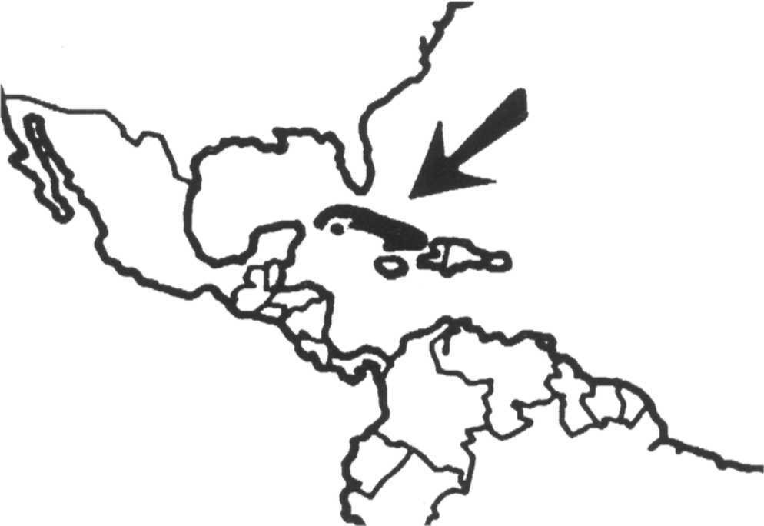

pugnacious disposition and a well-deserved reputation as a good jumper.

Some confusion has existed over the nesting mode for this species. Varona (1986) states that nests consist of holes excavated into the substrate, usually peat or soil with plants mixed in. However, in captivity this species usually constructs mound nests, which are also reported from the wild. Clutch size is typically 30-40 eggs.

Hybridization of this species with *C. acutus* have been reported under captive conditions in Cuba, and it may occur in the wild as well (Varona 1966, Ramos *et al.* 1994). Reproductive activity of *C. rhombifer* occurs one to two months later than the sympatric *C. acutus,* restricting hybridization to occasional contacts between *C. acutus* males and *C. rhombifer* females (Ramos, pers comm.). Hybrids are also known from *C. rhombifer* males and

*C. siamensis* females in captivity (Thang 1994). Hybrids are thought to be fertile.

### Conservation and status

Reduction of the species' distribution is evident. At one time the Cuban crocodile was more widely distributed on Cuba and surrounding islands. Today, its range in the wild appears to be restricted to the Zapata Swamp. Cuban crocodiles were, until recently, also found in the Lanier Swamp on the Isle of Pines. However, this population is reported to be extirpated, with the introduction of the common caiman possibly playing a significant role. A survey in the Zapata swamp (Ramos *et al.* 1994) used mark and recapture methods to estimate population densities of 11-104 individuals per km2. Total population in the wild is thought to be in the order of 3,000-6,000 individuals in an area of 300km2 in the southwestern part of the Zapata swamp. Reports from as early as 1982 (Chabreck 1982) indicated substantial recovery of this population which is confirmed by the recent survey. Active measures are underway to ensure that this population

remains well protected. Despite recent reassuring information on the status of this species in the wild it remains extremely vulnerable due to its restricted distribution. Wild populations have been greatly reduced and little is known of the species' behavior and ecology.

In 1959 and 1960, several hundred adults were collected and placed in pens with the objective of both conserving the species and developing commercial use. The largest farm, at Laguna del Tesoro, has about 1,500 breeding adults and produces 1,000-1,500 captive bred offspring annually. When the crocodiles were first placed in the pens in 1959, *C. rhombifer* were mixed with *C. acutus.* This resulted in hybridization between the two species. Since 1976, the two species have been separated and a stock of pure *C. rhombifer* has been isolated. The degree of genetic introgression remaining in the captive Cuban stock remains unknown. A second farm at Cayo Potrero on Isla de Juventud has 40 breeding stock obtained from the Laguna Tesoro farm but is not yet producing offspring. Products from the farms are meat for local consumption and culled juveniles for a taxidermy industry providing curios to the tourist trade. With the approval of the Laguna Tesoro farm as a captive breeding facility under CITES in 1994, international trade in skins from captive bred Cuban crocodiles has been initiated.

In 1985, 107 Cuban crocodiles were sent as a gift from Cuba to the Government of Vietnam. Four ofthe crocodiles were adult size and the remainder approximately 1 year old. Two of the juveniles died in transit and the remainder were distributed to several government organizations (zoos and forestry departments) throughout the country. By 1994, approximately half of the crocodiles were known to have died. Of the remainder, a number of adults have been

bred with *C. siamensis* and approximately 100 hybrids are thought to be in captivity at present. Discussions are underway to bring all *C. rhombifer* and hybrids together at one location and minimize the risk of releasing them to the wild (Thang 1994).

A captive breeding program and studbook involving 54 captive Cuban crocodiles (16.27.11) in the USA is coordinated by the American Zoo and Aquarium Association (AZA) (McMahan 1993).

### Priority projects

##### High priority

**Protection of the wild population in the Zapata Swamp:** The restricted area occupied by Cuban crocodiles needs to be given effective protection to ensure the survival of the species in the wild.

**Establishment of alternative wild populations:** Because of its limited distribution, the establishment of additional wild populations as insurance against unanticipated natural or human induced catastrophe is needed.

**Status of the Cuban crocodile in the Lanier Swamp, Isla de Juventud:** Until recently, Cuban crocodiles were also found in the Lanier Swamp. Recent reports suggest they have been extirpated, and that the introduction of the common caiman played a significant role. Surveys need to be conducted to determine the status of crocodilian populations on this island and plan active management alternatives, such as the reintroduction of Cuban crocodiles.

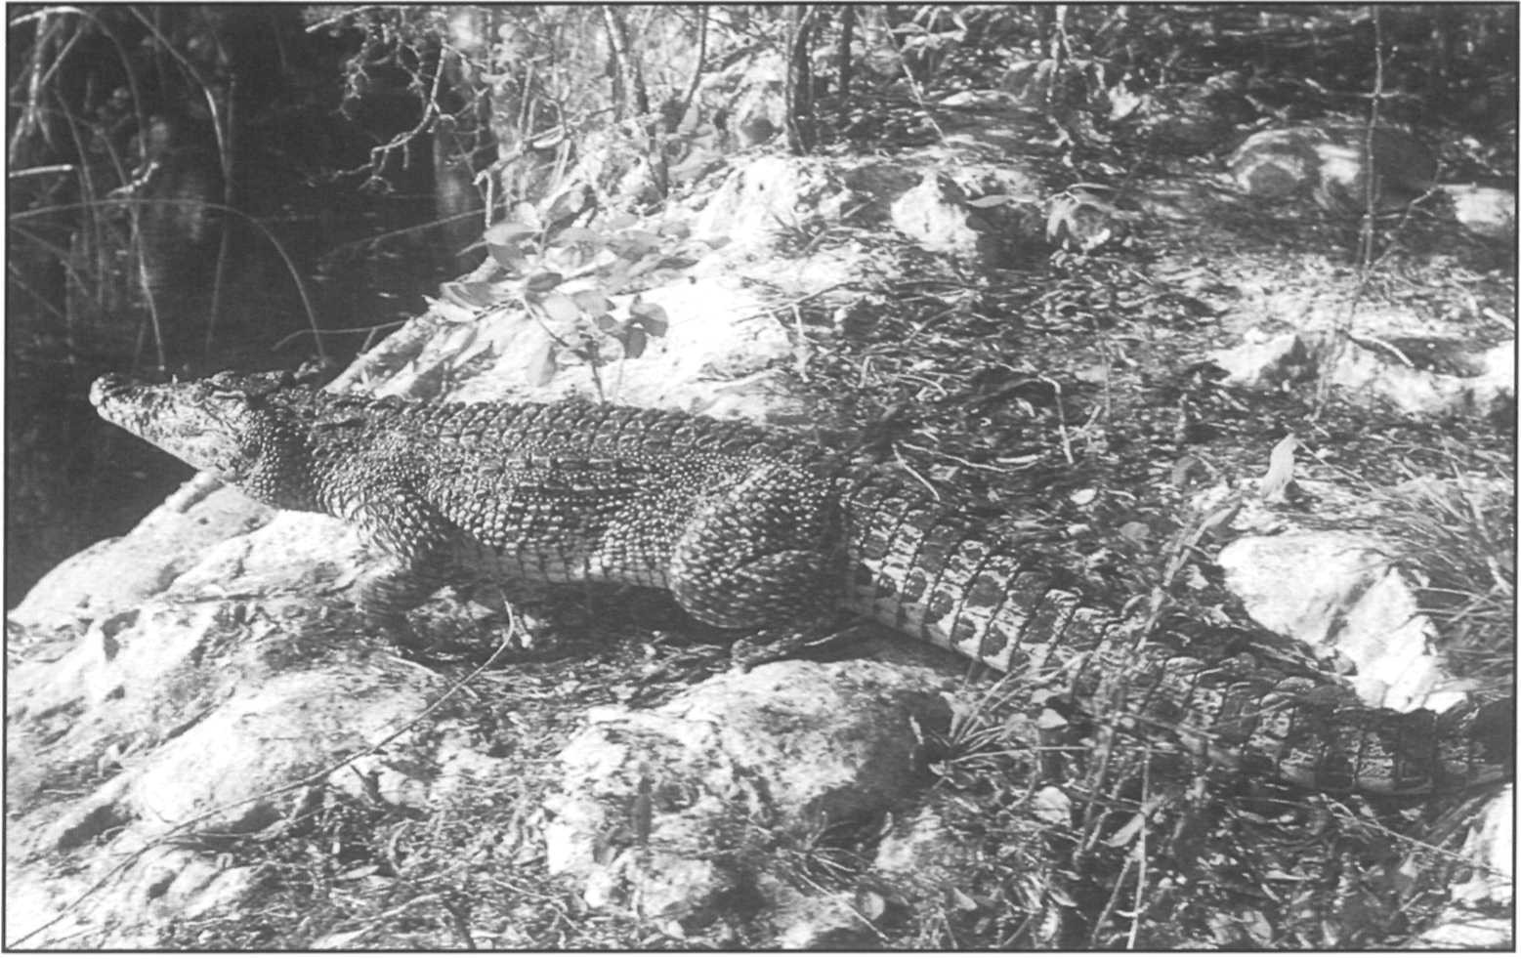Cuban crocodile, *Crocodylus rhombifer,* Lanier Swamp, Isla de Juventud, Cuba. An individual released from the farm for restocking the wild population.

P. Ross

##### Moderate priority

**Ecological interactions between Cuban crocodiles and the introduced *Caiman crocodilus* in the Lanier Swamp:** The introduction ofthe common caiman into the Lanier Swamp is thought to have played an important role in the apparent extirpation of *C. rhombifer* from this area. If any Cuban crocodiles remain in the swamp, investigations of caiman- crocodile interactions should be undertaken.

**Monitoring of the population:** A program of regular annual monitoring of the wild *C. rhombifer* population should be developed from the current Cuban field research activities.

This program should concentrate on repeatable standard methods that will provide data on the year to year trends of the population. Standardization of the locations, survey transects, days worked, and techniques applied will all improve the quantitative and comparable quality of the results.

**Coordination of captive breeding programs:** Three independent captive populations exist in Cuba, in the USA and in Vietnam. Assessment of the severity of introgression by hybridization and coordination to ensure optimum genetic diversity in the captive stock is needed.

## Crocodylus siamensis

**Common names:** Siamese crocodile, Buaya

kodok (Indonesia), Jara Kaenumchued (Thailand)

**Range:** Thailand, Cambodia, Vietnam, Indonesia, Lao PDR, Malaysia (Sabah, Sarawak)

**Conservation overview**

**CITES:** Appendix I

CSG Action Plan:

Availability of Survey Data - Poor

Need for Wild Population Recovery - Highest Potential for Sustainable Management - High

**1996 IUCN Red List: CR** Critically Endangered. Criteria

A.1.a. and c. severe decline in numbers and area >80% decline in three generations.

**Principal threats:** Habitat destruction, illegal hunting.

### Ecology and natural history

The ecology of the Siamese crocodile in the wild is virtually unknown. According to Smith (1919, 1931), the preferred habitat of this species is freshwater swamps and slow- moving sections of streams and rivers, but it was also found in lakes and rivers. Maximum size of males has been reported to be up to 4m, but most individuals do not exceed 3m. All our information on reproduction in this species has come from captive individuals. Females construct a mound nest during the annual wet season and lay 20-50 eggs (Youngprapakorn *et al.* 1971). Recent information is available on the chromosome number of

*C. siamensis* and hybrids with *C. porosus* (Youngprapakorn 1991, Chavananikul *et al.* 1994), and seasonal sperm cycles (Kitiyanant *et al.* 1994).

### Conservation and status

The Siamese crocodile was regarded as one of the world's most endangered crocodilians and was reported in 1992 as virtually extinct in the wild. Following the identification of this species as the highest priority for conservation action, considerable new information on its present distribution was collected. However, quantitative

assessments of its status in the wild are still completely lacking.

In Thailand, a survey conducted in November 1993 confirmed the presence of at least one wild adult

*C. siamensis* in Pang Sida National Park and another in Ang Lue Nai Wildlife Sanctuary (Ratanakorn *et al.* 1994). Both of these individuals are reported to live in small areas of suboptimal habitat. Indirect indications (tracks and slides) of other single specimens are reported at Yod Dome and Sanam Chai Kate (Kreetiyutanont 1993, Ratanakorn and Leelapatra 1994). The remnant population formerly reported in Bung Borapet is apparently extirpated due to illegal capture for farms and mortality in net fisheries, although there are plans by the Royal Thai Forest Service and Department of Fisheries to restock a seminatural captive population there. The status of *C. siamensis* in Thailand therefore appears to be reduced to non-breeding remnants in marginal habitats and it is almost extinct in the wild.

Reports on trade of small Siamese crocodiles into Thailand from Cambodia (Frazier 1991, Chea and Ratanakorn 1993) prompted further contacts and investigations which were facilitated by the improved political situation in Cambodia. Thuok and Tana (1994), report 14 localities in Cambodia where crocodiles (presumed to be mostly *C. siamensis)* are found, and indicate that there are 172 'farms' producing over 10,000 hatchlings per year. Wild crocodiles are reported to be diminishing their range and numbers due to human disturbance and habitat occupation, and to be restricted to inaccessible swamps in the hinterland. Particular concentrations are said to occur in flooded forests near Battambang and Siem Reap around the Tonle Sap (Great Lake), in the vicinity of Stung Treng on the upper Mekong, and in Preach Vihea swamp near Tbang Mean Chey on the upper Sen river. Populations of wild individuals were estimated to be from 50-300 up to 1,000-4,000 at specific locations, although the basis for these estimates is not given and they require confirmation.

In Lao PDR, Siamese crocodiles are said to still occur in a number of locations along the Mekong, but population levels are low and crocodiles have disappeared from several areas (Sawathvong 1994). Based on interviews conducted in villages from 1988 to 1993, 20 specific localities were identified of which five were said to support significant populations, but crocodiles are reported as rare or possibly extirpated from seven. In Vietnam, Cuc (1994) reports that Siamese crocodiles were once widely distributed throughout major rivers, lakes and swamps in southern Vietnam. Massive habitat conversion to agriculture, environmental degradation and aggressive hunting with guns, traps and explosive mines, have greatly depleted all populations. According to local informants no more than

100 individuals survive in the wild. The presence of

*C. siamensis* has not been confirmed in peninsular Malaya or Sarawak and Sabah in recent times (Sebastian 1993) and it may be extirpated there.

Museum specimens suggest that *C. siamensis* was formerly found in Indonesia on Borneo (Kalimantan) and Java ( Ross 1986). The report of Cox *et al.* (1993) that

*C. siamensis* held in farms in Kalimantan (Indonesia) were captured from rivers there, remains the only recent verification of the species in Indonesia.

The Mekong river basin and associated wetlands in Cambodia and Lao PDR appear to have the only remaining large wild populations of *C. siamenis* left, although these are fragmented and depleted.

The species is extensively maintained and bred in captivity in Thailand and Cambodia, and to a lesser extent in Vietnam, Lao PDR and Indonesia. Zoos in North America hold 132 specimens and in Europe 7 specimens. Captive breeding has also been accomplished in Russia (Moscow and Rostov zoos) and in Japan (Higashi-Izu zoo) (Honegger and Hunt 1990). The Thai captive population includes numbers of hybrids with *C. porosus.* The hybrids are fertile and F2s and backcrosses to both parents are reported (Chavananikul *et al.* 1994). Hybrids

with introduced *C. rhombifer* are also reported in Vietnam (Thang 1994). However, the captive population of pure

*C. siamensis,* which numbers many thousands in hundreds of facilities, provides a significant resource for conservation. Linking commercial incentives from captive propagation to conservation of wild populations will be the most significant component in the conservation of the species. Thailand has taken the lead in this development and two associations involving crocodile farmers and other interested persons were formed, the Crocodile Management Association of Thailand (CMAT) in 1990 and the Thai Association of Traders in Reptiles and Amphibians (TATRA) in 1993. Following CITES sanctions on the Thai wildlife trade in 1991 due to poor CITES implementation, two CSG members conducted a technical visit (Webb and Jenkins 1991b) and two reviews (Jelden and Messel 1992, Anon. 1994f). These interventions generated recommendations for crocodilian management, including adoption of legislation and regulations, surveys, control of illegal trade, regional conservation initiatives and a restocking program. Thai authorities, in conjunction with CMAT, TATRA and neighboring countries, are proceeding with the implementation of these recommendations, and a National Crocodile Management Plan has been drafted (Ratanakorn and Leelapatra 1994). Management recommendations for the species in Indonesia are presented in Messel *et al.* 1992.

The current situation of *C. siamensis* represents a significant improvement from the status reported in the 1992 Action Plan (effectively extinct in the wild), but poses major new challenges for quantitative survey and effective conservation action if the species is to survive. While the species remains Critically Endangered, there is a sufficient residual wild population, dispersed among many areas and countries, to provide a basis for recovery. If the pressures which have caused the virtual disappearance of this species in Thailand, Malaysia and Indonesia can be controlled or reversed then the species is likely to survive.

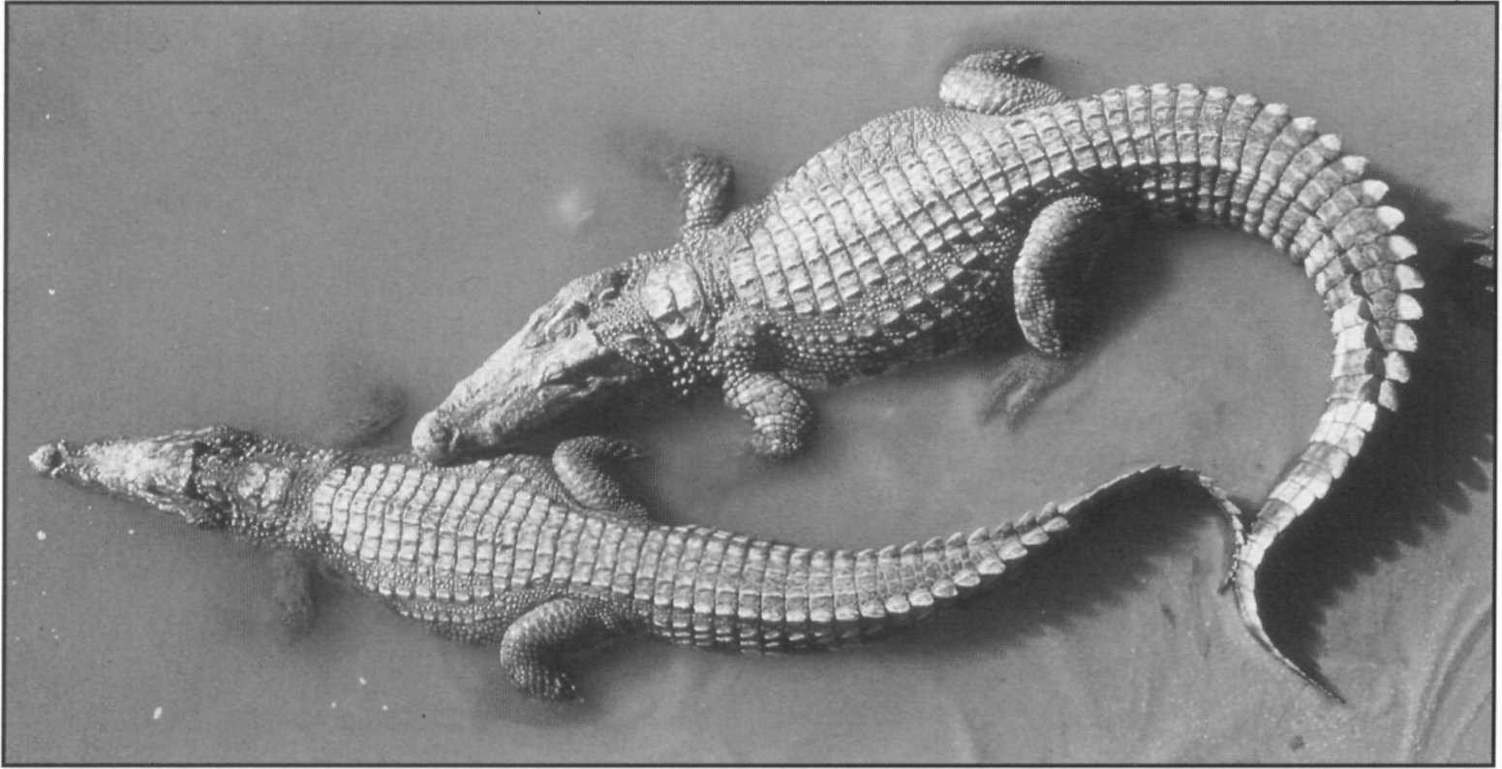Siamese crocodile, *Crocodylus siamensis.* New reports of wild populations in Cambodia and Vietnam offer some hope for the conservation of this Critically Endangered species.

G.J.W. Webb

The Siamese crocodile is relatively unthreatening to people (compared to *C. porosus)* and the possibility of people and crocodiles co-existing in natural settings seems possible. There is also the powerful economic force ofthe commercial industry based on *C. siamensis* which needs to be mobilized and channelled for conservation advantage. Considerable effort and action is still required, but the species has a reasonable chance of survival if the necessary actions can be implemented.

### Priority projects

##### High priority

**Status surveys and development of crocodile management and conservation programs in Cambodia and Lao PDR:** These two countries appear to be the remaining stronghold of the species. Identifying key areas and populations, and obtaining quantitative estimates of population size as a precursor to initiating conservation programs is needed.

**Implementation of protection of habitat and restocking in Thailand:** Thailand has the best organized protected areas system, the largest source of farm raised crocodiles for restocking and the most developed crocodile management program in the region. Although the species has virtually disappeared from the wild, re-establishment of viable populations in protected areas is feasible.

**Protection of crocodile populations in Vietnam:** A combination of habitat protection and captive breeding could prevent the complete loss of the species in Vietnam. Surveys, identification of suitable localities and the implementation of a conservation program coordinated with the captive breeding efforts of Vietnamese institutions is needed.

**Investigation of the taxonomy of the freshwater crocodiles in southeast Asia and the Indo-Malaysian Archipelago:** The relationships among the freshwater crocodiles in the Indo- Malaysian Archipelago are poorly understood. The clarification of these relationships is not only of scientific interest but also has important implications for conservation.

##### Moderate priority

**Coordination of captive breeding, trade and conservation in the South east Asian region:** Several countries in the region are already deeply involved in captive breeding programs for commercial use. Integration of this activity with necessary conservation actions for the wild populations (including funding surveys and conservation) could be a powerful force for conservation. A long term aim could be the re-establishment of viable wild populations and their sustainable use by ranching.

**Maintain a stock of pure *C. siamensis* in crocodile farms:** The bulk of the captive *C. siamensis* worldwide are maintained in several farms in Thailand where extensive interbreeding with *C. porosus* has taken place. Hybrids are preferred for their superior commercial qualities, but the hybridization threatens the genetic integrity of one of the most threatened species of crocodilians. Farms should be encouraged to segregate genetically pure *C. siamensis* for conservation, in addition to the hybrids they are promoting for hide production.

**Survey and protection of Siamese crocodiles in Indonesia:** Verification of the presence of *C. siamensis* in Kalimantan and Java is a first step to developing protection for the species within the context of the developing crocodile management strategy in Indonesia.

## Osteolaemus tetraspis

**Common names:** Dwarf crocodile, broad-nosed crocodile

**Range:** Angola, Benin, Burkina Faso, Cameroon, Central African Republic, Congo, Cote d'lvoire, Dem. Rep. Congo, Equatorial Guinea, Gabon, Gambia, Ghana, Guinea, Guinea- Bissau, Liberia, Mali, Nigeria, Senegal, Sierra Leone, Togo

**Conservation overview**

**CITES:** Appendix I

CSG Action Plan:

Availability of Survey Data - Extremely Poor Need for Wild Population Recovery - Moderate Potential for Sustainable Management - Low

**1996 IUCN Red List:** Not Listed **(LRlc** Lower Risk, least concern, wide distribution and numerous despite extensive local use)

**Principal threats:** Uncontrolled hunting, habitat destruction.

### Ecology and natural history

Dwarf crocodiles range throughout the lowland regions of west and central Africa. This is a little known, diminutive species of crocodilian. Maximum size probably rarely exceeds 2m. Specimens from the upper Congo in Dem. Rep. Congo were described by Schmidt (1919) as a separate genus (*Osteoblepharon osborni*), but later reduced to the species level (*Osteolaemus osborni*) by Inger (1948), and subsequently to a subspecies (*O. tetraspis osborni*) by Wermuth and Mertens (1961).

Waitkuwait (1989) indicates that the dwarf crocodile is primarily a denizen of swamps and swamp forests. It apparently prefers slow moving, calm bodies of water, and frequently utilizes burrows. Some individuals have been reported from isolated pools in savanna habitat, as spending the dry season in burrows (Waitkuwait 1989). In forested areas, dwarf crocodiles are known to make extensive nocturnal terrestrial forays, especially following rains. In many aspects of its ecology this species is very similar to the genus *Paleosuchus* in the New World. The species is also reported to be able to subsist in isolated forest pools (Waitkuwait 1990). An experimental program in Gambia augmenting the habitat with artificial pools found that small plastic pools were quickly colonized by

dwarf crocodile pairs and used successfully for breeding (Jones 1991).

Dwarf crocodiles are mound nesters, with nesting beginning in the early wet season. Females lay small clutches (mean 10) of small eggs, which require approximately 100 days for incubation (Waitkuwait 1989). Breeding physiology is described by Kofron and Steiner (1994). Huchzermeyer and Penrith (1995) suggest that, based on the intestinal morphology, there may be geographic races.

### Conservation and status

Basic information is reported from the Cote d'lvoire, Gabon, the Central African Republic and Congo. Additional surveys have been conducted in the Gambia, Senegal and Guinea Bissau (Jones 1991) and the CITES West and Central Africa Program has collected anecdotal and market information (Behra 1993a, 1993b). A GIS map of the species distribution has been prepared by the World Conservation Monitoring Center. Because of the lack of systematic surveys, good information on population status of the dwarfcrocodile is lacking and in most countries the status is unknown, although it appears to be generally widespread and abundant. Where survey data are available, populations appear to be somewhat depleted. Populations in the Gambia (Jones 1991), on the northern edge of the species distribution, and in Liberia (Kofron and Steiner 1994) are reported to be severely depleted. Countries thought to have major populations, by virtue of their large area and extensive wetlands, are Cote d'lvoire, Ghana (Lake Volta), Nigeria (Niger and Benue rivers), Gabon (Ogoue river), Congo and Dem. Rep. Congo (Congo/ Zaire and Ubangi rivers). Angola (Cabinda province), Mali and Senegal are probably the limits of the species range. Pooley's (1982) report of a population in the northern Central African Republic appears discontinuous to the remainder of the range and is in the internal

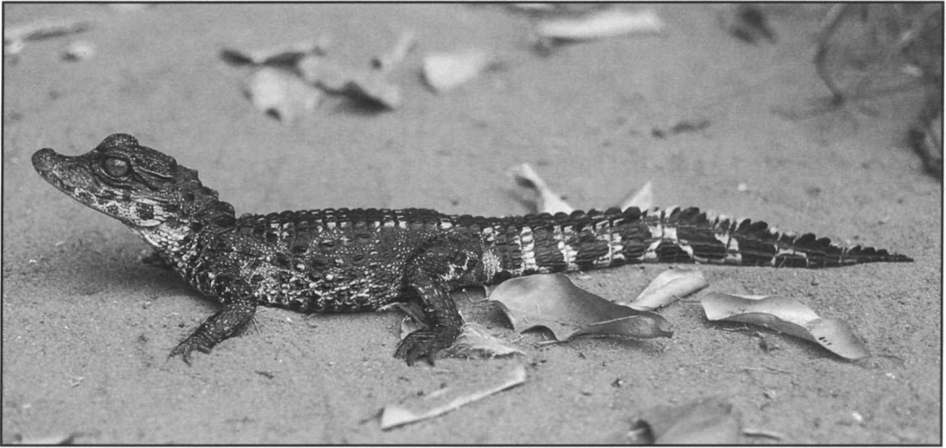Dwarf crocodile, *Osteoleamus tetraspis,* juvenile at Zoo National D'Abidjan, Cote d'lvoire.

drainage of Lake Chad via the Chari river. It would be interesting to establish if the dwarf crocodile range extends into the extensive marshes of the Bahr Salamat in southern Chad. Distribution ofthe subspecies *O. t. osborni,* reported from the upper Congo river remains poorly known.

B. Shwedick

Habitat destruction (deforestation, wetland alteration) and use for food are the principal threats to this species. Habitat destruction or alteration have been reported in Nigeria, Gambia, Ghana, and Liberia (Pooley 1982). The species is also extensively utilized for meat for local consumption. Sparse data from Congo (Hutton 1991) and Cameroon (Behra 1993a and b) suggest that tens of thousands of dwarf crocodiles are sold in local markets annually for consumption. Some skins are used for the local production of poor quality leather products.

Because of the relatively poor quality of the hide of dwarf crocodiles, intensive commercial hunting has not been a serious problem and there has been little incentive for management programs based on sustainable use. Togo is reported to have a legal harvest system but this program does not appear to be in effect. Congo had a CITES approved quota of 500 in 1987 but did not renew its request for a quota in 1989. Plans are under discussion for the establishment of captive breeding programs for conservation, tourism and possible meat

production in Togo, Cameroon (Behra 1993a and b) and Nigeria (Dore 1991). A cooperative study has been established between South African workers and the Congo to examine dwarf crocodile parasites (Huchzermeyer 1993).

### Priority projects

##### High priority

**Surveys of the status and distribution throughout west and central Africa:** Very few survey data are available from west and central Africa, so the status of this species, although it is widely distributed, remains mostly unknown. Because of the low quality of the hide of *Osteolaemus,* there is not much incentive for establishing sustainable- yield management programs. However, surveys need to be undertaken in order to determine population status and whether or not appropriate conservation measures should be taken. Because this species is broadly sympatric with

*C. cataphractus,* census work for both species could be combined. Surveys need to be conducted throughout west and central Africa, with priority given to the countries where the species status appears to be most threatened (e.g. Nigeria).

## Tomistoma schlegelii

**Common names:** Tomistoma, false gharial, Buaya sumpit (Indonesia), Takong (Thailand)

**Range:** Indonesia, Malaysia, Thailand (extirpated)

**Conservation overview**

**CITES:** Appendix I

CSG Action Plan:

Availability of Survey Data - Extremely Poor Need for Wild Population Recovery - Highest Potential for Sustainable Management - Low

**1996 IUCN Red List: DD** Data Deficient. Possibly CR Critically Endangered or EN Endangered, remaining populations suspected to be very small and highly fragmented. (Newly obtained information in Sumatra and Borneo will allow re-evaluation of status)

**Principal threats:** Habitat destruction.

### Ecology and natural history

The tomistoma or "false gharial" is one of the most unusual and little known of the crocodilians. It is a large species, with males attaining sizes of up to 5m, and has a distinctive narrow snout marked with dark blotches. The historic range of the species includes the Malay Peninsula (southern Thailand and Malaysia), Sumatra and Borneo (Indonesia, Malaysia). A report of the species in Sulawesi and Vietnam (Groombridge 1982) remains unsupported.

Little is known about the ecology of this species in the wild. *Tomistoma* appears to be restricted primarily to freshwater swamps, rivers and lakes and may occasionally use burrows. Slow-moving water and heavily vegetated habitats seem to be preferred. Females are mound nesters, and lay clutches of 20-60 very large eggs. Sexual maturity is attained among females at a length of 2.5-3m (Groombridge 1982, Bezuijen *et al.* 1997)

The evolutionary relationship of *Tomistoma* with other crocodilians has been a subject of recent debate, and no consensus has been reached. Traditionally, *Tomistoma* has been closely aligned with the true crocodiles (Crocodylidae) based on morphological evidence

(Tarsitano *et al.* 1989). Biochemical and immunological studies, however, suggest that *Tomistoma* is more closely related to the gharial (Gavialidae) (Densmore and Owen 1989). Poe (1996) summarises the arguments and supports the latter.

### Conservation and status

Since the publication of the first edition of the Action Plan (1992), new information has become available concerning the distribution of wild populations of *Tomistoma.* Early surveys were restricted to Sarawak, where numbers were extremely low. Whitaker (1984) surveyed Sabah, East Malaysia, but considered this area to be outside of the natural distribution of *Tomistoma.* Sebastian (1994) summarized information collated by the Asian Wetland Bureau on wetland areas and reported 26 confirmed locations in peninsular Malaysia, East Malaysia (Sarawak), Kalimantan and Sumatra. Additional unconfirmed reports from Marisa river, north Sulawesi, and Ca Mau, Minh Hai Province, Vietnam, would be significant range extensions if verified. There have been no records of *Tomistoma* in Thailand since 1970 and it is probably extirpated there (Ratanakorn *et al.* 1994).

Major centers of distribution are in Indonesia. Following the identification of *Tomistoma* as a major priority in the 1992 Action Plan, a CSG research program was initiated (coordinated by G. Webb and colleagues) that has produced a significant expansion of our knowledge of this species in Sumatra. Prior to the 1950s, *Tomistoma* appears to have occurred from southeastern Aceh province to southern Lampung province. Intensive hunting in the 1950s-1970s and increasing human use of habitats has reduced this range by approximately 30%. Currently, tomistoma are thought to occur from southeastern Sumatera Utara province to southern Sumatera Selantan province with an isolated population in Way Kambas National Park, Lampung Province. Western limits to the

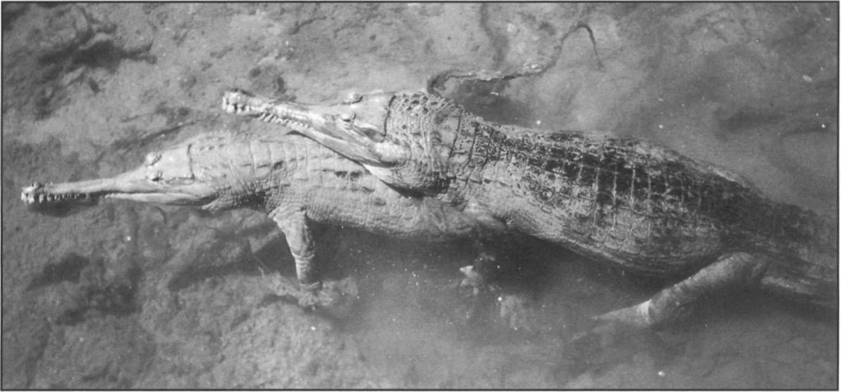The tomistoma, *Tomistoma schlegelii.* Courting pair photographed in captivity at Florida Cypress Gardens.

Surveys of this species in Indonesia and Malaya initiated as a result of the first Action Plan for Crocodiles 1992 have resulted in significant new information about the distribution and biology of this species.

range are probably the foothills of the Barisan Mountain Range (Bezuijen *et al.* 1997). Detailed studies have been conducted on breeding populations in Sumatra, in the Lalan and the Merang river and Berbak National Park (Bezuijen *et al.* 1995, 1997). Densities by spotlight survey were 0.18-0.26 individuals/km. Details of reproductive biology and habitat use are presented. In Kalimantan, Frazier and Maturbongs (1990), and Muin and Ramono (1994) report *Tomistoma* in East Kalimantan province and west of Samarinda, in the southwest of Kalimantan- Tenga province, including Tanjung Puting National Park, and in Kalimantan Barat in Danau Sentarum Wildlife Preserve. Ross *et al.* (1996) and Meijaard and Sozer (1996) provide additional recent sighting records and observations from the upper Mahakam river, Timur Province and Kalimantan Tengah province in Kalimantan. *Tomistoma* is said to be the most abundant freshwater crocodile in some of these areas.

B. Shwedick

In Malaysia, tomistoma are reported from Western Sarawak, and in peninsular Malaysia in Selangor swamp, the Pahang river and in Tesak Besra National Park. Status in Malaysia is unknown, but tomistoma appear to be quite rare and limited in distribution. A preliminary survey in Tesak Besra in 1997 did not record any *Tomistoma.*

These recent surveys have greatly expanded our information on the distribution of *Tomistoma,* although estimates of population numbers remain uncertain. There appear to be numerous locations in Indonesia where conservation projects for *Tomistoma* would be advisable. Nearly half ofthe recorded localities occur within protected areas, but the level of protection is often ineffective. Current threats are habitat loss by conversion of riparian habitat (dams, flood mitigation, channelling, de- forestation), and net fishing, which causes direct mortality and may deplete food sources for *Tomistoma.* The habitat needs of *Tomistoma* may be specific for floating vegetation mats and shady streamside vegetation. Examination of these requirements and design of suitable conservation and management within protected areas is desirable.

Captive *Tomistoma* are held by numbers of private facilities in Kalimantan, Sarawak and Thailand, as well as in European and US zoos. Jong's Crocodile Farm, Kuching, Sarawak, has 10 adults and 29 juveniles, while Samutprakan Crocodile Farm in Thailand has several large subadults. Successful captive breeding has been achieved in an Indonesian farm and in zoos in USA, and Europe.

### Priority projects

##### High priority

**Status surveys in Malaysia and Indonesia:** Quantitative surveys to establish the extent and size of the various reported populations in Sumatra, Kalimantan, Sarawak and Malaysia are needed. These should be conducted in conjunction with national authorities to identify the areas occupied, conservation threats and conservation actions needed.

**Development and implementation of conservation and research programs:** Following initial survey work, conservation plans for this species need to be drawn, particularly in Indonesia and Malaysia where *Tomistoma* is most widely distributed. Habitat protection measures should be undertaken and ecological investigations, including population monitoring, initiated. Identification of special habitat needs and the incorporation of appropriate land management regimes to preserve these needs should be included.

##### Moderate priority

**Verification of two outlying records:** Reported presence of *Tomistoma* in southwestern Vietnam and Sulawesi Island should be investigated.

## Gavialis gangeticus

**Common names:** Gharial, gavial

**Range:** Bangladesh (extinct), Bhutan (extinct?), India, Myanmar (extinct?), Nepal, Pakistan

**Conservation overview**

**CITES:** Appendix I

CSG Action Plan:

Availability of Survey Data - Adequate

Need for Wild Population Recovery - Highest Potential for Sustainable Management - Low

**1996 IUCN Red List: EN** Endangered. Criteria C.2.a. population <2,500 and severely fragmented. Population and Habitat Viability Analysis 1995.

**Principal threats:** Habitat destruction, limited distribution.

### Ecology and natural history

The gharial is the most long-snouted and together with the saltwater crocodile the largest of the living crocodilians (males up to 6-7m). Placed in a family by itself, the Gavialidae, the gharial has long been separated from the rest of the crocodilian stock, with the possible exception of *Tomistonut* (Densmore 1983). Gharial are arguably the most thoroughly aquatic of the extant

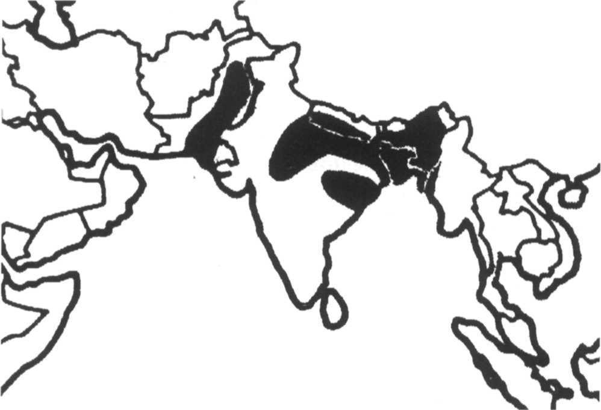

crocodilians, and adults apparently do not have the ability to walk in a semi-upright stance as other crocodilians do (Bustard and Singh 1978). Adult males grow a bulbous nasal appendage, which resembles an Indian pot called a 'ghara,' from which the species derives its name. Gharial are restricted to the northern part of the Indian subcontinent where they were found in four river systems: the Indus (Pakistan), the Ganges (India and Nepal), the Mahanadi (India) and the Brahmaputra (Bangladesh, India and Bhutan). The presence of the species in the Kaladan and Irrawaddy Rivers in Burma has also been reported (Smith 1931).

The gharial is typically a resident of deep, fast flowing rivers, but within these rivers prefers areas where the current is reduced (Whitaker and Basu 1983). Exposed sand banks are used for nesting. Although the function of the ghara is not well understood, it is apparently used as a visual sex indicator, as a sound resonator, or for bubbling or other associated sexual behaviors (Martin and Bellairs 1977).

The gharial appears to be primarily a fish-eating species, but very large individuals are known to eat other prey.

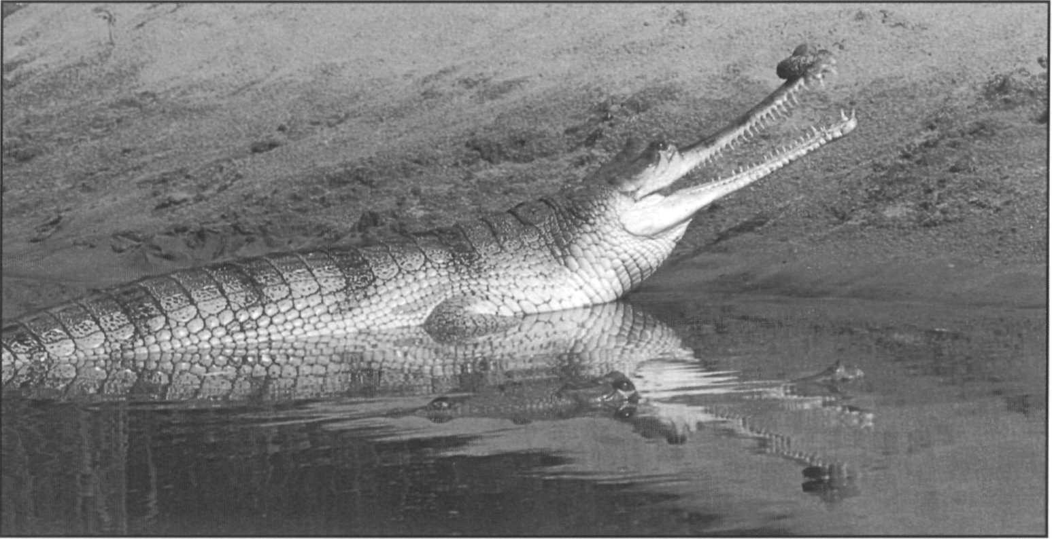Male gharial, *Gavialis gangeticus,* showing the swollen structure at the snout tip (ghara = pot) for which the species is named.

H. Andrews

Females may not reach sexual maturity until they are nearly 3m long. Nesting is done during the annual dry season in holes excavated in river sand banks (Whitaker and Basu 1983). Unlike most other crocodilians who carry their young from the nest in the mouth, gharial appear not to do this because of the unusual morphology of their jaws (Singh and Bustard 1977). However, post-natal maternal care has been observed. Female gharial typically lay 30-50 eggs, and the eggs are the largest of any crocodilian (average 160g).

### Conservation and status

The gharial is one of the most Endangered of the crocodilians. However, unlike the other seven most endangered crocodilians, good conservation programs are now in place over much of the species range. The species was literally brought back from the brink of extinction by restocking programs initiated first in India in 1975, and in Nepal in 1978. In India, a total of nine protected areas with an area of nearly 3,000km2 (along the Ganges and its tributaries and at Satkoshia Gorge on the Mahanadi) have been designated for gharial management (Rao and Singh 1994). Gharial are captive bred for release at six breeding centers and eggs are also collected from wild nests for captive raising and release. Over 3,000 juveniles have been released at 12 sites. The major release sites are the Chambal river (1,718 released 1979-1993), Ramganga river (257 released 1982-1994), Girwa river (172 released 1979-1994) and the Sharada river (105 released 1986-1992), all in the Ganges drainage, and in the Mahanadi river in Orissa (609 released 1977-1989). Follow- up surveys suggest an overall increase in the total wild population which has levelled off since 1990 as the number of available sites have become filled. Current wild population is estimated to be in excess of 1,500 individuals (Anon. 1993b), of which more than 1,000 are found in the Chambal river with around 64 nests a year at 15 different sites (Rao and Singh 1994). At several other areas and sites of smaller releases, such as the Satkoshia Gorge (Mahanadi River) and Ken and Son rivers, the restocking program has not resulted in population increases although some gharial remain. Increasing problems have been experienced with the high cost of captive breeding and the paucity of additional sites for the release of gharial. Increasing interactions between riverside human populations and gharials, as well as the negative effects of agriculture and fishing, restrict successful gharial populations to a few stretches of isolated and protected rivers. Increasing or even maintaining the program is problematic at present. A Population and Habitat Viability Analysis (PHVA) was conducted in early 1995 to plan future strategies (Rao *et al.* 1995). Population modelling under different assumptions suggested that the Chambal population may be self-

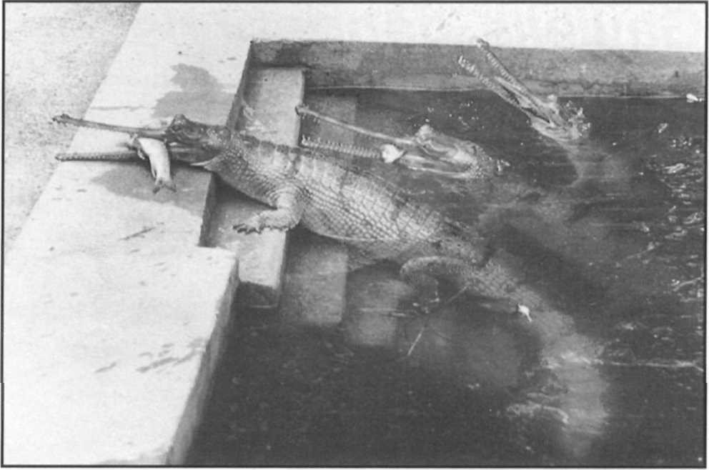

Gharial, *Gavialis gangeticus,* captive breeding stock at Nandakan Crocodile Center, Orissa, India. Restocking is maintaining this species in some protected localities such as the Chambal River.

R.J. Rao

sustaining but smaller populations in the Mahanadi and other localities require continued replenishment. Major recommendations derived from this analysis were the preparation of a National Management Plan, continuous monitoring of protected and restocked populations, an analysis of genetic diversity and the effects of a bottleneck in the founder stock, increased public education and the continuation of restocking. Migration out of protected areas was identified as a significant factor slowing population recovery. Recommendations to standardize and invigorate monitoring and conservation programs were also made.

In Nepal, gharial are restricted to remnant populations in the Karnali, Babai and Narayani rivers (tributaries of the Ganges). Total population is estimated at about 60 wild and 70 released gharials (Maskey and Percival 1994). A captive rearing program has released 432 gharial since 1978 and breeding of released gharials was recently reported (Maskey 1994). Most releases have been into the Narayani and its tributaries in central Nepal, with additional releases in the Koshi, Babai, Karnali and Rapti rivers.

Reports of gharial remaining in the Sind region of Pakistan are persistent (Ahmad 1990, Chaudhry 1993), but there appears to be a very small number, possibly only one or two individuals. The species is virtually extinct in Pakistan. The Pakistan government is currently planning a restocking effort with assistance from Indian institutions. A recent review of crocodiles in Bangladesh (Cox and Rahman 1994) suggest that although small numbers of the species continued to be reported into the 1980s it may no longer found in the wild. Known nesting areas that produced up to 12 nests as late as 1985 have seen none since 1990. The species is heavily impacted by fishing activities and habitat degradation. A part ofthe distribution on the Padma river is periodically moved into Indian jurisdiction as the river channel changes during floods. The gharial is in imminent danger of extirpation in Bangladesh. Historic reports of gharial in Myanmar have

not been verified for many years, but recent reports confirm that populations persist in the upper Brahamputra and in Bhutan.

The gharial is still very threatened. Gharial are extremely rare in both India and Nepal, virtually extirpated in Pakistan, Bhutan and Bangladesh, and probably extinct in Myanmar.

### Priority projects

##### High priority

**Survey of status and distribution in Pakistan:** The government of Pakistan is interested in implementing a restocking program similar to the ones in Nepal and India. However, apart from one recent sighting nothing is known about the status of the gharial. Surveys of the Indus River and Nara Canal are needed. Based on the results of this survey, action should be taken to set aside land for crocodile sanctuaries as a first step towards restocking.

**A National Management Plan for gharial in India and implementation of the recommendations of the Gharial PHVA:** Additional projects that should be developed under this program would include coordinated surveys and monitoring, genetic and migration studies, improved restocking activities, public education and periodic re- analysis of the status of the species.

**Development of international coordination** for gharial management and conservation between India and Nepal: Gharial populations occupy rivers that run between India and Nepal. Independent conservation programs are in effect in each country. Coordinated management of these shared populations would enhance conservation effectiveness. Joint surveys, training comparison of population trends and coordinated regulations and protection should be developed.

**Establishment of a captive rearing center in Pakistan:** A captive rearing center similar to those in India and Nepal is needed to supply animals for restocking in protected areas.

##### Moderate priority

**Status survey in the Irrawaddy and Kaladan River systems in Myanmar:** Although the gharial is considered to be extinct in Myanmar, small populations may still exist in isolated areas. Surveys need to be conducted to assess the current status of gharial in Myanmar.

**Expansion of restocking program in Nepal:** The vast majority of the releases of gharial in Nepal have been into the Narayani River system. Additional sites in eastern and western Nepal need to be identified and included in the restocking program.

# References

Abadia, G. 1995. *Crocodylus acutus* in Bahia Portete.

*CrocodileSpecialistGroupNewsletter*14(1):9.

Abercrombie, C.L., D. Davidson, C. Hope and

D.E. Scott. 1980. Status of Morelet's crocodile *(Crocodylus moreletii)* in Belize. *Biol. Conserv.* 17:103-113.

Abercrombie, C.L., C.A. Hope, J.M. Holmes, D.E. Scott and J.E. Lane. 1982. Investigations into the status of the Morelet's crocodile *(Crocodylus moreletii)* in Belize, 1980. In: *Crocodiles. Proc. 5th Working Meeting of the IUCN/SSC Crocodile Specialist Group, Gainesville, Florida.* 11-30. IUCN, Gland, Switzerland.

Ahmad, A. 1990. Pakistan. *Crocodile Specialist Group Newsletter*9(2):16.

Alvarez, A.J. 1995. Una desconocida (y triste) forma de extermino del Caiman negro. *Crocodile Specialist Group Newsletter* 14(2): 14-16.

Alvarez del Toro, M. 1974. *Los Crocodylia de Mexico.* Instituto Mexicano de Recursos Naturales Renovables, Mexico.

Amato, G. and J. Gatesy. 1994. PCR assays of variable nucleotide sites for identification of conservation units. In: *MolecularEcologyandEvolution, Approachesand Applications.* Schierwater, B., B. Stred, G.P. Wagner and R. DaSalle (eds.). 215-226. Birkauser Verlag, Basel, Switzerland.

Andrews, H. and P. McEachern. 1994. *Crocodile Conservation in Nepal.* IUCN Nepal and US AID, Kathmandu, Nepal. 28 pp.

Andrews, H. and R. Whitaker. 1994. Status ofthe saltwater crocodile*(Crocodylusporosus*Schneider,1801)inNorth Andaman Island. *Hamadryad.* 19:79-92.

Anon. 1993a. American crocodile thrives in hurricane's wake. *Crocodile Specialist Group Newsletter* 12(4):16.

Anon. 1993b. Crocodile Conservation and Management in India. *Report of a CSG Workshop, Madras, India 1-3 March 1993.* J. Hutton (compiler). 27 pp.

Anon. 1993c. Preliminary Breeding Results from CFI.

*Crocodile Specialist Group Newsletter* 12(3): 10.

Anon. 1994a. PNG Adopts Croc Marking Scheme.

Crocodile Specialist Group Newsletter 13(1):8.

Anon. 1994b. Steering Committee report and CITES 9th Conference report. *Crocodile Specialist Group Newsletter* 13(4):4, 7.

Anon. 1994c. Conservation Plan for the Conservation and Management of *Crocodylus porosus* in Queensland (DRAFT).*NatureConservationAct1992,Section106.* Queensland Dept. of Environment and Heritage, Brisbane, Australia. 101pp.

Anon. 1994d. Proposal. Maintainance of the Indonesian Population of the Saltwater Crocodiles *(Crocodylus porosus)* In: *Appendix II of CITES, 9th Conference of the Parties.* Doc 9.47:29-62.

Anon. 1994e. Proposal submitted Pursuant to Resolution on Ranching: Res. Conf. 3.15, Conf. 5.16 and Conf.

6.2 and 8.22. *Transfer the Ecuador population of* Melanosuchus niger *from Appendix I to Appendix II- Ranching Proposal to CITES.*

Anon. 1994f. Thailand review. *Crocodile Specialist Group Newsletter* 13(2):22-23.

Arteaga, A. 1993. Repoblamiento del embalse de Tacarigua (Ed. Falcon, Venezuela) con Caimanes del Costa *(Crocodylus acutus)* criados en cautiverio: Resultados preliminares. In: *Zoocria de los Crocodylia. Memorias de la I Reunion Regional del CSG:* 264-269. IUCN Gland, Switzerland.

Arteaga, A. 1994. Fudena evalua la situacion actual del Caiman del Costa en Venezuela. *Crocodile Specialist Group Newsletter* 13(4): 17-19.

Arteaga, A., A.E. Seijas, C. Chavez and J.B. Thorbjarnarson. 1994. Status and conservation of the Orinoco crocodile: An update. In: *Crocodiles. Proceedings of the 12th Working Meeting of the Crocodile Specialist Group,* 1:143-150. IUCN, Gland, Switzerland.

Asanza, E. 1985. *Distribucion, biologia reproductive y alimentacion de quatro especies de aligatoridae, especialmente* C. crocodilus *en la Amazonia del Ecuador.* Unpubl. thesis, Pontificia Universidad Catolica del Ecuador.

Asanza, E. 1992. Population dynamics, ecology and conservation of the black caiman, *Melanosuchus niger* in Ecuadorian Amazonia. In: *Crocodiles. Proceedings of the 11th Working meeting of the Crocodile Specialist Group of the Species Survival Commission of the IUCN.* 1:22-30. IUCN, Gland, Switzerland.

Aung Moe. 1994. The Status of Crocodylians in Myanmar. In: *Crocodiles, Proceedings of the 12th Working Meeting of the Crocodile Specialist Group IUCN-World Conservation Union,* 1:24-27. IUCN, Gland, Switzerland.

Avise, J.C. 1994. *Molecular markers, natural history and evolution.* Chapman and Hall, New York. 511 pp.

Ayarzaguena, J. 1984. Variaciones el la dietica de *Caiman sclerops* la relacion entre morfologia bucal y dietica. *Mem Soc. Cienc. Nat. La Salle* 44(122): 123-140.

Ayarzagüena, J. 1987. Conservacion de el caiman del Orinoco en Venezuela. Parte I. Rio Cojedes. *Primer Avance del Proyecto.* 15pp.

Ayarzagüena, J. 1990. An update on the recovery program for the Orinoco crocodile. *Crocodile Specialist Group Newsletter* 9(3): 16-18.

Barahona S., P. Bonilla, A. Martinez and H. Naranjo. 1996a. *Estado, Distribucion, sistematica y Conservacion de los crocodylia Colombianos.* Ministerio del Medio Ambiente, Santa Fe de Bogota, Colombia.

Barahona S., P. Bonilla, A. Martinez, H. Naranjo and M. Rodriguez. 1996b. *Estado, Distribucion, sistematica y Conservacion de los crocodylia Colombianos.* In: *Crocodiles, Proceedings ofthe 13th Working Meeting of the Crocodile Specialist Group, IUCN* - *The World Conservation Union,* 32-51. IUCN, Gland, Switzerland. Behler, J. 1993. Species Survival Plan for Chinese Alligator.

*Crocodile Specialist Group Newsletter* 12(4): 18.

Behra, O. 1987. *Etude de repartition des populations de crocodiles du Congo, du Gabon et de la R.C.A. leme, 2eme et 3eme partie: Gabon.* Secretariat de la Faune et de la Flore. Museum National d'Histoire Naturelle de Paris. Paris, France.

Behra, O. 1990. Kaw Swamp becomes a black caiman sanctuary. *Crocodile Specialist Group Newsletter* 9(1): 14. Behra, O. 1993a. Cameroon FAO crocodile management project. *Crocodile Specialist Group Newsletter* **12(1):** 16.

Behra, O. 1993b. Togo. *Crocodile Specialist Group Newsletter* 12(1):17.

Behra, O. 1994a. Black caiman in Kaw Swamp. *Crocodile Specialist Group Newsletter* 13(1): 12.

Behra, O. 1994b. Congo, Export of Crocodile Skins 1970- 1978. *Crocodile Specialist Group Newsletter* 13(3):4-5. Behra, O. 1994c. Crocodiles on the Deserts Doorstep.

*Crocodile Specialist Group Newsletter* 13(l):4-5.

Bezuijen, M.B., P. Cannucciari, C. Manolis, Samedi and

B.K. Simpson. 1995. Field expedition to the Lalan River and its tributaries, South Sumatra, Indonesia, August-October 1995: Assessment of the Distribution, Abundance, Status and Nesting Biology of the false gharial *(Tomistoma schlegelii).* Wildlife Management International Pty. Ltd. mimeo report. 101pp.

Bezuijen, M.R., Pandu Hartoyo, M. Elliot and B. Baker. 1997. *Second report on the ecology of the False Gharial* (Tomistoma schlegelii) *in Sumatera.* Wildlife Management International Pty. Ltd. mimeo report. 128pp.

Blake, D.K. and N. Jacobsen. 1992. The Conservation Status of the Nile Crocodile *(Crocodylus niloticus)* in South Africa. In: *Conservation and Utilization ofthe Nile Crocodile in Southern Africa. Handbook on Crocodile Farming.* Smith, G.A. and J.M. Marais (eds.). 11-21. Crocodilian Study Group of South Africa, Pretoria.

Borges, G.A., A. Arruda Filho. 1993. Avalicio do potential de ninhos de *Caiman crocodilus yacare* numa sub- regiao do Pantanal de Pocone-MT. In: *Zoocría de los Crocodylia. Memorias de la I Reunion Regional de Especialistas en Cocodrilos de la IUCN.* 55-117. IUCN. Gland, Switzerland.

Bowes, S.A. 1992. Black caiman in Zancudo Cocha.

*Crocodile Specialist Group Newsletter* ll(4):7-8.

Brazaitis, P. 1973. The identification of living crocodilians.

*Zoologica* 58:59-101.

Brazaitis, P. 1987. Identification of crocodilian skins and products. In: *Wildlife Management: Crocodiles and Alligators.* Webb, G.J.W., S.C. Manolis and P.J. Whitehead (eds.). 373-386. Surrey Beatty and Sons Pty Lim., Chipping Norton, Australia.

Brazaitis, P. 1989. The caiman of the Pantanal, past, present and future. In: *Crocodiles. Proc. 8th Working Meeting of the IUCN/SSC Crocodile Specialist Group, Quito, Ecuador.* 119-124. IUCN, Gland, Switzerland.

Brazaitis, P. 1994. *Draft Recovery Planfor the Saltwater crocodile,* Crocodylus porosus, *in the Republic of Palau.* US Fish and Wildlife Service, Honolulu.

Brazaitis, P., G. Amato, G. Rebelo, C. Yamashita and J. Gatesy. 1993. *Report to CITES on the biochemical systematics study of Yacare Caiman,* Caiman yacare, *of South Central America.* CITES Secretariat, Geneva, Switzerland.

Brazaitis, P., G.H. Rebelo and C. Yamashita. 1992. *Report of the WWF / TRAFFIC USA survey of Brazilian Amazonia crocodilians: survey period- July 1988 to January 1992.* Draft report prepared for WWF.

Brazaitis, P., C. Yamashita and G. Rebelo. 1988. *Preliminary report to the CITES Secretariat. CITES central South America caiman study. Phase I. Central and southern Brazil.* Unpubl. report to the CITES Secretariat.

Brazaitis, P., C. Yamashita and G. Rebelo. 1990a. *A summary report of the CITES central South American caiman study: Phase I: Brazil.* 1:100-115.

Brazaitis, P., C. Yamashita and G. Rebelo. 1990b. CITES central South American crocodilian study. *Species* 13-14:29.

Brisbin, I.L., C.A. Ross, M.C. Downes, M.A. Staton and

B. Gammon. 1986. *A Bibliography of the American Alligator.* Savannah River National Environmental Research Park. 310pp.

Brisbin Jr, I.L., E.A. Standora and M.J. Vargo. 1982. Body temperature and behavior of American alligators during cold winter weather. *Am. Midi. Nat.* 107:209-218.

Bustard, H.R. and L.A.K. Singh. 1978. Studies on the Indian gharial *Gavialis gangeticus* (Gmelin) (Reptilia, Crocodilia). Change in terrestrial locomotory pattern with age. /. *Bombay Nat. Hist. Soc.* 74:534-536.

Campbell, H.W. 1972a. Ecological or phylogenetic interpretations of crocodilian nesting habits. *Nature* 238:404-405.

Campbell, H.W. 1972b. Preliminary report: status investigation of Morelet's crocodile in Mexico. *Zoologica* 57(3):135-136.

Campos, Z., G. Mourao, M. Couthino and C. Abercrombie. 1995. Night-light counts, size structures and sex ratios in wild populations of *Caiman crocodilus yacare* in the Brazilian Pantanal. *Vida Silvestre Neotropical* 4(l):46-50.

Campos, Z. 1993. Effect of habitat on survival of eggs and sex ratio of hatchlings of *Caiman crocodilus yacare* in the Pantanal, Brazil. *J. Herp.* 27(2):127-132.

Campos, Z., M. Couthino and C. Abercrombie. 1995. Size Structure and sex ratio of dwarf caiman in the Serra Amolar, Pantanal, Brazil. *Herp. Journal.* 5:321-322.

Campos, Z. and W. Magnusson. 1995. Relationships between rainfall, nesting habitat and fecundity of *Caiman crocodilus yacare* in the Pantanal, Brazil. *J. Trop. Ecol.* 11:351-358.

Campos, Z. and G. Mourao. 1995. *Caiman latirostris* (Broad-snouted caiamn) nesting. *Herp. Review* 26(4):203-204.

Casas-Andreu, G. 1990. *Crocodylus acutus* on the coast of Jalisco. *Crocodile Specialist Group Newsletter* 9(4): 19-20.

Casas-Andreu, G. 1994. *Crocodylus acutus* surveys on the Santiago river. *Crocodile Specialist Group Newsletter* 13(1):13-14.

Chabreck, R.H. 1982. *Crocodile Management Programs in Cuba.* Report to FAO of United Nations, Rome 10pp.

Chaudhry, A.A. 1993. Status Reports of Crocodiles in Pakistan. *Crocodile Specialist Group Newsletter* 12(l):19-20.

Chavananikul, V., S. Wattanodorn and P. Youngprapakorn. 1994. Karyotypes of 5 species of crocodile kept in Samutprakan Crocodile farm and Zoo. In: *Crocodiles. Proceedings of the 12th Working Meeting of the Crocodile Specialist Group, IUCN* - *World Conservation Union,* 1:58-62. IUCN, Gland, Switzerland.

Chaves, A. 1993. Situation of *Crocodylus acutus* in the Central Pacific Region of Costa Rica. *Crocodile Specialist Group Newsletter* 12(4): 12-13.

Chea, Peng Cheang and P. Ratanakorn. 1993. Conservation, management and farming of crocodiles in Cambodia. In: *Crocodiles, Proceedings of the Second Regional Meeting of the Crocodile Specialist Group.* 13-23. Conservation Commission of the Northern Territory, Darwin, Australia.

Chen, Bihui. 1990. Preliminary studies of the home range of the Chinese alligator. In: *Crocodiles, Proceedings of the 10th Working Meeting of the Crocodile Specialist Group, IUCN-World Conservation Union,* 1:43-46. IUCN, Gland, Switzerland.

Chen, Bihui, Wang Chaolin and Lian Baodong. 1990. Observation on the burrow of Chinese alligator. In: *Crocodiles, Proceedings of the 10th Working Meeting of the Crocodile Specialist Group, IUCN - World Conservation Union,* 1:47-53. IUCN, Gland, Switzerland.

Cintra, R. 1986. Nascimiento de filhotes de *Caiman yacare* (Daudin, 1802) em condicoes semi-naturais no pantanal Matogrossense. *Papeis Avulsos Zool.,* S. Paulo. 36:91— 101.

CITES. 1995. *CITES Identification Guide-Crocodilians. 1995.* Environment Canada, Ottawa and CITES Secretariat, Geneva.

Cogger, H.G., E.E. Cameron, R.A. Sadlier and P. Eggler. 1993. *The Action Plan for Australian Reptiles.* Australian Nature Conservation Agency.

Collins, L. 1995. Crocodilian Skin production 1992-1993.

*Crocodile Specialist Group Newsletter* 14(1): 18-19.

Conservation Commission of the Northern Territory (CCNT). 1989. *A management program for* Crocodylus porosus *and* Crocodylus johnstoni *in the Northern Territory of Australia.* CCNT, Darwin.

Continho, M.E. 1993. Aspectos reproductivos do jacaré *(Caiman crocodilus yacare)* em pantanos; o efeito dos niveis de agua na produçáo de ninhos. In: *Zoocría de los Crocodylia. Memorias de la I° Reunión Regional de Especialistas en Cocodrilos de la IUCN.* 134-137. IUCN, Gland, Switzerland.

Cooper-Preston, H. and R.W.G. Jenkins. 1992. Natural history of the Crocodylia. Pp. 339-343. In: *Fauna of Australia: Amphibia and Reptilia* Vol 2A. Glasby C.J.,

G.J.B. Ross and P.L. Beesley (eds.). Australian Govnt. Publishing Service. Canberra, Australia.

Cott, H.B. 1961. Scientific results of an inquiry into the ecology and economic status of the Nile crocodile *(Crocodylus niloticus)* in Uganda and Northern Rhodesia. *Trans. Zool. Soc. London* 29:211-358.

Couthino, M. and Z. Campos. 1996. Effect of habitat and seasonality on the densities of caiman in southern Pantanal, Brazil. *J. Trop. Ecol.* 12:741-747.

Cox, J.H. 1985. *Crocodile nesting ecology in Papua New Guinea.* Field Document No. 5 of the FAO/UNDP, PNG/74/029, Assistance to the Crocodile Skin Industry Project. Wildlife Division, Port Moresby, Papua New Guinea.

Cox, J. 1992. *Development of the Crocodile Industry on a Sustainable Basis - Terminal Report.* FAO-PHPA Project GCP/INS/060/JPN. Food and Agriculture Organization of the United Nations, Rome: 96pp.

Cox, J.H., R. Frazier and R. Maturbongs. 1993. Freshwater crocodilians of Kalimantan (Indonesian Borneo). *Copeia* 1993(2):564-566.

Cox, J., and F. Gombek. 1985. *A preliminary survey of the crocodile resource in Sarawak, East Malaysia.* World Wildlife Fund Malaysia. IUCN/WWF Project No. MAL 74/85.

Cox, J.H. and M.M. Rahman 1994. An Assessment of Crocodile Resource Potential in Bangladesh. In: *Crocodiles, Proceedings of the 12th Working Meeting of theCrocodileSpecialistGroup,IUCN-WorldConservation Union,* 1:232-258. IUCN. Gland, Switzerland.

Craig, G.C. 1992. A population model for the Nile Crocodile with an analysis of sustainable harvesting strategies. In: *Crocodiles, Proceedings of the 11th Working Meeting of the Crocodile Specialist Group,* 1:78-81. IUCN, Gland, Switzerland.

Craighead Sr, F.C. 1968. The role of the Alligator in shaping plant communities and maintaining wildlife in the Southern Everglades. *Florida Nat.* 41:2-7,69-74,94. Crawshaw Jr, P.G. 1987. *Nesting ecology ofthe Paraguayan caiman* (Caiman yacare) *in the Pantanal of Mato Grosso, Brazil.* M.S. Thesis, University of Florida, Gainesville,

USA.

Crawshaw Jr, P.G. and G. Schaller. 1980. Nesting of the Paraguayan caiman *(Caiman yacare)* in Brazil. *Pap. Avulsos de Zoologia* 33:283-292.

Cuc, H.T. 1993. Status and conservation of crocodiles in Vietnam. In: *Crocodiles, Proceedings of the Second Regional Meeting of the Crocodile Specialist Group,* 25-

31. Conservation Commission of the Northern Territory, Darwin, Australia.

Cuc, H.T. 1994. Status and Conservation of Crocodiles in Vietnam. In: *Crocodiles, Proceedings of the 12 th Working Meeting of the Crocodile Specialist Group IUCN- The World Conservation Union,* 1:28-34. IUCN, Gland, Switzerland.

David, D.N. 1994. Harvesting wild crocodilians: Guidelines for developing a sustainable use program. In: *Crocodiles. Proceedings ofthe 12th Working Meeting of the Crocodile Specialist Group.* 274-309. IUCN, Gland, Switzerland.

David, D., D. Brunell, D. Carbonneau, H. Dutton, L. Hord, N. Wiley and A. Woodward. Florida's alligator management program, an update 1987-1995. In: *Crocodiles, proceedings of the 13th Working Meeting of the Crocodile Specialist Group, IUCN,* 410-428. IUCN. Gland, Switzerland.

de Sola, R. and A. Velasco. 1994. Commercial harvest of caimans in Venezuela 1993 and 1994 seasons. *Crocodile Specialist Group Newsletter* 13(3):16-18.

de Vries, T., F. Campos, S. de la Torre, E. Asanza, A. Cristina Sosa and F. Rodriguez. 1993. Investigacion y Conservacion en la Reserva de produccion faunistico Cuyabeno. In: *La Investigacion para la Conservacion de la Diversidad Biologica en el Ecuador.* 167. Memorias del Simposio llevado a cabo del 10 al 12 de junio de 1992.

Densmore III, L.D. 1983. Biochemical and immunological systematics of the order Crocodilia. *Evolutionary Biology* 16:397-465.

Densmore III, L.D. and R.D. Owen. 1989. Molecular systematics ofthe order Crocodylia. *Amer Zool.* 29:831- 841.

Departamento de Vida Silvestre. 1993. *Estudio y Protecion del Cocodrilo Americano (Crocodylus acutus) en la Republica Dominicana.* Secretaria de Estado de Agricultura, Santo Domingo, D.R. 209.

Diefenbach, C.O. da C. 1979. Ampullarid gastropods: staple food of *Caiman latirostris*? *Copeia* 1979:162- 163.

Dollinger, P. (ed.). 1983. *Identification manual, Vol 3: reptilia, amphibia, pisces.* CITES, Geneva, Switzerland.

Donoso-Barros, R. 1966a. Contribucion al conocimiento de los cocodrilos de Venezuela. Continuacion. *Physis* (Buenos Aires) 26(71):15-32.

Donoso-Barros, R. 1966b. Contribucion al conocimiento de los cocodrilos de Venezuela. Conclusion. *Physis* (Buenos Aires) 26(72):263-274.

Dore, P.O. 1991. Nigeria, Crocodile rehabilitation project.

*Crocodile Specialist Group Newsletter* 10(3):5-6.

Dugan, B.A. and A.S. Rand. 1981. Interactions between nesting crocodiles and iguanas. /. *Herpet.* 15:409-414. Elobied, A.M. 1993. Sudan Crocodile Survey, Update.

*Crocodile Specialist Group Newsletter* 12(3):7-8.

Elsey, R.M., T. Joanen and L. McNease. 1994. Louisiana's Alligator research and management program: an update. In: *Crocodiles, Proceedings ofthe 12th Working Meeting of the Crocodile Specialist Group. IUCN- The World Conservation Union,* Gland, Switzerland: 199— 229.

Ergueta, P. and L.F. Pacheco. 1990. Los crocodilios (Orden Crocodylia) de Bolivia. *Ecologia en Bolivia* 15:69-81.

Fergusson, R.A. 1992. A radiotelemetry and mark- recapture experiment to assess the survival of juvenile crocodiles released from farms into the wild in Zimbabwe. In: *Crocodiles, Proceedings of the 11th Working Meeting of the Crocodile Specialist Group,* 1:98-106. IUCN, Gland, Switzerland.

Fittkau, E.J. 1970. Role of caimans in the nutrient regime of mouth-lakes of Amazon affluents (an hypothesis). *Biotropica* 2:138-142.

Fittkau, E.J. 1973. Crocodiles and the nutrient metabolism of Amazonian waters. *Amazoniana* 4:103-133.

Forestieri, J. 1994. Crocodile and Caiman Farm. *Crocodile Specialist Group Newsletter* 13(3): 14-15.

Franz R., G. Morgan, N. Albury and S. Buckner. 1995. Fossil skeleton of a Cuban crocodile *(Crocodylus rhombifer)* from a Blue Hole on Abaco, Bahamas. *Caribbean Journal of Science.* 13(1-2): 149-152.

Franz, R., S. Reid and C. Puckett. 1985. Discovery of a population of Orinoco crocodile, *Crocodylus intermedius,* in southern Venezuela. *Biol. Conserv.*

32:137-147.

Frazier, S. 1991. Siamese Croc Farms. *Crocodile Specialist Group Newsletter* 10(l):5.

Frazier, R.S. and R.A. Maturbongs. 1990. *Kalimantan crocodile surveys. Report on initial series of crocodile surveys in East and Central Kalimantan, Indonesia.* Field Document No. 2. FAO/PHPA project No. GCP/ INS/060/JPN. FAO-PHPA Crocodile Resource Management Project. Jayapura, Indonesia. 53pp.

Fu, Jinzhong. 1994. Conservation, Management and farming of crocodiles in China. In: *Crocodiles. Proceedings ofthe 2nd Regional Meeting ofthe Crocodile Specialist Group, IUCN- The World Conservation Union,* Government printers and Conservation Commission of the Northern Territory, Darwin, Australia.

FUDENA. 1994. *Recovery plan for the Orinoco crocodile in Venezuela 1994-1999.* Unpubl. Report by FUDENA/ Venezuela Crocodile Specialist Group.

Games, I. and E. Severre. 1992. The status and distribution of Crocodiles in Tanzania. In: *Crocodiles, Proceedings of the 11th Working Meeting of the Crocodile Specialist Group,* Vol. 1:119-137. IUCN, Gland, Switzerland.

Garrick, L.D., and Lang, J.W. 1977. Social signals and behaviours of adult alligators and crocodiles. *Amer. Zool.* 17:225-39.

Garrick, L., J. Lang, and H.A. Herzog. 1978. Social signals of adult American alligators. *Bull. Amer. Mus. Nat. Hist.* 160:155-192.

Genolagani, J.G. and J.M. Wilmot 1990. Status of Crocodile Populations in Papua New Guinea: 1981- 1988. In: *Crocodiles. Proceedings of the 10th Working Meeting of the Crocodile Specialist Group, IUCN - World Conservation Union,* 122-160. IUCN, Gland, Switzerland.

Gerlach, J. and K.L. Canning. 1993. On the Crocodiles of the Western Indian Ocean. *Phelsuma.* 2(1993):54—58.

Gholi Kami H. 1994. Numbers of Crocodiles in Iran.

*Crocodile Specialist Group Newsletter* 13(1):7.

Gholi Kami H. and M. Saghari. 1993. Iranian Crocodile: Gando. *Crocodile Specialist Group Newsletter* 12(4): 4-5.

Godshalk, R. 1978. *El caiman del Orinoco,* Crocodylus intermedius, *en los llanos occidentales de Venezolanos con observaciones sobre su distribucion en Venezuela y recomendaciones para su Conservacion.* Caracas, Venezuela. Unpublished report to FUDENA.

Godshalk, R.E. 1982a. The habitat and distribution of *Paleosuchus* in Venezuela. In: *Crocodiles. Proceedings ofthe Fifth Working Meeting ofthe IUCN/SSC Crocodile Specialist Group, Gainesville, Florida,* 31-38. IUCN, Gland, Switzerland.

Godshalk, R. 1982b. Status and conservation of *Crocodylus intermedius* in Venezuela. In: Crocodiles. *Proceedings of the Fifth Working Meeting of the IUCN/SSC Crocodile Specialist Group, Gainesville, Florida,* 39-53. IUCN, Gland, Switzerland.

Godshalk, R.E. 1994. *Feasibility of a conservation and sustainable yield plan for the Yacare Caiman,* Caiman crocodilus yacare, *in Bolivia.* Unpubl. Master Thesis. University of Florida, Gainesville, Florida, USA. 158pp.

Gorzula, S. 1994. A longirostrine *Caiman crocodilus* from central Venezuela. *Crocodile Specialist Group Newsletter* 13(3):16.

Gorzula, S. and A. Paolillo. 1986. La ecologia y estado actual de los aligatoridos de la Guyana Venezolana. In: *Crocodiles. Proc. 7th Meeting of the IUCN/SSC Crocodile Specialist Group, Caracas, Venezuela.* 37-54. IUCN Gland, Switzerland.

Gorzula, S., J. Paolini and J.B. Thorbjarnarson. 1988. Applications of limnology and hydrology to crocodilian conservation and management. In: *Crocodiles. Proc. of the 8 th Working meeting IUCN / SSC Crocodile Specialist Group, Quito, Ecuador.* 169-182. IUCN, Gland, Switzerland.

Gorzula, S. and K. Pilgrim. 1992. *Crocodilian Resources in Guyana.* Mimeo report to Ministry of Agriculture, Guyana and CITES Secretariat. 42pp.

Gorzula, S. and A.E. Seijas. 1989. The common caiman. In: *Crocodiles Their ecology, management, and conservation. A Special Publication of the IUCN/SSC Crocodile Specialist Group. IUCN - The World Conservation Union* 44-61. IUCN, Gland, Switzerland.

Gorzula, S. and J. Woolford. 1990. *The crocodilian resources in Guyana. Part 1. A preliminary assessment of distribution, status and management potential.* Ministry of Agriculture, Cooperative Republic of Guyana. CITES Secretariat, Sustained Management Systems (SMS) report to the CITES Secretariat, Geneva, Switzerland.

Groombridge, B. 1982. *The IUCN Amphibia-Reptilia Red Data Book* IUCN. Gland, Switzerland. 426pp.

Groombridge, B. (ed.). 1994. *1994 IUCN Red List of Threatened Animals.* IUCN - The World Conservation Union. Gland, Switzerland. 1:286pp.

Hall, P.M. 1989. Variation in geographic isolates of the New Guinea crocodile (*Crocodylus novaeguineae* Schmidt) compared with the similar, allopatric, Philippine crocodile (*Crocodylus mindorensis* Schmidt). *Copeia* 1989(l):71-80.

Hall, P.M. 1990a. Crocodile Skin Industry Trade Statistics from Papua New Guinea, 1969-1980. In: *Crocodiles. Proceedings ofthe 9th Working Meeting ofthe Crocodile Specialist Group, IUCN - The World Conservation Union,* 1:268-330. IUCN, Gland, Switzerland.

Hall, P.M. 1990b. Harvest patterns of New Guinea (*Crocodylus novaeguineae*) and saltwater (C. *porosus*) crocodiles in Papua New Guinea, 1969-1980. *A ustralian Wildlife Research* 17(3):261-284.

Hall, P.M. 1991a. Dangerous to man? A record of an attack by a black caiman *(Melanosuchus niger)* in Guyana. *Herpetol. Rev.* 22(1):9-11.

Hall, P.M. 1991b. Estimation of nesting female crocodilian size from clutch characteristics: correlates of reproductive mode, and harvest implications. *Journal of Herpetology* 25(2):133-141.

Hall, P. and D.R. Johnson. 1987. Nesting biology of *Crocodylus novaeguineae* in Lake Murray District, Papua New Guinea. *Herpetologica* 43:249-258.

Hall, P.M. and K.M. Portier. 1994. Cranial morphometry of New Guinea *(Crocodylus novaeguineae)* crocodiles: ontogenetic variation in relative growth of the skull and an assessment of its utility as a predictor of the sex and size of individuals. *Herpetological Monographs* 8:203-225.

Herron, J. 1985. *Populations status, spatial relations, growth and injuries in black and spectacled caimans in Cocha Casu.* Unpublished Honours Thesis, Princeton University.

Herron, J.C. 1991. Growth rates of black caiman, *Melanosuchus niger,* and spectacled caiman, *Caiman crocodilus,* and the recruitment of breeders in hunted caiman populations. *Biol. Cons.* 55:103-113.

Herron, J.C. 1994. Body size, spatial distribution, and microhabitat use in the caimans, *Melanosuchus niger* and *Caiman crocodilus,* in a Peruvian lake. *J*. *Herpetol.* 28(4):508-513.

Herron, J.C, L.H. Emmons and J.E. Cadle. 1990. Observations on reproduction in the black caiman, *Melanosuchus niger. J. Herpetol.* 24(3):314—316.

Hines, T. and K. Rice. 1992. A report on an initial survey effort to assess the status of the black caiman, *Melanosuchus niger,* in the Amazonian region of Ecuador. In: *Crocodiles. Proceedings of the 11th Working meeting of the Crocodile Specialist Group of the Species Survival Commission of the IUCN - The World Conservation Union,* 1:168-175. IUCN, Gland, Switzerland.

Hines, T. and K.G. Rice. 1994. *A report on a survey to assess the status of black caiman (Melanosuchus niger) in the Amazon region of Ecuador.* Unpubl. Report to Pablo Evans and the Management Authority of Ecuador.

Honegger, R.E. and R.H. Hunt. 1990. Breeding crocodiles in zoological gardens outside the species range, with some data on the general situations in European zoos, 1989. In: *Crocodiles. Proc. 10th Working Meeting of the IUCN/SSC Crocodile Specialist Group, Gainesville, Florida.* 1:200-228. IUCN. Gland, Switzerland.

Huang, Chu-Chien. 1982. The ecology of the Chinese alligator and changes in its geographical distribution. In: *Crocodiles. Proc. of the 5th Meeting of the IUCN/ SSC Crocodile Specialist Group, Gainesville, Florida* 54-62. IUCN, Gland, Switzerland.

Huchzermeyer, F.W. 1993. Congo parasite study of dwarf crocodiles. *Crocodile Specialist Group Newsletter* 12(2):4.

Huchzermeyer, F. and M. Penrith. 1995. Geographical races of the Dwarf crocodile? *Crocodile Specialist Group Newsletter* 14(l):4-5.

Hunt, H. 1975. Maternal behavior in the Morelet's crocodile, *Crocodylus moreletii. Copeia* 1975: 763-764.

Hunt, H. 1977. Aggressive behavior by adult Morelet's crocodiles *Crocodylus moreletii* toward young. *Herpetologica* 33:195 201.

Hunt, R.H., L. Perkins and j. Tamarack. 1994. Assessment of Cox Lagoon, Belize, Central America, as a Morelet's crocodile sanctuary. In: *Crocodiles, Proceedings of the 12th Working Meeting of the CSG.* 2:329-340. IUCN, Gland, Switzerland.

Hunt, R.H. and J. Tamarack. 1992. Cox Lagoon: A preserve for *Crocodylus moreletii* in Belize. In: *Crocodiles, Proceedings ofthe 11 th Working Meeting of the CSG.* IUCN - The World Conservation Union, Gland, Switzerland. Vol. 1:183-191.

Hutton, J.M. 1989. Movement, home range, dispersal and separation of size classes in Nile crocodiles. *American Zoologist* 29(3): 1033-1050.

Hutton, J. 1990. *CITES Secretariat mission to assist the government of Guyana with the utilization of caiman resources through farming, ranching and cropping.* Unpubl. Report to CITES.8p.

Hutton, J. 1991. Congo bushmeat survey. *Crocodile Specialist Group Newsletter* 10(3):4.

Hutton, J.M. and G.F.T. Child 1989. Crocodile Management in Zimbabwe. In: *Crocodiles, Their Ecology, Management and Conservation.* 62-79. IUCN, Gland, Switzerland.

Hutton, J.M and I. Games. 1992. *The CITES Nile Crocodile project.* Secretariate of CITES, UNDP. Geneve Switzerland: 214.

Inger, R.F. 1948. The systematic status of the crocodile

*Osteoblepharon osborni.* Copeia 1948:15-19.

IUCN. 1994. *IUCN Red List Categories.* Prepared by the IUCN Species Survival Commission. IUCN - The World Conservation Union, Gland, Switzerland. 21pp.

IUCN/UNEP/WWF. 1991. *Caring for the Earth, A Strategy for Sustainable Living.* (R. Prescott-Allen, writer). Gland, Switzerland.

Jahoda, J.C. 1990. Observations on a population of black caiman *(Melanosuchus niger)* in Amazonian Ecuador. *Vida Silvestre Neotropical* 2(2):79-81.

Jelden, D., I. Games and A. Rosser. 1994. *Crocodile Management in Tanzania.* Summary report of an IUCN/ SSC Crocodile Specialist Group mission to Tanzania. Mimeo report:31.

Jelden, D. and H. Messel. 1992. Summary report of the Crocodile Specialist Group review committee on crocodile management in Thailand. In: *Crocodile Conservation Action. A Special publication of the Crocodile Specialist Group.* IUCN - The World Conservation Union. Gland, Switzerland. 71-77.

Jenkins, R.W.G. 1993. Sustainable Use of Crocodilians - conservation benefits. In: *Crocodiles, Proceedings of the 2nd Regional Meeting of the Crocodile Specialist Group, Darwin, Australia.* IUCN - The World Conservation Union, Gland, Switzerland.

Jenkins, R.W.G., F. Wayne King and J. Ayarzagüena. 1994. *Management of captive breeding of wildlife in Colombia withparticular emphasis on* Caiman crocodilus fuscus. A report prepared for the 31st Meeting of the CITES Standing Committee.

Joanen, T., L. McNease and D. Ashley 1990. Production volume and trends in the USA. In: *Crocodiles. Proceedings of the 10th Working Meeting of the Crocodile Specialist Group,* 276-285. IUCN, Gland, Switzerland. Jones, S. 1991. Crocodiles decline in West Africa. *Crocodile*

*Specialist Group Newsletter* 10(2):7-8.

Kar, S. 1994a. Crocodile Census in Orissa. *Crocodile Specialist Group Newsletter* 13(4): 10—11.

Kar, S. 1994b. Low Survival ofReleased Gharial. *Crocodile Specialist Group Newsletter* 13(3):6.

Kennet, R. and K. Christian. 1993. Aestivation by freshwater crocodiles *Crocodylusjohnstoni* occupying a seasonally ephemeral creek in tropical Australia. In: *Herpetology in Australia.* 315-319. D. Lunney and D. Ayers (eds). Surrey Beatty and Sons, Chipping Norton, NSW, Australia.

King, F.W. 1973. Summary of the surveys of the status of crocodilian species in South America undertaken by Professor F. Medem. In: *Crocodiles. Proc. 2nd Working Meeting of the IUCN/SSC Crocodile Specialist Group, New York.* 33-36. IUCN, Morges, Switzerland.

King, F.W. 1988. Crocodiles: Keystone wetland species. In: *Wildlife in the Everglades and Latin American wetlands. Abstracts of the Proceedings of the First Everglades Nat. Park Symposium, Miami 1985.* Dalyrymple G.H., W.F. Loftus and F.S. Bernardino (eds.). 18-19.

King, F.W. 1991. The first record of *Melanosuchus niger* from Venezuela. *Crocodile Specialist Group Newsletter* 10(4):24-25.

King, F.W. 1994. CITES inspection visit to Colombia.

*Crocodile Specialist Group Newsletter* 13(1):9-11.

King, F.W., A.L. Aquino, N. Scott and R. Palacios. 1994 Survey of caimans in Paraguay. In: *Crocodiles: Proceedings of the 12th Working Meeting of the Crocodile Specialist Group* 2:162-198. IUCN, Gland, Switzerland. King, F.W. and P. Brazaitis. 1971. Species identification of Commercial Crocodile Skins. *Zoologica* 56(2):

15-75.

King, F.W., R.L. Burke. 1989. *Crocodilian, Tuatara and Turtle Species ofthe World. A taxonomic andgeographic reference.* Assoc. Systematics Collections, Washington,

D.C. xxii + 216pp.

King, F.W. and C. Cerrato. 1990. *Survey of the Crocodilians of Honduras: An Addendum.* A re- evaluation of the results of the 1989 Survey conducted under the auspices of CITES and the Honduras Secretaria de Recursos Naturales Renovables. Mimeo report. 9pp.

King, F.W., M. Espinal and C. Cerrato. 1990. Distribution and Status of the Crocodilians of Honduras. In: *Crocodiles: Proceedings of the 10th Working Meeting of the Crocodile Specialist Group.* 1:313-354, IUCN, Gland, Switzerland.

King, F.W., J.P. Ross, J.V. Morales and D. Gutierrez. 1994. Survey of the status of crocodilians of Nicaragua. In: *Crocodiles. Proceedings of the 12th Working Meeting of the Crocodile Specialist Group.* IUCN, Gland, Switzerland: 121-161.

King, F.W. and D.H. Videz Roca, 1989. The caimans of Bolivia: A preliminary report on a CITES and Centro de Desarrollo Forestal sponsored survey of species distribution and status. In: *Proceedings of the 8th working meeting IUCN/SSC Crocodile Specialist Group, Quito, Ecuador.* 128-155.

Kitiyanant, Y., P. Youngprapakorn, C. Songthaveesin,

C. Tocharus, M. Jaruansuwan, S. Junprasert and

K. Pavasuthipaisit. 1994. Seasonal changes of sperm morphology and reproductive tracts of *Crocodylus siamensis.* In: *Crocodiles. Proceedings of the 12th Working Meeting of the Crocodile Specialist Group,* 2:268-275. IUCN, Gland, Switzerland.

Klemm, C. de and D. Navid. 1989. Crocodilians and the law. In: *Crocodiles their ecology, management and conservation.* A Special Publication of the IUCN/ SSC Crocodile Specialist Group. 80-100. IUCN, Gland, Switzerland.

Kofron, P. and C. Steiner. 1994. Observations on the African Dwarf crocodile, *Osteolaemus tetraspis. Copiea* 1994(2):533-535.

Kreetiyuntanont, K. 1993. Siamese crocodile (C. *siamensis)* in Khao Ang Ru Nai Wildlife sanctuary. *Nat. Hist. Bull. Siam Soc.* 41:135-137.

Kushlan, J.A. and F. Mazzotti. 1989a. Historic and present distribution of the America crocodile in Florida. *J*. *Herpet.* 23:1-7.

Kushlan, J.A. and F. Mazzotti. 1989b. Population biology of the America crocodile. *J. Herpet.* 23:7-21.

Lander, A. and F. Bisbal. 1994. Programa sobre la Conservacion del Caiman del Costa. *Crocodile Specialist Group Newsletter* 13(3): 18.

Larriera, A. 1993a. The experimental breeding station of *Caiman latirostris* at Santa Fe City, Argentina. In: *Zoocria de los Crocodylia. Memorias de la 1° Reunion Regional del CSGISSCIIUCN.* 160-163. IUCN,

Gland, Switzerland.

Larriera, A. 1993b. A program of monitoring and recovering of wild populations of caimans in Argentina with aim of management. Progress report. In: *Zoocria de los Crocodylia. Memorias de la I Reunion Regional de Grupo de Especialistas en Cocodrilos de la IUCN.* 270-277. IUCN, Gland, Switzerland.

Larriera, A. 1994. *Caiman latirostris* Ranching Program in Santa Fe, Argentina, with the aim of management. In: *Crocodiles. Proc. 12th Working Meet. Croc. Specialist Group IUCN / SSC.* 1:188-198. IUCN, Gland,

Switzerland.

Larriera, A., A. Imhof, C. von Finck, A.L. Costa and S.C. Tourn. (eds.). 1994. *Memorias del IV Workshop sobre Conservacion y Manejo del Yacare Overo* (Caiman latirostris). Fundacion Banco Bica. Santa Fe, Argentina. 128pp.

Larriera, A., A. Imhof, C. von Finck, A.L. Costa and S.C. Tourn. In press. *Memorias del V Workshop sobre Conservacion y Manejo del Yacare Overo* (Caiman latirostris). Fundacion Banco Bica. Santa Fe, Argentina. Larriera, A. and L.M. Verdade (eds.). 1995. *Conservacion y Manejo de los Crocodylia de America Latina.*

Fundacion Banco Bica, Santo Tome, Santa Fe, Argentina. 232 pp.

Loveridge, J.P., and J.M. Hutton. 1992. Trends in nest numbers and clutch sizes of *Crocodylus niloticus* at four localities on lake Kariba, Zimbabwe. In: *Crocodiles, Proceedings of the 11th Working Meeting of the Crocodile Specialist Group,* 1:286-293. IUCN, Gland, Switzerland. Lugo Rugeles, M. 1996. Avance en la Investigation del estatus del Caiman del Orinoco. *Crocodile Specialist*

*Group Newsletter* 15(4): 14-16.

Mace, G.M., N. Collar, J. Cooke, K. Gaston, J. Ginsberg,

N. Leader Williams, M. Maunder and E.J. Milner- Gulland. 1992. The development of new criteria for listing species on the IUCN Red List. *Species* 19:16-22. Mace, G.M. and R. Lande. 1991. Assessing extinction threats: toward a reevaluation of IUCN threatened

species categories. *Conserv. Biol.* 5(2):148—157.

Magnusson, W.E. 1979. *The distribution of caiman within the Parque Nacional da Amazonia (Tapajos).* Unpubl. report to the National Amazon Research Institute, Manaus.

Magnusson, W.E. 1982. Biological aspects of the conservation ofAmazonian crocodilians. In: *Crocodiles. Proc. of the 5th Working Meeting of the IUCN/SSC Crocodile Specialist Group, Gainesville, Florida.* 108-

116. IUCN, Gland, Switzerland

Magnusson, W.E. 1984. Economics, developing countries, and the captive propagation of crocodilians. *Wildl. Soc. Bull.* 12:194-197.

Magnusson, W.E. 1985. Habitat selection, parasites and injuries in Amazonian crocodiles. *Amazonia* 9: 193-204.

Magnusson, W.E. 1989. *Paleosuchus.* In: *Crocodiles: Their Ecology, Management and Conservation. A Special Publication of the IUCN/SSC Crocodile Specialist Group.* 168-175. IUCN, Gland, Switzerland.

Magnusson, W.E. 1992a. Paleosuchus palpebrosus. *Catalogue of American Amphibians and Reptiles.* 554.1— 554.2.

Magnusson, W.E. 1992b. Paleosuchus trigonatus. *Catalogue of American Amphibians and Reptiles.* 555.1-554.3.

Magnusson, W.E., E.V. Da Silva and A.P. Lima. 1987. Diets of amazonian crocodilians. *J. Herpet.* 21: 85-95.

Magnusson, W.E., R. da Silveira and Z. Campos. 1994. *Levantamento das populaçoes de jacares das Anavilhanas, Amazonia Central Relatoria Tecnico A Fundaçao o Boticario de Poteçao a Natureza* (FBPN). Magnusson, W.E., A.P. Lima and R.A. Sampaio. 1985.

Sources of heat for nests from *Paleosuchus trigonatus* and a review of crocodilian nest temperatures. *J. Herpet.* 19(2):199 207.

Manolis, C. 1995. *Monitoring* Crocodylus porosus *nests in Papua New Guinea: A review with recommendations.* Unpubl. consultancy report by Wildl. Manage. International, Darwin.

Martin, B.G.H. and A.D'A. Bellairs. 1977. The narial excresence and pterygoid bulla of the gharial, *Gavialis gangeticus* (Crocodilia). *J. Zool. Lond.* 182:541-558.

Maskey, T.M. 1994. Captive Breeding Success. *Crocodile Specialist Group Newsletter* 13(3):7.

Maskey, T.M. and H.F. Percival. 1994. Status and Conservation of Gharial in Nepal. In: *Crocodiles, Proceedings of the 12th Working Meeting of the CSG.* 1:77-83. IUCN, Gland, Switzerland.

Mazzotti, F.J. and L.A. Brandt. 1994. Ecology of the American Alligator in a seasonally fluctuating environment. In: *Everglades: The ecosystem and its restoration.* Davis, S.M. and J.C. Ogden (eds.). 485-

505. St Lucie Press, Delray Beach, Florida.

McEachern, P. 1994. Interim results of the IUCN Nepal Crocodile Survey. In: *Crocodiles, Proceedings of the 12th Working Meeting of the Crocodile Specialist Group* Volume 2:199-217. IUCN - The World Conservation Union, Gland, Switzerland.

Mcllhenny, E.A. 1935. *The Alligator's Life History.*

The Christopher Publishing House, Boston.

McMahan, W. 1993. *Application for a Species Survival Plan for the Cuban crocodile.* Mimeo report AAZPA. 10pp.

McNamara, K.J. and G.J. Wyre. 1993. The conservation, management and farming of crocodiles in Western Australia. In: *Crocodiles, Proceedings of the 2nd Regional Meeting of the Crocodile Specialist Group,* 272-289. IUCN. Gland, Switzerland.

Medem, F. 1974. Project 748. Orinoco crocodile status survey. *World Wildl. Yb.* 1973-1974:254-256.

Medem, F. 1976. Project 748. Orinoco crocodile status survey. *World Wildl. Yb.* 1975-6: 191-193.

Medem, F. 1981. *Los Crocodylia de Sur America. Vol. 1. Los Crocodylia de Colombia.* Colciencias, Bogota. 354pp.

Medem, F. 1983. *Los Crocodylia de Sur America. Vol. II. Venezuela, Trinidad-Tobago, Guyana, Suriname, Guayana Francesa, Ecuador, Peru, Bolivia, Brasil, Paraguay, Argentina, Uruguay.* Colciencias, Bogota. 270pp.

Meerman, J.C. 1992. *The status ofcrocodiles in the eastern Corazol district.* Occasional Papers ofthe Belize Natural History Society. l(l-4):l-5.

Meijaard, E. and R. Sozer. 1996. Reported sightings of crocodiles in Kalimantan. *Crocodile Specialist Group Newsletter* 15(4): 12-14.

Messel, H. 1993. Indonesia Review. *Crocodile Specialist Group Newsletter* 12(4):7 10.

Messel, H., J. Hutton and G.J.W. Webb. 1993. *Second Workshop to review the aims objectives and operation of the Crocodile Farming Institute (CFI):* Palawan, Republic of the Philippines. Mimeo report. 9pp.

Messel, H., D. Jelden and G. Hemley. 1992. Summary report of the Crocodile Specialist Group Review Committee on Crocodile Management in Indonesia. In: *Crocodile Conservation Action. A Special Publication of the Crocodile Specialist Group of SSC.* 55-70. IUCN, Gland, Switzerland.

Messel, H. and F.W. King. 1990. The status of *Crocodylus porosus* in the Solomon Islands. In: *Crocodiles, Proceedings of the 10th Working Meeting of the Crocodile Specialist Group* 2:39-69. IUCN, Gland, Switzerland. Messel, H. and F.W. King. 1991. Only one species of Crocodile, *Crocodylus porosus,* occurs in Palau, and

darned few of them. *Crocodile Specialist Group Newsletter* 10(4):22.

Messel, H. and F.W. King. 1992a. Survey of the crocodile populations of the Republic of Palau, Caroline Islands, Pacific Ocean. In: *Crocodiles, Proceedings of the 10th Working Meeting of the Crocodile Specialist Group* 1:302-351. IUCN, Gland, Switzerland.

Messel, H. and F.W. King. 1992b. Survey and Plan for the recovery of the Crocodile Population of the Republic of Vanuatu, Southwestern Pacific Ocean. In: *Crocodile Conservation Action. A Special Publication of the Crocodile Specialist Group.* 102-128. IUCN, Gland, Switzerland.

Messel, H., F.W. King, G.J.W. Webb and C.A. Ross. 1992. Summary Report on the Workshop on the Prospects and Future Strategy of Crocodile Conservation of the two species *(Crocodylus porosus, Crocodylus mindorensis)* occurring in the Philippines. In: *Crocodile Conservation Action. A Special publication of the Crocodile Specialist Group of the Species Survival Commission of IUCN.* 98-

101. IUCN, Gland, Switzerland.

Messel, H. and G.C. Vorlicek. 1989. Ecology *of Crocodylus porosus* in northern Australia. In: *Crocodiles: Their Ecology, Management and Conservation. A Special Publication of the IUCN/SSC Crocodile Specialist Group.* 164-183. IUCN, Gland, Switzerland.

Messel, H., G.C. Vorlicek, A.G. Wells and W.J. Green. 1978-1987. *Surveys of the tidal river systems in the Northern Territory of Australia and their crocodile populations.* Pergamon Press Ltd, Oxford, England, and Sydney, Australia. (A series of 20 monographs.)

Messel, H., G.C. Vorlicek, A.G. Wells, W.J. Green, H.S. Curtis, C.R.R. Roff, CM . Weaver and A. Johnson. 1981. *Surveys of Tidal Waterways on Cape York Peninsula, Queensland, Australia, and their Crocodile Populations. Monograph 16.* Pergamon Press Ltd, Oxford, England, and Sydney, Australia.

Miller, J.D. 1993. Crocodiles in Queensland: a brief review. In: *Crocodiles, Proceedings ofthe 2nd Regional Meeting of the Crocodile Specialist Group.* 272-289. IUCN, Gland, Switzerland.

Modha, M.L. 1967. The ecology of the Nile crocodile *(Crocodylus niloticus* Laurenti) on Central Island, Lake Rudolf. *E. Afr. Wildl. J.* 5:74-95.

Moler, P.E. 1991. *American crocodilepopulation dynamics.* Bureau of Wildlife research Florida Game and Freshwater Fish Commission, Tallahassee, Florida. Final Report study No. 7532: 24.

Moler, P. and C. Abercrombie. 1992. Growth and Survival of *Crocodylus acutus* in South Florida, USA. In: *Crocodiles, proceedings of the 11th Working Meeting of the Crocodile Specialist Group.* 14. IUCN, Gland Switzerland.

Montague, J.J. 1983. Influence of water level, hunting pressure and habitat type on crocodile abundance in the Fly River drainage, Papua New Guinea. *Biol. Conserv.* 26:306-339.

Montague, J.J. 1984. Morphometric analysis of *Crocodylus novaeguineae* from the Fly River drainage, Papua New Guinea. *Aust. Wildl. Res.* 11:395-414.

Morato, S.A.A. 1992. Distribuiçao geográfica de *Caiman latirostris* (Daudin, 1802) (Crocodylia: Alligatoridae) no Estado do Paraná, Brasil. In: *Anais do 2°. Workshop sobre Conservaçaoe Manejo do Jacaré-de-Papo-Amarelo* (Caiman latirostris). Verdade, L.M. and A. Lavorenti (eds.). 28-32. ESALQ, Piracicaba, Brasil.

Morgan, G.S., R. Franz and R. Crombie. 1993. The Cuban crocodile, *Crocodylus rhombifer,* from Late Quarternary fossil deposits on Grand Cayman. *Caribbean Journal of Science* 29(3-4):153-164.

Moulton, T.P. 1993. O Programa sobre Ecologia do Jacaré-de-Papo-Amarelo *(Caiman latirostris)* no CEPARNIC, Ilha do Cardoso, Sao Paulo, Brasil. In: *Anais do 3°. Workshop sobre Conservaçao e Manejo do Jacaré-de-Papo-Amarelo* (Caiman latirostris). Verdade, L., I. Packer, M. Rocha, F. Molina,

P. Duarte and L. Lula (eds.). 133-134. ESALQ, Piracicaba, Brasil.

Mourao, G., Z. Campos and M. Coutinho. 1994. Test of an aerial survey for caiman and other wildlife in the Pantanal, Brazil. *Wildl. Soc. Bull.* 22:50-56.

Mourao, G. and Z. Campos. 1995. Survey of Broad snouted caiman, *Caiman latirostris,* Marsh deer, *Blastocerus dichotomus* and Capybara, *Hydorchaeris Hydrochaeris* in the area to be inundated by Porto Primavera Dam, Brazil. *Biological Conservation* 73:27-31.

Mourao, G., Z. Campos, M. Couthino and C. Abercrombie. 1996. Size structure of illegally harvested and surviving caiman *Caiman crocodilus yacare* in Pantanal, Brazil. *Biological Conservation* 75: 261-265.

Muin, A. and W. Ramono. 1994. *Preliminary Survey of Buaya Sumpit* (Tomistoma schlegelii) *and Buaya Kadok* (Crocodylus siamensis) *in East Kalimantan.* Report to ACSUG and CSG unpub. 5pp.

Ogden, J.C. 1978. Status and nesting biology of the American crocodile, *Crocodylus acutus,* (Reptilia, Crocodilidae) in Florida. *J. Herpet.* 12:183-196.

Ortega, G. and P. Regoniel. 1993. Conservation, Management and Farming of Crocodiles in the Philippines. *CFI News* 6(1):4-11.

Ortega, G., P. Regoniel and C.A. Ross. 1994. Status of Crocodiles in the Philippines. An Update 1994. In: *Crocodiles, Proceedings of the 12th Working Meeting of the Crocodile Specialist Group* 1:151-154. IUCN, Gland, Switzerland.

Ortiz van Halle, B. 1995. Uso y Abuso del Caiman Negro, difficultades que affronta para su recuperacion. *Crocodile Specialist Group Newsletter* 14(2):3-5.

Otte, K.-C. 1974. Project 579. Research Programme *Melanosuchus niger* in the Manu National Park. *World Wildl. Yb.* 1973-4:257-260.

Otte, K.-C. 1978. Untersuchungen zur Biologie des Mohrenkaiman *(Melanosuchus niger* Spix 1825) im Nationalpark Manu (Peru): Beitrage zur Morphologie, Physiologie, Ethologie und Okologie. Munich. 311pp.

Ottenwalder, J.A. and J.P. Ross. 1991. Crocodiles in Cuba. CITES mission June 9-16 1991. Report of the technical advisors. Part 2. In: *Crocodile Conservation Action. A Special Publication of the Crocodile Specialist Group of the Species Survival Commission of IUCN* 28-40. IUCN, Gland, Switzerland.

Ouboter, P. 1992. Status and conservation of crocodilians of northeastern Belize. In: *Crocodiles, Proceedings of the 11th Working Meeting of the CSG.* 2:18-29. IUCN, Gland, Switzerland.

Ouboter, P. 1996. *Ecological studies on crocodilians in Suriname. Niche segregation and competition in three predators.* SPB Academic Publishing, Amsterdam. 139pp.

Ouboter, P.E. and L.M.R. Nanhoe. 1988. Habitat selection and migration of *Caiman crocodilus crocodilus* in a swamp and swamp-forest in northern Suriname. *J. Herpet.* 22:283-294.

Pacheco, L.F. 1990a. *Algunos aspectos de la biologia y etologia de* Melanosuchus niger *en cautiverio.* Tesis de Grado para optar el titulo de licenciado en biologia. Facultad de Ciencias Puras e Naturales. Universidad Mayor de San Andres, La Paz, Bolivia.

Pacheco, L.F. 1990b. Feeding, reproduction and growth in captive *Melanosuchus niger.* In: *Crocodiles. Proc. 10th Working Meeting of the IUCN/SSC Crocodile Specialist Group.* 2:109-122. IUCN, Gland, Switzerland. Pacheco, L.F. 1993a. *Abundance, distribution, and habitat use of crocodilians in Beni, Bolivia.* M.S. Thesis,

University of Florida, Gainesville. 142 pp.

Pacheco, L.F. 1993b. La primera experiencia en crianza de *Melanosuchus niger* en Bolivia. In: *Zoocria de los Crocodylia. Memorias de la 1° Reunion del CSG, Grupo de Especialistas en Cocodrilos de la UICN:* IUCN, 164—

170. IUCN, Gland, Switzerland.

Pacheco, L. 1994. Estimating crocodilian abundance in forest lagoons. In: *Crocodiles. Proceedings of the 12th Working Meeting of the Crocodile Specialist Group,* 2:241-244. IUCN, Gland, Switzerland.

Pacheco, L. 1995. Black caiman breeding in Normandia lagoon. *Crocodile Specialist Group Newsletter* 14(1):9. Pacheco, L.F., J. Aparicio and J.B. Thorbjarnarson. 1991. The first reintroduction of black caiman, *Melanosuchus niger,* into the wild. *Herpetological*

*Review* 22(3):90-91.

Pachon, A., and J.M. Rios. 1993. *Diagnostico preliminar del estado de la población y reproducción del caimán negro* (Melanosuchus niger, *Spix, 1825) en la región del Rio Amazonas (Colombia).* Unpubl. Report. Universidad Nacional de Colombia. Instituto de Ciencias Naturales. Bogotá.

Paolilla, A. and S. Gorzula. 1985. *Paleosuchuspalpebrosus* (dwarf caiman) migration. *Herpetological Review* 16:27. Peres, C.P. and A.M. Carkeek. 1993. How caimans protect fish stocks in western Brazilian Amazonia - a case for

maintaining the ban on caiman hunting. *Oryx.*

27(4):225-230.

Perez-Higareda, G. 1980. Notes on nesting of *Crocodylus moreletii* in Southern Veracruz, Mexico. *Bull. Maryland Herp. Soc.* 16:52-53.

Platt, S. 1994a. *Crocodylus moreletii* and *Crocodylus acutus* in Belize. *Crocodile Specialist Group Newsletter* 13(4):15-16.

Platt, S.G. 1994b. *Preliminary assessment of the status of the American crocodile* (Crocodylus acutus) *in the Turneffe Atoll, Belize.* Report to the Coral Cay Foundation and the University College, Belize. 14pp.

Platt, S. and R.R. Montanucci. 1993. *Nesting ecology, juvenile and subadult food habits, and status of Morelet' s crocodile* (Crocodylus moreletii) *in Belize.* Unpubl. report to The Wildlife Conservation Society NYZS, New York. 16pp.

Plotkin, M.J., F. Medem, R.A. Mittermeier and I.D. Constable. 1983. Distribution and conservation of the black caiman *(Melanosuchus niger).* In: *Advances in herpetology and evolutionary biology. Museum of Comparative Zoology.* Rhodin, A.G.J. and K. Miyata (eds.). 695-705. Cambridge.

Plotkin, P. and G. Zanella. 1994. Crocodiles predate on sea turtles. *Crocodile Specialist Group Newsletter* 13(1):11-12.

Poe, S. 1996. Data set incongruence and the phylogeny of Crocodilians. *Syst. Biol.* 45(4):393-414.

Pooley, A.C. 1982. The status of African crocodiles in 1980. In: *Crocodiles. Proc. 5th Working Meeting IUCN/SSC Crocodile Specialist Group, Gainesville, Florida.* 174-228. IUCN Gland, Switzerland.

Powell, J. 1973. Crocodilians of Central America, including Mexico and the West Indies. In: *Crocodiles. Proc. 2nd Working Meeting of the IUCN/SSC Crocodile Specialist Group, New York.* IUCN, Morges, Switzerland.

Pritchard, P.C.H. 1995. Short Notes, Reptiles,

Paleosuchus trigonatus. Herp. Review 26(1):43.

Quero de Peña, M. 1993. Avances de los programas de Conservacion de los crocodilidos de Venezuela. In: *Zoocria delos Crocodylia. Memorias dela 1°Reunion Regional del CSG, Santa Marta, Colombia.* 277-300. IUCN, Gland, Switzerland.

Quero de Peña, M. and A. Velasco. 1995. Ecological pause for caiman harvest. *Crocodile Specialist Group Newsletter* 14(4): 14-15.

Ramirez-Perilla, J.A. 1991. Efecto de la cantidad y frecuencia alimentaria de una dieta experimental sobre la tasa de crecimiento de un ejemplar juvenil de *Crocodylus intermedius,* Crocodylia: Crocodylidae. *Caldasia.* 16(79):531-538.

Ramo, C. and B. Busto. 1986. Censo aereo de caimanes *(Crocodylus intermedius)* en el Rio Tucupido (Portuguesa-Venezuela) con observaciones sobre su actividad de soleamiento. In: *Crocodiles. Proc. 7th Working Meeting of the Crocodile Specialist Group, Caracas, Venezuela.* 109-119. IUCN, Gland, Switzerland.

Ramo, C, B. Busto and A. Utrera. 1992. Breeding and rearing the Orinoco crocodile *Crocodylus intermedius* in Venezuela. *Biol. Cons.* 60:101-108.

Ramos, R., V. de Buffrenil and J.P. Ross 1994. Current status of the Cuban crocodile, *Crocodylus rhombifer,* in the wild. In: *Crocodiles, Proceedings of the 12th Working Meeting of the Crocodile Specialist Group.* 1:113-140. IUCN, Gland, Switzerland.

Rao, R.J. 1992. Conservation Status of Crocodiles in Madhya Pradesh, India. In: *Crocodiles, Proceedings ofthe11thWorkingMeetingoftheCrocodileSpecialist Group.* 2:32-45. IUCN, Gland, Switzerland.

Rao, R.J. 1994a. Ecological Studies of Indian Crocodiles, an overview. In: *Crocodiles, Proceedings ofthe12thWorkingMeetingoftheCrocodileSpecialist Group.* 1:259-273. IUCN, Gland, Switzerland.

Rao, R.J. 1994b. Gharial PHVA. *Crocodile Specialist Group Newsletter* 13(4): 11.

Rao, R.J., D. Basu, S.M. Hasan, B.B. Sharma, S. Molur and S. Walker (eds.). 1995. *Population and Habitat Viability Assessment (PHVA) Workshop for Gharial, Report. Zoos' Print.* X(8):3-60.

Rao, R.J. and L.A.K. Singh. 1994. Status and Conservation of the Gharial in India. In: *Crocodiles, Proceedings of the 12th Working Meeting of the Crocodile Specialist Group.* 1:84-97. IUCN, Gland, Switzerland.

Ratanakorn, P. 1993. Conservation, management and farming of crocodiles in Thailand. In: *Crocodiles, Proceedings of the Second Regional Meeting of the Crocodile Specialist Group.* 371-409. Conservation Commission of the Northern Territory, Darwin, Australia.

Ratanakorn, P., B. Amget and B. Otley. 1994. Preliminary Surveys of Crocodiles in Thailand. In: *Crocodiles, Proceedingsofthe12thWorkingMeetingoftheCrocodile Specialist Group.* 1:35-49. IUCN, Gland, Switzerland.

Ratanakorn, P. and W. Leelapatra. 1994 (dated October 1997). *Thailand National Crocodilian Management Plan.* Draft, unpublished MS. 19pp.

Rebelo, G.H. and D. Louzada. 1984. Os jacares de aguas emendadas. *Resumos XI Congresso Brasileiro de Zoologia:* 286-288.

Regoniel, P. 1993. Distribution and Status of Crocodiles in the Province of Palawan. *CFI News* 6(3):6—11.

Rhodes, W. 1996. South Carolina Alligator report.

*Crocodile Specialist Group Newsletter* 16(l):20—21. Rice, K.G. 1996. *Dynamics of exploitation of the*

*AmericanAlligator:environmentalcontaminantsand harvest.* PhD Diss. University of Florida, Gainesville. 165pp.

Ritchie, J. with Johnson Jong. 1993. *Bujang Senang Terror of Batang Lupar.* Samasa Press, Kuching, Sarawak. 134pp.

Rodriguez,G.1990.*Informe,inventariodelaspoblaciones silvestres de cocodrilos* (C. acutus) *en el embalse El Cajon.* Unpublished report, Depto. Vida Silvestre. Dir. Gen. Recursos Nat. Renov. Tegucigalpa, Honduras. 8pp.

Rodriguez, J.V. and M.A. Rodriguez. 1991. *Analisis de lasOperacionesdeCriayConservaciondeCrocodylus rhombifer en Cuba. CITES Mission to Cuba, June 9- June 16 1991.* Report of the technical advisors. CITES Secretariat Report. 26pp.

Ross, C.A. 1982. *Smithsonian Institution/ World Wildlife FundPhilippinecrocodileproject.* Final Report WWF #1489. 34pp.

Ross, C.A. 1986. Comments on Indopacific Crocodile Distributions. In: *Crocodiles, Proceedings of the 7th Working Meeting of the Crocodile Specialist Group.* 349-353. IUCN, Gland, Switzerland.

Ross, C.A. 1990. *Crocodylus raninus* S. Muller and Schlegel, a valid species of crocodile (Reptilia, Crocodylidae) from Borneo. *Proc. Biol. Soc. Wash.* 103(4):955-961.

Ross, C.A. 1992. Designation of a lectotype for *Crocodylus raninus* S. Muller and Schlegel (Reptilia: Crocodylidae), the Borneo Crocodile. *Proc. Biol. Soc. Wash.* 105(2):400-402.

Ross, J.P. 1996. Application of the new IUCN Criteria to crocodilian status evaluation: In: *Crocodiles, Proceedings of the 13 th Working Meeting of the Crocodile Specialist Group.* 499-504. IUCN, Gland, Switzerland.

Ross, C.A., and A.C. Alcala. 1983. Distribution and status of the Philippine crocodile *(Crocodylus mindorensis). Philippine J. Biol.* 12:169-173.

Ross, J.P., D. Auth, F.W. King and P. Pritchard. 1995. Which dwarf caiman is Marine. *Crocodile Specialist Group Newsletter* 14(l):20.

Ross, C. A., J. Cox Jr. and H. Kurniati. 1996. Preliminary survey of Palustrine crocodiles in Kalimantan. Project progress report, LIPI, Indonesia and Smithsonian Inst. USA. mimeo report. 45pp.

Ross, F.D. and G.C. Mayer. 1983. On the dorsal armor of the Crocodilia. In: *Advances in Herpetology and Evolutionary Biology.* Rhodin, A.G.J. and K. Miyata (eds.). 305-331. Museum of Comparative Zoology, Cambridge, Massachusetts.

Santos, S.A., M. Stoll, M. Silva, Z. Campos, W. Magnusson and G. Mourao. 1996. Diets of *Caiman crocodilus yacare* from different habitats in the Brazilian Pantanal. *Herp. Journal.* 6:111-117.

Sasa, M. and G. Chaves. 1992. Tamano, estructura y distribucion de una poblacion de *Crocodylus acutus* en Costa Rica. *Rev. Biol. Trop.* 40(1): 131-134.

Sawathvong, S. 1994. The status of crocodile of the Lao

P.D.R. In: *Crocodiles. Proceedings of the 12th Working Meeting of the Crocodile Specialist Group.* 1:16-23. IUCN, Gland, Switzerland.

Schaller, G.B. and P.G. Crawshaw. 1982. Fishing behaviour of the Paraguayan caiman. *Copeia* 1982:66-72.

Schmidt, K.P. 1919. Contributions to the herpetology of the Belgian Congo. Part 1. Turtles, crocodiles, lizards and chameleons. *Bull. Am. Mus. Nat. Hist.* 39:385-624.

Schmidt, K. 1924. Notes on Central American crocodiles. *Field Museum Natural History, Zoological Series* 12(6):79-92.

Schubert, A. 1994. Conservation of American Crocodile.

*Crocodile Specialist Group Newsletter* 13(3): 14.

Schubert, A., D. Birdsall, G. Santana and H. Mendez. 1995. *The status of the American Crocodile* (Crocodylus acutus) *in the Dominican Republic.* 19pp.

Schubert, A. and G. Santana. 1996. The Conservation of the American Crocodile *(Crocodylus acutus)* in the Dominican Republic. In: *Contributions to West Indian Herpetology: A Tribute to Albert Schwartz.* R. Powell and R.W. Henderson (eds.). 425-433. SSAR, Ithaca NY. Contributions to Herpetology No. 12.

Scott Jr., N.J., A. Aquino and L.A. Fitzgerald. 1990. Distribution, habitats and conservation of the caiman (Alligatoridae) of Paraguay. *Vida Silvestre Neotropical* 2:43-51.

Sebastian, A.C. 1993. The crocodilians of Malaysia. In: *Crocodiles, Proceedings ofthe Second Regional Meeting of the Crocodile Specialist Group.* 445-460. Conservation Commission of the Northern Territory, Darwin, Australia.

Sebastian, A.C. 1994. The Tomistoma, *Tomistoma schlegelii,* in Southeast Asia, a Status Review and Priorities for its Conservation. In: *Crocodiles: Proceedings of the 12th Working Meeting of the Crocodile Specialist Group.* 1:98-112. IUCN, Gland, Switzerland.

Seijas, A.E. 1988. *Habitat use by the American crocodile andthe spectacled caiman coexisting along the Venezuelan coastal region.* Unpubl. Masters Thesis. University of Florida, Gainesville, Florida.

Seijas, A.E. 1992. Status of Orinoco crocodile populations in some localities in the Venezuelan llanos. In: *Crocodiles. Proceedings of the 11th Working meeting of the Crocodile Specialist Group* 2:79. IUCN, Gland, Switzerland.

Seijas, A.E. 1993a. Cria de caimanes del Orinoco en la UNELLEZ, Venezuela. In: *Zoocria de los Crocodylia. Memorias de la 1° Reunion Regional del Grupo de Especialistas en Cocodrilos de la UICN.* 182-195. IUCN, Gland, Switzerland.

Seijas, A.E. 1993b. Bibliografia sobre los Crocodylia de Venezuela. *Biollania.* 9:151-170.

Sigler, L. 1994. Donations of Crocodilians to the Miguel Alvarez del Toro Zoo. *Crocodile Specialist Group Newsletter* 13(1):14-15.

Sigler, L. and S. Gonzalez. 1994. Reproduction of Morelet's crocodile in Mexico City. *Crocodile Specialist Group Newsletter* 13(4): 19.

Simbotwe, M.P. 1993. Crocodile census on Lake Tanganyika. *Crocodile Specialist Group Newsletter* 12(1):17.

Singh, L.A.K. and H.R. Bustard. 1977. Studies on the Indian gharial, *Gavialis gangeticus* (Gmelin): V. Preliminary observations on maternal behavior. *Indian Forester* 103:671-678.

Smith, M.A. 1919. *Crocodilus siamensis. J. Nat. Hist. Soc.*

*Siam* 3:217-222.

Smith, M.A. 1931. Loricata, Testudines. In: *The fauna of British India including Ceylon and Burma. Reptilia and Amphibia.* Vol. I. Taylor and Francis, London.

Solmu, G.C. 1994. Status of *Crocodylus porosus* and *Crocodylus novaeguineae* population in Papua New Guinea, 1981-1994. In: *Crocodiles, Proceedings of the 12 th Working Meeting ofthe Crocodile Specialist Group.* 2:77-102. IUCN, Gland, Switzerland.

Soorae, P.S. 1994. Nile Crocodile in Kenya. *Crocodile Specialist Group Newsletter* 13(4): 5-6.

Stearman, A.M. and K.H. Redford. 1992. Commercial hunting by subsistence hunters: Siriono Indians and Paraguayan caiman in lowland Bolivia. *Human Organization* 51(3):235-244.

Stuart, S. 1994. IUCN's report on CITES ninth conference of the parties. *Species* 23:34-42.

Stuebing, R.B. and S.A. Mohd. Sah. 1992. Distribution, population structure and some aspects of the ecology of the estuarine crocodile *(Crocodylus porosus* Schneider) in the Kilas River, Sabah. In: *Crocodiles, Proceedings of the 11th Working Meeting of the Crocodile Specialist Group.* 2:149-162. IUCN, Gland, Switzerland.

Takashima, H. 1955. Records of crocodiles captured in the neighboring sea of Japan. *Misc. Reports of the Yamashina's Institute for Ornithology and Zoology* 7:30- 32.

Taplin, L.E., G.C. Grigg and L.A. Beard. 1993. Osmoregulation of the Australian freshwater crocodile, *Crocodylusjohnstoni,* in fresh and salt waters. *J. Comp. Physiol.* B163:70-77.

Tarsitano, S.F., E. Frey and J. Reiss. 1989. The evolution of the crocodilia: A conflict between morphological and biochemical data. *Amer. Zool.* 29:843-856.

Taylor, R.D., D.K. Blake and J.P. Loveridge. 1992. Crocodile numbers on Lake Kariba, Zimbabwe and factors influencing them. In: *Crocodiles, Proceedings of the 11th Working Meeting of the Crocodile Specialist Group.* 2:286-293. IUCN, Gland, Switzerland.

Thang, N.Q. 1994. The status of *Crocodylus rhombifer* in the Socialist Republic of Vietnam. In: *Crocodiles. Proceedings of the 12 th Working Meeting of the Crocodile Specialist Group.* 1:141-142. IUCN, Gland, Switzerland.

Thomsen, J. 1993. Traffic International Comments.

*Crocodile Specialist Group Newsletter* 12(4):8-9.

Thorbjarnarson, J. 1988a. *Status, ecology and conservation of the Orinoco crocodile* (Crocodylus intermedius) *in Venezuela.* Unpubl. Report to FUDENA.

Thorbjarnarson, J. 1988b. The status and ecology of the American crocodile in Haiti. *Bull. Florida State Mus. Biol. Sci.* 33:1-86.

Thorbjarnarson, J. 1989. Ecology of the American crocodile, *Crocodylus acutus.* In: *Crocodiles: Their Ecology, Management and Conservation. A Special Publication of the Crocodile Specialist Group.* 228-258. IUCN, Gland, Switzerland.

Thorbjarnarson, J. 1992. *Crocodiles: An Action Plan for their Conservation.* H. Messel, F.W. King and J.P. Ross (eds.). IUCN, Switzerland. 136pp.

Thorbjarnarson, J.B. 1993. Efforts to conserve the Orinoco crocodile in the Capanaparo River, Venezuela. In: *Zoocria de los Crocodylia. Memorias de la 1° Reunion del CSG, Grupo de Especialistas en Cocodrilos de la UICN.* 320-320. IUCN, Gland, Switzerland.

Thorbjarnarson, J.B. (1996). The reproductive characteristics of the Order Crocodylia. *Herpetologica* 52(l):8-24.

Thorbjarnarson, J.B. and R. Franz. 1987. Orinoco crocodile. In: *Catalog of American Amphibians and Reptiles.* 406.1-406.2. Society for the Study of Amphibians and Reptiles.

Thorbjarnarson, J.B. and G. Hernandez. 1990. Recent investigations into the status of Orinoco crocodiles in Venezuela. In: *Crocodiles. Proc. 9th Working Meeting of the Crocodile Specialist Group.* 2:308-328. IUCN, Gland, Switzerland.

Thorbjarnarson, J.B. and G. Hernandez. 1992. Recent investigations of the status and distribution of the Orinoco crocodile, *Crocodylus intermedius,* in Venezuela *Biological Conservation.* 62:179-188.

Thorbjarnarson, J. and G. Hernandez 1993a. Reproductive ecology of the Orinoco crocodile *(Crocodylus intermedius)* in Venezuela. I. Nesting ecology and egg and clutch relationships. *Journal of Herpetology.* 27(4):363-370.

Thorbjarnarson, J. and G. Hernandez 1993b. Reproductive ecology of the Orinoco crocodile *(Crocodylus intermedius)* in Venezuela. II. Reproductive and social behavior. *Journal of Herpetology.* 27(4): 371-379.

Thuok, N. and T. Tang. 1994. Country Report on Crocodile Conservation in Cambodia. In: *Crocodiles, Proceedings of the 12 th Working Meeting of the Crocodile Specialist Group.* 1:3-15. IUCN, Gland, Switzerland.

TRAFFIC. 1994. *Traffic Bulletin* 13(2):12.

Tucker, A.D. 1995. Are sustainable harvest models relevant to Johnstone's crocodile? The role of population simulations in adaptive management. In: *Conservation through Sustainable Use of Wildlife.* Grigg, G., P. Hale and D. Lunney (eds.). 151-160. Surrey Beatty Ltd, Chipping Norton, NSW, Australia.

Tucker, A.D., H.I. McCallum, C.J. Limpus and K.R. McDonald. 1993. *Crocodylus johnstoni* in the Lynd River, Queensland: continuation of a long term field study. In: *Crocodiles, Proceedings of the 2nd Regional Meeting of the Crocodile Specialist Group.* 469-473. IUCN, Gland, Switzerland.

Vaca V., N. 1992. *Ecologia y distribucion de los crocodilidos en la Estacion Biologica del Beni.* Tesis de Licenciatura. Universidad Autonoma Gabriel Rene Moreno, Santa Cruz, Bolivia.

Vaca V., N. 1993. Informe del estudio herpetologico de la reserva de vida Silvestre de los rios Blanco y Negro. In: *Reservade Vida Silvestre Rios Blanco y Negro. Programa de Investigacion 1992-1993. Informe Trimestrial de Avance. ProyectoPrioridadesde Conservacion, Potencial de Uso Sostenible de Recursos y Desarollo de Plan de Manejo.* Fundacion Amigos de la Naturaleza y Wildlife Conservation Society.

Van Dink, P.P. 1993. *Myanmar Turtles. Report on a preliminary Survey of the testudines of the Ayeyarwady Basin.* WWF. unpubl. report.

Varona, L. 1986. Algunos datos sobre etologia de Crocodylus rhombifer (Reptilia, Crocodylidae). *Poeyana* 313:1-8.

Varona, L.S. 1966. Notas sobre los crocodilidos de Cuba y una descripcion de una nueva especie del Pleistocene *Poeyana* 16:1-34.

Vasquez, P.G. 1991. *Melanosuchus niger* (Spix) black caiman. *Catalogue of American Amphibians and Reptiles.* 530.1-530.4.

Vasquez, P.G. and C. Pickens. 1995. Estado de Conservacion de los Crocodylia en el Peru. In: *La Conservacion y el Manejo de Caimanes y Cocodrilos de America Latina.* Larriera, A. and L.M. Verdae (eds.). 1:135-157. Fundacion Banco Bica, Santo Tome, Santa Fe, Argentina.

Vasquez, R.P. 1981. *Bases bioecologicas para elmanejo de los alligatoridae en Jenaro Herrera (Requena-Peru).* Tesis Universidad Nacional Agraria, La Molina, Lima. 205pp.

Vasquez, R.P. 1982-3. Analisis de la situacion actual de los caimanes y del cocodrilo de Tumbes en el Peru. *Revista Forestal del Peru* 11:171-187.

Velasco, A. and J. Ayarzagüena. 1992. *Situación actual de las poblaciones venezolanas de baba* (Caiman crocodilus), *sometidas a aprovechamiento.* Reporte para CITES. Infrome Final MARNR-CITES. 77pp.

Velasco, A., R. de Sola and M. Quero. 1995. Programa de Manejo de la baba *(Caiman crocodilus)* de Venezuela. In: *La Conservacion y el Manejo de Caimanes y Cocodrilos de America Latina.* Larriera, A. and L.M. Verdade (eds.). 1:213-220. Fundacion Banco Bica, Santa Fe, Argentina.

Velasco, A., V. Trejo and I. Zapata. 1994. Stomach contents of *Caiman crocodilus* from the Orinoco Delta of Venezuela. *Crocodile Specialist Group Newsletter* 13(3):20 21.

Venturino, J.J. 1994. Distribución, estado de las poblaciones y manejo de *Caiman latirostris* en la provincia de Entre Rios, Argentina. In: *Memorias del IV Workshop sobre Conservacion y Manejo del Yacare Overo* (Caiman latirostris). Larriera, A., A. Imhof, C. von Finck, A.L. Costa and S.C. Tourn (eds.). 31-39. Fundación Banco Bica. Santa Fe, Argentina.

Verdade, L.M. and A. Lavorenti. 1990. Preliminary notes on the status and conservation of *Caiman latirostris* in Sao Paulo, Brazil. In: *Proc. 10th Work. Meet. Croc. Spec. Group.* 2:231-237. IUCN, Gland, Switzerland.

Verdade, L.M. and A. Lavorenti (eds.). 1992. *Anais do 2°. Workshop sobre Conservaçao e Manejo do Jacaré- de-Papo-Amarelo* (Caiman latirostris). ESALQ, Piracicaba, Brasil. 111pp.

Verdade, L.M. and P. Oliveira. In press. The conservation and management of the broad-snouted caiman in Sao Paulo, Brazil. In: *Memorias del V Workshop sobre Conservacion y Manejo del Yacare Overo* (Caiman latirostris). Larriera, A., A. Imhof, M.C. von Finck,

A.L. Costa and S.C. Tourn (eds.). Fundación Banco Bica. Santa Fe, Argentina.

Verdade, L.M., I.U. Packer, M.B. Rocha, F.B. Molina,

P.G. Duarte and L.A.B.M. Lula (eds.). 1993. *Anais do 3°. Workshop sobre Conservaçao e Manejo dojacaré-de- papo-amarelo* (Caiman latirostris). ESALQ, Piracicaba. 220pp.

Verdade, L.M. and M.E.B. Santiago (eds.). 1991. *Anais do 1°. Workshop sobre Conservaçao e Manejo do Jacaré- de-Papo-Amarelo* (Caiman latirostris). ESALQ, Piracicaba. 34pp.

Verdi, L., L. Moya and R. Pezo. 1980. *Observaciones preliminares sobre la bio-ecologia del lagarto bianco* Caiman crocodylus *(Linnaeus 1758) (Alligatoridae) en la cuenca del rio Samiria, Loreto, Peru.* Seminario sobre los proyectos de investigacion ecologica para el manejo de los recursos naturales renovables del bosque humido tropical. 37pp.

Vliet, K. 1989. Social displays of the American alligator *(Alligator mississippiensis). Amer. Zool.* 29:1019-1031. Waitkuwait, W.E. 1988. *Untersuchungen zur Erhaltung und Bewirtschaftung von Krokodilen in der Republik Cote d'lvoire (Westafrika).* Unpublished Ph.D. Dissertation. Ruprecht-Karls-Universität, Heidelberg.

279pp.

Waitkuwait, W.E. 1989. Present knowledge on the West African slender-snouted crocodile, *Crocodylus cataphractus* Cuvier 1824 and the West African dwarf crocodile, *Osteolaemus tetraspis,* Cope 1861. In: *Crocodiles. Their ecology, management andconservation. A Special Publication of the IUCN/SSC Crocodile Specialist Group.* 259-275. IUCN, Gland, Switzerland.

Waitkuwait, E. 1990. Ivory Coast. *Crocodile Specialist Group Newsletter* 9(4): 13.

Waller, T. and P.A. Micucci. 1993. Relevamiento de la distribución. habitat y abundancia de los crocodilios de la Provincia de Corrientes, Argentina. In: *Zoocría de los Crocodylia. Memorias de la I° Reunión Regional de Especialistas en Cocodrilos de la IUCN.* 341 -38 5. IUCN, Gland, Switzerland.

Watanabe, M.E. 1983. The Chinese alligator: is farming the last hope? *Oryx,* Oct. 1983.

Watanabe, M. and Huang Chu-Chien. 1984. Status of the Chinese alligator in the People's Republic of China. In: *Crocodiles. Proceedings ofthe 6th Meeting ofthe IUCN/ SSC Crocodile Specialist Group, Victoria Falls, Zimbabwe and St. Lucia Estuary, South Africa.* 91-102. IUCN, Gland, Switzerland.

Webb, G.J.W. 1993. Chinese Alligators - Conservation Philosophy under test. *Crocodile Specialist Group Newsletter* 12(4):19-21.

Webb, G.J.W. 1994. Nauru, Vagrant Crocodile. *Crocodile Specialist Group Newsletter* 13(4): 13.

Webb, G.J.W., R. Buckworth and S.C. Manolis. 1983. *Crocodylus johnsoni* in the McKinlay River, N.T. VI. Nesting Biology. *Aust. Wildl. Res.* 10:607-637.

Webb, G.J.W. and R.W.G. Jenkins. 1991a. *Management of crocodilians in Indonesia: a review with recommendations.* Australian National Parks and Wildlife Service, Canberra, unpubl. report. 48pp.

Webb, G., andR. Jenkins. 1991b. *Management of crocodiles in Thailand-A review with recommendations.* Report to Crocodile Management Association of Thailand and Royal Forest Department.

Webb, G.J.W. and C. Manolis. 1993. Viewpoint: conserving Australia's crocodiles through commercial incentives. In: *Herpetology in Australia.* Lunney, D. and D. Ayers (eds.). 250-256. Surrey Beatty and Sons, Chipping Norton, NSW, Australia.

Webb, G.J.W., S.C. Manolis and R. Buckworth. 1983.

*Crocodylus johnstoni* in the McKinlay river area, N.T.

I. Variation in the diet, and a new method of assessing the relative importance of prey. *Aust. J. Zool.* 30:877- 899.

Webb, G., C. Manolis, B. Otley and A. Heyward. 1992. Crocodile Management and Research in the Northern Territory: 1990-1992. In: *Crocodiles. Proceedings of the 11th Working Meeting of the Crocodile Specialist Group, Victoria Falls, Zimbabwe.* 2:233-275. IUCN, Gland, Switzerland.

Webb, G.J.W., S.C. Manolis and B. Otley. 1994. Crocodile Management and Research in the Northern Territory: 1992-94. In: *Crocodiles, Proceedings of the 12th Working Meeting of the Crocodile Specialist Group.* 1:167-180. IUCN, Gland, Switzerland.

Webb, G.J.W. and B. Vernon. 1992. Crocodilian management in the Peoples Republic of China - A review with recommendations. In: *Crocodile Conservation Action. Special Publication of the Crocodile Specialist Group.* 1-27. IUCN, Gland, Switzerland.

Webb, G.J.W., P.J. Whitehead and S.C. Manolis. 1987. Crocodile management in the Northern Territory of Australia. In: *Wildlife Management: Crocodile and Alligators.* Webb, G.J.W., S.C. Manolis and P.J. Whitehead (eds.). 107-124. Surrey Beatty and Sons, Chipping Norton, Australia.

Wermuth, H. and R. Mertens. 1961. *Schildkröten, Krokodile, Brückenechsen.* Gustav Fisher Verlag, Jena. 422pp.

Whitaker, R. 1984. *A survey of the crocodile resource in Sabah, East Malaysia.* World Wildlife Fund Project No. 3127. Kuala Lumpur.

Whitaker, R. 1987. The management of crocodilians in India. In: *Wildlife Management: Crocodiles and Alligators.* Webb, G.J.W., S.C. Manolis and PJ. Whitehead (eds.). 63-72. Surrey Beatty and Sons, Chipping Norton, Australia.

Whitaker, R. and D. Basu. 1983. The gharial *(Gavialis gangeticus):* Areview. *J. Bombay Nat. Hist. Soc.* 79:531— 548.

Whitaker, R. and Z. Whitaker. 1979. Preliminary crocodile survey - Sri Lanka. *J*. *Bombay Nat. Hist. Soc.* 76:66-85. Whitaker, R. and Z. Whitaker. 1984. Reproductive biology of the mugger. *J. Bombay Nat. Hist. Soc.* 81(2):297-

316.

Whitaker, R. and Z. Whitaker. 1989. Ecology of the mugger crocodile. In: *Crocodiles: Their Ecology, Management and Conservation. A Special Publication of the Crocodile Specialist Group.* 276-297. IUCN, Gland, Switzerland.

Whitehead, P.J., R.S. Seymour and G. Webb. 1992. Energetics of embryonic development in *Crocodylus johnstoni* embryos. *Physiol. Zool.* 63:949-964.

Woodward, A.R., D.N. David and R.L. Degner. 1993. The rise and fall of crocodile skin prices: Where do we go from here? In: *Proceedings of the 2nd Regional Meeting of the CSG, Darwin, Australia.* IUCN, Gland, Switzerland.

Woodward, A.R., C.T. Moore and M.F. Delaney. 1991. *Experimental Alligator Harvest.* Final Report, Study number: 7567. Bureau of Wildlife Research, Florida Game and Fresh Water Fish Commission. Gainesville. 118pp.

Woodward, A.R, J.H. White and S.B. Linda. 1995. Maximum size of the Alligator *(Alligator mississippiensis). J.Herpet.* 29(4):507-513.

Youngprapakorn, P. 1991. Crocodile chromosomes.

*Crocodile Specialist Group Newsletter* 10(3):20.

Youngprapakorn, U., E.W. Cronin and J.A. McNeely. 1971. Captive breeding of crocodiles in Thailand. In: *Crocodiles. Proc. of the 1st Working Meeting of the IUCN/SSC Crocodile Specialist Group, New York.* 98-

101. IUCN, Morges, Switzerland.

Zhang, Zheng-dong. 1993. Thai Group to Run ARCCAR.

*Crocodile Specialist Group Newsletter* 12(4):6.

Zhang, Zheng-dong. 1994a. New Alligator Breeding Center. *Crocodile Specialist Group Newsletter* 13(1):8.

Zhang, Zheng-dong. 1994b. Hainan Alligator

Developments. *Crocodile Specialist Group Newsletter*

13(4):13.

Appendix 1

# Vernacular and Trade Names for Crocodilians of the World

Preferred English common name first, country of use indicated, tr= used in trade, simple translations between major languages usually not listed

*Alligator mississippiensis -* American alligator, gator, coco Louisiana (tr), coco America (tr),

*Alligator sinensis* - Chinese alligator, Yangtse alligator, T'o, Yow Lung, Chinese (tr)

*Caiman crocodilus -* common caiman, spectacled caiman, baba, babilla (Venezuela, Colombia), guajipal (Nicaragua), jacaré tinga, jacaré, lagarto bianco, cocodrilo, ocoroche, cascarudo, cachirre, tulisio, selvaggio (tr), caimano rosso (tr), caimano dagli occhiali (tr)

*Caiman latirostris -* broad-snouted caiman, jacaré overo, Jacaré de papo amarelo, Caiman de hocico ancho, Ururan, Overos (tr), Selvaggio (tr)

*Caiman yacare -* Yacaré, Jacaré, Lagarto, Yacaré negro, Yacaré tinga

*Melanosuchus niger -* black caiman, Jacaré assu (also açu, uassu, guaçu), Jacaré negro, Caimán negro, Caimán, Cocodrilo

*Paleosuchus palpebrosus*-dwarf caiman, Cuvier's smooth- fronted caiman, Jacaré pagua, Cachirre, musky caiman, Cocodrilo, Caiman nano (tr).

*Paleosuchus trigonatus -* smooth-fronted caiman,

Schneider's smooth-fronted caiman, Cachirre, Jacaré coroa

*Crocodylus acutus -* American crocodile, Cocodrilo, Lagarto, Caiman de la costa, Caimán aguja, Caimano Centro America (tr), caimano sur America (tr)

*Crocodylus cataphractus* - slender-snouted crocodile, African gavial, Cabinda (tr), Nigeria corné (tr), Cattafratto (tr)

*Crocodylus intermedius -* Orinoco crocodile, Caiman del Orinoco

*Crocodylus johnsoni -* Australian freshwater crocodile, freshie, Johnson's, Johnstone's or Johnston's crocodile, gaviale spezial (tr)

*Crocodylus mindorensis -* Philippine crocodile

*Crocodylus moreletii -* Morelet's crocodile, alligator (Belize), Cocodrilo de pantano (Mexico), messico (tr)

*Crocodylus niloticus -* Nile crocodile, Mamba (Swahili), Garwe (Shona), Ngwenya (Ndebele), "Africa" (tr), "Madagascar" (tr), "Tanganyika" (tr)

*Crocodylus novaeguineae* - New Guinea crocodile, Buaya air tawar, Pukpuk, wahne huala, Singapore large scale (tr).

*Crocodylus palustris -* mugger, muggar, marsh crocodile, Ala kimbula (Singhalese), Chenganni (Tamil), Kulathi muthalai (Tamil), Mithapanir kumhir (Bengali), Gohee (Nepal), Baghori (Pakistan), kumbhira (Oriya)

*Crocodylus porosus -* saltwater crocodile, salty, estuarine crocodile, Indo-Pacific crocodile, Buaya muara (Indonesia), Baya, Pukpuk, Kone huala (PNG), Jara Kaenumkem (Thai), Gatte kimbula (Singhalese), Semmukhan muthalai (Tamil), Lona-panir kumir (Bengali) Yeao sanoo or Koron (Nicobars), Buala or Dhala khumbhira (Oriya), Tamah (Karen), Singapore small scale (tr)

*Crocodylus rhombifer -* Cuban crocodile, Cocodrilo, Criollo, Cocodrilo perla

*Crocodylus siamensis -* Siamese crocodile, Buaya kodok (Indonesia), Jara Kaenumchued (Thailand), Tailandia (tr)

*Osteolaemus tetraspis -* dwarf crocodile, broad-nosed crocodile, Pistul (tr), Cabinda nero (tr), Coccodrilo nano (tr)

*Tomistoma schlegelii -* tomistoma, false gharial, Buaya sumpit (Indonesia), Takong (Thailand)

*Gavialis gangeticus -* gharial, gavial, Godul (Assam), Baishal or Mecho kumhir (Bengali), Bahsoolia nakar (Hindi), Chimpta or Chuchche gohee (Nepal), Ghadiala naka or Thanta kumbhira (Oriya)

Appendix 2

# IUCN Red List Categories

Prepared by the IUCN Species Survival Commission

As approved by the 40th Meeting of the IUCN Council, Gland, Switzerland 30 November 1994

##### Introduction

1. The threatened species categories now used in Red Data Books and Red Lists have been in place, with some modification, for almost 30 years. Since their introduction these categories have become widely recognised internationally, and they are now used in a whole range of publications and listings, produced by IUCN as well as by numerous governmental and non- governmental organisations. The Red Data Book categories provide an easily and widely understood method for highlighting those species under higher extinction risk, so as to focus attention on conservation measures designed to protect them.
2. The need to revise the categories has been recognised for some time. In 1984, the SSC held a symposium, 'The Road to Extinction' (Fitter & Fitter 1987), which examined the issues in some detail, and at which a number of options were considered for the revised system. However, no single proposal resulted. The current phase of development began in 1989 with a request from the SSC Steering Committee to develop a new approach that would provide the conservation community with useful information for action planning.

In this document, proposals for new definitions for Red List categories are presented. The general aim of the new system is to provide an explicit, objective framework for the classification of species according to their extinction risk.

**Version 2.0: Mace *et al.* (1992)**

A major revision of Version 1.0, including numerical criteria appropriate to all organisms and introducing the non- threatened categories.

**Version 2.1: IUCN (1993)**

Following an extensive consultation process within SSC, a number of changes were made to the details of the criteria, and fuller explanation of basic principles was included. A more explicit structure clarified the significance of the non- threatened categories.

**Version 2.2: Mace & Stuart (1994)**

Following further comments received and additional validation exercises, some minor changes to the criteria were made. In addition, the Susceptible category present in Versions 2.0 and 2.1 was subsumed into the Vulnerable category. A precautionary application of the system was emphasised.

**Final Version**

This final document, which incorporates changes as a result of comments from IUCN members, was adopted by the IUCN Council in December 1994.

The revision has several specific aims: All future taxon lists including categorisations should be based

on this version, and not the previous ones.

* to provide a system that can be applied consistently by different people;
* to improve the objectivity by providing those using the criteria with clear guidance on how to evaluate different factors which affect risk of extinction;
* to provide a system which will facilitate comparisons across widely different taxa;
* to give people using threatened species lists a better understanding of how individual species were classified.

1. The proposals presented in this document result from a continuing process of drafting, consultation and validation. It was clear that the production of a large number of draft proposals led to some confusion, especially as each draft has been used for classifying some set of species for conservation purposes. To clarify matters, and to open the way for modifications as and when they became necessary, a system for version numbering was applied as follows:

**Version 1.0: Mace & Lande (1991)**

The first paper discussing a new basis for the categories, and presenting numerical criteria especially relevant for large vertebrates.

1. In the rest of this document the proposed system is outlined in several sections. The Preamble presents some basic information about the context and structure of the proposal, and the procedures that are to be followed in applying the definitions to species. This is followed by a section giving definitions of terms used. Finally the definitions are presented, followed by the quantitative criteria used for classification within the threatened categories. It is important for the effective functioning of the new system that all sections are read and understood, and the guidelines followed.

**References:**

Fitter, R., and M. Fitter, ed. (1987) *The Road to Extinction.*

Gland, Switzerland: IUCN.

IUCN. (1993) *Draft IUCN Red List Categories.* Gland, Switzerland: IUCN.

Mace, G. M. *et al.* (1992) "The development of new criteria for listing species on the IUCN Red List." *Species* 19: 16-22. Mace, G. M., and R. Lande. (1991) "Assessing extinction threats: toward a reevaluation of IUCN threatened species

categories." *Conserv. Biol.* 5.2: 148-157.

Mace, G. M. & S. N. Stuart. (1994) "Draft IUCN Red List Categories, Version 2.2". *Species* 21-22: 13-24.

##### Preamble

The following points present important information on the use and interpretation of the categories (= Critically Endangered, Endangered, etc.), criteria (= A to E), and sub-criteria (= a,b etc., i,ii etc.):

1. **Taxonomic level and scope of the categorisation process** The criteria can be applied to any taxonomic unit at or below the species level. The term 'taxon' in the following notes, definitions and criteria is used for convenience, and may represent species or lower taxonomic levels, including forms that are not yet formally described. There is a sufficient range among the different criteria to enable the appropriate listing of taxa from the complete taxonomic spectrum, with the exception of micro-organisms. The criteria may also be applied within any specified geographical or political area although in such cases special notice should be taken of point 11 below. In presenting the results of applying the criteria, the taxonomic unit and area under consideration should be made explicit. The categorisation process should only be applied to wild populations inside their natural range, and to populations resulting from benign introductions (defined in the draft IUCN Guidelines for Re-introductions as "..an attempt to establish a species, for the purpose of conservation, outside its recorded distribution, but within an appropriate habitat and eco- geographical area").
2. **Nature of the categories**

All taxa listed as Critically Endangered qualify for Vulnerable and Endangered, and all listed as Endangered qualify for Vulnerable. Together these categories are described as 'threatened'. The threatened species categories form a part of the overall scheme. It will be possible to place all taxa into one of the categories (see Figure 1).

1. **Role of the different criteria**

For listing as Critically Endangered, Endangered or Vulnerable there is a range of quantitative criteria; meeting any one of these criteria qualifies a taxon for listing at that level of threat. Each species should be evaluated against all the criteria. The different criteria (A-E) are derived from a wide review aimed at detecting risk factors across the broad range of organisms and the diverse life histories they exhibit. Even though some criteria will be inappropriate for certain taxa (some taxa will

**Figure 1:** Structure of the Categories

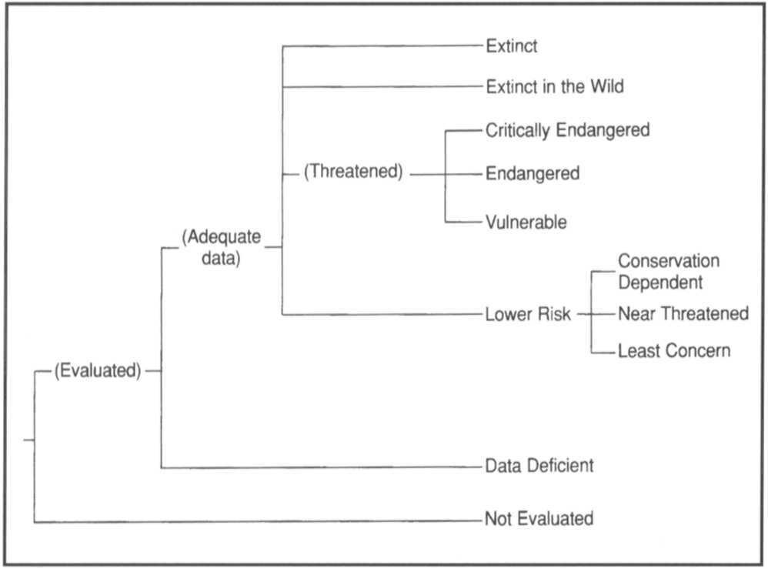

never qualify under these however close to extinction they come), there should be criteria appropriate for assessing threat levels for any taxon (other than micro-organisms). The relevant factor is whether any one criterion is met, not whether all are appropriate or all are met. Because it will never be clear which criteria are appropriate for a particular species in advance, each species should be evaluated against all the criteria, and any criterion met should be listed.

1. **Derivation of quantitative criteria**

The quantitative values presented in the various criteria associated with threatened categories were developed through wide consultation and they are set at what are generally judged to be appropriate levels, even if no formal justification for these values exists. The levels for different criteria within categories were set independently but against a common standard. Some broad consistency between them was sought. However, a given taxon should not be expected to meet all criteria (A-E) in a category; meeting any one criterion is sufficient for listing.

1. **Implications of listing**

Listing in the categories of Not Evaluated and Data Deficient indicates that no assessment of extinction risk has been made, though for different reasons. Until such time as an assessment is made, species listed in these categories should not be treated **as** if they were non-threatened, and it may be appropriate (especially for Data Deficient forms) to give them the same degree of protection as threatened taxa, at least until their status can be evaluated.

Extinction is assumed here to be a chance process. Thus, a listing in a higher extinction risk category implies a higher expectation of extinction, and over the time-frames specified more taxa listed in a higher category are expected to go extinct than in a lower one (without effective conservation action). However, the persistence of some taxa in high risk categories does not necessarily mean their initial assessment was inaccurate.

1. **Data quality and the importance of inference and projection**

The criteria are clearly quantitative in nature. However, the absence of high quality data should not deter attempts at applying the criteria, as methods involving estimation, inference and projection are emphasised to be acceptable throughout. Inference and projection may be based on extrapolation of current or potential threats into the future (including their rate of change), or of factors related to population abundance or distribution (including dependence on other taxa), so long as these can reasonably be supported. Suspected or inferred patterns in either the recent past, present or near future can be based on any of a series of related factors, and these factors should be specified.

Taxa at risk from threats posed by future events of low probability but with severe consequences (catastrophes) should be identified by the criteria (e.g. small distributions, few locations). Some threats need to be identified particularly early, and appropriate actions taken, because their effects are irreversible, or nearly so (pathogens, invasive organisms, hybridization).

1. **Uncertainty**

The criteria should be applied on the basis of the available evidence on taxon numbers, trend and distribution, making due allowance for statistical and other uncertainties. Given that data are rarely available for the whole range or population of a taxon, it may often be appropriate to use the information

that is available to make intelligent inferences about the overall status of the taxon in question. In cases where a wide variation in estimates is found, it is legitimate to apply the precautionary principle and use the estimate (providing it is credible) that leads to listing in the category of highest risk.

Where data are insufficient to assign a category (including Lower Risk), the category of 'Data Deficient' may be assigned. However, it is important to recognise that this category indicates that data are inadequate to determine the degree of threat faced by a taxon, not necessarily that the taxon is poorly known. In cases where there are evident threats to a taxon through, for example, deterioration of its only known habitat, it is important to attempt threatened listing, even though there may be little direct information on the biological status of the taxon itself. The category 'Data Deficient' is not a threatened category, although it indicates a need to obtain more information on a taxon to determine the appropriate listing.

1. Conservation actions in the listing process

The criteria for the threatened categories are to be applied to a taxon whatever the level of conservation action affecting it. In cases where it is only conservation action that prevents the taxon from meeting the threatened criteria, the designation of 'Conservation Dependent' is appropriate. It is important to emphasise here that a taxon require conservation action even if it is not listed as threatened.

1. Documentation

All taxon lists including categorisation resulting from these criteria should state the criteria and sub-criteria that were met. No listing can be accepted as valid unless at least one criterion is given. If more than one criterion or sub-criterion was met, then each should be listed. However, failure to mention a criterion should not necessarily imply that it was not met. Therefore, if a re-evaluation indicates that the documented criterion is no longer met, this should not result in automatic down-listing. Instead, the taxon should be re-evaluated with respect to all criteria to indicate its status. The factors responsible for triggering the criteria, especially where inference and projection are used, should at least be logged by the evaluator, even if they cannot be included in published lists.

1. Threats and priorities

The category of threat is not necessarily sufficient to determine priorities for conservation action. The category of threat simply provides an assessment of the likelihood of extinction under current circumstances, whereas a system for assessing priorities for action will include numerous other factors concerning conservation action such as costs, logistics, chances of success, and even perhaps the taxonomic distinctiveness of the subject.

1. Use at regional level

The criteria are most appropriately applied to whole taxa at a global scale, rather than to those units defined by regional or national boundaries. Regionally or nationally based threat categories, which are aimed at including taxa that are threatened at regional or national levels (but not necessarily throughout their global ranges), are best used with two key pieces of information: the global status category for the taxon, and the proportion of the global population or range that occurs within the region or nation. However, if applied at regional or national level it must be recognised that a global category of threat may not be the same as a regional or national category for a particular taxon. For example, taxa classified as Vulnerable on the basis of their global declines in numbers or range might

be Lower Risk within a particular region where their populations are stable. Conversely, taxa classified as Lower Risk globally might be Critically Endangered within a particular region where numbers are very small or declining, perhaps only because they are at the margins of their global range. IUCN is still in the process of developing guidelines for the use of national red list categories.

1. Re-evaluation

Evaluation of taxa against the criteria should be carried out at appropriate intervals. This is especially important for taxa listed under Near Threatened, or Conservation Dependent, and for threatened species whose status is known or suspected to be deteriorating.

1. Transfer between categories

There are rules to govern the movement of taxa between categories. These are as follows: (A) A taxon may be moved from a category of higher threat to a category of lower threat if none of the criteria of the higher category has been met for five years or more. (B) If the original classification is found to have been erroneous, the taxon may be transferred to the appropriate category or removed from the threatened categories altogether, without delay (but see Section 9). (C) Transfer from categories of lower to higher risk should be made without delay.

1. Problems of scale

Classification based on the sizes of geographic ranges or the patterns of habitat occupancy is complicated by problems of spatial scale. The finer the scale at which the distributions or habitats of taxa are mapped, the smaller the area will be that they are found to occupy. Mapping at finer scales reveals more areas in which the taxon is unrecorded. It is impossible to provide any strict but general rules for mapping taxa or habitats; the most appropriate scale will depend on the taxa in question, and the origin and comprehensiveness of the distributional data. However, the thresholds for some criteria (e.g. Critically Endangered) necessitate mapping at a fine scale.

##### Ill) Definitions

1. **Population**

Population is defined as the total number of individuals of the taxon. For functional reasons, primarily owing to differences between life-forms, population numbers are expressed as numbers of mature individuals only. In the case of taxa obligately dependent on other taxa for all or part of their life cycles, biologically appropriate values for the host taxon should be used.

1. Subpopulations

Subpopulations are defined as geographically or otherwise distinct groups in the population between which there is little exchange (typically one successful migrant individual or gamete per year or less).

1. Mature individuals

The number of mature individuals is defined as the number of individuals known, estimated or inferred to be capable of reproduction. When estimating this quantity the following points should be borne in mind:

* Where the population is characterised by natural fluctuations the minimum number should be used.
* 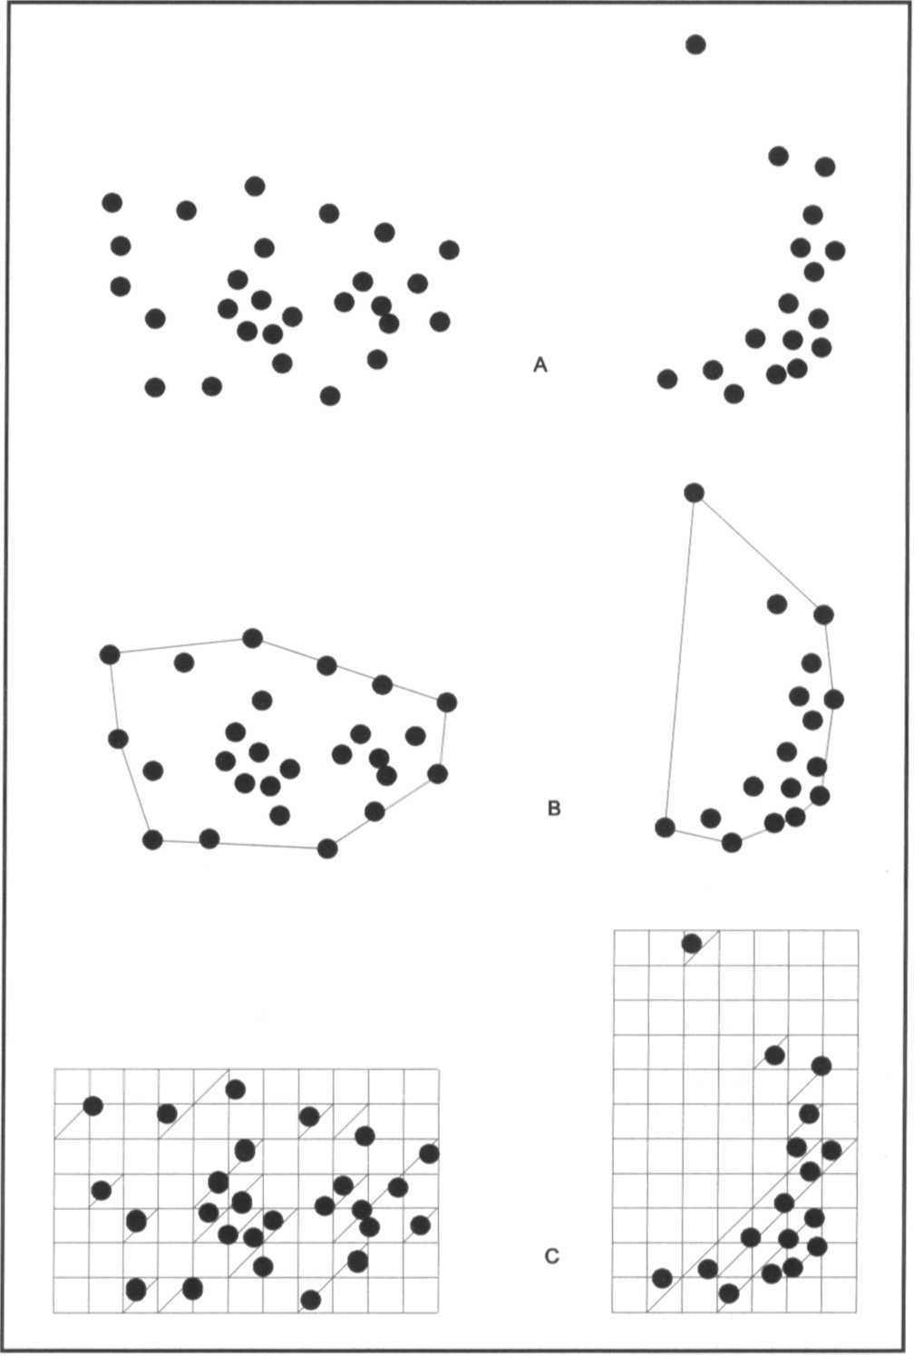This measure is intended to count individuals capable of reproduction and should therefore exclude individuals that are environmentally, behaviourally or otherwise reproductively suppressed in the wild.
* In the case of populations with biased adult or breeding sex ratios it is appropriate to use lower estimates for the number of mature individuals which take this into account (e.g. the estimated effective population size).
* Reproducing units within a clone should be counted as individuals, except where such units are unable to survive alone (e.g. corals).
* In the case of taxa that naturally lose all or a subset of mature individuals at some point in their life cycle, the estimate should be made at the appropriate time, when mature individuals are available for breeding.

1. **Generation**

Generation may be measured as the average age of parents in the population. This is greater than the age at first breeding, except in taxa where individuals breed only once.

1. **Continuing decline**

A continuing decline is a recent, current or projected future decline whose causes are not known or not adequately controlled and so is liable to continue unless remedial measures are taken. Natural fluctuations will not normally count as a continuing decline, but an observed decline should not be considered to be part of a natural fluctuation unless there is evidence for this.

1. **Reduction**

A reduction (criterion A) is a decline in the number of mature individuals of at least the amount (%) stated over the time period (years) specified, although the decline need not still be continuing. A reduction should not be interpreted as part of a natural fluctuation unless there is good evidence for this. Downward trends that are part of natural fluctuations will not normally count as a reduction.

1. **Extreme fluctuations**

Extreme fluctuations occur in a number of taxa where population size or distribution area varies widely, rapidly and frequently, typically with a variation greater than one order of magnitude (i.e. a tenfold increase or decrease).

1. **Severely fragmented**

Severely fragmented refers to the situation where increased extinction risks to the taxon result from the fact that most individuals within a taxon are found in small and relatively isolated subpopulations. These small subpopulations may go extinct, with a reduced probability of recolonisation.

1. **Extent of occurrence**

Extent of occurrence is defined as the area contained within the shortest continuous imaginary boundary which can be drawn to encompass all the known, inferred or projected sites of present occurrence of a taxon, excluding cases of vagrancy. This measure may exclude discontinuities or disjunctions within the overall distributions of taxa (e.g. large areas of obviously unsuitable habitat) (but see 'area of occupancy'). Extent of occurrence can often be measured by a minimum convex polygon (the smallest polygon in which no internal angle exceeds 180 degrees and which contains all the sites of occurrence).

**Figure 2:** Two examples of the distinction between extent of occurrence and area of occupancy, (a) is the spatial distribution of known, inferred or projected sites of occurrence. (b) shows one possible boundary to the extent of occurrence, which is the measured area within this boundary. (c) shows one measure of area of occupancy which can be measured by the sum of the occupied grid squares.

1. **Area of occupancy**

Area of occupancy is defined as the area within its 'extent of occurrence' (see definition) which is occupied by a taxon, excluding cases of vagrancy. The measure reflects the fact that a taxon will not usually occur throughout the area of its extent of occurrence, which may, for example, contain unsuitable habitats. The area of occupancy is the smallest area essential at any stage to the survival of existing populations of a taxon (e.g. colonial nesting sites, feeding sites for migratory taxa). The size of the area of occupancy will be a function of the scale at which it is measured, and should be at a scale appropriate to relevant biological aspects of the taxon. The criteria include values in km2, and thus to avoid errors in classification, the area of occupancy should be measured on grid squares (or equivalents) which are sufficiently small (see Figure 2).

1. Location

Location defines a geographically or ecologically distinct area in which a single event (e.g. pollution) will soon affect all individuals of the taxon present. A location usually, but not always, contains all or part of a subpopulation of the taxon, and is typically a small proportion of the taxon's total distribution.

1. **Quantitative analysis**

A quantitative analysis is defined here as the technique of population viability analysis (PVA), or any other quantitative form of analysis, which estimates the extinction probability of a taxon or population based on the known life history and specified management or non-management options. In presenting the results of quantitative analyses the structural equations and the data should be explicit.

##### The Categories 1

**EXTINCT (EX)**

A taxon is Extinct when there is no reasonable doubt that the last individual has died.

**EXTINCT IN THE WILD (EW)**

A taxon is Extinct in the wild when it is known only to survive in cultivation, in captivity or as a naturalised population (or populations) well outside the past range. A taxon is presumed extinct in the wild when exhaustive surveys in known and/or expected habitat, at appropriate times (diurnal, seasonal, annual), throughout its historic range have failed to record an individual. Surveys should be over a time frame appropriate to the taxon's life cycle and life form.

**CRITICALLY ENDANGERED (CR)**

A taxon is Critically Endangered when it is facing an extremely high risk of extinction in the wild in the immediate future, as defined by any of the criteria (A to E) on pages 94-95.

**ENDANGERED (EN)**

A taxon is Endangered when it is not Critically Endangered but is facing a very high risk of extinction in the wild in

risk of extinction based on its distribution and/or population status. A taxon in this category may be well studied, and its biology well known, but appropriate data on abundance and/ or distribution is lacking. Data Deficient is therefore not a category of threat or Lower Risk. Listing of taxa in this category indicates that more information is required and acknowledges the possibility that future research will show that threatened classification is appropriate. It is important to make positive use of whatever data are available. In many cases great care should be exercised in choosing between DD and threatened status. If the range of a taxon is suspected to be relatively circumscribed, if a considerable period of time has elapsed since the last record of the taxon, threatened status may well be justified.

**NOT EVALUATED (NE)**

A taxon is Not Evaluated when it is has not yet been assessed against the criteria.

##### The Criteria for Critically Endangered, Endangered and Vulnerable

CRITICALLY ENDANGERED (CR)

A taxon is Critically Endangered when it is facing an extremely high risk of extinction in the wild in the immediate future, as defined by any of the following criteria (A to E):

1. Population reduction in the form of either of the following:
   1. An observed, estimated, inferred or suspected reduction ofat least 80% over the last 10 years or three generations, whichever is the longer, based on (and specifying) any of the following:

the near future, as defined by any of the criteria (A to E) on page 95.

**VULNERABLE(VU)**

A taxon is Vulnerable when it is not Critically Endangered or Endangered but is facing a high risk of extinction in the wild in the medium-term future, as defined by any of the criteria (A to D) on pages 95 and 96.

**LOWER RISK (LR)**

A taxon is Lower Risk when it has been evaluated, does not satisfy the criteria for any of the categories Critically Endangered, Endangered or Vulnerable. Taxa included in the Lower Risk category can be separated into three subcategories:

* + 1. direct observation
    2. an index of abundance appropriate for the taxon
    3. a decline in area of occupancy, extent of occurrence and/or quality of habitat
    4. actual or potential levels of exploitation
    5. the effects of introduced taxa, hybridisation, pathogens, pollutants, competitors or parasites.
  1. A reduction of at least 80%, projected or suspected to be met within the next 10 years or three generations, whichever is the longer, based on (and specifying) any of (b), (c), (d) or (e) above.

1. Extent of occurrence estimated to be less than 100km2 or area of occupancy estimated to be less than 10km2, and
2. **Conservation Dependent (cd).** Taxa which are the focus of a

estimates indicating any two of the following:

continuing taxon-specific or habitat-specific conservation programme targeted towards the taxon in question, the cessation of which would result in the taxon qualifying for one of the threatened categories above within a period of five years.

1. **Near Threatened (nt).** Taxa which do not qualify for Conservation Dependent, but which are close to qualifying for Vulnerable.
2. **Least Concern (lc).** Taxa which do not qualify for Conservation Dependent or Near Threatened.

**DATA DEFICIENT (DD)**

A taxon is Data Deficient when there is inadequate information to make a direct, or indirect, assessment of its

1. Severely fragmented or known to exist at only a single location.
2. Continuing decline, observed, inferred or projected, in any of the following:
   1. extent of occurrence
   2. area of occupancy
   3. area, extent and/or quality of habitat
   4. number of locations or subpopulations
   5. number of mature individuals.
3. Extreme fluctuations in any of the following:
   1. extent of occurrence
   2. area of occupancy
   3. number of locations or subpopulations
   4. number of mature individuals.
4. Population estimated to number less than 250 mature individuals and either:
   1. An estimated continuing decline of at least 25% within three years or one generation, whichever is longer or
   2. A continuing decline, observed, projected, or inferred, in numbers of mature individuals and population structure in the form of either:
      1. severely fragmented (i.e. no subpopulation estimated to contain more than 50 mature individuals)
      2. all individuals are in a single subpopulation.
5. Population estimated to number less than 50 mature individuals.
6. Quantitative analysis showing the probability of extinction in the wild is at least 50% within 10 years or three generations, whichever is the longer.

**ENDANGERED (EN)**

A taxon is Endangered when it is not Critically Endangered but is facing a very high risk of extinction in the wild in the near future, as defined by any of the following criteria (A to E):

1. Population reduction in the form of either of the following:
   1. An observed, estimated, inferred or suspected reduction ofat least 50% over the last 10 years or three generations, whichever is the longer, based on (and specifying) any of the following:
2. Population estimated to number less than 2500 mature individuals and either:
   1. An estimated continuing decline of at least 20% within five years or two generations, whichever is longer, or
   2. A continuing decline, observed, projected, or inferred, in numbers of mature individuals and population structure in the form of either:
      1. severely fragmented (i.e. no subpopulation estimated to contain more than 250 mature individuals)
      2. all individuals are in a single subpopulation.
3. Population estimated to number less than 250 mature individuals.
4. Quantitative analysis showing the probability of extinction in the wild is at least 20% within 20 years or five generations, whichever is the longer.

**VULNERABLE (VU)**

A taxon is Vulnerable when it is not Critically Endangered or Endangered but is facing a high risk of extinction in the wild in the medium-term future, as defined by any of the following criteria (A to E):

1. Population reduction in the form of either of the following:
   1. An observed, estimated, inferred or suspected reduction ofat least 20% over the last 10 years or three generations, whichever is the longer, based on (and specifying) any of the following:
      1. direct observation
      2. an index of abundance appropriate for the taxon
      3. a decline in area of occupancy, extent of occurrence and/or quality of habitat
      4. actual or potential levels of exploitation
      5. the effects of introduced taxa, hybridisation, pathogens, pollutants, competitors or parasites.
   2. A reduction of at least 50%, projected or suspected to be met within the next 10 years or three generations, whichever is the longer, based on (and specifying) any of (b), (c), (d), or (e) above.
2. Extent of occurrence estimated to be less than 5000km2 or area of occupancy estimated to be less than 500km2, and estimates indicating any two of the following:
3. direct observation
4. an index of abundance appropriate for the taxon
5. a decline in area of occupancy, extent of occurrence and/or quality of habitat
6. actual or potential levels of exploitation
7. the effects of introduced taxa, hybridisation, pathogens, pollutants, competitors or parasites.
   1. A reduction of at least 20%, projected or suspected to be met within the next ten years or three generations, whichever is the longer, based on (and specifying) any of (b), (c), (d) or (e) above.
8. Extent of occurrence estimated to be less than 20,000km2 or area of occupancy estimated to be less than 2000km2, and estimates indicating any two of the following:
   1. Severely fragmented or known to exist at no more than five locations.
   2. Continuing decline, inferred, observed or projected, in any of the following:
9. Severely fragmented or known to exist at no more than ten locations.
10. Continuing decline, inferred, observed or projected, in any of the following:
    1. extent of occurrence
    2. area of occupancy
    3. area, extent and/or quality of habitat
    4. number of locations or subpopulations
    5. number of mature individuals.
11. Extreme fluctuations in any of the following:
    1. extent of occurrence
    2. area of occupancy
    3. area, extent and/or quality of habitat
    4. number of locations or subpopulations
    5. number of mature individuals
12. Extreme fluctuations in any of the following:
    1. extent of occurrence
    2. area of occupancy
    3. number of locations or subpopulations
    4. number of mature individuals.
13. extent of occurrence
14. area of occupancy
15. number of locations or subpopulations
16. number of mature individuals
17. Population estimated to number less than 10,000 mature individuals and either:
18. Population is characterised by an acute restriction in its area of occupancy (typically less than 100km2) or in the number of locations (typically less than five). Such a
    1. An estimated continuing decline of at least 10% within 10 years or three generations, whichever is longer, or
    2. A continuing decline, observed, projected, or inferred, in numbers of mature individuals and population structure in the form of either:

taxon would thus be prone to the effects of human activities (or stochastic events whose impact is increased by human activities) within a very short period of time in an unforeseeable future, and is thus capable of becoming Critically Endangered or even Extinct in a very short period.

* + 1. severely fragmented (i.e. no subpopulation estimated to contain more than 1000 mature individuals)
    2. all individuals are in a single subpopulation

1. Population very small or restricted in the form of either of the following:
   1. Population estimated to number less than 1000 mature individuals.
2. Quantitative analysis showing the probability of extinction in the wild is at least 10% within 100 years.

*Note: copies of the IUCN Red List Categories booklet, are available on request from IUCN (address on back cover of this Action Plan)*

1 Note: As in previous IUCN categories, the abbreviation of each category (in parenthesis) follows the English denominations when translated into other languages.

**IUCN/SSC Action Plans for the Conservation of Biological Diversity**

*Action Plan for African Primate Conservation: 1986-1990.* Compiled by J.F. Oates and the IUCN/SSC Primate Specialist Group, 1986,41 pp. (Out of print.)

*Action Plan for Asian Primate Conservation: 1987-1991.* Compiled by A.A. Eudey and the IUCN/SSC Primate Specialist Group, 1987,65 pp. (Out of print.)

*Antelopes.GlobalSurveyandRegionalActionPlans.Part1.EastandNortheast Africa.* Compiled by R. East and the IUCN/SSC Antelope Specialist Group, 1988, 96 pp. (Out of print.)

*Dolphins, Porpoises and Whales. An Action Plan for the Conservation of Biological Diversity: 1988-1992.* Second Edition. Compiled by W.F. Perrin and the IUCN/SSC Cetacean Specialist Group, 1989, 27 pp. (Out of print).

*TheKouprey.AnActionPlanforitsConservation.*CompiledbyJ.R.MacKinnon,

S.N. Stuart and the IUCN/SSC Asian Wild Cattle Specialist Group, 1988, 19 pp. (Out of print.)

*Weasels, Civets, Mongooses and their Relatives. An Action Plan for the Conservation of Mustelids and Viverrids.* Compiled by A. Schreiber, R. Wirth,

M. Riffel, H. van Rompaey and the IUCN/SSC Mustelid and Viverrid Specialist Group, 1989, 99 pp. (Out of Print.)

*Antelopes. Global Survey and Regional Action Plans. Part 2. Southern and South-central Africa.* Compiled by R. East and the IUCN/SSC Antelope Specialist Group, 1989, 96 pp. (Out of print.)

*Asian Rhinos. An Action Plan for their Conservation.* Compiled by Mohd Khan bin Momin Khan and the IUCN/SSC Asian Rhino Specialist Group, 1989, 23 pp. (Out of print.)

*Tortoises and Freshwater Turtles. An Action Plan for their Conservation.* Compiled by the IUCN/SSC Tortoise and Freshwater Turtle Specialist Group, 1989,47 pp.

*African Elephants and Rhinos. Status Survey and Conservation Action Plan.* Compiled by D.H.M. Cumming, R.F. du Toit, S.N. Stuart and the IUCN/SSC African Elephant and Rhino Specialist Group, 1990, 73 pp. (Out of print.)

*Foxes, Wolves, Jackals, and Dogs. An Action Plan for the Conservation of Canids.* Compiled by J.R. Ginsberg, D.W. Macdonald, and the IUCN/SSC Canid and Wolf Specialist Groups, 1990, 116 pp.

*The Asian Elephant. An Action Plan for its Conservation.* Compiled by C. Santiapillai, P. Jackson, and the IUCN/SSC Asian Elephant Specialist Group, 1990, 79 pp.

*Antelopes.GlobalSurveyandRegionalActionPlans.Part3.WestandCentral Africa.* Compiled by R. East and the IUCN/SSC Antelope Specialist Group, 1990, 171 pp.

Offers. *An Action Plan for their Conservation.* Compiled by P. Foster-Turley, S.Macdonald, C. Mason and the IUCN/SSC Otter Specialist Group, 1990, 126 pp.

*Rabbits, Hares and Pikas. Status Survey and Conservation Action Plan.* Compiled by J.A. Chapman, J.E.C. Flux, and the IUCN/SSC Lagomorph Specialist Group, 1990, 168 pp.

*AfricanInsectivoraandElephant-Shrews.AnActionPlanfortheirConservation.* Compiled by M.E. Nicoll, G.B. Rathbun and the IUCN/SSC Insectivore, Tree-Shrew and Elephant-Shrew Specialist Group, 1990, 53 pp.

*Swallowtail Butterflies. An Action Plan for their Conservation.* Compiled by

T.R. New, N.M. Collins and the IUCN/SSC Lepidoptera Specialist Group, 1991,36 pp.

*Crocodiles. An Action Plan for their Conservation.* Compiled by J. Thorbjarnarson, H. Messel, F.W. King, J.P. Ross and the IUCN/SSC Crocodile Specialist Group, 1992, 136 pp.

*South American Camelids. An Action Plan fortheir Conservation.* Compiled by

H. Torres and the IUCN/SSC South American Camelid Specialist Group, 1992, 58 pp.

*AustralasianMarsupialsandMonotremes.AnActionPlanfortheirConservation.* Compiled by M. Kennedy and the IUCN/SSC Australasian Marsupial and Monotreme Specialist Group, 1992, 103 pp.

*Lemurs of Madagascar. An Action Plan for their Conservation: 1993-1999.* Compiled by R.A. Mittermeier, W.R. Konstant, M.E. Nicoll, O. Langrand and the IUCN/SSC Primate Specialist Group, 1992, 58 pp. (Out of print.)

*Zebras, Asses and Horses. An Action Plan for the Conservation of Wild Equids.* Compiled by P. Duncan and the IUCN/SSC Equid Specialist Group, 1992, 36 pp.

*Old Worid Fruit Bats. An Action Plan for their Conservation.* Compiled by S. Mickleburgh, A.M. Hutson, P.A. Racey and the IUCN/SSC Chiroptera Specialist Group, 1992, 252 pp. (Out of print.)

*Seals, Fur Seals, Sea Lions, and Walrus. Status Survey and Conservation Action Plan.* Peter Reijnders, Sophie Brasseur, Jaap van der Toorn, Peter van der Wolf, Ian Boyd, John Harwood, David Lavigne, Lloyd Lowry, and the IUCN/ SSC Seal Specialist Group, 1993, 88 pp.

*Pigs, Peccaries, and Hippos. Status Survey and Conservation Action Plan.* Edited by William LR. Oliver and the IUCN/SSC Pigs and Peccaries Specialist Group and the IUCN/SSC Hippo Specialist Group, 1993, 202 pp.

*TheRedPanda,Olingos,Coatis,Raccoons,andtheirRelatives.StatusSurvey and Conservation Action Plan for Procyonids and Ailurids.* (In English and Spanish) Compiled by Angela R. Glatston and the IUCN/SSC Mustelid, Viverrid, and Procyonid Specialist Group, 1994, 103 pp.

*Dolphins,Porpoises,andWhales.1994-1998ActionPlanfortheConservation of Cetaceans.* Compiled by Randall R. Reeves and Stephen Leatherwood together with the IUCN/SSC Cetacean Specialist Group, 1994, 91 pp.

*Megapodes. An Action Plan for their Conservation 1995-1999.* Compiled by Rene W.R.J.Dekker, Philip J.K.McGowan and the WPA/Birdlife/SSC Megapode Specialist Group, 1995, 41 pp.

*Partridges,Quails,Francolins,SnowcocksandGuineafowl.Statussurveyand Conservation Action Plan 1995-1999.* Compiled by Philip J.K. McGowan, Simon D. Dowell, John P. Carroll and Nicholas J.A.Aebischer and the WPA/ BirdLife/SSC Partridge, Quail and Francoliln Specialist Group. 1995, 102 pp.

*Pheasants.StatusSurveyandConservationActionPlan1995-1999.*Compiled by Philip J.K. McGowan and Peter J. Garson on behalf of the WPA/BirdLife/ SSC Pheasant Specialist Group, 1995, 116 pp.

*Wild Cats: Status Survey and Conservation Action Plan.* Compiled and edited by Kristin Nowell and Peter Jackson and the IUCN/SSC Cat Specialist Group, 1996, 406 pp.

*Eurasian Insectivores and Tree Shrews. Status Survey and Conservation Action Plan.* Compiled by David Stone and the IUCN/SSC Insectivore, Tree Shrew and Elephant Shrew Specialist Group. 1996, 108 pp.

*African Primates. Status Survey and Conservation Action Plan* (Revised edition). Compiled by John F. Oates and the IUCN/SSC Primate Specialist Group. 1996, 80 pp.

*The Cranes. Status Survey and Conservation Action Plan.* Compiled by Curt D. Meine and George W. Archibald and the IUCN/SSC Crane Specialist Group, 1996, 401 pp.

*Orchids. Status Survey and Conservation Action Plan.* Edited by Eric Hagsater and Vinciane Dumont, compiled by Alec Pridgeon and the IUCN/SSC Orchid Specialist Group, 1996, 153 pp.

*Palms. Their Conservation and Sustained Utilization. Status Survey and Conservation Action Plan.* Edited by Dennis Johnson and the IUCN/SSC Palm Specialist Group, 1996, 116 pp.

*Conservation of Mediterranean Island Plants. 1. Strategy for Action.* Compiled by O. Delanoë, B. de Montmollin, L. Olivier and the IUCN/SSC Mediterranean Islands Plant Specialist Group, 1996, 106 pp.

*Asian Rhinos. Status Survey and Conservation Action Plan* (Second edition). Edited by Thomas J. Foose and Nico van Strien and the IUCN/SSC Asian Rhino Specialist Group, 1997, 112 pp.

*Wild Sheep and Goats and their relatives. Status Survey and Conservation Action Plan.* Edited by David M. Shackleton and the IUCN/SSC Caprinae Specialist Group, 1997, 390 pp.

*The Ethiopian Wolf. Status Survey and Conservation Action Plan.* Compiled and edited by Claudio Sillero-Zubiri and David Macdonald and the IUCN/SSC Canid Specialist Group, 1997, 123pp.

*Cactus and Succulent Plants. Status Survey and Conservation Action Plan.* Compiled by Sara Oldfield and the IUCN/SSC Cactus and Succulent Specialist Group, 1997, 212 pp.

*Dragonflies. Status Survey and Conservation Action Plan.* Compiled by Norman W. Moore and the IUCN/SSC Odonata Specialist Group, 1997,

28 pp.

*The African Wild Dog. Status Survey and Conservation Action Plan.* Compiled and edited by Rosie Woodroffe, Joshua Ginsberg and David Macdonald and the IUCN/SSC Canid Specialist Group, 1997, 166pp.

*Tapirs. Status Survey and Conservation Action Plan.* Compiled and edited by Daniel M. Brooks, Richard E. Bodmer and Sharon Matola and the IUCN/SSC Tapir Specialist Group, 1997, 164 pp.

*Grebes. Status Survey and Conservation Action Plan.* Compiled by Colin O'Donnel and Jon Fjeldsa and the IUCN/SSC Grebe Specialist Group, 1997, 59 pp.

*Hyaenas. Status Survey and Conservation Action Plan.* Compiled by Gus Mills and Heribert Hofer and the IUCN/SSC Hyaena Specialist Group, 1998, 154 pp.

**A more detailed list of IUCN/SSC publications is available from the SSC office, Rue Mauverney 28, CH 1196 Gland, Switzerland.**

**Tel: +41 22 999 0150, Fax: +41 22 999 0015, E-mail:** [**mcl@hq.iucn.org**](mailto:mcl@hq.iucn.org)

IUCN/Species Survival Commission

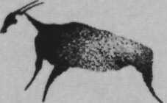

The Species Survival Commission (SSC) is one of six volunteer commissions of IUCN - The World Conservation Union, a union of sovereign states, government agencies and non- governmental organizations. IUCN has three basic conservation objectives: to secure the conservation of nature, and especially of biological diversity, as an essential foundation for the future; to ensure that where the earth's natural resources are used this is done in a wise, equitable and sustainable way; and to guide the development of human communities towards ways of life that are both of good quality and in enduring harmony with other components of the biosphere.

The SSC's mission is to conserve biological diversity by developing and executing programs to save, restore and wisely manage species and their habitats. A volunteer network comprised of nearly 7,000 scientists, field researchers, government officials and conservation leaders from 188 countries, the SSC membership is an unmatched source of information about biological diversity and its conservation. As such, SSC members provide technical and scientific counsel for conservation projects throughout the world and serve as resources to governments, international conventions and conservation organizations.

The IUCN/SSC Action Plan series assesses the conservation status of species and their habitats, and specifies conservation priorities. The series is one of the world's most authoritative sources of species conservation information available to nature resource managers, conservationists and government officials around the world.

IUCN Species Survival Commission

Rue Mauverney 28. CH-1196 Gland, Switzerland. Tel: + +41 22 999 01 53, Fax: + +41 22 999 00 15

E-mail: [lwh@hq.iucn.org](mailto:lwh@hq.iucn.org)

IUCN Publications Services Unit,

219c Huntingdon Road, Cambridge, CB3 ODL, UK. Tel: + +44 1223 277894, Fax: + +44 1223 277175

E-mail: [iucn-psu@wcmc.org.uk](mailto:iucn-psu@wcmc.org.uk)

**IUCN**

**The World Conservation Union** SPECIES SURVIVAL COMMISSION